Homework 2

Davneet Kaur

1. a. Add a feature to the expression parsing code

**Ans:** The below screenshot shows three features (one each for integer, float and string) added to the expression parsing code:

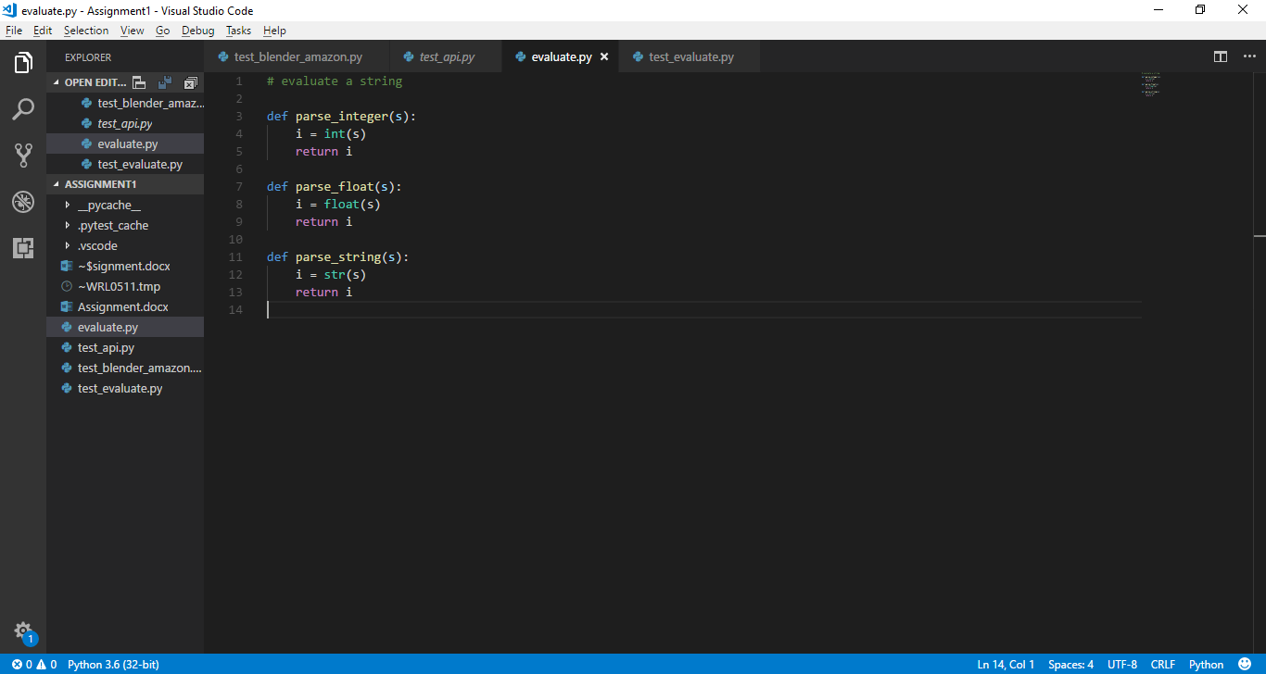

b. Verify through testing with pytest and direct connection that the expression parser works on some feature you have added.

**Ans:** The below screenshots show the test of above features:

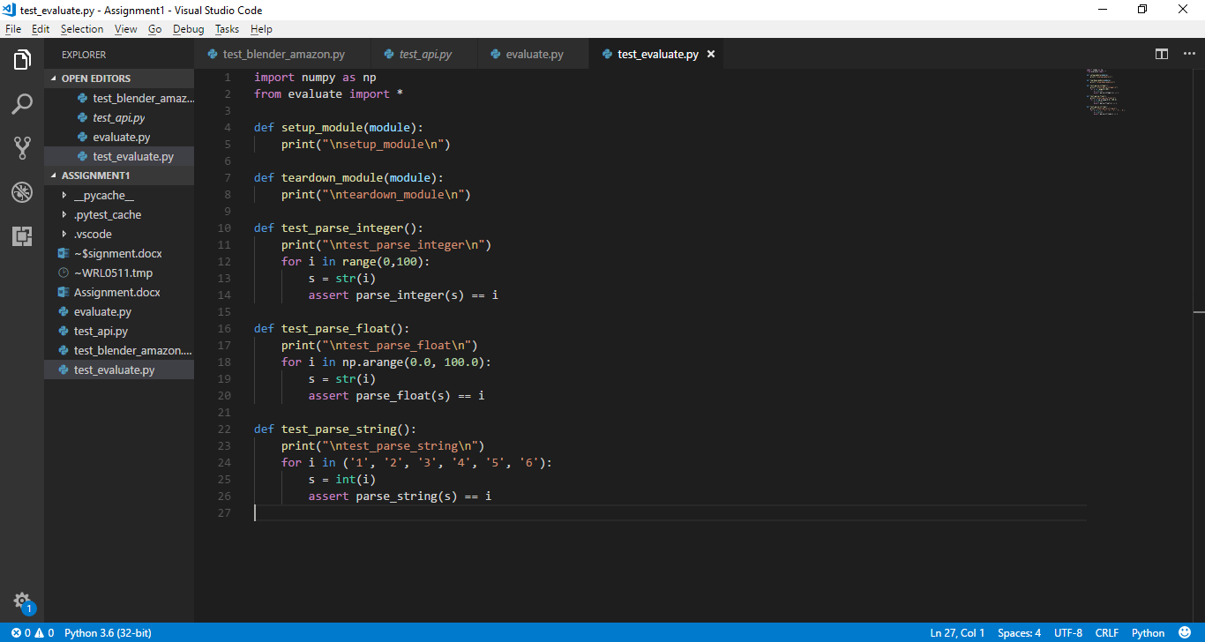

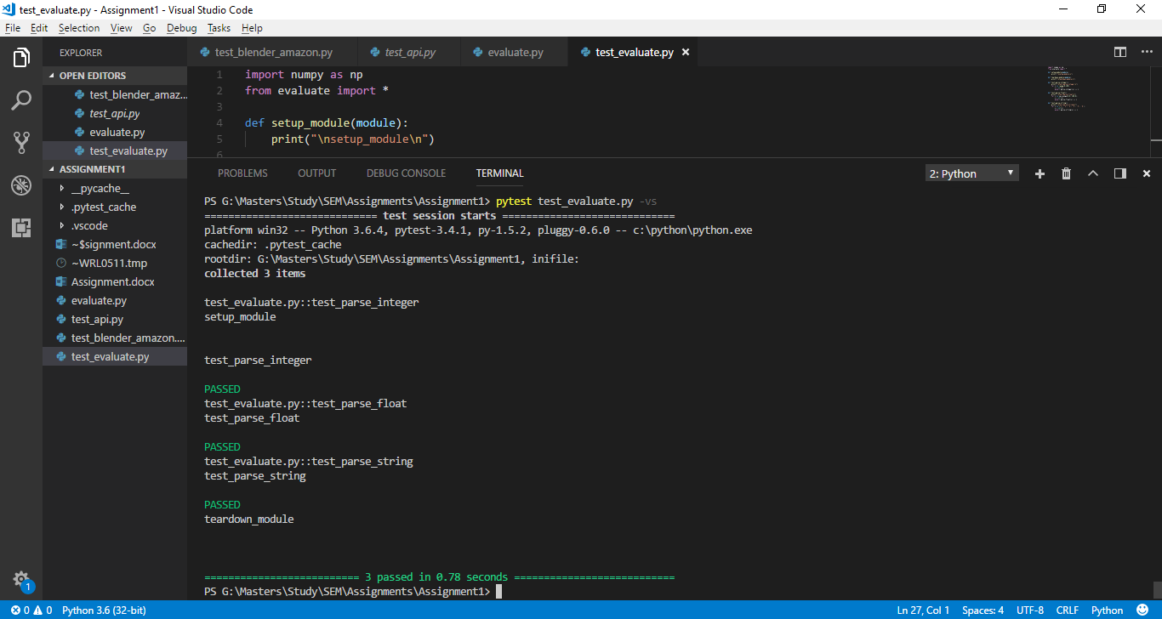

1. Verify using requests and pytest that some API on this list works correctly:

<https://github.com/toddmotto/public-apis>

**Ans:** The below screenshots show 2 tests for the ‘Data USA’ API. First test is for the ‘about’ page of this API. Second test is for one query on this API.

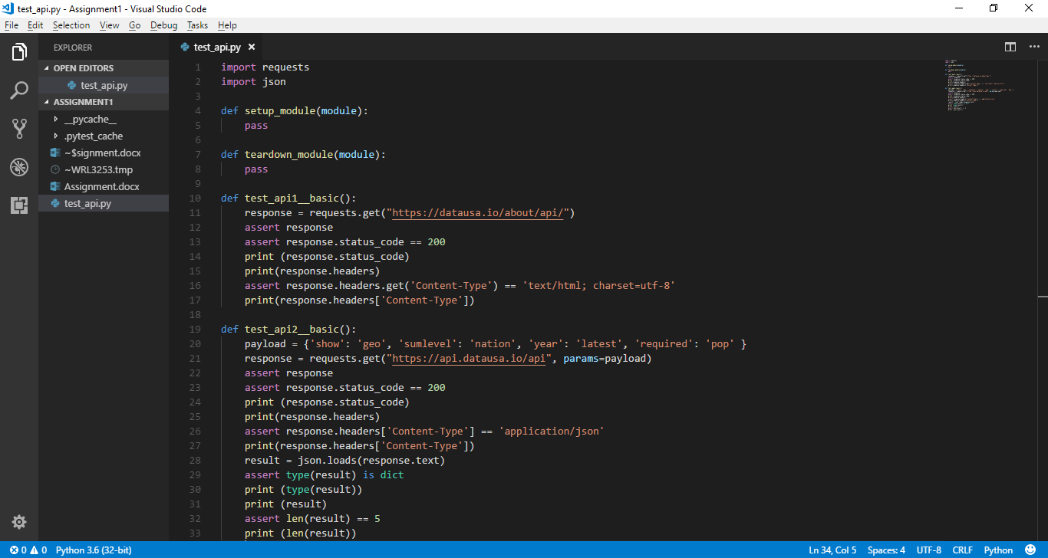

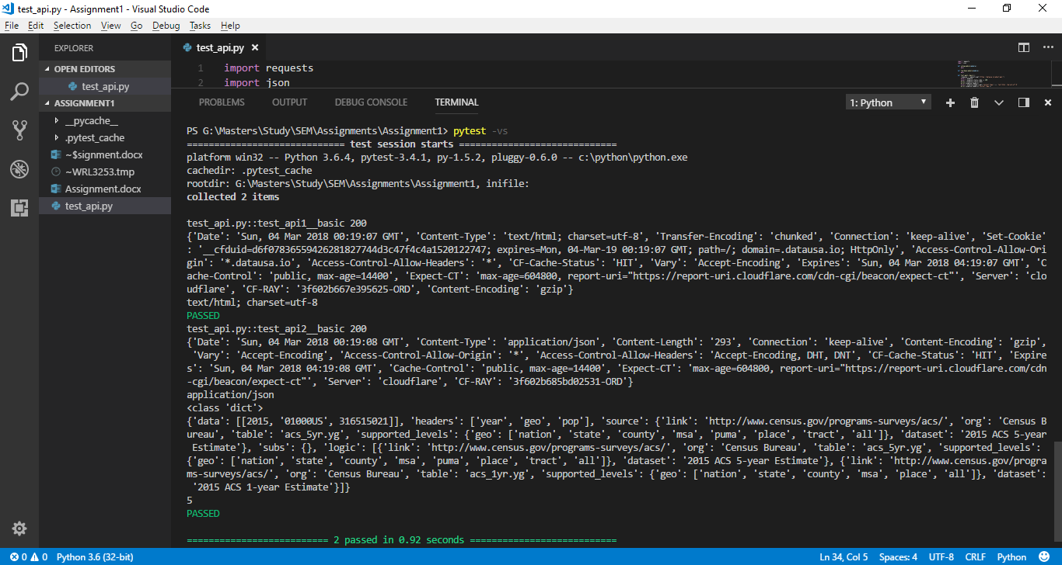

1. Verify using webdriver and pytest that either "Oster" or "Hamilton Beach" is one of the blenders brands sold on Amazon on the "blender" search page.

**Ans:** The below screenshots show the code to test the above requirements:

