Paperless Restaurant App

6G6Z1111: Advanced Web Development

3/6/2019 – Connor Partington - 16062949

2019

Contents

Screenshots 2

Login View 2

Waiter View 4

Kitchen View 7

Counter View 11

Admin View 13

Additional 16

# Screenshots

## Login View

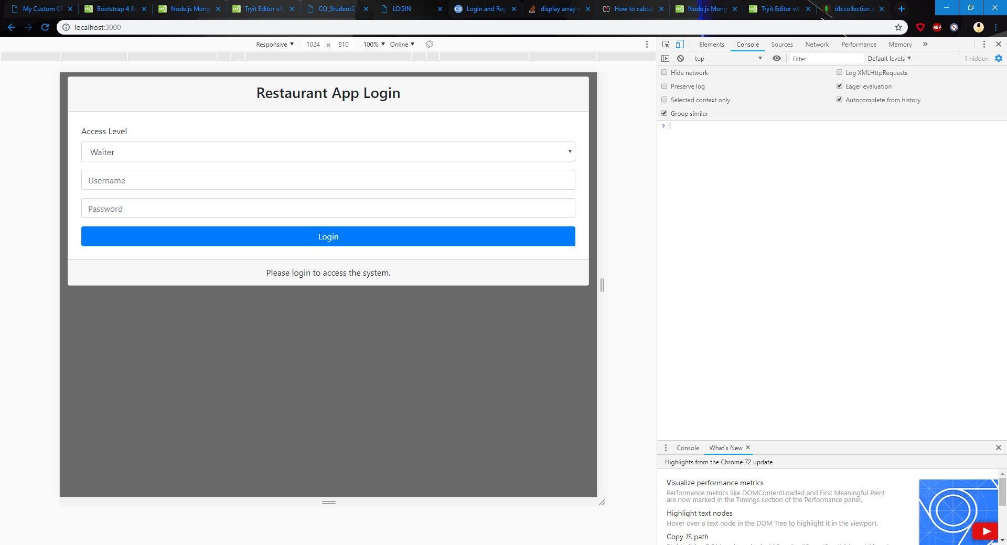

Figure 1 - Login page for staff (Laptop - 1024x810)

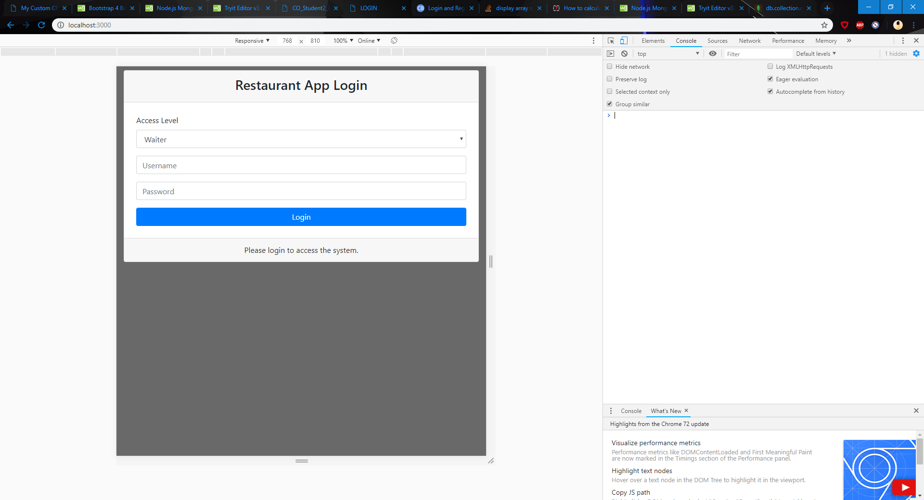

Figure 2 - Login page for staff (Tablet - 768x810)

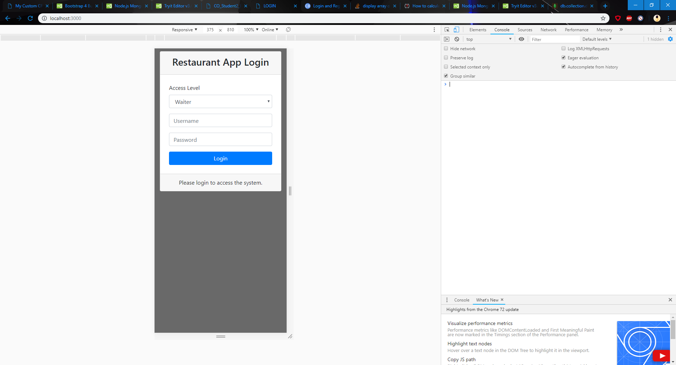

Figure 3 - Login page for staff (Mobile M - 375x810)

## Waiter View

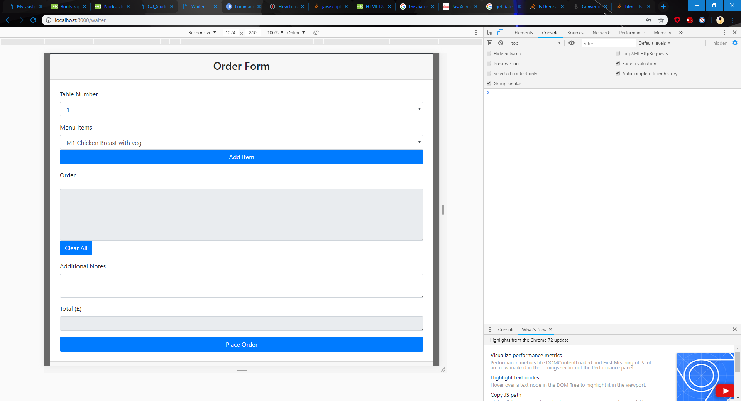

Figure 4 – Place order form for waiters after logging into the system (Laptop - 1024x810)

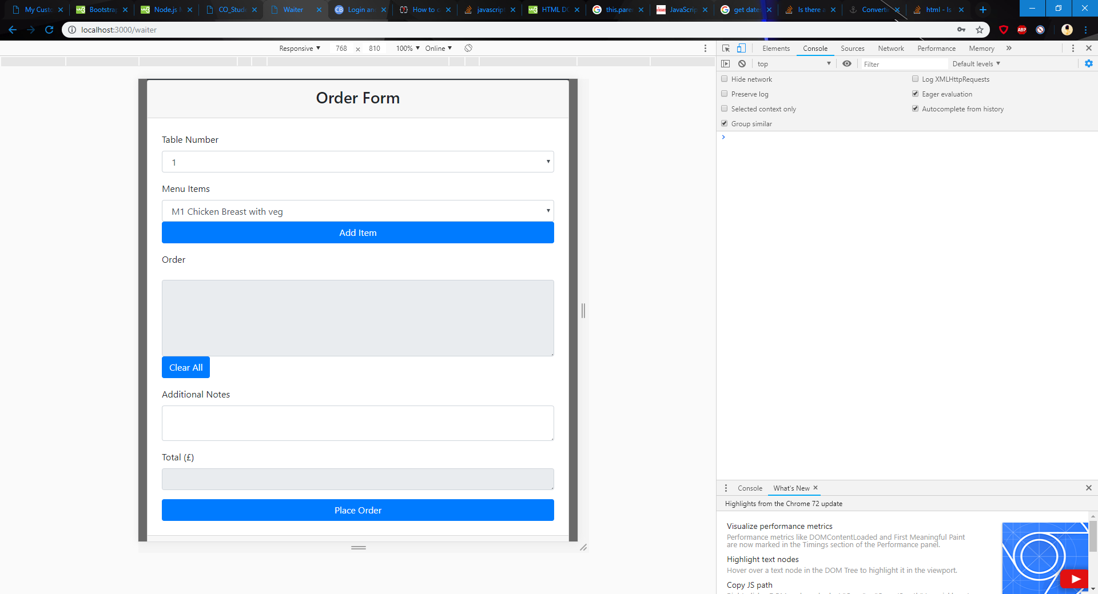

Figure 5 - Place order form for waiters after logging into the system (Tablet - 768x810)

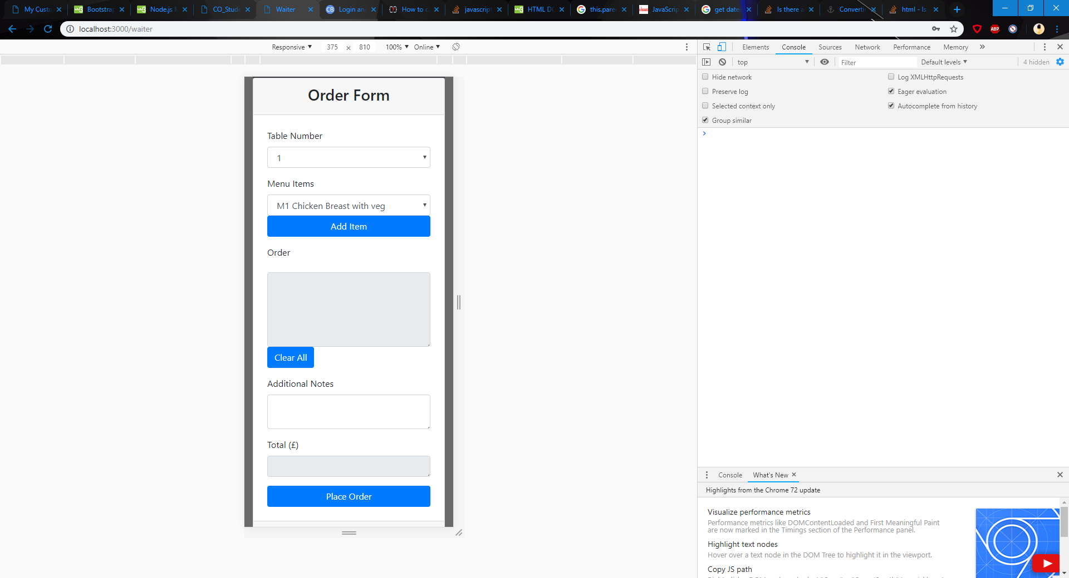

Figure 6 - Place order form for waiters after logging into the system (Mobile M - 375x810)

## Kitchen View

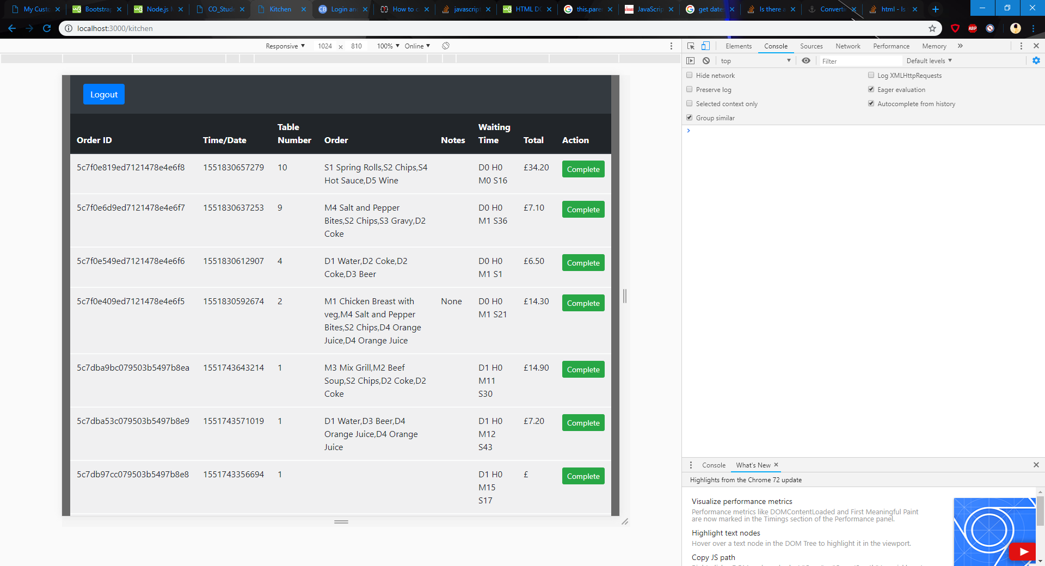

Figure 7 – Kitchen view after kitchen staff have logged in (Laptop - 1024x810)

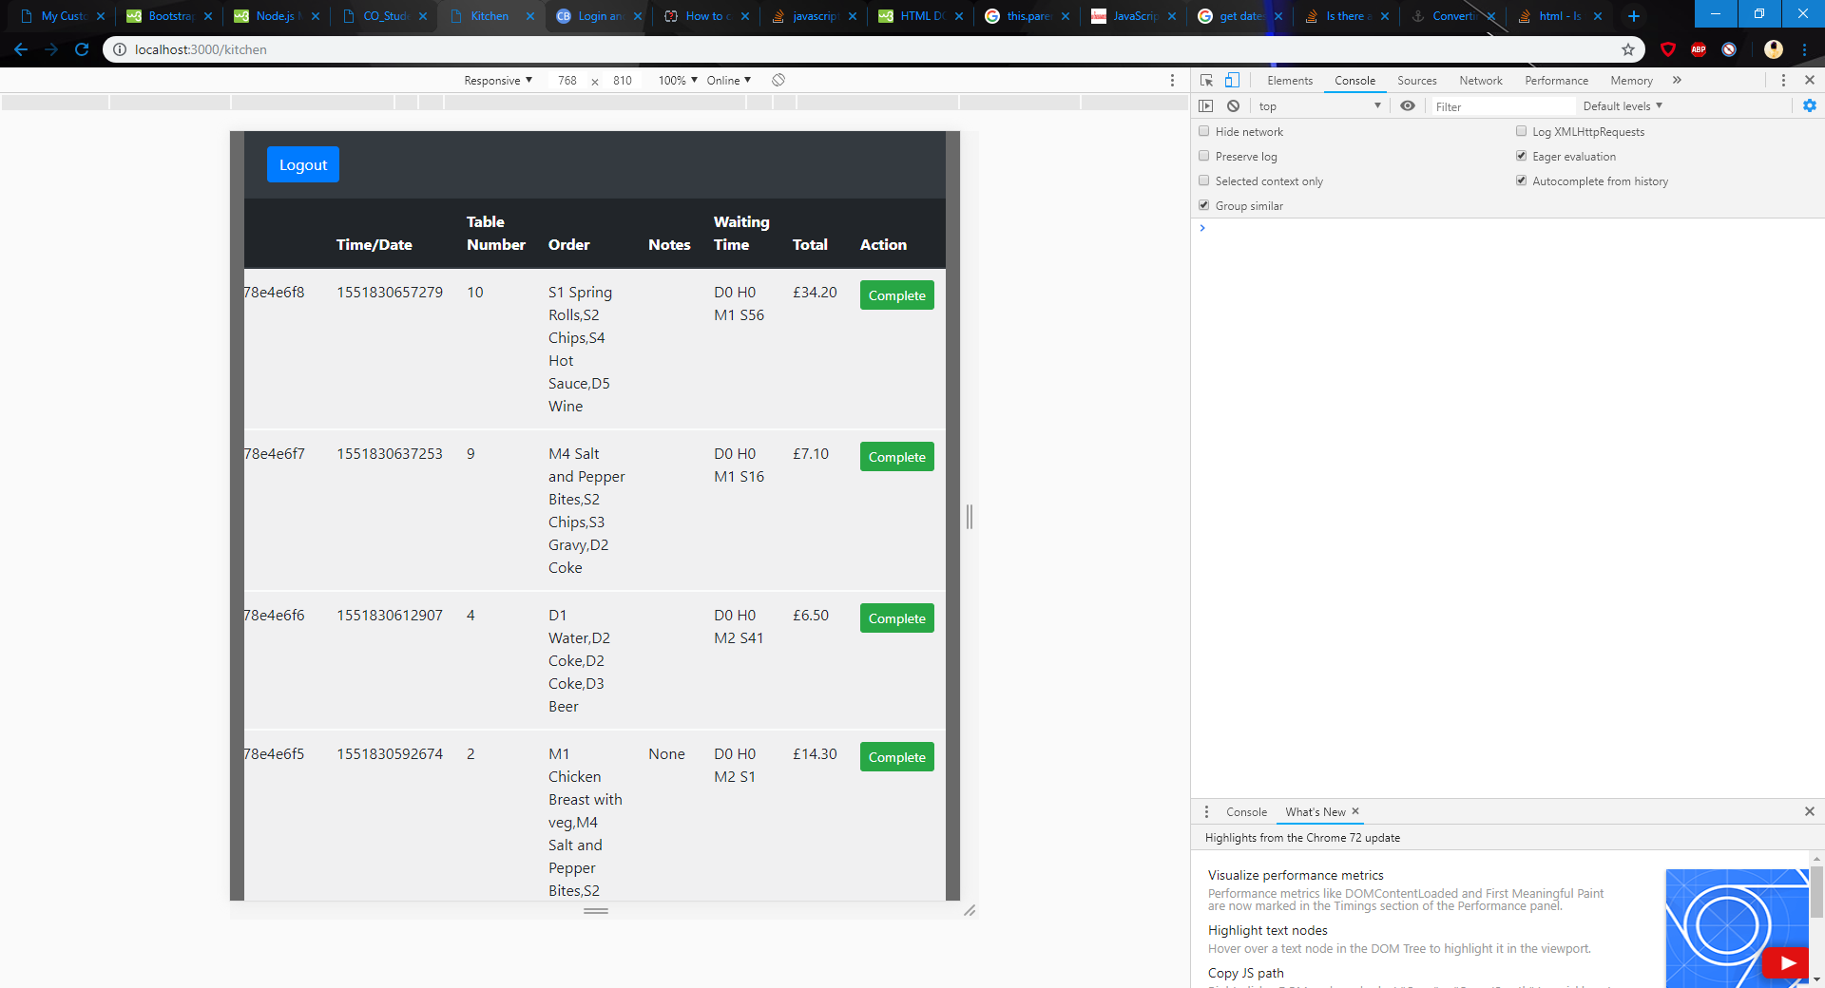

Figure 8 - Kitchen view after kitchen staff have logged in (Tablet - 768x810)

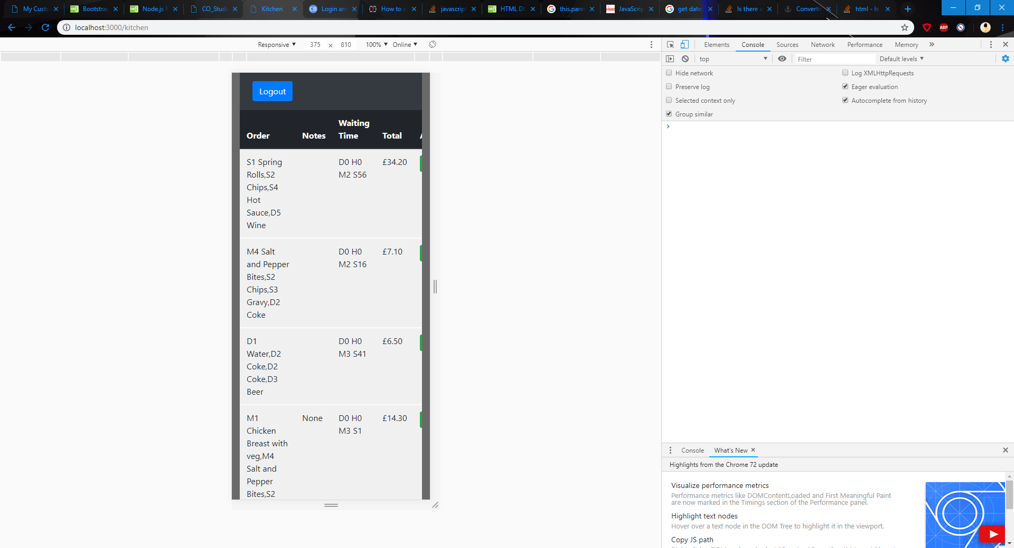

Figure 9 - Kitchen view after kitchen staff have logged in (Mobile M - 375x810)

## Counter View

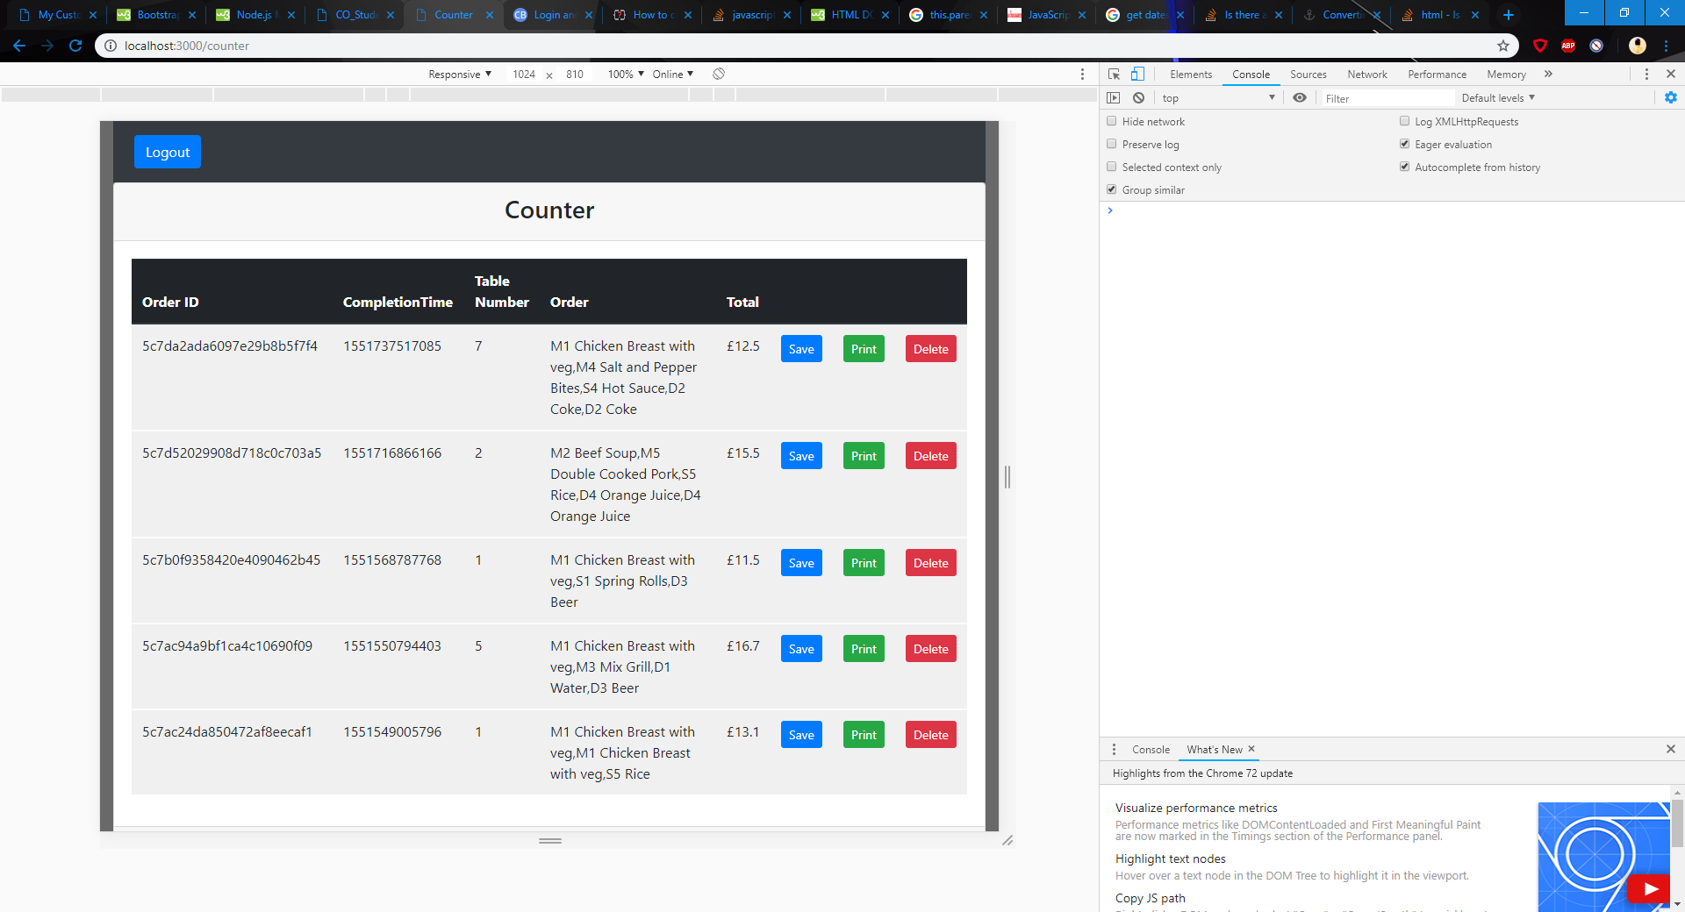

Figure 10 – Counter view after counter staff have logged in (Laptop - 1024x810)

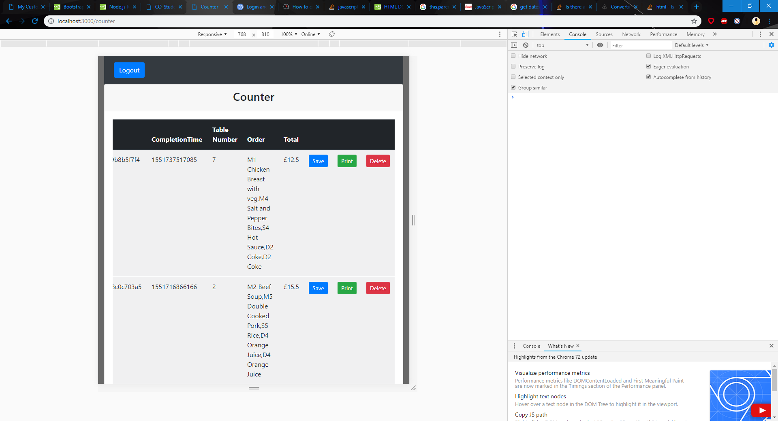

Figure 11 - Counter view after counter staff have logged in (Tablet - 768x810)

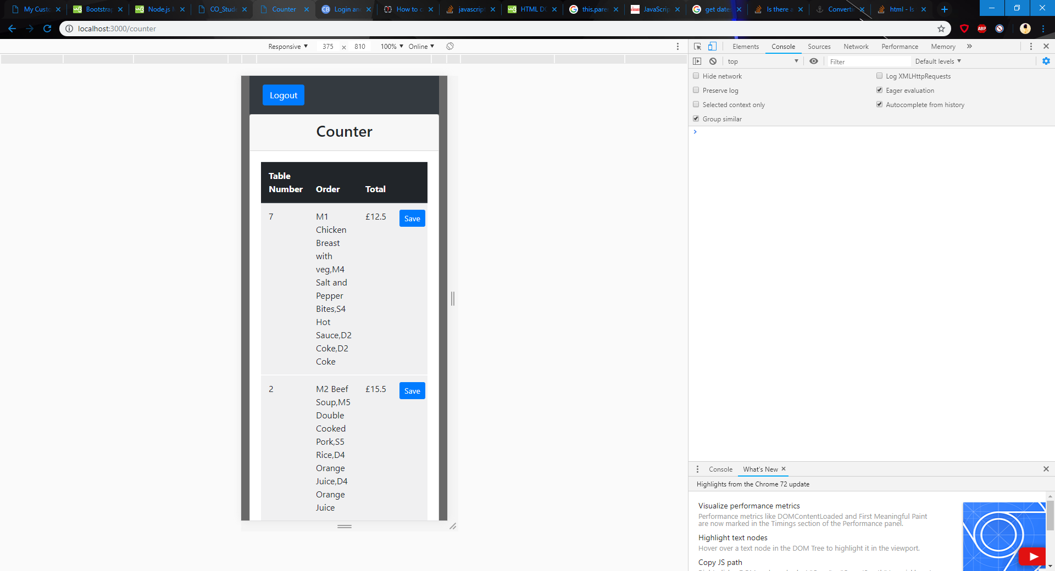

Figure 12 - Counter view after counter staff have logged in (Mobile M - 375x810)

## Admin View

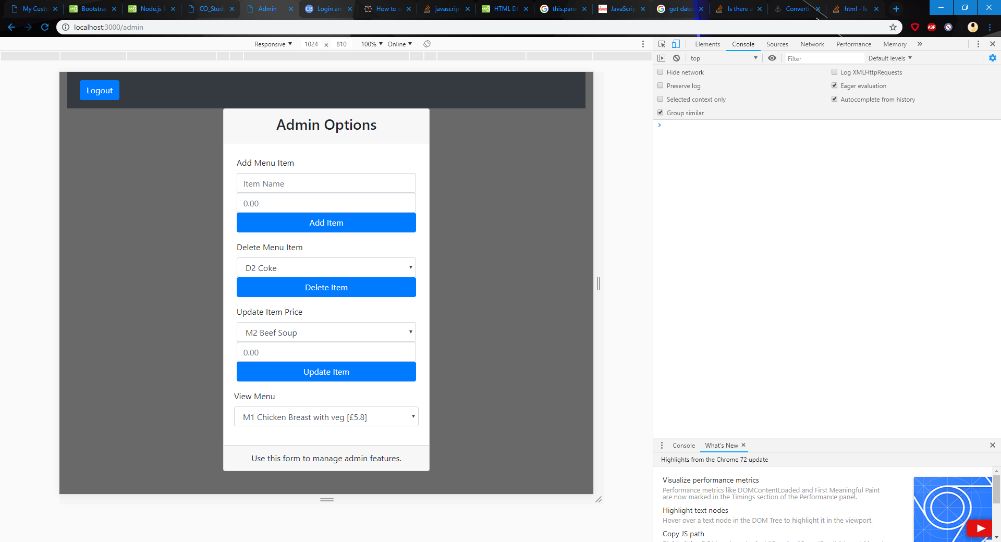

Figure 13 – Admin view after admin staff have logged in (Laptop - 1024x810)

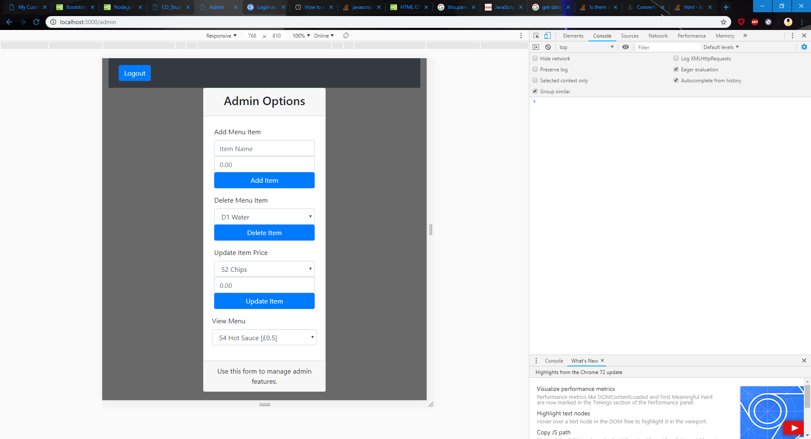

Figure 14 - Admin view after admin staff have logged in (Tablet - 768x810)

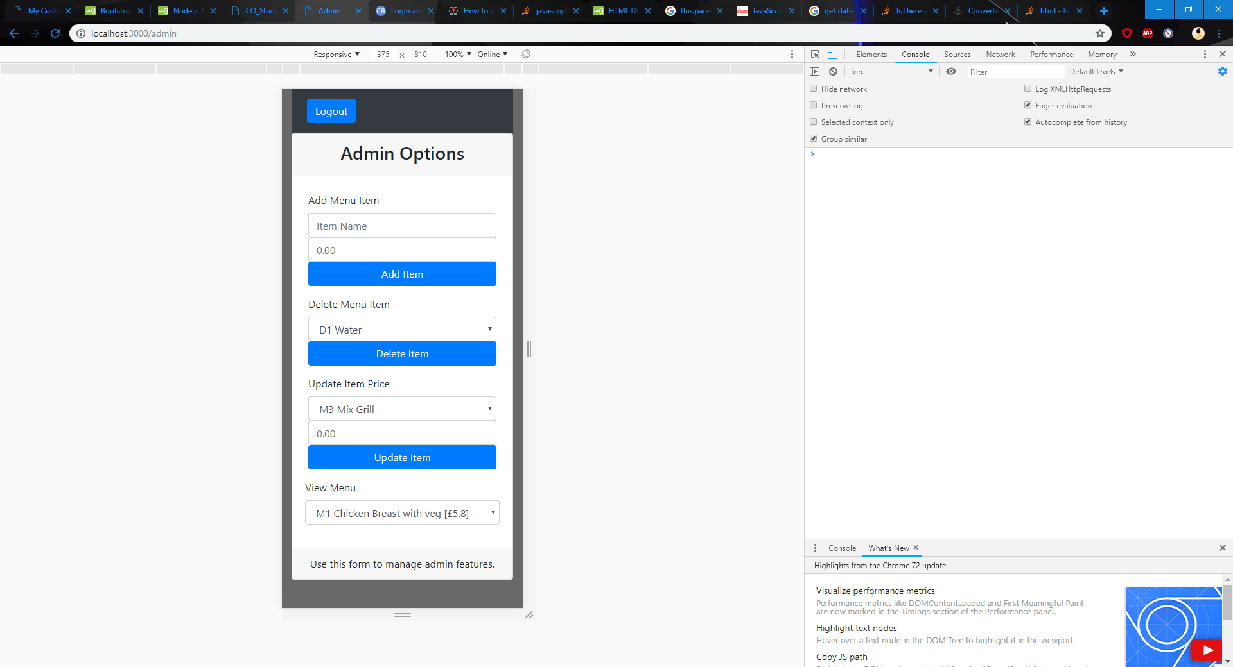

Figure 15 - Admin view after admin staff have logged in (Mobile M - 375x810)

## Additional

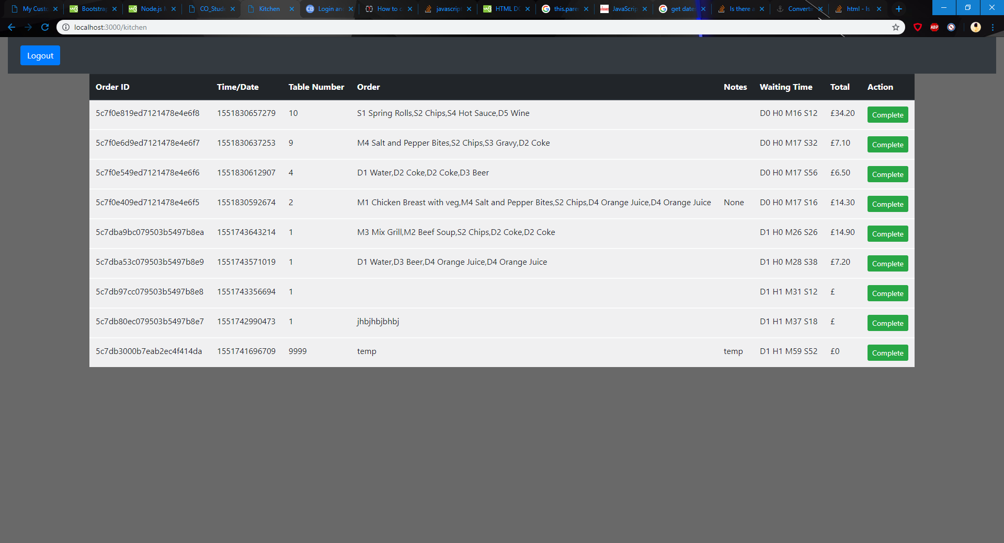

Figure 16 – Task 4 (4.2) use of timestamps, ‘customerWaitingTime’, WaitingTime, Updates every 10 seconds

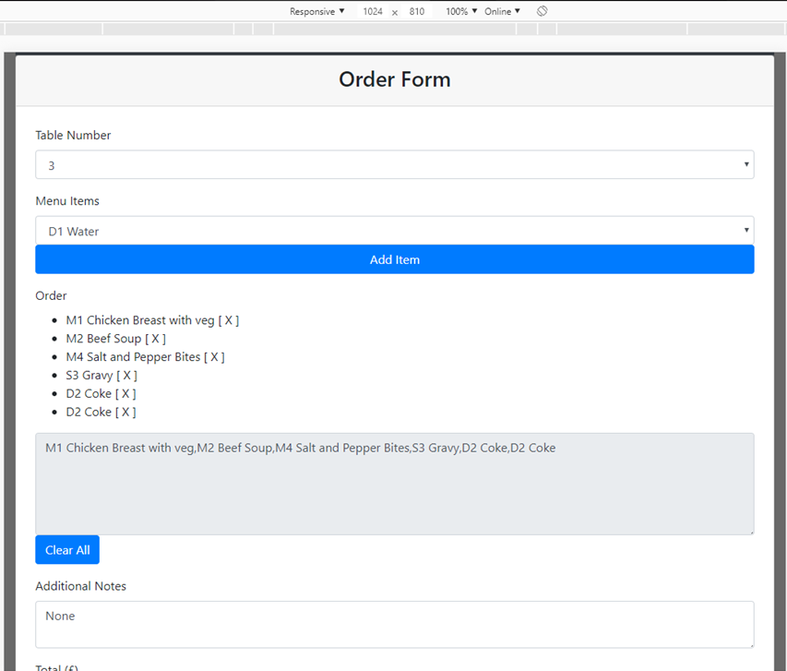

Figure 17 - Place order form with added items (Laptop - 1024x810)