Title (130 characters)

Design and Development of an Ultra-small Trans-nasal Biopsy Device for the Gastrointestinal (GI) Tract

**Abstract** (175 words, no references)

Tissue biopsy samples play a vital role in the diagnosis and treatment of conditions of upper and lower GI tract. Currently, GI Biopsy samples are obtained using single-bite forceps during upper endoscopy (EGD) through the working channel of a gastroscope. The high cost of sedation prior to EGD is prohibitive and therefore limits frequent surveillance of GI conditions. Further, there is, though minimal, risk of gut perforation when larger forceps are used to obtain tissue from the gut. Smaller pediatric forceps have a limitation associated with limited tissue samples they can capture. Curling artefacts are commonly visible in incisional forceps biopsies impacting tissue orientation and the ability to make accurate diagnoses. Here, we describe a novel image-guided precisely controlled ultra-small biopsy device and biopsying technique for GI tract that uses cryo-adhesion properties of tissue. This is the smallest biopsy device recorded in literature with comparable tissue quantity to the standard forceps that can be used even in unsedated trans-nasal endoscopy (TNE).

**Introduction**

Tissue Biopsy play a crucial role in the surveillance, treatment and diagnosis of many conditions of the GI tract such as gastroesophageal reflux disease (GERD), Barrett’s esophagus, eosinophilic esophagitis, celiac disease (CD), inflammatory bowel dysfunction (IBD), environmental enteric dysfunction (EED) [1]. These samples are usually obtained using single-bite biopsy forceps acquired through the working channel of an endoscope during upper esophagastroduodenoscopy (EGD). Biopsy samples are then sectioned into histology slides where cellular or tissue changes that accompany disease can be observed under microscope and a final diagnosis made by a pathologist. Biopsies can also be used for metagenomic sequencing to better understand patients’ disease genetic predisposition and disease pathogenesis [2, 3]. The tissue samples can also be cultured to investigate any changes in gut flora that can be used as an indicator for disease [4].

The current standard of care for acquisition of GI biopsies from upper GI tract is during EGD. 6 million EGD procedures are performed in the US annually, representing a cost burden of over $32 billion [5]. Since the cost of anesthesia-administered sedation accounts for about 35.5% of the total cost of an EGD procedure [6], unsedated trans-nasal endoscopy (TNE) has the potential to greatly decrease the cost of obtaining GI biopsies. TNE also provides an avenue for obtaining biopsies in subjects in whom EGD would be contraindicated such as subjects with low-blood pressure or pediatric subjects who may not tolerate sedation [ref]. Unsedated TNE further requires shorter procedure time since it obviates the need for need for post-procedure patient observation time, increasing the capacity and efficiency of endoscopy facilities [7].

TNE endoscopes have a working channel of 1.5 – 2.0 mm that limit the size of forceps that can used through them [8]. Small-caliber forceps capture small biopsy sample volumes which may not be adequate for proper diagnoses; there are reports of incorrect gastric indefinite neoplasia (GIN) diagnoses resulting from use of small-capacity forceps [9]. Pediatric forceps are also more likely to introduce crush artifact to the captured samples which may limit the diagnostic utility of biopsies [10]. There is therefore a need for a biopsy device compatible with TNE with the ability to obtain artifact-free biopsies.

Here, we report an ultra-thin trans-nasal biopsy (uTNB) device that is compatible with the working channels of pediatric/TNE endoscopes. This device consists of two co-axial tubes (inlet tube: diameter 0.5 mm, outlet tube: diameter 1.2 mm) with a metallic tip of length 4 – 8 mm and diameter 1.2 mm. The inlet tube transmits a coolant to the metallic tip which then flows out through the outlet tube and gets collected in a receptacle outside the body. The process of biopsy capture involves the threading the biopsy device through the working channel of the endoscope, which is then placed in contact with the gut epithelium to be biopsied (Fig. 1(a)), the metallic tip is then cooled to a defined temperature and left in contact for a specific amount of time before it being retracted, obtaining a biopsy in the process as shown in Fig. 1(c). In this paper, we describe and discuss the steps undertaken to develop uTNB and the results obtained from both animal and in-human studies carried out. We also show that uTNB has the capacity to capture biopsy samples equivalent in size and of a superior quality to those obtained with standard biopsy forceps.

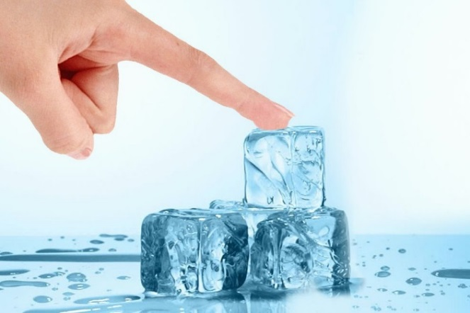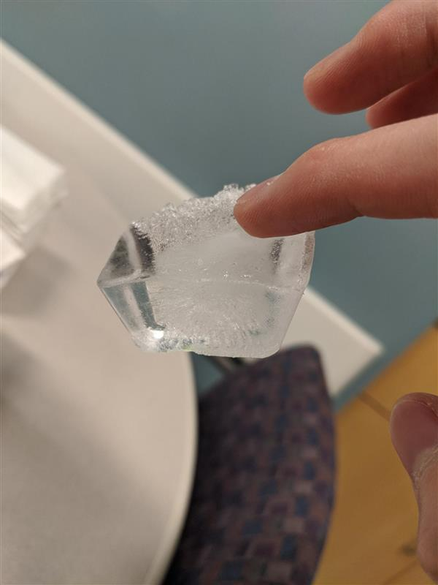

Fig. 1| **Method for biopsy acquisition by controlled cooling of tissue using an ultra-small biopsy device**. **a**, the inspiration for tissue capture by cooling is derived from the tongue sticking to a cold pole in winter or a wet finger sticking to a block of ice. **b**, The biopsy process involves placing a biopsy device consisting of metallic tip is to an area of moist gut epithelium. **c**, the metallic tip is then cooled to a defined temperature for a specific amount of time and **d**, then retracted, capturing tissue and leaving a biopsy mark.

**Results**

**Establishing ideal uTNB temperature and tissue contact time**

We carried out a numerical simulation to ascertain appropriate uTNB temperatures and their corresponding uTNB-tissue contact time duration required to acquire biopsies of desired depths. Literature values of the molecular composition of tissue in the GI tract were used to estimate the thermal conductivities of human esophageal, gastric, and duodenal epithelia lining [11]. The thermal conductivities of these organ walls were then substituted into the bioheat equation, while taking into consideration the phase change occurring when body fluid solidify and the blood flow into the tissue [12 – 24], the parameters for uTNB temperature and the requisite uTNB-tissue contact time can be estimated. Using finite element analysis, setting the uTNB length to 4 mm and outer diameter to 1.2 mm, the time taken for the temperature at the depth of interest to turn 0oC was numerically investigated.

In Fig. 2a, we report the effect of uTNB temperature on biopsy capture time of duodenum epithelial tissue. The device temperature was set at -20oC, -25oC, and -30oC and the temperature at base of the duodenum of the epithelium (1.0 mm) investigated. As shown in the figure, with a device of -20oC the time taken for the temperature at the base of the epithelium to cross 0oC was found to be over 5 seconds. The corresponding time for the device at -25oC and -30oC was 7 seconds and 5 seconds, respectively.

We then fixed the uTNB temperature at -30oC and investigated the time required to obtained biopsies of different depths as shown in Fig. 2b. The time required for the temperature at 0.8 mm, 1.0 mm, and 1.2 mm to cross 0oC was found to be about 2.5 seconds, 5 seconds, and 10 seconds, respectively. This shows that by fixing the temperature of the uTNB device at -30oC, we can modulate the depth of the biopsies captured by changing the uTNB-tissue contact time.

As shown in Fig. 2c, the time required for biopsy capture of both gastric and duodenal epithelia is about 5 seconds. The esophageal squamous epithelium (~0.45 mm) would require about 1 second. However, the tensile strength of the esophageal epithelium has been found to be over 0.3 MPa [25], therefore the tensile strength of the epithelial ice formed from cooling needs to exceed 0.3 MPa. In Fig. 2d, the tensile strength of ice at the base of the esophageal epithelium is plotted from the change in temperature [26] calculated from that location. The tensile strength of ice takes about 4 seconds to exceed 0.3 MPa.

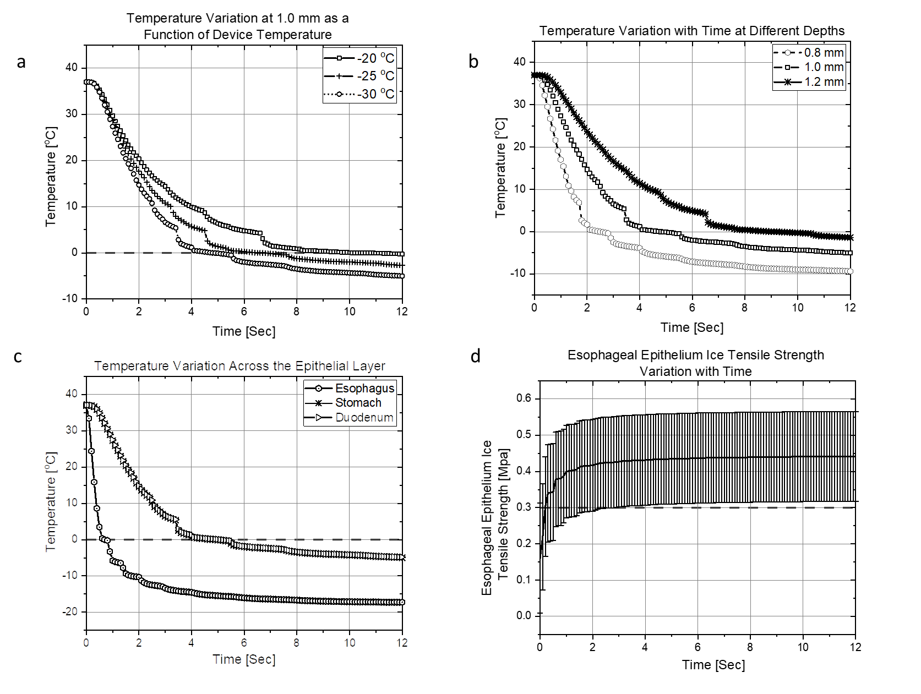

**Fig. 2 | uTNB temperature and tissue-contact time characterization**. **a**, Using duodenum wall tissue to investigate the change in temperature at 1.0 mm depth (approximate duodenum epithelial depth), with uTNB devices of temperature -20oC, -25oC, and -30oC the epithelium gets frozen in 10 seconds, 7 seconds and 5 seconds, respectively. **b**, Using a uTNB of -30oC the tissue depth of 0.8 mm, 1.0 mm and 1.2 mm get frozen in 2.5 seconds, 5 seconds and 9.5 seconds, respectively. **c**, With a -30oC uTNB, gastric and duodenum epithelia (~1.0 mm) takes the same amount of time to freeze, while esophageal epithelium (~0.45 mm) takes 1 second to freeze. **d**, However, with the tensile strength of human esophageal epithelium being greater than 0.3 MPa, the tensile strength of ice at 0.45 mm depth would have to exceed 0.3 MPa for the complete epithelial biopsy capture, which takes about 4 seconds.

**Choice of a coolant for use in uTNB**



**Fig. 3 | Estimation of vapor quality yield and the latent heat lost when coolant is throttled into uTNB metallic tip.** The graph at the top shows the estimated vapor quality yield obtained when a coolant experiences a unit change in pressure resulting in a unit rise in temperature by Joule-Thompson expansion. The graph at the bottom represents the resulting loss in latent from the phase change of the coolant from liquid to gas. The vapor quality yield of CO2, Freon R134A and Freon R410A are almost the same across the from -40oC to 30oC, however, Freon R410A results in a higher enthalpy transfer to latent heat of vaporization at temperatures above 0oC. CO2 displays superior cooling properties from latent heat transfer, but its propensity for phase change to solid state makes it a less desirable coolant for uTNB.

The choice of coolant for use in uTNB is an important parameter. Cooling happens by two major events: cooling by Joule-Thompson expansion and by evaporation, an estimation of the coolant’s expansivity and the resulting enthalpy conversion to latent heat of vaporization is therefore vital in selecting a coolant [ref]. We carried out a numerical estimation of the vapor quality yield of four commonly available coolants (R744 (CO2), R134A, R410A, NO2) to ascertain which one works best in low expansivity regimes such as in the ultra-small uTNB. Fig. 3a is a plot of the estimated vapor quality yield that results when the coolants are throttled into a chamber such as uTNB tip resulting in a unit drop in pressure causing a unit temperature drop (derivation in methods). In the region where coolant expansion is minimal, as in the ultrasmall cryo-probes, much of the cooling arises from enthalpy transfer to latent heat of vaporization extraction by the coolant from the surrounding. Therefore, an estimation of the weighted latent of vaporization at different temperature values is a good indicator of which coolant would be ideal for our application. For example, from Fig. 2b, we can ascertain that Freon 410A and Freon 134A are ideal for cooling tissue at body temperature (37.6 deg. C), however, as the cooling continues to around 0oC, Freon 410A is a superior coolant. CO2 is a better coolant within the -20 oC to -40 oC window, however, the requirement for high-pressure operation condition for liquid CO2 use and its propensity to solidify at low pressures hence blocking small channels is an unavoidable deterrent. R410A is therefore the best coolant of choice over CO2, R134A and NO2.

**uTNB tip configuration for optimal cooling**

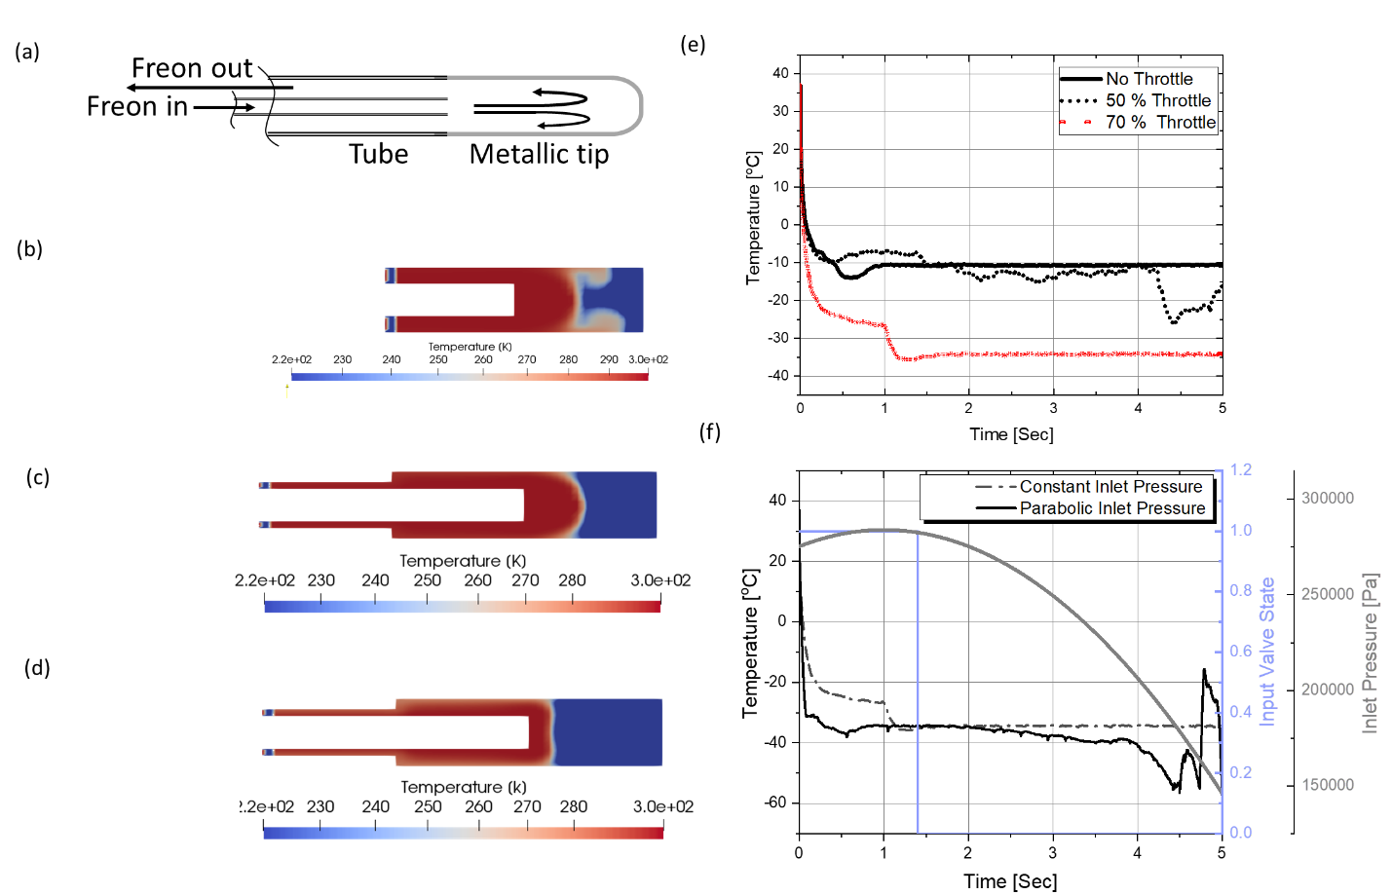

**Fig. 4 | Design and optimization of fluid flow in uTNB that results in the efficient cooling of the tip. a,** Freon R410A flows through an inner perfusion tube (internal diameter (ID) 0.25 mm, Outer diameter (OD) 0.5 mm) and into the metallic tip and flows out through an outer exhaust tube (internal diameter (ID) 1.0 mm, outer diameter (OD) 1.2 mm) . **c**, With the throttle at the exit of the tip into the exhaust tube, there is more cooling than was without the throttle. **d**, Varying the inlet pressure in a monotonically decreasing fashion allows for better cooling of the metallic tip. **e**, The change in temperature over time as the coolant is pumped into the tip shows that at 70% throttle cooling is better than at 50% throttle. **f**, A monotonically decreasing inlet pressure can be achieved by opening an inlet valve into a small reservoir that supplies the uTNB and shutting the valve after 1.4 seconds.

The metallic tip at the distal end of uTNB consists of a closed-ended hollow tip in which a perfusion tube (outer diameter (OD): 0.5 mm, inner diameter (ID): 0.25 mm) feeds the coolant (R410A). The coolant then expands into the tip, exits through an exhaust tube (OD: 1.2 mm, ID: 1.0 mm) and vented out through a port at the proximal part of the device into a collection reservoir. To optimize the cooling efficiency of uTNB, different uTNB tip configurations were tested using a numerical test bench (C++ OpenFOAM). We found that by limiting the speed of the coolant leaving the tip, by placing a throttling element at the tip exit into the exhaust tube, we obtained better cooling (Figs. 4b, 4c and 4e). As shown in Fig. 4e, 70% throttle produced better cooling than 50%, indicating that the desired temperature can be achieved by adjusting the percentage of throttle. To further eliminate the uneven pedestal on the cooling curve at 70% throttle, we modulated the inlet pressure in a monotonically decreasing fashion. This can be achieved by placing an electronically controlled valve at the inlet to the uTNB, which when opened into the uTNB and closed after 1.4 seconds leads to a slowly changing pressure profile at the tip as indicated in Fig. 4f. The details of the numerical simulation can be seen in the methods section.

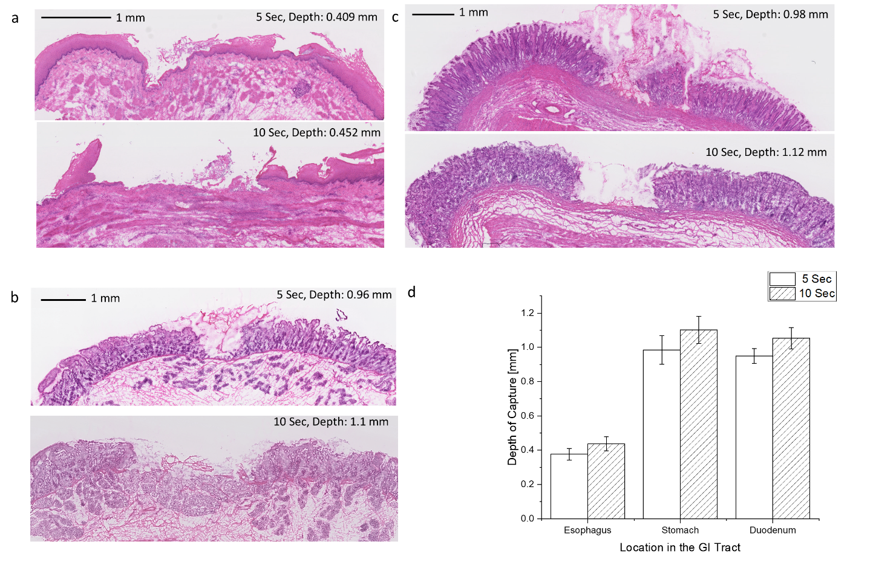

**Fig. 5 | In vivo demonstration of the relationship between uTNB-tissue contact time to depth of biopsy capture. a,** uTNB was developed and used to capture biopsies in vivo in swine; with a contact times of 5- and 10-seconds biopsies of 0.4 mm, 0.45 mm depths were captured, respectively. **b**, uTNB captured biopsies of depth 0.98 mm and 1.12 mm with 5- and 10- seconds contact time, respectively. **c**, Duodenum biopsies of depth 0.96 mm and 1.2 mm were captured by uTNB with tissue contact times of 5 seconds and 10 seconds, respectively. **d**, Three swine studies were performed and two biopsies obtained at each tissue contact time point from each location of esophagus, stomach and duodenum.

To validate the utility and efficacy of uTNB in obtaining biopsies from the GI tract, swine studies were designed. Swine were chosen for their anatomic gut anatomical similarities to human [ref]. Three swine studies were performed in which their gut was intubated using an endoscope. In each animal, three biopsies were obtained for uTNB-tissue contact time of 5 and 10 seconds, respectively, in the esophagus, stomach and duodenum. In the esophagus, the mean depth of biopsies obtained after 5 seconds tissue contact was 0.409 mm, while that after 10 seconds was 0.452 mm. In the stomach, the biopsies obtained after 5 seconds and 10 seconds of contact time were of depth 0.98 mm and 1.12 mm, respectively. Duodenal biopsies were of depth 0.96 mm and 1.1 mm after 5 seconds and 10 seconds, respectively. These results indicate a positive correlation between biopsies depth and uTNB-tissue contact time close to what was predicted with numerical simulations shown in Fig. 2.

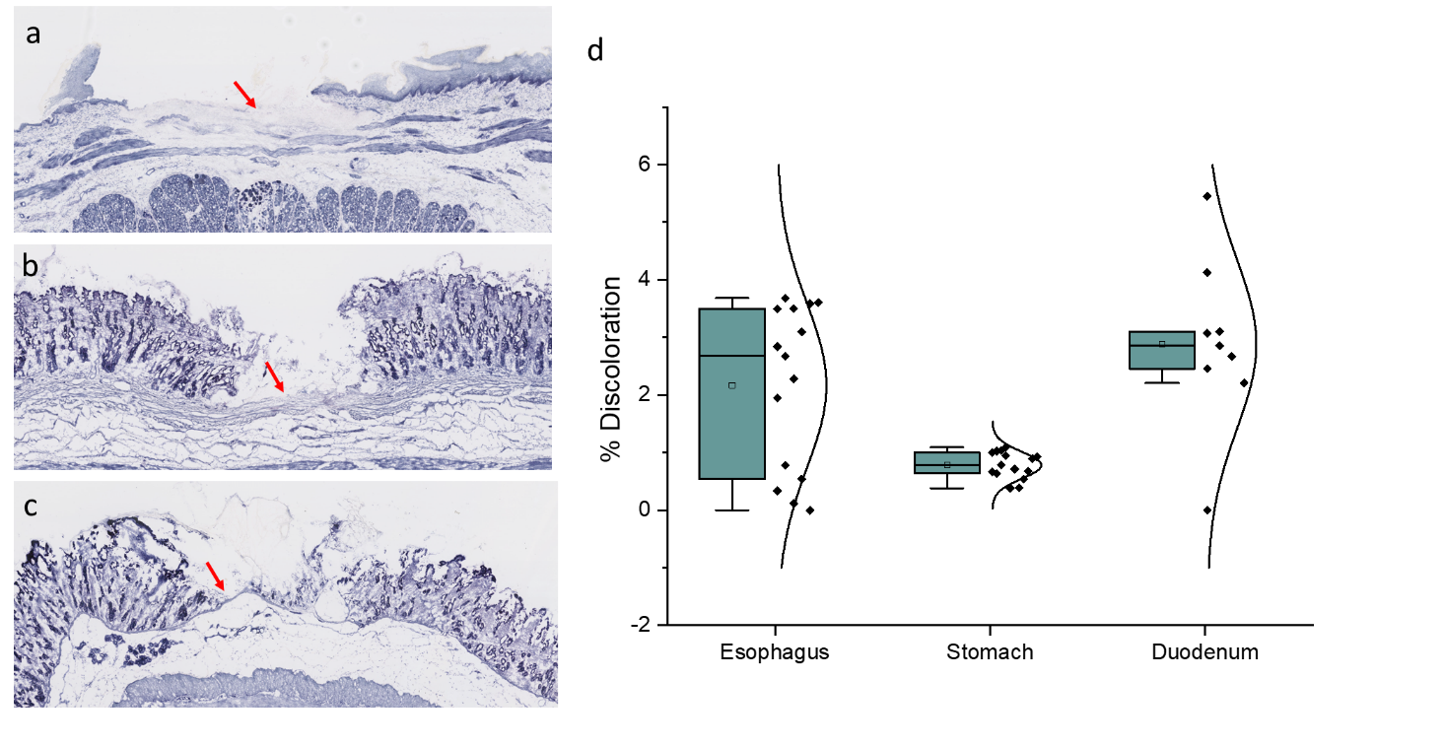

**Fig. 6 | Lactate dehydrogenase (LDH) staining of biopsied tissue to evaluate tissue viability after tissue capture by cooling. a**, The discoloration of the stain on the prosected section of esophagus is evidence for loss of cell viability in tissue. **b,** Similar discoloration was seen on the prosected gastric and **d,** duodenal tissue. **e**, The proportion of the depth of the discolored tissue to the entire wall thickness is as low as less than 5%, however the level of damage in the gastric wall is much smaller with a more tighter distribution than what was seen on esophageal and duodenal walls; this is due to the much thicker muscularis mucosa present in the gastric wall.

In order to assess the level of tissue damage and loss of cell viability imposed upon by thermal cooling of uTNB on the tissue [refs], we used a staining technique that probes the level of lactate dehydrogenase (LDH) isoenzymes in the biopsied area of the gut. The areas biopsied in the gut were prosected and frozen in optimal cutting temperature (OCT) medium, sectioned, and stained with LDH viability stain (NTBC). Fig. 6a, 6b and 6c show NTBC slides of the prosected tissue from esophagus, stomach and duodenum where biopsies were captured after 10-seconds uTNB-tissue contact time. As shown in Fig. 6d, LDH discoloration, an indication of tissue damage and loss of cell viability, was limited to less than 5% of the total thickness of the gut wall. Further, the discoloration in the stomach was diminutive with minimal variation, probably due the presence of a thicker muscularis mucosa layer. The results shown in Fig. 6 confirm the safety of uTNB for use in capturing biopsies in the gut.

Results

(8 display items, figures and tables)

Non-nested sections (up to 60 characters)

Discussion

**Methods**

**Estimating Probe temperature and the required uTNB-tissue contact time**

The finite element simulation for uTNB temperature and contact time was performed in C++. Using molecular composition of tissue obtained literature, for example the small intestine is composed of 80.6% water, 5.9% lipid and 13.0% protein [11], the thermal conductivity of tissue can then be estimated as follows:

(A-1)

Where, and denote the thermal conductivities of water, lipid and protein, respectively, while , and are the compositional ratios of the different molecular components in the tissue. Heat conduction through tissue can then be modelled using the Fourier-Biot equation as follows [12]:

(A-2)

Where , are the estimated density and specific heat capacity of the tissue, derived from weighted values of the individual components making up the intestinal wall tissue and is the temperature at position at time . With a blood perfusion rate of through the capillaries in the intestine, the equation above can be modified as follows [13]:

(A-3)

Where, , , , and represent blood density, tissue density, blood specific heat capacity, tissue specific heat capacity and blood temperature, respectively.

|  |  |
| --- | --- |
| Variables |  |
|  | ~0.21145 Wm-1K-1  [14] |
|  | ~0.25 Wm-1K-1  [15] |
|  | T > 0 [16]  T < 0 [17] |
|  | 911 kgm-3  [14] |
|  | 1369.86301 kgm-3 [18] |
|  | T > 0 [19]  T < 0 [20] |
|  | 2348.33 J/kg/K [14] |
|  | 3595 J/kg/K [21] |
|  | T > 0 [22]  T < 0 [17] |
|  | 1. T < 0 |
|  |  |
|  |  |
|  |  |

In order to solve the equation in (A-3) numerically, the coordinate , , can be discretized in the following manner:

Therefore can then be represented as .

Equation (3) can then be represented as follows:

.

Taking as the phase changing temperature, in the interval , was modified as [23]:

,

and for the interval can also be modified as:

.

For a uTNB of length of 4 mm, diameter 1.2 mm, L was set to 4 mm, W to the semi-circumference of 1.9 mm and D to 2 mm (depth of the organ wall). The boundary condition was set such that was set to uTNB device temperature and the temperature at infinity was set to body temperature of oC.

**Choosing an appropriate coolant**

Throttling a subcooled liquid (refrigerant) into an expansion chamber results in cooling by two phenomena: cooling of the fluid stream due to the enthalpy transfer to the latent heat of vaporization and the expansion coupled reduction in total internal energy.

As the liquid exits the throttle, shown in Fig. 1 above, it expands and evaporates into a liquid-vapor mixture. Assuming the expansion and evaporation is an isenthalpic process, the enthalpy at the input is equal at that at the output .

The composition at the input being purely liquid, enthalpy is the liquid state enthalpy . At the output the fluid consists of both saturated liquid and vapor with the saturated vapor fraction in the mixture expressed as the vapor quality . Therefore,

B- 1

To a large extent, the amount of expansion and subsequent potential for evaporative enthalpy change is a function of the vapor quality and the latent heat of vaporization.

With the assumption that this is an adiabatic isenthalpic process, the total enthalpy before and after expansion and evaporation is immutable. By taking , and , the value of required to cause a unit drop in temperature = 1 K when a unit drop in pressure Pa is imposed on the throttled fluid can derived as follows:

B -2(a)

B- 2(b)

Since the fluid at the input is liquid and is considered incompressible . The vapor quality yield from a unit drop in pressure resulting in a unit drop in temperature can be obtained by plugging and into the equation such that .

B - 3(a)

B - 3(b)

The average vapor quality is dependent on both pressure and temperature and can be expressed as:

B - 4

Hence from eqn. 3(a) and 3(b),

B - 5(a)

B - 5(b)

Where,

, , and

Solving the differential equations 3(a) and 3(b) can be achieved using Dirichlet boundary condition of , at the critical point and , and the Neumann boundary condition of , at any temperature below the critical temperature . The constants using the boundary conditions are fixed to be and . Therefore can be estimated to be

B - 6

**Configuration of uTNB tip**

We employed commercially available Freon 410A distributed in small 2-lb containers of output pressure 250 PSI (1723.69 kPa). The design constraint for uTNB length was 1.2 m, compatible with the working channel length of endoscopes. We provided for a safer distance of about 0.8 m from the R410A container to the device, a total of length 2.0 m from the Freon container to the uTNB tip. The flow rate through the tube into the tip was experimentally determined to be 1.2 x 10-7 m3/s, therefore the pressure drop across the inlet tube was determined using the Darcy-Weisbach equation [ref], giving an inlet pressure of about 32 PSI (220 kPa) inside the tip. The outlet pressure from the tip was estimated to be 21 PSI (146 kPa), based on the experimental value of the coolant gaseous flow rate out of a mock device of 30 x 10-6 m3/s.

With the inlet and outlet pressure defined, the length of the tip was set to 4 mm, and the ID 1.0 mm. Using finite element analysis, we modified the open source OpenFOAM solver interMixingFoam [ref] such that volume fraction denoted the volume fraction in each finite volume cell occupied by liquid Freon R410A, volume fraction was attributed to the vapor phase of the coolant and fraction represents air.

The Intermixing solver was modified as follows, beginning with the equations governing the evolution of the volume fractions of the three phases.

C - 1

where is the velocity of the fluid in the tip (we approximated equal speed for all phases), represents volumetric source arising from the loss of gain of mass as the liquid phase changes to vapor phase, , densities of the liquid and vapor phases of the coolant, respectively, and the diffusion coefficient of the vaporized coolant into the air.

was derived as follows

C-2

is the vapor mass fraction, calculated as

C - 3

with being the combined density of the gas (vapor and air) contained in each cell obtained from

C - 4

The energy equation describing the evolution of temperature in each cell was modified to

C - 5

with , and being the latent heat of vaporization, isobaric specific heat capacity and thermal conductivity, respectively. The conservation of momentum equation was modified as follows:

C - 7

Where p is the pressure, is the force of gravity and the term accounting for the viscous stress, the surface tension. Surface tension is expressed as

C - 8

The pressure equation was modified to reflect the changes in pressure resulting from phase change:

C - 9

Equations used to evaluate R410A’s , and can be obtained from REFPROP [ref], where , and values were obtained as weighted values of the volume fractions in each cell. The diffusion constant between the vapor phase of the coolant R410A and air was obtained using the generalized equation for gas diffusion derived by Chen et al [ref].

Taking advantage of the radial symmetry of the device, we implemented a 2D simulation accounting for the changes in radial and longitudinal directions. uTNB tip was split into 600 cells; 15 cells in the radial, and 40 cells in the longitudinal directions. The pressure boundary conditions at the inlet and exit were set to 32 PSI and 21 PSI, respectively. While for temperature, the inlet temperature was set to 298.15 K, initial outlet and wall temperatures were set to body temperature 310.15 K. To mimic heat conduction from body tissue to uTNB, we set the wall conditions with a fixed temperature gradient of 6700 K/m.

**Swine studies and histological analyses**

This animal study protocol was approved by the MGH IACUC (protocol number 2016N000215). Prior to the study, the animal was sedated, anesthetized and intubated. A gastroscope (Pentax EG2990K) was inserted trans-orally to the duodenum. uTNB was then threaded through the instrument channel of the endoscope. uTNB console was activated and the duodenal epithelium touched after 5 seconds. Three biopsies from 15 – 20 cm from the pyloric sphincter for 5-seconds tissue contact time. The endoscope was retrieved to approximately 5 cm from the pyloric sphincter, three more biopsies were obtained at 10-second uTNB-tissue contact time. The process was repeated in the stomach and in the esophagus. Fiduciary marks were placed alongside biopsied areas using electrocautery forceps. The biopsies were thawed, placed in Histo-Wrap, sandwiched between foam in a cassette and placed in 10% buffered formalin. After the experiment, the animal was euthanized and the areas biopsied prosected, frozen in optimal cutting temperature (OCT) medium. The biopsies and the prosected tissue were transferred to the Wellman center photohistology core for processing, sectioning and staining.

References (up to 50)

1. Peixoto, A., Silva, M., Pereira, P., & Macedo, G. Biopsies in Gastrointestinal Endoscopy: When and How. GE Port. J. Gastroenterol. **23**, 19 - 27 (2016).
2. Douglas, G. M. et al. Multi-omics Differentially Classify Disease State and Treatment Outcome in Pediatric Crohn's Disease. Microbiome **6**, 13 (2008).
3. Peterson, D. A., Frank, D. N., Pace, N. R., & Gordon, J. I. Metagenomic Approaches for Defining the Pathogenesis of Inflammatory Bowel Diseases. Cell Host Microbe. **3,** 417 - 427 (2008).
4. Walburga, D., Monic, S., & Yurdagül, Z. Microbiota in the Gastrointestinal Tract. Med. Sci. (Basel) **6,** 116 (2018).
5. Peery, A. F. et al. Burden and Cost of Gastrointestinal, Liver, and Pancreatic Diseases in the United States: Update 2018. Gastroenterol. **156**, 254–272 (2019).
6. Helmers, R. A. et al. Overall Cost Comparison of Gastrointestinal Endoscopic Procedures With Endoscopist- or Anesthesia-Supported Sedation by Activity-Based Costing Techniques. Mayo Clin. Proc. Innov. Qual. Outcomes **1** 234–241 (20017).
7. Parker, C., Alexandridis, E., Plevris, J., O’Hara, J., Panter, S. Transnasal endoscopy: no gagging no panic! Frontline Gastroenterol. **7** 246–256 (2016).
8. Rodriguez, S. A. et al. Ultrathin endoscopes. TECHNOLOGY STATUS EVALUATION REPORT **71**, 893-898 (2010).
9. Matsuo, Y. et al. Endoscopic small-capacity forceps increase the pathological diagnosis of gastric indefinite neoplasia. Turk J Gastroenterol. **29**, 481-7 (2018).
10. Goutal-Landry, C.M., Mansell, J., Ryan, K.A., & Gaschen, F.P. Effect of Endoscopic Forceps on Quality of Duodenal Mucosal Biopsy in Healthy Dogs. J Vet Intern Med. **27**, 456–461 (2013).
11. H. Q Woodard, and D. R. White, “The composition of body tissues,” The British Journal of Radiology, 59, 1209 – 1219, (1986).
12. T. N. Narasimhan, “FOURIER’S HEAT CONDUCTION EQUATION: HISTORY, INFLUENCE, AND CONNECTIONS, “Reviews of Geophysics, 37, 1, (1999).
13. K. R. Diller, “Modelling of Bioheat Transfer Processes at High and Low Temperatures,” ADVANCES IN HEAT TRANSFER, 22, 157-357, (1992).
14. https://itis.swiss/virtual-population/tissue-properties/database/
15. A. Lervik, F. Bresme, S. Kjelstrup, D. Bedeaux, and J. M. Rubi, “Heat transfer in protein-water interfaces,” Phys Chem Chem Phys. 21; 12(7), 1610-1617, (2010).
16. M. L. V. Ramires, C. A. Nieto de Castro, Y. Nagasaka, A. Nagashima, M. J. Assael, and W. A. Wakeham, “Reference Data for the Thermal Conductivity of Water,” American Institute of Physics and American Chemical Society.
17. Yin-Chao Yen, “Review of thermal properties of snow, ice and sea ice,” CRREL Report 81-10, (1981).
18. H. Fischer, I. Polikarpov, and A. Craievech, “Average protein density is a molecular-weight-dependent function,” Protein Sci., 13(10), 2825 – 2828, (2004).
19. R. E. Jones, and G. L. Harris, “ITS-90 Density of Water Formulation for Volumetric Standards Calibration,” J. Res. Natl. Inst. Stand. Technol. 97, 335, (1992)
20. A. Melinder, “Thermophysical Properties of Aqueous Solutions Used as Secondary Working Fluids,” KTH Doctoral Thesis.
21. N. V. Prabhu, and K. A. Sharp, “Heat Capacity in Proteins,” Annu. Rev. Phys. Chem. 46, 521-548, (2005).
22. N. S. Orsborne, H. F. Stimson, and D. C. Ginnings, “MEASUREMENT OF HEAT CAPACITY AND HEAT OF VAPORIZATION OF WATER IN THE RANGE 0o and 100oC,” Journal of Research of the National Bureau of Standards, 23, (1939).
23. C. Bonacina, G. Comini, A Fasano, and M. Primecerio, “Numerical Solution of Phase-Change Problems,” Int. J. Heat Mass Transfer, 16, 1825 – 1832, (1973).
24. Goyal, R. K, Biancani, P, Phillips, A, and Spiro, H. A, Mechanical Properties of the Esophageal Wall, The Journal of Clinical Investigation **50**, 1456 -1465 (1971).

Valiantzas, J. D, Modified Hazen-Wlliams and Darcy-Weisbach Equations for Friction and Local head Losses along Irrigation Laterals, Journal of Irrigation and Drainage Engineering 131 (2005).

Schlottke, J., Weigand, B., Direct Numerical Simulation of Evaporating Droplets, Journal of Computational Physics 227, 5215 – 5237 (2008).

Mohammadi, E., Narayanaswamy, R., King, A., A study of the Phase Change in Three Phase Environment, 21st Australasian Fluid Mechanics Conference Adelaide, Australia (2018).

https://www.nist.giv/srd/refprop

Chen, N. H, and Othmer, D. F, New Generalized Equation for Gas Diffusion Coefficient, Journal of Chemical and Engineering 7, 37- 41 (1962).

Gonzalez, L. M., Moeser, A. J, and Blikslager, A. T., Porcine models of digestive disease: the future of large animal translational research, Transl Res. 166(1): 12–27 (2015).

Acknowledgements

Author Contributions

------------------------------------------------------------------------------------------------------------------------------------------

Figures

1. Concept diagram- General Idea of the Biopsy Device - done
2. Choice of the coolant- done
3. Graph Cooling and Freezing of Tissue- done
4. Temperature Profile of the tip/Graph for Different Pressure Profiles- pending
5. Cryobiopsy Device in action – (M-mode)
6. Area of Tissue captured/Depth vs Time
7. Human Study- Histology (Duodenum, stomach)