Title (130 characters)

Design and Development of an Ultra-small Trans-nasal Biopsy Device for the Gastrointestinal (GI) Tract

**Abstract** (175 words, no references)

Tissue biopsy samples play a vital role in the diagnosis and treatment of conditions of upper and lower GI tract. Currently, GI Biopsy samples are obtained using single-bite forceps during upper endoscopy (EGD) through the working channel of a gastroscope. The high cost of sedation prior to EGD is prohibitive and therefore limits frequent surveillance of GI conditions. Further, there is, though minimal, risk of gut perforation when larger forceps are used to obtain tissue from the gut. Smaller pediatric forceps have a limitation associated with limited tissue samples they can capture. Curling artefacts are commonly visible in incisional forceps biopsies impacting tissue orientation and the ability to make accurate diagnoses. Here, we describe a novel image-guided precisely controlled ultrasmall biopsy device and biopsying technique for GI tract that uses cryo-adhesion properties of properties of tissue. This is the smallest biopsy device recorded in literature with comparable tissue quantity to the standard forceps that can be used even in unsedated trans-nasal endoscopy (TNE).

**Introduction**

Tissue Biopsy play a crucial role in the surveillance, treatment and diagnosis of many conditions of the GI tract such as gastroesophageal reflux disease (GERD), Barrett’s esophagus, eosinophilic esophagitis, celiac disease (CD), inflammatory bowel dysfunction (IBD), environmental enteric dysfunction (EED) [1]. These samples are usually obtained using single-bite biopsy forceps acquired through the working channel of an endoscope during upper esophagastroduodenoscopy (EGD). Biopsy samples are then sectioned into histology slides where cellular or tissue changes that accompany disease can be observed under microscope and a final diagnosis made by a pathologist. Biopsies can also be used for metagenomic sequencing to better understand patients’ disease genetic predisposition and disease pathogenesis [2, 3]. The tissue samples can also be cultured to investigate any changes in gut flora that can be used as an indicator for disease [4].

The current standard of care for acquisition of GI biopsies from upper GI tract is during EGD. 6 million EGD procedures are performed in the US annually, representing a cost burden of over $32 billion [5]. Since the cost of anesthesia-administered sedation accounts for about 35.5% of the total cost of an EGD procedure [6], unsedated trans-nasal endoscopy (TNE) has the potential to greatly decrease the cost of obtaining GI biopsies. TNE also provides an avenue for obtaining biopsies in subjects in whom EGD would be contraindicated such as subjects with low-blood pressure or pediatric subjects who may not tolerate sedation [ref]. Unsedated TNE further requires shorter procedure time since it obviates the need for need for post-procedure patient observation time, increasing the capacity and efficiency of endoscopy facilities [7].

TNE endoscopes have a working channel of 1.5 – 2.0 mm that limit the size of forceps that can used through them [8]. Small-caliber forceps capture small biopsy sample volumes which may not be adequate for proper diagnoses; there are reports of incorrect gastric indefinite neoplasia (GIN) diagnoses resulting from use of small-capacity forceps [9]. Pediatric forceps are also more likely to introduce crush artifact to the captured samples which may limit the diagnostic utility of biopsies [10]. There is therefore a need for a biopsy device compatible with TNE with the ability to obtain artifact-free biopsies.

Here, we report an ultra-thin trans-nasal biopsy (uTNB) device that is compatible with the working channels of pediatric/TNE endoscopes. This device consists of two co-axial tubes (inlet tube: diameter 0.5 mm, outlet tube: diameter 1.2 mm) with a metallic tip of length 4 – 8 mm and diameter 1.2 mm. The inlet tube transmits a coolant to the metallic tip which then flows out through the outlet tube and gets collected in a receptacle outside the body. The process of biopsy capture involves the threading the biopsy device through the working channel of the endoscope, which is then placed in contact with the gut epithelium to be biopsied (Fig. 1(a)), the metallic tip is then cooled to a defined temperature and left in contact for a specific amount of time before it being retracted, obtaining a biopsy in the process as shown in Fig. 1(c). In this paper, we describe and discuss the steps undertaken to develop uTNB and the results obtained from both animal and in-human studies carried out. We also show that uTNB has the capacity to capture biopsy samples equivalent in size and of a superior quality to those obtained with standard biopsy forceps.

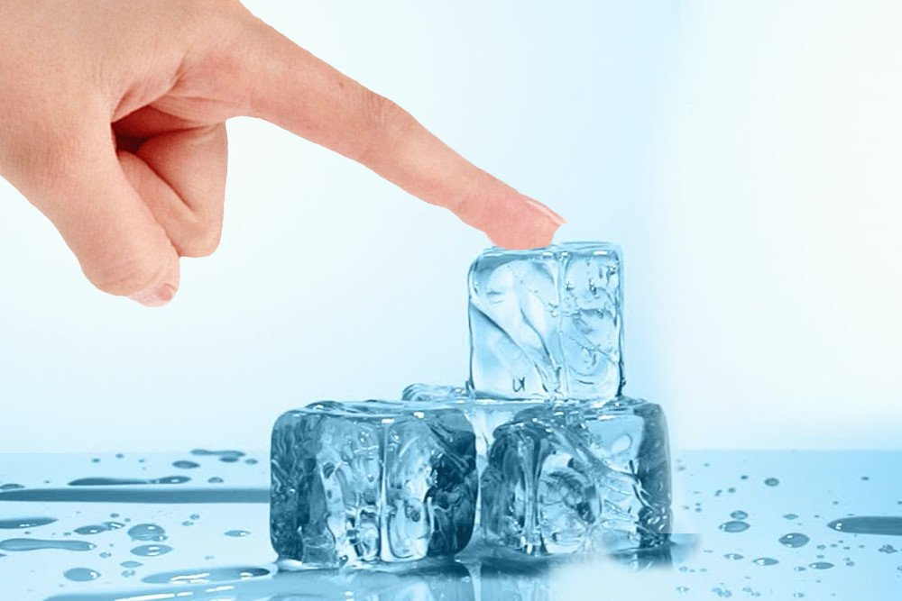

Fig. 1| **Method for biopsy acquisition by controlled cooling of tissue using an ultra-small biopsy device**. **a**, the inspiration for tissue capture by cooling is derived from the tongue sticking to a cold pole in winter or a wet finger sticking to a block of ice. **b**, The biopsy process involves placing a biopsy device consisting of metallic tip is to an area of moist gut epithelium. **c**, the metallic tip is then cooled to a defined temperature for a specific amount of time and **d**, then retracted, capturing tissue and leaving a biopsy mark.

**Results**

**Establishing ideal uTNB temperature and tissue contact time**

We carried out a numerical simulation to ascertain appropriate uTNB temperatures and their corresponding uTNB-tissue contact time duration required to acquire biopsies of desired depths. Literature values of the molecular composition of tissue in the GI tract were used to estimate the thermal conductivities of human esophageal, gastric, and duodenal epithelia lining [11]. The thermal conductivities of these organ walls were then substituted into the bioheat equation, while taking into consideration the phase change occurring when body fluid solidify and the blood flow into the tissue [12 – 24], the parameters for uTNB temperature and the requisite uTNB-tissue contact time can be estimated. Using finite element analysis, setting the uTNB length to 4 mm and outer diameter to 1.2 mm, the time taken for the temperature at the depth of interest to turn 0oC was numerically investigated.

In Fig. 2a, we report the effect of uTNB temperature on biopsy capture time of duodenum epithelial tissue. The device temperature was set at -20oC, -25oC, and -30oC and the temperature at base of the duodenum of the epithelium (1.0 mm) investigated. As shown in the figure, with a device of -20oC the time taken for the temperature at the base of the epithelium to cross 0oC was found to be over 5 seconds. The corresponding time for the device at -25oC and -30oC was 7 seconds and 5 seconds, respectively.

We then fixed the uTNB temperature at -30oC and investigated the time required to obtained biopsies of different depths as shown in Fig. 2b. The time required for the temperature at 0.8 mm, 1.0 mm, and 1.2 mm to cross 0oC was found to be about 2.5 seconds, 5 seconds, and 10 seconds, respectively. This shows that by fixing the temperature of the uTNB device at -30oC, we can modulate the depth of the biopsies captured by changing the uTNB-tissue contact time.

As shown in Fig. 2c, the time required for biopsy capture of both gastric and duodenal epithelia is about 5 seconds. The esophageal squamous epithelium (~0.45 mm) would require about 1 second. However, the tensile strength of the esophageal epithelium has been found to be over 0.3 MPa [25], therefore the tensile strength of the epithelial ice formed from cooling needs to exceed 0.3 MPa. In Fig. 2d, the tensile strength of ice at the base of the esophageal epithelium is plotted from the change in temperature [26] calculated from that location. The tensile strength of ice takes about 4 seconds to exceed 0.3 MPa.

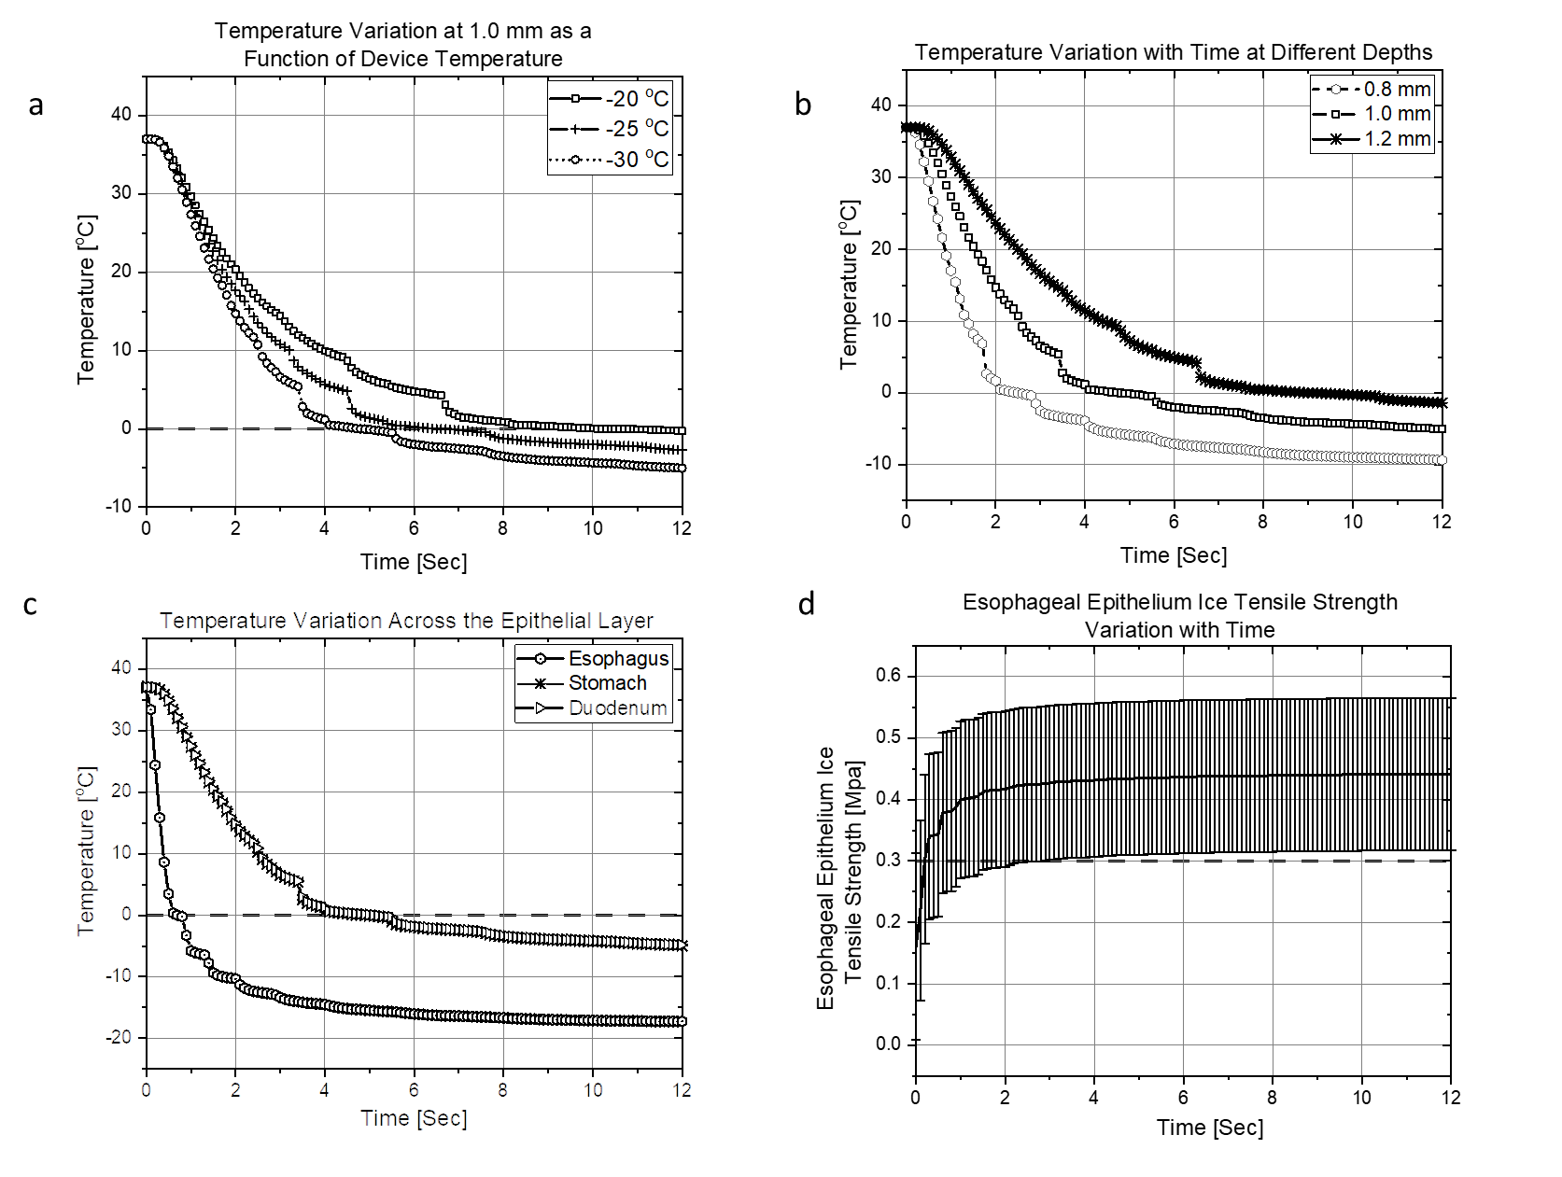

**Fig. 2 | uTNB temperature and tissue-contact time characterization**. **a**, Using duodenum wall tissue to investigate the change in temperature at 1.0 mm depth (approximate duodenum epithelial depth), with uTNB devices of temperature -20oC, -25oC, and -30oC the epithelium gets frozen in 10 seconds, 7 seconds and 5 seconds, respectively. **b**, Using a uTNB of -30oC the tissue depth of 0.8 mm, 1.0 mm and 1.2 mm get frozen in 2.5 seconds, 5 seconds and 9.5 seconds, respectively. **c**, With a -30oC uTNB, gastric and duodenum epithelia (~1.0 mm) takes the same amount of time to freeze, while esophageal epithelium (~0.45 mm) takes 1 second to freeze. **d**, However, with the tensile strength of human esophageal epithelium being greater than 0.3 MPa, the tensile strength of ice at 0.45 mm depth would have to exceed 0.3 MPa for the complete epithelial biopsy capture, which takes about 4 seconds.

**Choice of a coolant for use in uTNB**



**Fig. 3 | Estimation of vapor quality yield and the latent heat lost when coolant is throttled into uTNB metallic tip.** The graph at the top shows the estimated vapor quality yield obtained when a coolant experiences a unit change in pressure resulting in a unit rise in temperature by Joule-Thompson expansion. The graph at the bottom represents the resulting loss in latent from the phase change of the coolant from liquid to gas. The vapor quality yield of CO2, Freon R134A and Freon R410A are almost the same across the from -40oC to 30oC, however, Freon R410A results in a higher enthalpy transfer to latent heat of vaporization at temperatures above 0oC. CO2 displays superior cooling properties from latent heat transfer, but its propensity for phase change to solid state makes it a less desirable coolant for uTNB.

The choice of coolant for use in uTNB is an important parameter. Cooling happens by two major events: cooling by Joule-Thompson expansion and by evaporation, an estimation of the coolant’s expansivity and the resulting enthalpy conversion to latent heat of vaporization is vital [ref]. We carried out a numerical estimation of the vapor quality yield of four commonly available coolants (R744 (CO2), R134A, R410A, NO2) to ascertain an ideal coolant for use in the ultra-small uTNB. Fig. 3a is a plot of the estimated vapor quality yield that ensues when a coolant is throttled into the uTNB tip resulting in a unit drop in pressure leading to a unit temperature drop (derivation in methods). In the regime where coolant expansion is minimal, as in the ultrasmall cryo-probes, much of the cooling arises from enthalpy transfer to latent heat of vaporization extraction by the coolant from the surrounding. Therefore, an estimation of the weighted latent of vaporization at different temperature values can be a good indicator of which coolant would be ideal for our application. For example, from Fig. 2b, we can ascertain that Freon 410A and Freon 134A are ideal for cooling tissue at body temperature (37.6 deg. C), however, as the cooling continues to around 0 degrees, Freon 410A is a superior coolant. CO2 is a better coolant within the -20 oC to -40 oC window, however, the requirement for high-pressure operation condition for liquid CO2 use and its propensity to solidify at low pressures hence blocking small delivery channels is an unavoidable deterrent. R410A is therefore a better coolant of choice over CO2, R134A and NO2.

**uTNB tip configuration for optimal cooling**

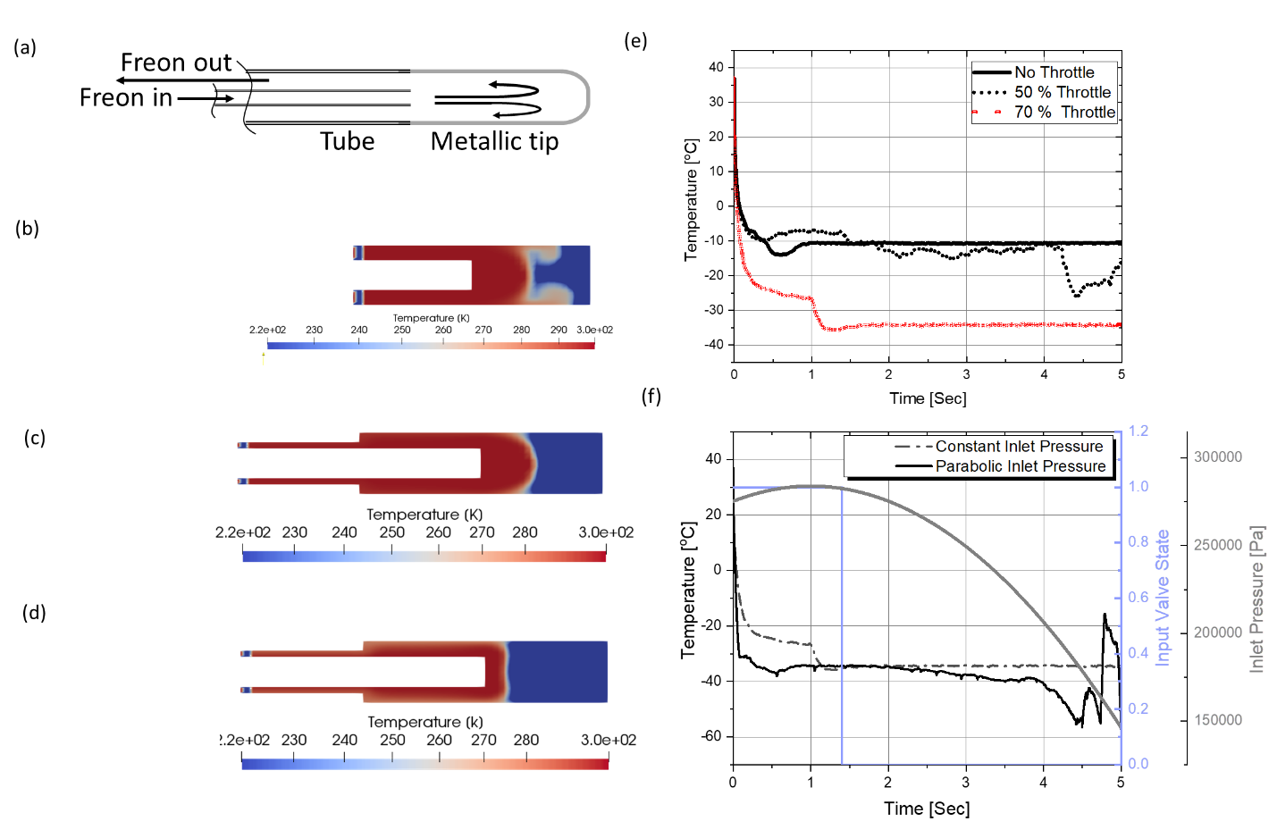

**Fig. 4 | Design and optimization of fluid flow in uTNB that results in the efficient cooling of the tip. a,** Freon R410A flows through an inner perfusion tube (internal diameter (ID) 0.25 mm, Outer diameter (OD) 0.5 mm) and into the metallic tip and flows out through an outer exhaust tube (internal diameter (ID) 1.0 mm, Outer diameter (OD) 1.2 mm) . **c**, With the throttle at the exit of the tip into the exhaust tube, there is more cooling than was without the throttle. **d**, Varying the inlet pressure in a monotonically decreasing fashion allows for better cooling of the metallic tip. **e**, The change in temperature over time as the coolant is pumped into the tip shows that 70% throttle at the exit is better than 50% throttle. **f**, A monotonically decreasing inlet pressure can be achieved by a opening an inlet valve into a tiny reservoir that supplies the uTNB and shutting it down after 1.4 seconds.

In order to optimize the cooling efficiency in the hollow uTNB tip, the tip configuration and the inlet-outlet pressure profile into and out of the tip ought to be optimized. Using numerical fluid dynamic simulations, iterations of different tip configurations and pressure profiles were tested numerically to arrive at the optimum design. The simulations were done using open source C++ based OpenFOAM software (refer to details in the methods).

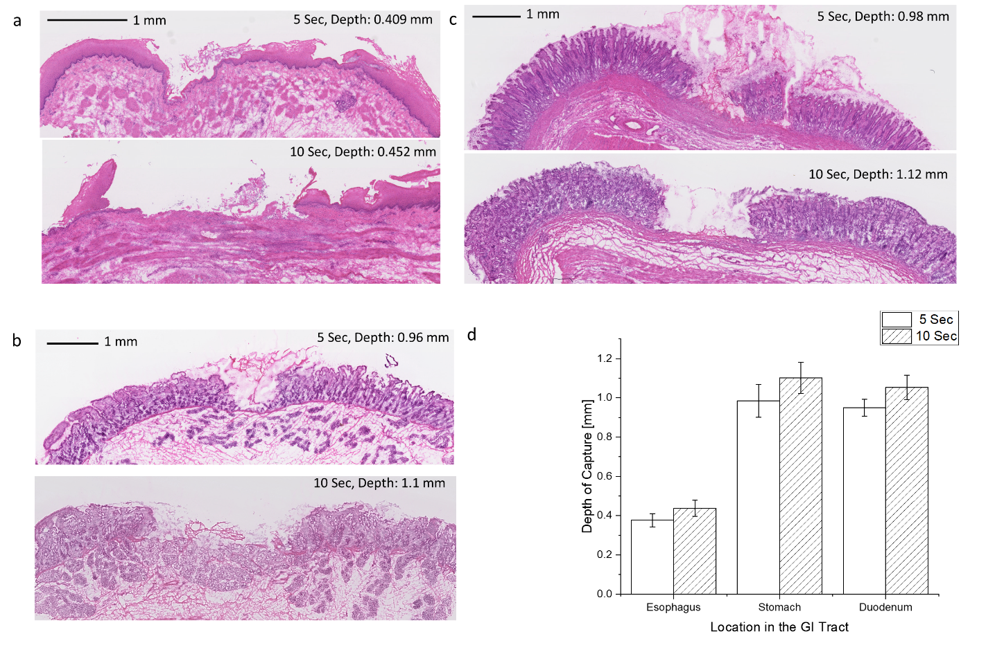

A uTNB device was fabricated, tested on the benchtop for the cooling performance and IACUC approved animal study designed to test the parameters obtained from the numerical simulations. Three swine studies were planned to test the depth of tissue capture as a function of uTNB-tissue contact time and to investigate the damage caused by the cooling on the remaining tissue. We used a special stain to show the extent of damage as indicated by the presence or absence of the lactate dehydrogenase (LDH) enzyme in tissue.

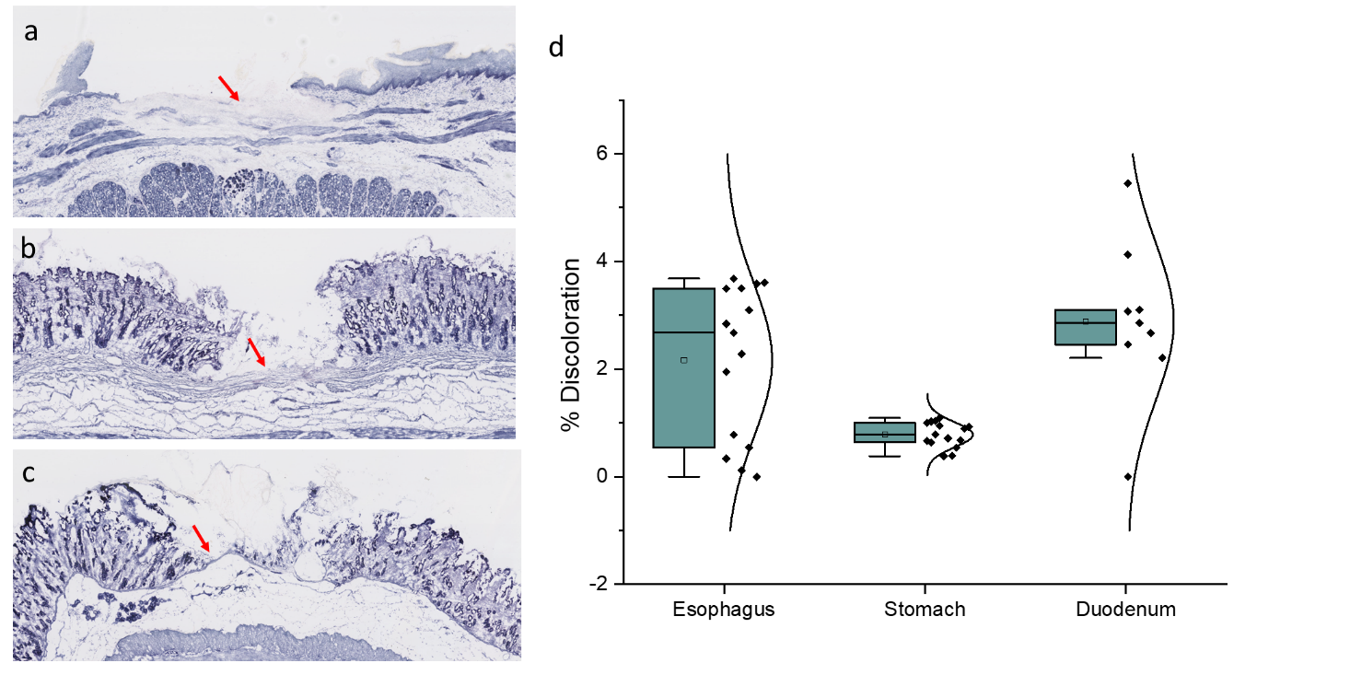Results

(8 display items, figures and tables)

Non-nested sections (up to 60 characters)

Discussion

**Methods**

**Estimating Probe temperature and uTNB-tissue contact time**

The finite element simulation for uTNB temperature and contact time was performed in C++. Using molecular composition of tissue obtained literature, for example the small intestine is composed of 80.6% water, 5.9% lipid and 13.0% protein [11], the thermal conductivity of tissue can then be estimated as follows:

(A-1)

Where, and denote the thermal conductivities of water, lipid and protein, respectively, while , and are the compositional ratios of the different molecular components in the tissue. Heat conduction through tissue can then be modelled using the Fourier-Biot equation as follows [12]:

(A-2)

Where , are the estimated density and specific heat capacity of the tissue, derived from weighted values of the individual components making up the intestinal wall tissue and is the temperature at position at time . With a blood perfusion rate of through the capillaries in the intestine, the equation above can be modified as follows [13]:

(A-3)

Where, , , , and represent blood density, tissue density, blood specific heat capacity, tissue specific heat capacity and blood temperature, respectively.

|  |  |
| --- | --- |
| Variables |  |
|  | **~0.21145 Wm-1K-1  [14]** |
|  | **~0.25 Wm-1K-1  [15]** |
|  | **T > 0 [16]**  **T < 0 [17]** |
|  | **911 kgm-3  [14]** |
|  | **1369.86301 kgm-3 [18]** |
|  | **T > 0 [19]**  **T < 0 [20]** |
|  | **2348.33 J/kg/K [14]** |
|  | **3595 J/kg/K [21]** |
|  | **T > 0 [22]**  **T < 0 [17]** |
|  | 1. T < 0 |
|  |  |
|  |  |
|  |  |

In order to solve the equation in (A-3) numerically, the coordinate , , can be discretized in the following manner:

Therefore can then be represented as .

Equation (3) can then be represented as follows:

.

Taking as the phase changing temperature, in the interval , within the temperature interval can be modified as [23]:

,

and for the interval can also be modified as:

.

For a uTNB of length of 4 mm, diameter 1.2 mm, L was set to 4 mm, W to the semi-circumference of 1.9 mm and D to 2 mm (depth of the organ wall). The boundary condition was set such that was set to uTNB device temperature and the temperature at infinity was set to body temperature of oC.

**Choosing an appropriate coolant**

Throttling a subcooled liquid (refrigerant) into an expansion chamber results in cooling by two phenomena: cooling of the fluid stream due to the enthalpy transfer to the latent heat of vaporization and the expansion coupled reduction in total internal energy.

As the liquid exits the throttle, shown in Fig. 1 above, it expands and evaporates into a liquid-vapor mixture. Assuming the expansion and evaporation is an isenthalpic process, the enthalpy at the input is equal at that at the output .

The composition at the input being purely liquid, enthalpy is the liquid state enthalpy . At the output the fluid consists of both saturated liquid and vapor with the saturated vapor fraction in the mixture expressed as the vapor quality . Therefore,

1

To a large extent, the amount of expansion and subsequent potential for evaporative enthalpy change is a function of the vapor quality and the latent heat of vaporization.

With the assumption that this is an adiabatic isenthalpic process, the total enthalpy before and after expansion and evaporation is immutable. By taking , and , the value of required to cause a unit drop in temperature = 1 K when a unit drop in pressure Pa is imposed on the throttled fluid can derived as follows:

2(a)

2(b)

Since the fluid at the input is liquid and is considered incompressible . The vapor quality yield from a unit drop in pressure and unit drop in temperature can be obtained by plugging and into the equation such that .

3(a)

3(b)

The average vapor quality is dependent on both pressure and temperature and can be expressed as:

4

Hence from eqn. 3(a) and 3(b),

5(a)

5(b)

Where,

, , and

Solving the differential equations 3(a) and 3(b) can be achieved using Dirichlet boundary condition of , at the critical point and , and the Neumann boundary condition of , at any temperature below the critical temperature . The constants using the boundary conditions are fixed to be and . Therefore can be estimated to be

6

Equation 6 can be of value in estimating the cooling potential of different refrigerants at specific temperature windows. In the regime where coolant expansion is minimal, as in ultrasmall cryo-probes, much of the cooling arises from the latent heat of vaporization extraction by the coolant from the surrounding. Therefore, an estimation of the weighted latent of vaporization at different temperature values can be a good indicator of which coolant would be ideal for specific applications. For example, from fig. 2, we can ascertain that Freon 410A and Freon 134A are ideal for cooling tissue at body temperature (37.6 deg. C), however, as the cooling continues to around 0 degrees, Freon 410A is a superior coolant. CO2 is a better coolant within the -20 oC to -40 oC window, however, the requirement for high-pressure operation condition for liquid CO2 use and the propensity of the gas to solidify at low pressures hence blocking small delivery channels is an unavoidable deterrent.

References (up to 50)

1. Peixoto, A., Silva, M., Pereira, P., & Macedo, G. Biopsies in Gastrointestinal Endoscopy: When and How. GE Port. J. Gastroenterol. **23**, 19 - 27 (2016).
2. Douglas, G. M. et al. Multi-omics Differentially Classify Disease State and Treatment Outcome in Pediatric Crohn's Disease. Microbiome **6**, 13 (2008).
3. Peterson, D. A., Frank, D. N., Pace, N. R., & Gordon, J. I. Metagenomic Approaches for Defining the Pathogenesis of Inflammatory Bowel Diseases. Cell Host Microbe. **3,** 417 - 427 (2008).
4. Walburga, D., Monic, S., & Yurdagül, Z. Microbiota in the Gastrointestinal Tract. Med. Sci. (Basel) **6,** 116 (2018).
5. Peery, A. F. et al. Burden and Cost of Gastrointestinal, Liver, and Pancreatic Diseases in the United States: Update 2018. Gastroenterol. **156**, 254–272 (2019).
6. Helmers, R. A. et al. Overall Cost Comparison of Gastrointestinal Endoscopic Procedures With Endoscopist- or Anesthesia-Supported Sedation by Activity-Based Costing Techniques. Mayo Clin. Proc. Innov. Qual. Outcomes **1** 234–241 (20017).
7. Parker, C., Alexandridis, E., Plevris, J., O’Hara, J., Panter, S. Transnasal endoscopy: no gagging no panic! Frontline Gastroenterol. **7** 246–256 (2016).
8. Rodriguez, S. A. et al. Ultrathin endoscopes. TECHNOLOGY STATUS EVALUATION REPORT **71**, 893-898 (2010).
9. Matsuo, Y. et al. Endoscopic small-capacity forceps increase the pathological diagnosis of gastric indefinite neoplasia. Turk J Gastroenterol. **29**, 481-7 (2018).
10. Goutal-Landry, C.M., Mansell, J., Ryan, K.A., & Gaschen, F.P. Effect of Endoscopic Forceps on Quality of Duodenal Mucosal Biopsy in Healthy Dogs. J Vet Intern Med. **27**, 456–461 (2013).
11. H. Q Woodard, and D. R. White, “The composition of body tissues,” The British Journal of Radiology, 59, 1209 – 1219, (1986).
12. T. N. Narasimhan, “FOURIER’S HEAT CONDUCTION EQUATION: HISTORY, INFLUENCE, AND CONNECTIONS, “ Reviews of Geophysics, 37, 1, (1999).
13. K. R. Diller, “Modelling of Bioheat Transfer Processes at High and Low Temperatures,” ADVANCES IN HEAT TRANSFER, 22, 157-357, (1992).
14. https://itis.swiss/virtual-population/tissue-properties/database/
15. A. Lervik, F. Bresme, S. Kjelstrup, D. Bedeaux, and J. M. Rubi, “Heat transfer in protein-water interfaces,” Phys Chem Chem Phys. 21; 12(7), 1610-1617, (2010).
16. M. L. V. Ramires, C. A. Nieto de Castro, Y. Nagasaka, A. Nagashima, M. J. Assael, and W. A. Wakeham, “Reference Data for the Thermal Conductivity of Water,” American Institute of Physics and American Chemical Society.
17. Yin-Chao Yen, “Review of thermal properties of snow, ice and sea ice,” CRREL Report 81-10, (1981).
18. H. Fischer, I. Polikarpov, and A. Craievech, “Average protein density is a molecular-weight-dependent function,” Protein Sci., 13(10), 2825 – 2828, (2004).
19. R. E. Jones, and G. L. Harris, “ITS-90 Density of Water Formulation for Volumetric Standards Calibration,” J. Res. Natl. Inst. Stand. Technol. 97, 335, (1992)
20. A. Melinder, “Thermophysical Properties of Aqueous Solutions Used as Secondary Working Fluids,” KTH Doctoral Thesis.
21. N. V. Prabhu, and K. A. Sharp, “Heat Capacity in Proteins,” Annu. Rev. Phys. Chem. 46, 521-548, (2005).
22. N. S. Orsborne, H. F. Stimson, and D. C. Ginnings, “MEASUREMENT OF HEAT CAPACITY AND HEAT OF VAPORIZATION OF WATER IN THE RANGE 0o and 100oC,” Journal of Research of the National Bureau of Standards, 23, (1939).
23. C. Bonacina, G. Comini, A Fasano, and M. Primecerio, “Numerical Solution of Phase-Change Problems,” Int. J. Heat Mass Transfer, 16, 1825 – 1832, (1973).
24. Goyal, R. K, Biancani, P, Phillips, A, and Spiro, H. A, Mechanical Properties of the Esophageal Wall, The Journal of Clinical Investigation **50**, 1456 -1465 (1971)

Acknowledgements

Author Contributions

------------------------------------------------------------------------------------------------------------------------------------------

Figures

1. Concept diagram- General Idea of the Biopsy Device - done
2. Choice of the coolant- done
3. Graph Cooling and Freezing of Tissue- done
4. Temperature Profile of the tip/Graph for Different Pressure Profiles- pending
5. Cryobiopsy Device in action – (M-mode)
6. Area of Tissue captured/Depth vs Time
7. Human Study- Histology (Duodenum, stomach)