

Dipartimento di Ingegneria Elettrica e dell’Informazione – DEI

Corso di Laurea Magistrale in Ingegneria Informatica

**Brain Tumor Segmentation**

Professor:

Prof. Andrea Guerriero

Student:

Davide MINERVINI

**1. Problem Presentation and Dataset Analysis: 3**

1.1: Importance of Brain Tumor Segmentation 3

1.2: Characteristics of Brain Tumors 4

1.3: Related Works and Literature 5

1.4: Dataset Description 7

**2. Pre-processing 9**

2.1: Z-Score Normalization 9

2.2: Bias Field Correction 10

2.3: Gaussian Smoothing Noise Reduction 11

**3. Algorithms for Brain Tumor Segmentation 13**

3.1: Thresholding-based Method 13

3.2: Region-based Method (with K-Means Clustering) 15

**4. Results and evaluation metrics discussion 19**

4.1: Dice Similarity Index 19

4.2: Jaccard Similarity Index 20

4.3: Volume Similarity Index 20

**5. Conclusions 22**

# **1. Problem Presentation and Dataset Analysis:**

## **1.1: Importance of Brain Tumor Segmentation**

Brain tumor segmentation plays a crucial role in the field of medical imaging, specifically in the diagnosis, treatment planning and monitoring of brain tumors. Accurate and automated segmentation methods are essential for efficient and reliable analysis of medical images, enabling radiologists and clinicians to make informed decisions regarding patient care.

Manual segmentation of brain tumors is a time-consuming and labor-intensive task, subject to inter-observer and intra-observer variability: it requires expertise and can be prone to errors due to the complex nature of brain tumor morphology. Therefore, the development of automated segmentation methods has gained significant attention in recent years.

By automating the segmentation process, we can overcome the limitations of manual segmentation and improve the efficiency and accuracy of tumor delineation. Automated segmentation methods not only save time but also provide consistent and reproducible results, allowing for better comparisons between different patients and follow-up examinations.

The challenges in brain tumor segmentation arise from the inherent complexity of brain tumor characteristics, including irregular shapes, heterogeneous intensities, and infiltrative growth patterns. Additionally, the presence of edema, necrotic regions, and partial volume effects further complicates the segmentation task. Therefore, the development of robust and reliable automated segmentation methods is essential to address these challenges.

In recent years, significant advancements have been made in brain tumor segmentation research. Deep learning-based approaches, such as convolutional neural networks (CNNs) and U-Net architectures, have shown promising results in accurately segmenting brain tumors from multimodal magnetic resonance imaging (MRI) data.

Overall, automated brain tumor segmentation methods have the potential to enhance clinical decision-making, improve patient management, and contribute to a deeper understanding of tumor characteristics. By leveraging advanced image analysis techniques, we can streamline the segmentation process, reduce human errors, and provide clinicians with reliable and quantitative information for optimal patient care.

## 

## 

## **1.2: Characteristics of Brain Tumors**

* Tumor Morphology: Brain tumors can exhibit diverse morphological patterns, including irregular shapes, variable sizes, and complex boundaries. They can infiltrate surrounding brain tissues, leading to diffused boundaries that are challenging to delineate accurately. Additionally, tumors can have necrotic regions, cystic components, and edema, further complicating the segmentation process.
* Heterogeneous Intensity: Brain tumors often exhibit heterogeneous intensity patterns in medical imaging modalities, such as magnetic resonance imaging (MRI). Tumors can have regions with varying signal intensities due to differences in cellularity, vascularity, and the presence of different tissue types (e.g., solid tumor tissue, necrosis, edema). This heterogeneity poses a significant challenge for segmentation algorithms that rely on intensity-based thresholds or statistical models.
* Multimodal Imaging: Brain tumor imaging typically involves multiple MRI sequences, such as T1-weighted, T2-weighted, and contrast-enhanced T1-weighted images. Each imaging sequence provides different information about tumor characteristics, such as tumor shape, edema, and vascularization. Integrating information from multiple modalities is essential for accurate tumor segmentation and requires advanced fusion techniques.
* Partial Volume Effect: The partial volume effect occurs when a voxel contains a mixture of different tissue types due to the limited resolution of medical images. In brain tumor segmentation, this effect can lead to misclassifications at the tumor boundaries, where the tumor tissue is mixed with adjacent healthy tissue. Handling the partial volume effect is crucial for achieving accurate and precise tumor segmentation.
* Inter- and Intra-Tumor Heterogeneity: Brain tumors exhibit significant inter- and intra-tumor heterogeneity, both spatially and temporally. This heterogeneity arises from differences in tumor subtypes, genetic variations, and treatment effects. Capturing this heterogeneity accurately during segmentation is important for tailoring individualized treatment strategies and monitoring treatment response.

## 

## 

## **1.3: Related Works and Literature**

The field of brain tumor segmentation has attracted significant research attention over the years, resulting in numerous studies and a wide range of proposed methods. In this section, we will review some of the related works and highlight significant contributions in the area of brain tumor segmentation.

* Traditional Image Processing Techniques: Early approaches to brain tumor segmentation relied on traditional image processing techniques, such as thresholding, region-growing, and edge detection methods. These methods often utilized intensity-based features and geometric properties to identify tumor regions. While they provided initial insights into tumor localization, they struggled to handle the inherent complexity and heterogeneity of brain tumors.
* Machine Learning-Based Approaches: Machine learning techniques have been widely explored for brain tumor segmentation. These methods involve training classifiers or regression models using labeled training data to learn the mapping between input image features and tumor regions. Various machine learning algorithms, including support vector machines (SVMs), random forests, and decision trees, have been employed to achieve accurate tumor segmentation. Additionally, features derived from texture analysis, shape descriptors, and spatial information have been integrated to improve segmentation performance.
* Deep Learning-Based Approaches: Deep learning, particularly convolutional neural networks (CNNs), has revolutionized the field of medical image segmentation, including brain tumor segmentation. CNNs can automatically learn hierarchical representations from the input data, enabling them to capture intricate patterns and spatial dependencies. U-Net, a popular architecture for medical image segmentation, has been widely used for brain tumor segmentation tasks. By leveraging large-scale annotated datasets and transfer learning, deep learning-based approaches have demonstrated remarkable performance improvements, achieving state-of-the-art results in brain tumor segmentation.
* Multi-Modal Fusion Techniques: Given the availability of multi-modal brain tumor imaging, researchers have explored techniques to leverage complementary information from different imaging modalities. Fusion methods, such as feature-level fusion and decision-level fusion, aim to combine the strengths of each modality to enhance tumor segmentation accuracy. These approaches have shown promise in improving the robustness and reliability of tumor delineation.
* Evaluation Metrics and Benchmark Datasets: To facilitate fair comparisons and objective evaluations of different segmentation methods, benchmark datasets and evaluation metrics have been established. The BraTS (Brain Tumor Segmentation) challenge dataset, introduced in the context of the Multimodal Brain Tumor Segmentation Challenge, has become a widely used benchmark for evaluating brain tumor segmentation algorithms. Evaluation metrics such as the Dice similarity index, Jaccard similarity index, and volume similarity index have been commonly employed to measure the similarity between the segmented tumor regions and the ground truth annotations.

These related works and studies demonstrate the continuous efforts to improve brain tumor segmentation accuracy and address the challenges posed by tumor characteristics. The advancements in machine learning, deep learning, and multi-modal fusion techniques have significantly contributed to the development of more robust and accurate segmentation methods. However, despite the progress made, there is still room for further research and innovation to enhance the clinical applicability and effectiveness of brain tumor segmentation algorithms.

Here's a brief summary some studies that made a significant contribution to the field of brain tumor segmentation:

* *Havaei et al., "Brain Tumor Segmentation with Deep Neural Networks," Medical Image Analysis, 2017*: This study introduced a deep learning-based approach for brain tumor segmentation using convolutional neural networks (CNNs). The authors proposed a novel architecture called "DeepMedic," which combined multi-scale contextual information with high-resolution details for accurate tumor segmentation. The study demonstrated the effectiveness of CNNs in capturing complex spatial patterns and achieved competitive results on benchmark datasets. The contribution of this study lies in showcasing the potential of deep learning techniques for improving brain tumor segmentation accuracy.
* *Bakas et al., "Advancing The Cancer Genome Atlas Glioma MRI Collections with Expert Segmentation Labels and Radiomic Features," Nature Scientific Data, 2017*: In this study, the authors focused on the annotation and augmentation of the Cancer Genome Atlas (TCGA) glioma MRI dataset with expert segmentation labels and radiomic features. The dataset was made publicly available to the research community, enabling the development and evaluation of brain tumor segmentation algorithms. The contribution of this study lies in providing a valuable resource that facilitated the development of new methods and allowed for comparative evaluations of different segmentation approaches on a large-scale dataset.
* *Menze et al., "The Multimodal Brain Tumor Image Segmentation Benchmark (BRATS)," IEEE Transactions on Medical Imaging, 2015*: The BRATS study aimed to establish a benchmark dataset and evaluation framework for brain tumor segmentation. The authors curated a diverse collection of multi-modal brain tumor images and provided ground truth annotations for tumor subregions. They also defined evaluation metrics, such as the Dice similarity index, to assess the accuracy of segmentation algorithms. This contribution significantly contributed to the standardization of evaluation protocols and enabled fair comparisons between different segmentation methods.
* *Pereira et al., "Brain Tumor Segmentation Using Convolutional Neural Networks in MRI Images," IEEE Transactions on Medical Imaging, 2016*: This study proposed a CNN-based approach for brain tumor segmentation in MRI images. The authors introduced a segmentation network that combined a fully convolutional network (FCN) architecture with an autoencoder, allowing for end-to-end training and improved segmentation accuracy. The study demonstrated the effectiveness of deep learning in capturing both local and global contextual information for accurate tumor delineation. The contribution of this study lies in showcasing the potential of CNNs for brain tumor segmentation and highlighting the importance of leveraging large-scale annotated datasets for training.
* *Wang et al., "Automatic Brain Tumor Detection and Segmentation Using U-Net Based Fully Convolutional Networks," Annual Conference on Medical Image Understanding and Analysis, 2017*: This study proposed an automatic brain tumor detection and segmentation method based on the U-Net architecture. The authors trained a fully convolutional network with an encoder-decoder structure to capture detailed tumor boundaries and segment different tumor subregions. The study demonstrated the effectiveness of U-Net in achieving accurate and efficient tumor segmentation. The contribution of this study lies in showcasing the applicability of U-Net-based networks for brain tumor segmentation tasks.

These studies collectively contributed to the advancement of brain tumor segmentation by introducing novel methodologies, benchmark datasets, and evaluation metrics. They demonstrated the potential of deep learning techniques, such as CNNs and U-Net, in improving segmentation accuracy and provided valuable resources for the research community to develop and evaluate new segmentation algorithms.

## 

## **1.4: Dataset Description**

The BRATS2020 dataset is a widely used benchmark dataset in the field of brain tumor segmentation. It was specifically designed to foster research and advancements in the automatic segmentation of brain tumors using multimodal magnetic resonance imaging (MRI) data. The dataset is composed by a collection of preoperative MRI scans acquired from patients diagnosed with gliomas, which are the most common primary brain tumors.

Key features of the BRATS2020 dataset include:

* Multimodal MRI: The dataset provides multi-parametric MRI data, including:
  + T1-Weighted (T1) Scan: T1-weighted scans provide good anatomical detail and are commonly used as a baseline for comparison with other MRI sequences. In T1-weighted images, cerebrospinal fluid (CSF) appears dark, while gray matter and white matter have different intensities. T1 scans help identify brain structures and provide information about tissue composition.
  + T1-Weighted Contrast-Enhanced (T1CE) Scan: T1-weighted contrast-enhanced scans are obtained after the administration of a contrast agent, typically Gadolinium-based, which helps highlight regions with disrupted blood-brain barrier integrity. The contrast agent accumulates in areas with increased vascularity, such as tumor regions, enhancing their visibility in the image. T1CE scans provide valuable information about tumor location, extent, and enhancement characteristics.
  + T2-Weighted (T2) Scan: T2-weighted scans are sensitive to water content and are useful for identifying edema, inflammation, and certain tumor characteristics. In T2-weighted images, CSF appears bright, while gray matter and white matter have different intensities. T2W scans help visualize abnormalities in brain tissue, including tumor infiltration, peritumoral edema, and cystic structures.
  + Fluid-Attenuated Inversion Recovery (FLAIR) Scan: FLAIR scans are T2-weighted images with the suppression of signal from CSF. The suppression of CSF signals allows for better visualization of pathological changes by reducing the influence of CSF-related artifacts. FLAIR scans are particularly useful for detecting lesions surrounded by edema, such as tumors and inflammatory conditions.

These different MRI modalities capture complementary information about the

tumor and its surrounding tissues, enabling comprehensive analysis.

* Ground Truth Annotations: Each MRI scan in the dataset is accompanied by expert manual segmentations of tumor subregions, including the whole tumor, tumor core, and enhancing tumor. These ground truth annotations serve as reference standards for evaluating the accuracy of segmentation algorithms.
* Heterogeneity: The BRATS2020 dataset captures the heterogeneity of brain tumors, encompassing variations in tumor size, shape, location, and appearance across different patients. This diversity reflects the real-world challenges encountered in clinical practice and enables the development of robust segmentation algorithms.
* Large-Scale: The dataset consists of a substantial number of cases, with a total of 369 MRI scans. This large-scale nature allows for more comprehensive evaluations and facilitates the development of data-driven segmentation methods.

The availability of the BRATS2020 dataset has significantly contributed to the advancement of brain tumor segmentation research by providing a standardized and comprehensive benchmark for evaluating different segmentation algorithms.

# **2. Pre-processing**

Consulting the existing literature and the related works, it appears clear that there’s not a rigid and ascertained method to perform brain tumor segmentation, since the pre-processing phase. However, the application of this pre-processing pipeline (adapted to our computational resources and the nature of our dataset) seems to be the more coherent one to follow:

## **2.1: Z-Score Normalization**

This method is a commonly used technique in image processing and aims to standardize the intensity values across the dataset. By applying the z-score normalization, the pixel intensities of the MRI images are transformed relative to the mean and standard deviation of the entire dataset.

The process begins by calculating the mean and standard deviation of the pixel intensities from all the images in the dataset. The mean represents the average intensity level, while the standard deviation indicates the spread or variability of the intensity values. Subsequently, each pixel intensity in the images is transformed by subtracting the mean and dividing by the standard deviation. This transformation results in a distribution of intensity values centered around zero, with a standard deviation of one.

The z-score normalization is advantageous as it removes any global intensity variations present in the dataset, enabling better comparability and analysis of the images. It helps to mitigate the impact of variations in image acquisition settings, scanner parameters, and patient-specific characteristics, which can introduce unwanted biases in the intensity values. By standardizing the intensities, the z-score normalization enhances the consistency and facilitates the subsequent processing and analysis steps, such as segmentation and feature extraction.

In the context of brain tumor segmentation, the z-score normalization aids in reducing the influence of intensity variations caused by factors unrelated to the tumor pathology. This normalization step ensures that the intensity values are consistent and comparable across different scans, improving the robustness and reliability of the segmentation algorithms and subsequent quantitative analysis.

Overall, the z-score normalization method plays a vital role in the pre-processing pipeline by standardizing the intensity values of the brain tumor dataset, enhancing the accuracy and reliability of the subsequent analysis and segmentation tasks.

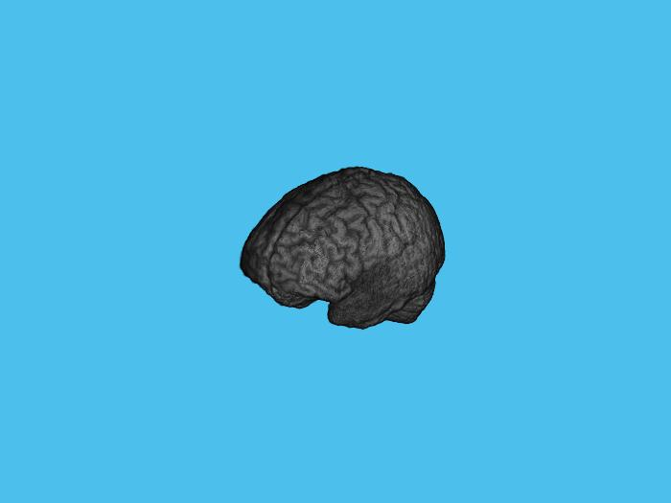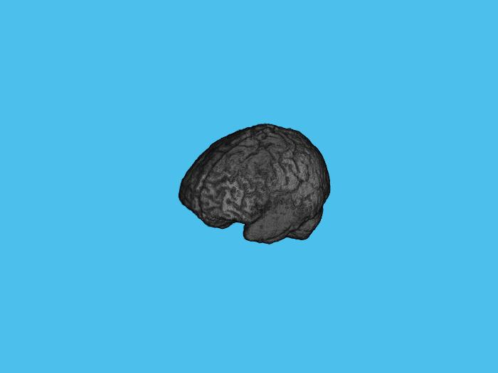

In figure we can compare the nii file corresponding to the t1 scan and the same file after z-score normalization.

## **2.2: Bias Field Correction**

Bias Field Correction addresses the presence of intensity variations caused by a phenomenon known as the bias field or intensity inhomogeneity. Bias field refers to a smoothly varying non-uniformity in the image intensities, which can result from various sources such as the imaging device, acquisition protocols, and patient-specific factors.

The Bias Field Correction method aims to estimate and remove this intensity inhomogeneity to improve the accuracy and reliability of subsequent image analysis tasks, such as segmentation. It operates by modeling and compensating for the spatially varying intensity distortions present in the images.

The process begins with the estimation of the bias field, which captures the underlying intensity variation across the image. Several algorithms can be employed for bias field estimation, including parametric models, non-parametric methods, and spatially adaptive techniques. These algorithms analyze the image intensities and spatial characteristics to estimate the bias field.

Once the bias field is estimated, it is then used to correct the image by dividing the original intensities by the estimated bias field. This division operation equalizes the intensity variations, effectively removing the influence of the bias field and improving the overall image quality.

Bias Field Correction is crucial in brain tumor segmentation tasks as it helps to enhance the accuracy and consistency of the segmentation results. By removing the intensity inhomogeneity, the method ensures that the segmentation algorithms can operate on images with more uniform intensity distributions. This leads to more reliable and precise tumor delineation, as the segmentation algorithms can focus on the tumor characteristics rather than being influenced by the intensity variations caused by the bias field.

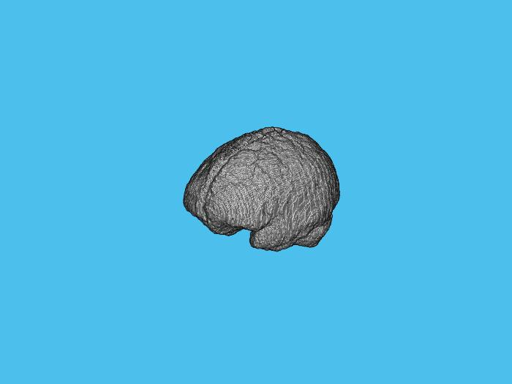

In figure we can compare the nii file corresponding to the t1 scan and the same file after Bias Field Correction.

## **2.3: Gaussian Smoothing Noise Reduction**

Gaussian Smoothing, also known as Gaussian filtering or Gaussian blur, is a widely used image processing technique employed as a pre-processing step in various medical image analysis tasks, including brain tumor segmentation. Its primary purpose is to reduce the impact of noise present in the images while preserving the important structural details.

Noise can be introduced during the image acquisition process or introduced during subsequent image processing steps. It can degrade the quality of the images and adversely affect the performance of subsequent analysis algorithms. Gaussian Smoothing helps to mitigate the effects of noise by applying a spatially adaptive low-pass filtering operation.

The technique gets its name from the Gaussian function, which is a bell-shaped curve used as a smoothing kernel. The Gaussian filter convolves this kernel with the input image, resulting in a smoothed version of the image. The filter operates by averaging the intensities of neighboring pixels, with the weights determined by the Gaussian kernel.

The key parameter in Gaussian Smoothing is the standard deviation (σ) of the Gaussian function. It controls the width of the smoothing kernel and determines the degree of smoothing applied to the image. A larger standard deviation leads to a broader kernel and stronger smoothing effect, while a smaller standard deviation preserves finer details at the cost of less noise reduction.

By applying Gaussian Smoothing, high-frequency noise is effectively attenuated, leading to a smoother appearance in the image. The technique helps to improve the signal-to-noise ratio, making it easier to identify and analyze important features and structures, such as tumor boundaries, with reduced interference from noise.

Gaussian Smoothing is particularly beneficial in brain tumor segmentation as it helps to suppress noise while preserving the underlying anatomical structures. It can aid in creating more homogeneous images and enhancing the clarity of tumor boundaries, thereby improving the accuracy of subsequent segmentation algorithms.

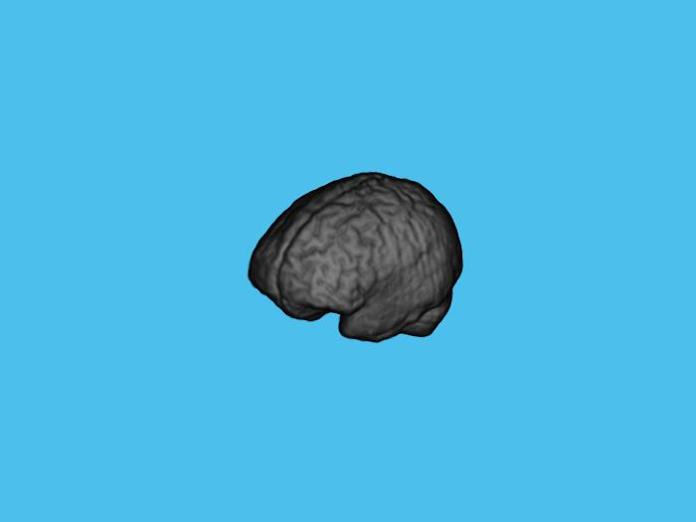

In figure we can compare the nii file corresponding to the t1 scan and the same file after Gaussian Smoothing Noise Reduction.

NB: All the files included in the dataset had already been Skull-Stripped. Skull-Stripping is a pre-processing method that aims to remove the shape of the skull from the data, providing a better file to perform segmentation on.

In section 4 we will discuss the results of this pre-processing pipeline.

# **3. Algorithms for Brain Tumor Segmentation**

The task of brain tumor segmentation involves partitioning brain images into different regions, typically including tumor core, tumor-enhancing region, peritumoral edema, and healthy brain tissue. This segmentation process aids in understanding the extent of tumor growth, assessing treatment response, and guiding surgical interventions.

Accurate segmentation is challenging due to the inherent complexity and heterogeneity of brain tumors. Tumors exhibit variations in size, shape, intensity, and appearance across different modalities, making it difficult to define a universal segmentation approach. Therefore, various algorithms and techniques have been developed to tackle this task.

In this project work, we focus on the Threshold-based method implementation as the main one. We will present possible matlab implementations for Region-Based Method, too. However, the parameter tuning for K-means clustering in this task was shown to be not efficient and too time-consuming.

## **3.1: Thresholding-based Method**

The thresholding-based method is a commonly employed technique for brain tumor segmentation. This method relies on setting intensity thresholds to separate tumor regions from the background and healthy brain tissue. The underlying assumption is that the intensity values of tumor regions differ significantly from those of healthy tissue.

In this method, the first step is to select appropriate threshold values that can effectively differentiate tumor regions. These thresholds can be determined manually based on domain knowledge or automatically through various thresholding algorithms.

In our case, the provided code demonstrates how the thresholding value is determined for brain tumor segmentation. Here's an explanation of the process:

1. Thresholding Using a Range of Values: A range of threshold values is defined, ranging from 0.01 to 0.99 with a step size of 0.01. These values represent the intensity thresholds for classifying tumor regions. Each threshold value will be evaluated to find the optimal threshold for segmentation.
2. Jaccard Index Calculation: For each threshold value, a binary mask is created by thresholding the normalized image. The binary mask separates potential tumor regions from the background and healthy brain tissue. Small objects (artifacts) within the binary mask are removed using the bwareaopen function.

To evaluate the quality of the segmentation, the Jaccard index (also known as the Intersection over Union) is calculated. The Jaccard index measures the similarity between the segmented tumor mask and the ground truth mask. It is computed as the ratio of the intersection of the two masks to their union.

1. Threshold Selection: The threshold value that yields the highest Jaccard index is identified as the best threshold for tumor segmentation. This is determined by finding the maximum value in the Jaccard index array and retrieving the corresponding threshold value.

The final tumor mask is generated using the best threshold value. The image is thresholded with this value to obtain a binary mask. Similar to the previous step, small objects within the mask are removed using the bwareaopen function to clean up the segmentation.

To further refine the tumor mask, morphological operations are applied to each slice of the 3D mask. A disk-shaped structuring element is used for morphological operations like opening, closing, and filling holes. This process helps to improve the smoothness and connectivity of the segmented tumor regions.

By iteratively evaluating different threshold values and measuring their performance using the Jaccard index, the algorithm identifies the best threshold value that maximizes the similarity between the segmented tumor mask and the ground truth. The resulting tumor mask is then refined using morphological operations.

This approach provides an automated and data-driven method for thresholding-based brain tumor segmentation, adapting the threshold value to the specific characteristics of the input image.

To implement the thresholding-based method, the brain image is typically pre-processed to enhance the contrast and normalize the intensity values. This helps to mitigate intensity variations caused by factors such as acquisition parameters and imaging artifacts.

Pixels with intensity values above the upper threshold are classified as tumor regions, while those below the lower threshold are considered healthy brain tissue. The region between the upper and lower thresholds may represent the peritumoral edema.

The thresholding-based method offers several advantages, including its simplicity, computational efficiency, and ease of implementation. It can provide satisfactory results when tumors exhibit clear intensity differences from healthy tissue. Additionally, it does not rely on complex algorithms or training data.

However, the thresholding-based method has limitations. It may struggle with tumors that have overlapping intensity values with healthy tissue or tumors with significant intensity variations. Determining optimal threshold values can be challenging, as they may vary across different tumor types and imaging modalities.

## **3.2: Region-based Method (with K-Means Clustering)**

Region-based methods for brain tumor segmentation aim to partition the brain MRI scan into distinct regions based on the characteristics of the tissue. The underlying assumption is that different tissue types, such as tumor and non-tumor regions, exhibit distinct intensity patterns in the image. By identifying and separating these regions, the tumor can be delineated from the surrounding healthy tissue.

K-means clustering is a popular technique employed in region-based segmentation algorithms. It is an unsupervised learning algorithm used for partitioning data points into k clusters based on their feature similarity. In the context of brain tumor segmentation, the k-means algorithm is applied to group image pixels into different classes or clusters, where each cluster represents a different tissue type.

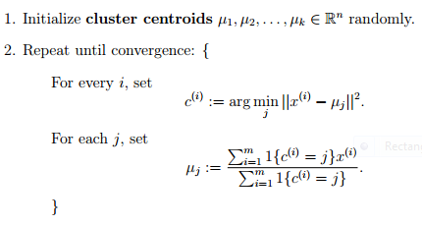

K-means algorithm in pseudo-code

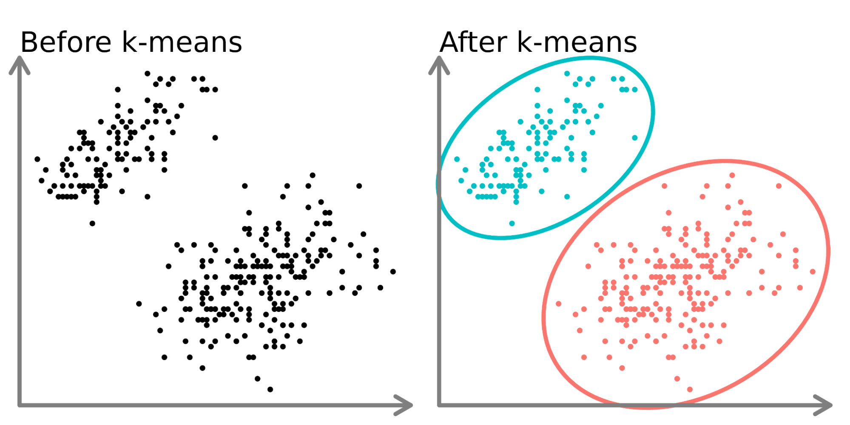

K-means clustering example

The implementation of k-means clustering in the region-based method for brain tumor segmentation involves the following steps:

1. Input Preparation: The brain MRI scan is preprocessed, including normalization and conversion to a suitable data type, to ensure consistent and reliable results.
2. Feature Extraction: In this case, the feature used for clustering is the intensity value of each pixel within the normalized MRI scan. Each pixel is represented as a data point with its intensity value as the feature.
3. K-means Clustering: The k-means algorithm is applied to the extracted features (pixel intensities) to partition the image into k clusters. The number of clusters is determined based on the desired segmentation outcome, typically representing tumor and non-tumor regions.
4. Labeling and Segmentation: Once the k-means clustering is performed, each pixel is assigned to one of the clusters based on its feature similarity (intensity). The cluster with the most similar intensity to each pixel determines its label or class assignment.
5. Cleanup and Refinement: The segmented image may contain noise or artifacts due to the inherent variability in the data. Post-processing steps, such as morphological operations, are applied to refine and clean up the segmented image, improving the accuracy and quality of the tumor region delineation.
6. Output and Evaluation: The segmented image, representing the tumor and non-tumor regions, can be further analyzed, evaluated, and compared to ground truth masks or other segmentation results. Various metrics, such as Dice Similarity Index and Jaccard Similarity Index, can be calculated to assess the accuracy and performance of the segmentation.

By utilizing k-means clustering within the region-based method, the algorithm can effectively separate different tissue types based on their intensity patterns. This allows for the identification and localization of tumor regions in brain MRI scans, aiding in diagnosis, treatment planning, and monitoring of brain tumors.

Here's a brief explanation of the implemented code:

* The region-based segmentation is performed using the k-means clustering algorithm. The number of classes to segment (in this case, tumor and non-tumor regions) and the maximum number of iterations for k-means are specified. The imsegkmeans function segments the image into the specified number of classes based on intensity similarities;
* The segmented image is further refined using morphological operations. A disk-shaped structuring element is created using the strel function. The segmented image is then processed to obtain a clean binary mask by applying morphological operations (imopen) on the class representing the tumor regions (label 2).

The Advantages in using this method are:

* Simplicity: The region-based method with k-means clustering is relatively straightforward to implement. The algorithm's simplicity makes it accessible and easier to understand.
* Unsupervised Learning: K-means clustering is an unsupervised learning algorithm, meaning it does not require prior labeled data for training. This makes it applicable to a wide range of brain MRI scans without the need for extensive manual annotation.
* Efficiency: K-means clustering is computationally efficient and can handle large datasets efficiently. It converges relatively quickly and scales well to larger image volumes.
* Intensity-Based Segmentation: The method utilizes intensity values as features for segmentation. This can be effective when the tumor region exhibits distinct intensity patterns compared to healthy tissue, as it allows for differentiation based on pixel intensity alone.

While the drawbacks of the method are:

* Sensitivity to Initialization: K-means clustering is sensitive to the initial centroids' placement, as it can lead to different segmentation results. Initialization biases can influence the final segmentation outcome, requiring careful initialization strategies or multiple runs with different initializations.
* Limited to Intensity Information: The region-based method solely relies on intensity information for segmentation. It may struggle with cases where tumor regions do not exhibit significant intensity differences from healthy tissue or when tumors have heterogeneous intensity patterns.
* Over-Segmentation or Under-Segmentation: Depending on the choice of the number of clusters (k), the method may suffer from over-segmentation or under-segmentation issues. Over-segmentation occurs when the algorithm assigns multiple clusters to the same tissue type, leading to fragmented regions. Under-segmentation happens when the algorithm fails to separate distinct tissue types, resulting in merged or incomplete regions.
* Lack of Spatial Context: The region-based method with k-means clustering does not explicitly consider spatial relationships between pixels. It treats each pixel independently based on its intensity, which may result in less accurate segmentations, especially in cases where spatial coherence plays a crucial role.
* Limited Robustness to Noise and Artifacts: K-means clustering is sensitive to noise and image artifacts present in MRI scans. It may mistakenly assign noisy or artifact-affected pixels to different clusters, leading to erroneous segmentations. Post-processing steps, such as cleanup operations, can help mitigate these issues to some extent.

These drawbacks should be taken into consideration when applying the method and interpreting the segmentation results.

# 

# **4. Results and evaluation metrics discussion**

In this section, we will discuss how we obtained the results for the evaluation of the segmentation process. While the project includes scripts meant to be run on a single .nii file and get the relative metrics of evaluation, the general idea is to get some overall average metrics to evaluate the algorithm performances on the entire dataset. Given the entity of the problem and the dataset we are working on, the metrics chosen to evaluate the performance of the segmentation methods are:

## **4.1: Dice Similarity Index**

The Dice Similarity Index (DSI), also known as the Dice coefficient or F1 score, is a common evaluation metric used to assess the similarity between two sets of segmentations. In the context of brain tumor segmentation, the DSI measures the agreement between the predicted tumor region and the ground truth tumor region.

Practically, the DSI compares the overlap between the segmented tumor region and the reference tumor region. It quantifies the proportion of correctly classified tumor voxels (true positives) in relation to the total number of tumor voxels present in both the predicted and ground truth segmentations.

Mathematically, the Dice Similarity Index is defined as:

*DSI = (2 * TP) / (2 * TP + FP + FN)*

where:

* TP (True Positives) represents the number of voxels that are correctly classified as tumor in both the predicted and ground truth segmentations.
* FP (False Positives) represents the number of voxels that are incorrectly classified as tumor in the predicted segmentation but not in the ground truth.
* FN (False Negatives) represents the number of voxels that are incorrectly classified as non-tumor in the predicted segmentation but are tumor in the ground truth.

A perfect DSI score of 1 indicates a complete overlap between the predicted and ground truth segmentations, implying that all tumor voxels are correctly identified. Conversely, a DSI score of 0 indicates no overlap between the segmentations, indicating a complete mismatch between the predicted and ground truth tumor regions.

In brain tumor segmentation, a good result is typically associated with a high DSI score close to 1. This suggests that the predicted segmentation aligns well with the ground truth, accurately capturing the tumor region. A higher DSI indicates better segmentation performance, reflecting a higher level of agreement between the predicted and ground truth segmentations.

On the other hand, a bad result is characterized by a low DSI score close to 0. This suggests poor segmentation performance, with the predicted segmentation failing to capture the tumor region accurately. A lower DSI indicates a larger discrepancy between the predicted and ground truth segmentations, highlighting the limitations or errors in the segmentation algorithm.

## **4.2: Jaccard Similarity Index**

The Jaccard Similarity Index (JSI), also known as the Jaccard coefficient or Intersection over Union (IoU), is another commonly used evaluation metric for assessing the similarity between two sets or segmentations. It provides a measure of the overlap between the predicted tumor region and the ground truth tumor region.

The JSI compares the intersection (common area) of the segmented tumor region and the reference tumor region with their union (total area). It quantifies the proportion of correctly classified tumor voxels (true positives) in relation to the total number of tumor voxels present in both the predicted and ground truth segmentations.

Mathematically, the Jaccard Similarity Index is defined as:

*JSI = TP / (TP + FP + FN)*

where: TP, FP and FN are defined as we’ve seen before.

Similar to the Dice Similarity Index, a perfect JSI score of 1 indicates a complete overlap between the predicted and ground truth segmentations, indicating a perfect match between the two. Conversely, a JSI score of 0 indicates no overlap between the segmentations, suggesting a complete mismatch between the predicted and ground truth tumor regions.

## **4.3: Volume Similarity Index**

The Volume Similarity Index (VSI) is another evaluation metric commonly used in medical image segmentation tasks, including brain tumor segmentation. It measures the similarity between the volumes of the predicted tumor region and the ground truth tumor region.

The VSI compares the volume of the intersection (common area) of the segmented tumor region and the reference tumor region with the average volume of the predicted and ground truth tumor regions. It provides a measure of how well the predicted volume matches the ground truth volume.

Mathematically, the Volume Similarity Index is defined as:

*VSI = (2 * |Vp ∩ Vg|) / (|Vp| + |Vg|)*

where:

* |Vp ∩ Vg| represents the volume of the intersection between the predicted tumor region (Vp) and the ground truth tumor region (Vg).
* |Vp| represents the volume of the predicted tumor region.
* |Vg| represents the volume of the ground truth tumor region.

A perfect VSI score of 1 indicates that the predicted tumor volume perfectly matches the ground truth tumor volume, suggesting a complete agreement in terms of size and shape. Conversely, a VSI score of 0 indicates no overlap between the predicted and ground truth tumor volumes, indicating a complete mismatch.

In the context of brain tumor segmentation, a good result is typically associated with a higher Volume Similarity Index close to 1. This indicates a close agreement in terms of volume between the predicted and ground truth tumor regions, suggesting accurate segmentation with similar sizes and shapes. A higher VSI score reflects better segmentation performance, indicating a more precise representation of the tumor volume.

Conversely, a bad result is characterized by a lower Volume Similarity Index close to 0, indicating a significant mismatch between the predicted and ground truth tumor volumes. A lower VSI score suggests a larger discrepancy in volume, indicating suboptimal segmentation performance.

Let’s discuss the obtained results in the next section.

# **5. Conclusions**

The implementation of the thresholding-based segmentation method gave the following results (on t1 scan):

| Input file type | ADS | AJS | AVS |
| --- | --- | --- | --- |
| Z-score -> Bias Field Correction -> Gaussian Smoothing | 0.0654 | 0.0347 | 57.0440 |
| No pre-processing | 0.1769 | 0.0975 | 6.8122 |
| Z-score only | 0.1175 | 0.0642 | 20.4723 |
| Bias Field Correction Only | 0.1199 | 0.0645 | 17.4211 |
| Gaussian Smoothing Only | 0.1692 | 0.0929 | 6.6175 |

As we can see, pre-processing methods are not successfully giving us better results in segmentation, so it would be pointless to test them with different order of execution. That’s probably due to the strong Heterogeneity of data and the parameter tuning in our implementation of the thresholding method. Here’s another thing we can try to improve those results: considering all the different scans for the same datapoint and try to understand if they can give us a more accurate implementation of the segmentation process.

Applying a combined threshold-based method on a single scan, the results are:

| Input file type | DS | JS | VS |
| --- | --- | --- | --- |
| t1+t1ce+t2+flair scans | 0.52162 | 0.63925 | 0.63925 |

Which are far more encouraging than the old ones.



Example of extracted tumor region by the combination of the

threshold-method considering all the scans for the same datapoint.

Applying the same combined segmentation process to all the dataset, the results are:

| Input file type | ADS | AJS | AVS |
| --- | --- | --- | --- |
| t1+t1ce+t2+flair scans | 0.17324 | 0.1919 | 0.6392 |

Which are not as promising as the results shown for a single iteration of the algorithm, but there surely is an overall improvement in the performance metrics.

There are other more flexible methods that try to overcome the variable nature of the problem. They require a higher degree of complexity than the ones we saw in our project and, given the entity and the amount of computation they perform, it would be a better choice to run and debug them in other programming languages or frameworks.

* **Level-set Method**:

The level set method is a mathematical technique used for image segmentation. It allows for the delineation of complex shapes and evolving boundaries in an image. It represents the evolving boundary as an implicit function, known as the level set function, which evolves over time to capture the desired shape accurately.

In practical terms, the level set method involves the following steps:

1. Initialization: The level set function is initialized by assigning positive or negative values to different regions inside and outside the desired object boundary, respectively. This initialization can be done manually or using automatic methods.
2. Evolution: The level set function evolves iteratively over time, guided by certain mathematical equations, to move the boundary towards the desired object's edges. The evolution process is driven by the properties of the image and the desired shape.
3. Re-initialization: To ensure that the level set function remains a signed distance function (a function that measures the distance from a point to the boundary), it needs to be re-initialized periodically during the evolution process.
4. Segmentation: After a sufficient number of iterations, the final level set function represents the segmented region as a zero-level contour, separating the object of interest from the background.

Mathematically, the level set method is based on the concept of a signed distance function and the notion of curve evolution. The evolving boundary is represented by a level set function, typically denoted by Φ(x, y), where (x, y) represents the spatial coordinates.

The level set function evolves over time according to the level set equation, which is derived from the Euler-Lagrange equation. The equation consists of two main terms:

1. Geodesic Active Contour Term: This term ensures that the evolving curve moves towards the edges of the object by minimizing the image gradient along the curve. It promotes boundary contraction and captures the object's shape information.
2. Balloon Term: This term introduces a force that expands or contracts the evolving curve, enabling it to adapt to complex shapes and irregular boundaries. The balloon term allows the curve to handle topological changes such as splitting or merging.

The level set equation combines these terms, along with other parameters, to control the evolution process. By solving the equation iteratively, the level set function evolves, converging to the desired object boundary and accurately segmenting the region of interest.

In summary, the level set method represents the evolving boundary as a level set function, which evolves over time using mathematical equations. It allows for the segmentation of complex and evolving shapes by iteratively updating the level set function to capture the desired object's boundary accurately.

A possible implementation of this method is included in the code, but it requires further debugging to work properly.

* **ML-based Method**:

The ML-based method, or Machine Learning-based method, is an approach that utilizes machine learning algorithms and models to perform various tasks, including image segmentation. It involves training a model on a large dataset and then using the trained model to make predictions or classify data based on learned patterns and features. Here's a practical and mathematical explanation of the ML-based method for image segmentation.

In practical terms, the ML-based method for image segmentation involves the following steps:

1. Data Preparation: A large dataset of images, along with their corresponding ground truth segmentations, is collected or created. The dataset is divided into training and testing sets.
2. Feature Extraction: Relevant features are extracted from the input images to capture important characteristics that can distinguish different regions or objects. These features can include color, texture, shape, or higher-level representations obtained from deep learning models.
3. Model Training: A machine learning algorithm or model is chosen, such as convolutional neural networks (CNNs), random forests, or support vector machines (SVMs). The model is trained using the training set, where the input images and their corresponding segmented regions are used to learn the mapping between features and segmentations.
4. Model Evaluation: The trained model is evaluated using the testing set, which contains unseen images. The model's performance is assessed based on metrics such as accuracy, precision, recall, or the Dice similarity index, comparing the predicted segmentations with the ground truth.
5. Inference: Once the model is trained and evaluated, it can be used for inference on new, unseen images. The model takes an input image and predicts the corresponding segmentation or assigns class labels to different regions.

Mathematically, the ML-based method involves formulating the image segmentation task as a supervised learning problem. Given an input image, denoted as X, the goal is to learn a mapping function f(X) that predicts the corresponding segmentation or assigns class labels to each pixel.

The mapping function f(X) is typically represented by a machine learning model with learnable parameters. For example, in the case of CNNs, the model consists of multiple layers, including convolutional, pooling, and fully connected layers. These layers learn to extract hierarchical representations and features from the input image.

During the training phase, the model is trained to minimize a loss function that quantifies the dissimilarity between the predicted segmentations and the ground truth segmentations. This is achieved through an optimization process, such as stochastic gradient descent (SGD) or Adam, which adjusts the model's parameters iteratively to minimize the loss.

The learning process involves forward propagation, where the input image passes through the model, and the predicted segmentation is obtained. Then, the loss is calculated by comparing the predicted segmentation with the ground truth. Backward propagation is performed to compute the gradients of the loss with respect to the model's parameters, enabling the update of the parameters through gradient descent.

Once the model is trained, inference is performed by feeding new, unseen images into the trained model. The model applies the learned mapping function to the input image, generating the predicted segmentation or class labels.

In summary, the ML-based method for image segmentation involves training a machine learning model on a dataset of images and ground truth segmentations. The model learns to extract relevant features and map them to segmentations through an optimization process. During inference, the trained model predicts segmentations or assigns class labels to unseen images based on the learned patterns and features.