Screenshot #1: postgres_brands.png (Country-specific brand join)
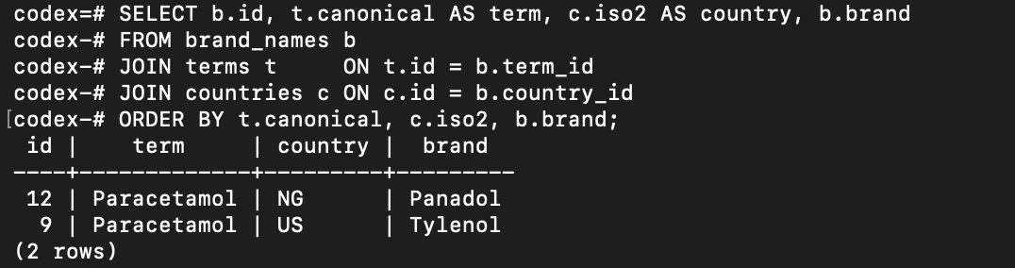

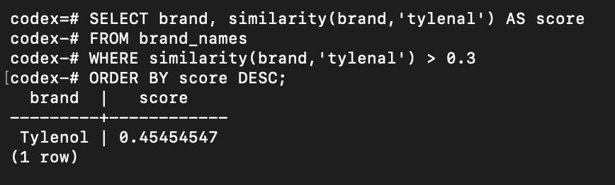
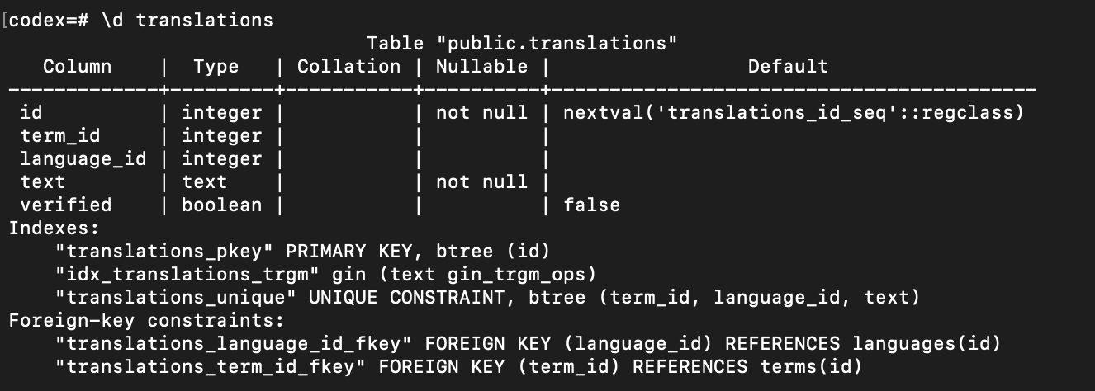
Screenshot #2: postgres_fuzzy.png (Fuzzy search)
Screenshot #3: postgres_constraints.png (Table constraints)

