Distributional Silicon Sampling: Training Decision Models to Predict Human Response Distributions
Abstract
Replacing human respondents with generative large language models (LLMs) in silicon sampling severely biases downstream econometric inference because autoregressive post-training collapses choice uncertainty, inflates regression coefficients, and triggers safety refusals. We propose distributional silicon sampling using single-pass decision models that score valid options directly in representation space and output normalized choice probabilities without text generation. Because off-the-shelf decision models are trained on single-label objective benchmarks and remain overconfident on subjective choices, we fine-tune open-weight decision models (Kev 0.8B, 4B, and 9B) on 1.88 million persona-linked survey responses from US social and behavioral surveys (US ISSP and Twin-2K-500) across 17 harmonized attributes. Minimizing distributional cross-entropy calibrates conditional choice distributions at unit temperature without target-study human data. Fine-tuning reduces held-out survey cross-entropy by up to $27.5\%$ and generalizes zero-shot to two held-out marketing studies. In COVID-19 vaccine conjoint analysis, Kev 9B (FT) eliminates safety refusals, outperforms generative LLMs by orders of magnitude, and reduces Multinomial Logit part-worth MSE by $64\%$ to $67\%$ over Kev 9B (base). In a six-arm nutrition labeling randomized trial, Kev 9B (FT) halves OLS treatment-effect MSE relative to Kev 9B (base), improves calibration across seen and unseen shopper covariates, and recovers causal OLS effects on interpretive labels while delineating modality limits on visual warnings.
Keywords. Decision models, Silicon sampling, Econometric inference, Conjoint analysis, Marketing research

1. Introduction
Simulating consumer choices, attitudes, and survey responses with foundation models, commonly referred to as silicon sampling, has attracted growing interest in marketing and behavioral research. In marketing research, the primary goal is downstream econometric inference, such as estimating part-worth utilities in conjoint analysis or causal treatment effects in randomized experiments. Currently, research relies on off-the-shelf generative large language models (LLMs) that generate text autoregressively. However, replacing human respondents with off-the-shelf generative LLM outputs severely biases measurements and downstream regressions because post-training for deterministic reasoning and safety compliance collapses choice uncertainty and triggers safety refusals on sensitive options (Goli and Singh 2024, Leng et al. 2026, Wang et al. 2026). Whereas existing post-inference methods adjust or reweight fixed model outputs after inference using human benchmark data (Leng et al. 2026, Wang et al. 2026), we explore whether aligning models before inference—by changing both their output architecture and their training weights—improves human approximation.
Architecturally, we adopt the emerging family of single-pass decision models (Palmer 2026). Instead of generating text tokens, a decision model takes a respondent persona and a structured question (e.g., a categorical choice task or an ordinal Likert scale) and outputs a normalized probability distribution over the valid options in one forward pass. This readout eliminates sampling variance and safety refusals while integrating directly into maximum likelihood and ordinary least squares regressions. Yet architecture alone is insufficient: off-the-shelf base decision models share the same training limitation as generative LLMs. Because standard training pairs each prompt with a single ground-truth label, off-the-shelf models treat genuine disagreement among respondents who share a persona as classification error, yielding overconfident probabilities and biased regression estimates. To overcome this limitation, we fine-tune open-weight decision models (Kev 0.8B, 4B, and 9B; Palmer (2026)) via persona-conditioned distributional training on 1.88 million general US survey responses. Our approach advances current silicon-sampling practice along two dimensions: replacing token generation with a probabilistic decision architecture and aligning model weights distributionally with empirical human populations.
Zero-shot evaluations across two held-out marketing studies confirm both gains. First, on a COVID-19 vaccine conjoint benchmark (Kreps et al. 2020, Wang et al. 2026), generative LLMs (Gemini 3.5 Flash-Lite and Gemini 4 Argon) suffer severe Multinomial Logit (MNL) bias ($MSE=0.59$ to $26.22$) that worsens under extended reasoning and triggers safety refusals. Off-the-shelf Kev 9B (base) ($MSE=0.2449$ under random personas and $0.0815$ under respondent personas) already outperforms generative LLMs by over an order of magnitude, and Kev 9B (FT) reduces MNL MSE by a further $64\%$ to $67\%$ to $0.0875$ and $0.0267$, approaching the 200-respondent human subsample ($MSE=0.0065$). Second, in a six-arm front-of-package nutrition labeling randomized trial (Grummon et al. 2025), Kev 9B (FT) lowers respondent-level choice cross-entropy, reduces OLS treatment-effect MSE by $53\%$ relative to Kev 9B (base) ($0.0022$ versus $0.0047$; human subsample $0.0016$), and recovers causal effects on interpretive labels even when conditioning on shopper nutrition covariates unseen during training.

2. Literature Review
Early work in silicon sampling prompted generative LLMs with demographic profiles to simulate human responses in political, economic, and marketing surveys (Argyle et al. 2023, Brand et al. 2023, Horton et al. 2023, Santurkar et al. 2023, Durmus et al. 2024, Goli and Singh 2024, Sarstedt et al. 2024). Although generative LLMs often capture the direction of average preferences, prior studies document systematic discrepancies from human populations, including mode collapse onto a single option, attenuated within-group variance, demographic stereotyping, and prompt sensitivity (Santurkar et al. 2023, Koo et al. 2024, Shu et al. 2024, Wadi and Fredette 2025, Deas and McKeown 2025, Kabir et al. 2025, Zahradnickova et al. 2026, Jung et al. 2026). In marketing applications, these distortions severely bias downstream econometric estimation (Goli and Singh 2024, Leng et al. 2026, Wang et al. 2026). In choice-based conjoint analysis, relying on AI choices or naively pooling them with human data biases Multinomial Logit (MNL) part-worth estimates, while scaling model capability or chain-of-thought (CoT) reasoning worsens error by inducing overly deterministic choices (Wang et al. 2026). Recent marketing studies address these discrepancies after inference by treating the language model as a fixed generator. Specifically, they use human benchmark data to statistically debias downstream regression parameters (AAE; Wang et al. 2026, Angelopoulos et al. 2023) or optimally reweight ensembles of candidate prompts, personas, and model checkpoints (HuMCal; Leng et al. 2026). Complementing these post-inference methods, we align predictions at the model level before inference along two dimensions: output architecture and training supervision.
Architecturally, several studies avoid the cost and sampling variance of repeated Monte Carlo text sampling by extracting exact next-token probabilities over option symbols (e.g., "A", "B", and "C") from causal LLMs (Kadavath et al. 2022, Kuribayashi et al. 2024, Bentegeac et al. 2025, Wadi et al. 2026). Yet symbol-level readouts remain sensitive to vocabulary and token-frequency priors. Decision models, also known as System One architectures, resolve this sensitivity via a single-pass scoring head (Asseri and Asseri 2026, Deußer et al. 2026, Geuter et al. 2026, Li 2026, Li and Wagle 2026, Palmer 2026). This head evaluates each supplied option directly in representation space and restricts probability mass strictly to the valid options without open-ended generation or safety refusals. However, existing decision models are pretrained on single-label objective benchmarks such as mathematics, code verification, and factual question answering, causing severe probability compression on subjective and ordinal tasks (Gao et al. 2026).
On the training dimension, prior fine-tuning in silicon sampling supervises models on one-hot individual responses. For example, Wang et al. (2026) fine-tuned GPT-4o on 50 target-study conjoint tasks under a generic persona to emit a single choice token (A, B, or C), which increased parameter error relative to the human sample. Even with a probabilistic output head, supervising on one-hot respondent labels treats disagreement among individuals who share a persona as label noise. Prior research moves toward distributional supervision by fine-tuning causal language models on fixed group histograms (Suh et al. 2025, Ku et al. 2026, Huang et al. 2026). We instead train decision models directly on empirical sample probability distributions aggregated across survey respondents matching subsets of persona attributes. This supervision calibrates conditional choice distributions from broad demographic subgroups to full individual personas, which improves generalizability.

3. Methodology
Decision model architecture and choice probabilities. Consider a survey or experimental dataset of human respondents indexed by $i∈\{1,…,N\}$. Each respondent possesses a multi-attribute persona state $s_{i}$ (e.g., sex, age, education, income, political party, and race) and answers a set of questions $Q_{i}$. Each question $q∈Q_{i}$ presents $K_{q}$ discrete answer options $Y_{q}=\{y_{1},…,y_{K_{q}}\}$. For categorical choice items, the options are unordered alternatives; for ordinal score items, the options are ordered rating levels $y_{1}≺y_{2}≺…≺y_{K_{q}}$. Let $y_{i,q}=(y_{i,q,1},…,y_{i,q,K_{q}})∈\{0,1\}^{K_{q}}$ denote respondent $i$’s observed one-hot response on question $q$, where $y_{i,q,k}=1$ if respondent $i$ selected option $y_{k}$ and $0$ otherwise.
Given a conditioning persona profile $s$, a decision model (Palmer 2026) processes the prompt in one causal forward pass without a vocabulary generation head. The prompt places $s$ in a state segment, followed by the question stem $q$, each option $y_{k}$ enclosed in dedicated option delimiters, and a terminal decision token appended after the final option. Because the terminal decision token follows all $K_{q}$ options, its final-layer hidden state $h_{q}^{dec}(s)∈R^{d_{model}}$ causally attends to the persona, the question stem, and the full option set. Let $h_{q,k}(s)∈R^{d_{model}}$ denote the final-layer hidden state at the closing delimiter of option $k$. Using learned affine projections $(W_{q},b_{q})$ and $(W_{k},b_{k})$ with $W_{q},W_{k}∈R^{d_{head}×d_{model}}$ and $b_{q},b_{k}∈R^{d_{head}}$, the decision head computes a scalar score $z_{q,k}(s)$ for each option $k$:
$$z_{q,k}(s)=\frac{(W_{q}h_{q}^{dec}(s)+b_{q})^{⊤}\left(W_{k}h_{q,k}(s)+b_{k}\right)}{\sqrt{d_{head}}}.$$ | (1)
Applying a softmax function over the $K_{q}$ scores yields the normalized choice distribution in a single pass:
$$P_{model}(Y_{q}=y_{k}∣s;θ)=\frac{exp(z_{q,k}(s)/T)}{\sum_{m=1}^{K_{q}}{exp}(z_{q,m}(s)/T)},$$ | (2)
where $T$ denotes the readout temperature.
Empirical sample-distribution training. Rather than training on isolated one-hot responses, we supervise model parameters $θ$ directly against empirical sample probability distributions constructed across subsets of persona attributes. Let $|s_{i}|$ denote the number of recorded attributes in a respondent’s full persona $s_{i}$. At each training epoch, we draw a subset size $κ$ uniformly from a schedule $K=(1,2,3,4,5,\text{"full"},\text{"full"})$. Setting $ℓ=|s_{i}|$ when $κ=\text{"full"}$ and $ℓ=min(κ,|s_{i}|)$ otherwise, we sample $ℓ$ attributes without replacement from $s_{i}$ to form a conditioning sub-persona $s^{(ℓ)}⊆s_{i}$. Let $I(q,s^{(ℓ)})=\{j:s_{j}⊇s^{(ℓ)}, q∈Q_{j}\}$ denote all training respondents who match $s^{(ℓ)}$ and answered question $q$, with sample size $n_{q,s^{(ℓ)}}=|I(q,s^{(ℓ)})|≥1$. Aggregating their observed choices yields the empirical sample probability distribution ${\hat{p}}_{q∣s^{(ℓ)}}=({\hat{p}}_{q,1∣s^{(ℓ)}},…,{\hat{p}}_{q,K_{q}∣s^{(ℓ)}})$:
pq,k∣s(ℓ)=1nq,s(ℓ)j∈I(q,s(ℓ))​yj,q,k, k∈{1,…,Kq}. | (3)
We optimize $θ$ by minimizing the distributional cross-entropy loss against ${\hat{p}}_{q∣s^{(ℓ)}}$:
$$L_{q,s^{(ℓ)}}(θ)=−\sum_{k=1}^{K_{q}}{{\hat{p}}_{q,k∣s^{(ℓ)}}}\log_{2}P_{model}​\left(Y_{q}=y_{k}∣s^{(ℓ)};θ\right).$$ | (4)
Up to the constant entropy of ${\hat{p}}_{q∣s^{(ℓ)}}$, minimizing Equation 4 directly minimizes the Kullback-Leibler divergence $D_{KL}​\left({\hat{p}}_{q∣s^{(ℓ)}} ∥ P_{model}(⋅∣s^{(ℓ)};θ)\right)$. Coarse sub-personas ($ℓ≤5$) pool multiple matching respondents to supply low-variance empirical choice shares, while full-persona draws ($ℓ=|s_{i}|$) preserve fine-grained individual conditioning. Sampling across $K$ also trains the model to marginalize consistently when downstream studies provide partial persona profiles at test time.

4. Survey Training and Validation

4.1 Training Corpus and Model Configuration
Survey microdata and question split. We construct a harmonized training corpus from two public US survey microdata sources (Table 1). The first comprises $10$ consecutive US waves of the International Social Survey Programme (US ISSP, 2015 to 2024; Table W1), spanning modules on work, government, social networks, religion, inequality, the environment, health, family, national identity, and digital societies (767,484 responses from 14,356 respondents across $616$ questions). The second is the Twin-2K-500 panel (Toubia et al. 2025), covering psychological, economic, and behavioral items (1,127,649 responses from 2,058 participants across $974$ questions). Combined, the corpus contains 1,895,133 responses from 16,414 respondents across 1,590 questions ($761$ Likert score items and $829$ categorical choice items). We partition the corpus strictly by question into 1,572 training items (1,881,950 observations) and $18$ unseen validation items (13,183 observations across $4$ US ISSP and $14$ Twin-2K-500 questions).
Harmonized persona attributes. Respondents are represented by up to $17$ harmonized demographic and attitudinal attributes (Table W2). Eleven attributes appear in both surveys (sex, age, education, religion, religious attendance, political ideology, marital status, main activity, political party, household income, and US census region), four appear only in US ISSP (prior voting, urban-rural residence, union membership, and ancestry), and two appear only in Twin-2K-500 (race and household size). The 16,414 respondents span 16,338 distinct full-persona configurations, and unrecorded attributes for any respondent are omitted from the state prompt.
Decision models and optimization. We evaluate the Kev decision-model family (Gao et al. 2026, Palmer 2026) across three scales (Kev 0.8B, Kev 4B, and Kev 9B), comparing each off-the-shelf base checkpoint against its fine-tuned FT counterpart. Each base model is trained in bfloat16 precision using Low-Rank Adaptation (LoRA, rank $r=64$, $α=128$) across all linear backbone projections alongside the trainable decision head. We optimize Equation 4 using AdamW (peak learning rate $5×{10}^{−5}$, weight decay $0.01$, a $10\%$ cosine warmup with cosine decay, and gradient clipping at $1.0$). Throughout training and held-out evaluation, validation cross-entropy is computed against observed individual one-hot responses $y_{i,q}$ under respondent $i$’s full persona $s_{i}$, and the lowest-validation-loss checkpoint is selected. At evaluation, off-the-shelf models use their released calibration temperatures ($T=2.35$ for 0.8B, $T=2.41$ for 4B, and $T=2.19$ for 9B), whereas all fine-tuned models use unit temperature ($T=1.00$) without post-hoc tuning.
Table 1. Summary of the survey training corpus, validation split, and held-out evaluation studies
Split | Dataset | Attributes | Questions | Likert (score) | Categorical (choice) | Respondents | Observations
Training | US ISSP (2015 to 2024) | 15 | 612 | 470 | 142 | 14,356 | 760,473
Training | Twin-2K-500 | 13 | 960 | 287 | 673 | 2,058 | 1,121,477
Training | Combined | 17 | 1,572 | 757 | 815 | 16,414 | 1,881,950
Validation | US ISSP (2015 to 2024) | 15 | 4 | 4 | 0 | 1,827 | 7,011
Validation | Twin-2K-500 | 13 | 14 | 0 | 14 | 2,058 | 6,172
Validation | Combined | 17 | 18 | 4 | 14 | 3,885 | 13,183
Held-out study | COVID-19 vaccine conjoint (full / eval subsample) | 9 | 5 / 5 | 0 | 5 / 5 | 1,971 / 200 | 9,855 / 1,000
Held-out study | Nutrition labeling RCT (full / eval subsample) | 13 | 36 / 36 | 0 | 36 / 36 | 5,633 / 200 | 33,798 / 1,200

Note. Training and validation splits partition the harmonized US ISSP (10 waves, 2015 to 2024) and Twin-2K-500 (Toubia et al. 2025) microdata strictly by survey question. Held-out study rows report full / evaluation subsample counts for Study 1 (Kreps et al. 2020, Wang et al. 2026) and Study 2 (Grummon et al. 2025).

4.2 Held-Out Survey Validation
Off-the-shelf decision models exhibit high cross-entropy on the $18$ unseen validation questions, and larger models do not reliably perform better (2.4262 bits on Kev 0.8B, 2.3586 bits on Kev 4B, and 2.3983 bits on Kev 9B; Table 2 and Figure 1). Distributional fine-tuning reduces held-out validation cross-entropy by $26.0\%$ to $27.5\%$ and improves accuracy steadily with model scale, reaching 1.7963 bits on Kev 0.8B ($0.34$ epochs), 1.7431 bits on Kev 4B ($0.67$ epochs), and 1.7377 bits on Kev 9B ($0.60$ epochs). Most of the reduction occurs within the first $0.10$ epochs as the decision head adapts to subjective response distributions, followed by steady gains from persona conditioning.
Table 2. Choice cross-entropy on the held-out survey validation split
Model | Base valid CE | FT valid CE (best) | FT valid CE (end Ep. 1) | Valid CE change | Best ckpt (epoch)
Kev 0.8B | 2.4262 | 1.7963 | 1.8141 | -26.0% | 0.34
Kev 4B | 2.3586 | 1.7431 | 1.7604 | -26.1% | 0.67
Kev 9B | 2.3983 | 1.7377 | 1.7589 | -27.5% | 0.60

Note. Cross-entropy (CE) is reported in bits ($\log_{2}$) across 13,183 observations on 18 unseen US ISSP and Twin-2K-500 items. Off-the-shelf (Base) models use released calibration temperatures ($T=2.35$, $2.41$, and $2.19$); fine-tuned (FT) models use unit temperature ($T=1.00$) at the lowest-validation-CE checkpoint and at Epoch 1 completion.
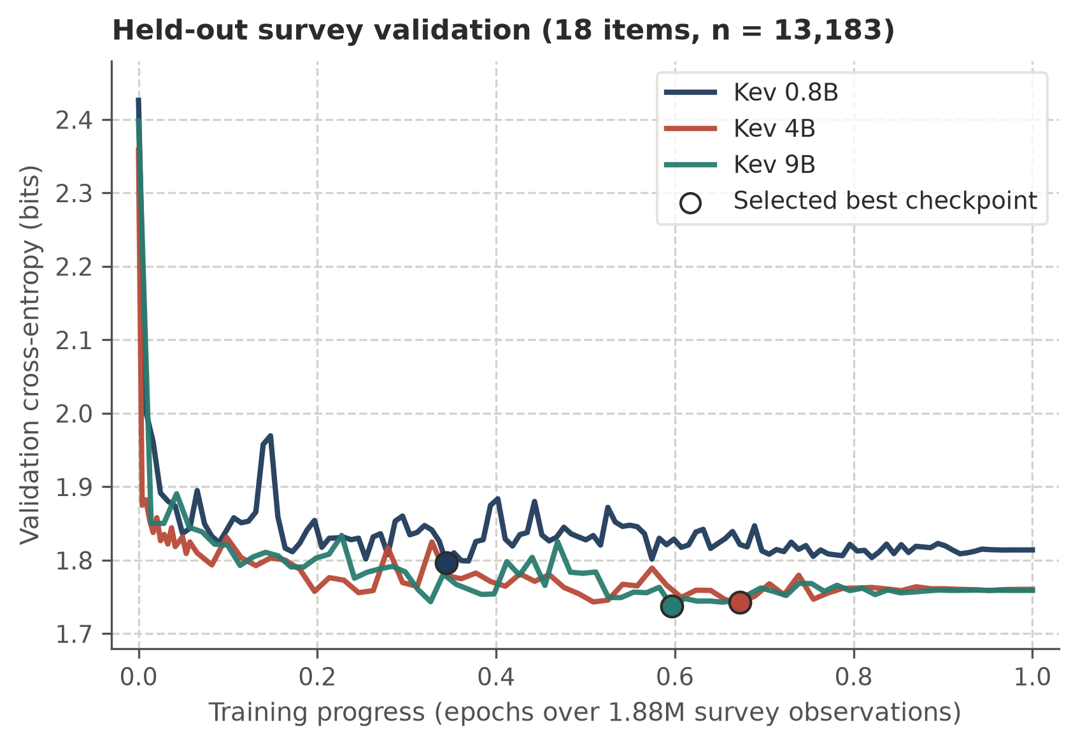
Figure 1. Epoch 1 validation cross-entropy trajectories across model scales
Note. Cross-entropy (in bits) across Epoch 1 on the held-out survey validation split (18 unseen US ISSP and Twin-2K-500 questions, n = 13,183; evaluated every 50 steps on 0.8B and 9B and every 200 steps on 4B). Circles denote the selected lowest-validation-CE checkpoint for each scale.

5. Study 1: Choice-Based Conjoint Analysis
To test whether fine-tuning on human response distributions generalizes to out-of-sample human studies, we estimate each held-out study’s econometric model on the predicted responses and compare the resulting regression parameters against the human estimates.

5.1 Experimental Design and Multinomial Logit Specification
For our first held-out study, following the benchmark protocol of Wang et al. (2026), we use a COVID-19 vaccine conjoint dataset (Kreps et al. 2020) to investigate part-worth utility recovery (Table 1). In this study, 1,971 US respondents each complete $t∈\{1,…,5\}$ paired choice tasks (9,855 observations). Each task presents two hypothetical vaccine profiles (Option A and Option B) with binary attribute vectors $x_{i,t,A},x_{i,t,B}∈\{0,1\}^{d}$, alongside a no-vaccine outside option (Option C) whose utility is normalized to zero. Profiles vary across $7$ attributes represented by $d=11$ non-reference binary indicators: efficacy ($70\%$ and $90\%$ vs. $50\%$), protection duration ($5$ years vs. $1$ year), major side effects ($1$ in 1,000,000 vs. $1$ in 10,000), minor side effects ($1$ in $30$ vs. $1$ in $10$), regulatory status (emergency use authorization vs. full FDA approval), origin (China and the United Kingdom vs. the United States), and endorsement (Joe Biden, the US CDC, and the WHO vs. Donald Trump).
Under the standard Multinomial Logit (MNL) model (Wang et al. 2026), choice probabilities for parameter vector $β∈R^{d}$ are:
$$P_{m}(x_{i,t};β)=\frac{exp(x_{i,t,m}^{⊤}β)}{1+exp(x_{i,t,A}^{⊤}β)+exp(x_{i,t,B}^{⊤}β)}, m∈\{A,B\},$$ | (5)
with $P_{C}(x_{i,t};β)=1−P_{A}(x_{i,t};β)−P_{B}(x_{i,t};β)$. Given observed or predicted choice shares $(p_{i,t,A},p_{i,t,B},p_{i,t,C})$ across $n$ choice sets, we estimate $\hat{β}$ via Newton-CG maximum likelihood:
β=argminβ∈Rd−1n(i,t)​m∈{A,B,C}​pi,t,mlogPm(xi,t;β). | (6)
Human respondents and generative LLMs supply one-hot choices, whereas decision models supply continuous probabilities from Equation 2. Let $β^{*}∈R^{11}$ denote the ground-truth MNL vector estimated on all 9,855 human choices. Following Wang et al. (2026), we evaluate models on a 200-respondent subsample (n = 1,000 choice sets) using Mean Absolute Percentage Error ($MAPE$) and Mean Squared Error ($MSE$):
$$MAPE(\hat{β},β^{*})=\frac{1}{d}\sum_{j=1}^{d}{\frac{|{\hat{β}}_{j}−β_{j}^{*}|}{|β_{j}^{*}|}}×100\%,$$ | (7)
$$MSE(\hat{β},β^{*})=\frac{1}{d}\sum_{j=1}^{d}{(}{\hat{β}}_{j}−β_{j}^{*})^{2}.$$ | (8)
We test both unconditioned random personas and $9$-attribute respondent personas (US region, gender, age, education, race, income, religion, political party, and ideology; Table W2). Decision models score the verbatim survey instrument (Kreps et al. 2020), whereas generative LLMs (Gemini 3.5 Flash-Lite at minimal and high thinking; Gemini 4 Argon at low and high thinking) use the Wang et al. (2026) prompt format (which additionally states country). Unlike Wang et al. (2026), who excluded vaccine opt-out respondents due to LLM safety refusals, we retain the full untruncated respondent population and benchmark against MNL estimated directly on the 200 sampled humans.

5.2 Conjoint Estimation Results
Generative LLM bias and inverse scaling with reasoning. Estimating MNL on the 200 sampled humans yields a finite-sample benchmark of $MSE=0.0065$ (Table 3; Figure W1 and Figure W2). Consistent with Wang et al. (2026), generative LLMs exhibit severe bias under random personas ($MSE=3.2073$ to $26.2179$). Conditioning on the $9$ respondent attributes cuts error substantially ($MSE=0.5925$ to $2.1687$), yet estimates remain far from the human benchmark. Moreover, higher reasoning budgets and model scale worsen parameter recovery. Under respondent personas, raising Gemini 3.5 Flash-Lite thinking from minimal to high doubles MSE ($0.5925$ to $1.1984$), while Gemini 4 Argon degrades further ($1.7637$ at low and $2.1687$ at high).
Why generative LLMs fail and why choice probabilities matter. Humans choose the no-vaccine option in $20.3\%$ of subsample tasks, whereas unconditioned generative LLMs almost never opt out ($0.0\%$ to $3.0\%$), and Gemini 4 Argon (high) refuses $16$ of $1,000$ tasks outright. Because generative LLMs also pick a single winning profile nearly deterministically, MNL coefficients explode (Figure 2, Panel B; Table W3): under respondent personas, Efficacy: 90% reaches $+1.846$ to $+3.538$ versus $+0.746$ for humans. Scoring options with Kev 9B (base) ($T=2.19$) eliminates refusals and cuts MSE by an order of magnitude, to $0.2449$ (random) and $0.0815$ (respondent). Crucially, forcing Kev 9B (base) to output only its top-scoring option—rather than full choice probabilities—raises respondent-persona MSE nearly $23$-fold ($0.0815$ to $1.8678$), back into the generative LLM range.
Gains from distributional survey fine-tuning. Without using any target-study conjoint data, Kev 9B (FT) ($T=1.00$) cuts MNL MSE relative to Kev 9B (base) by $64.3\%$ under random personas ($0.2449$ to $0.0875$) and by $67.2\%$ under respondent personas ($0.0815$ to $0.0267$; Table 3). Fine-tuning also lowers choice cross-entropy (1.6370 to 1.5192 bits random; 1.5255 to 1.4449 bits respondent) and restores realistic opt-out shares ($19.0\%$ and $28.1\%$ vs. $11.9\%$ and $16.4\%$ for base). In Figure 2 (Panel A; Table W3), Kev 9B (base) overstates efficacy and institutional endorsements, placing only $5$ of $11$ estimates inside the human subsample’s $95\%$ confidence intervals. Kev 9B (FT) places $8$ of $11$ estimates inside the subsample $95\%$ intervals, closely matching humans on efficacy ($+0.217$ and $+0.562$ vs. $+0.361$ and $+0.746$), EUA ($−0.123$ vs. $−0.115$), origin ($−0.192$ and $−0.553$ vs. $−0.140$ and $−0.570$), and endorsements (Biden $+0.135$ vs. $+0.095$; WHO $+0.516$ vs. $+0.273$; US CDC $+0.621$ vs. $+0.416$, down from base $+1.017$), while conservatively attenuating Duration: 5 years ($+0.035$ vs. $+0.261$) and Major side effects ($+0.043$ vs. $+0.304$).
Table 3. Multinomial logit part-worth parameter recovery on the COVID-19 vaccine conjoint benchmark
Model | Configuration | Random Persona |  | Respondent Persona
Model | Configuration | MAPE (%) | MSE | MAPE (%) | MSE
Human benchmark
Survey subsample | Observed choices | — | — | 22.1 | 0.0065
Decision model
Kev 9B | Fine-tuned | 84.0 | 0.0875 | 56.4 | 0.0267
Kev 9B | Off-the-shelf | 135.4 | 0.2449 | 93.5 | 0.0815
Generative LLMs
Gemini 3.5 Flash-Lite | Minimal thinking | 531.7 | 3.2073 | 203.6 | 0.5925
Gemini 3.5 Flash-Lite | High thinking | 998.2 | 14.4555 | 335.8 | 1.1984
Gemini 4 Argon | Low thinking | 1,394.3 | 23.3998 | 376.7 | 1.7637
Gemini 4 Argon | High thinkingª | 1,507.7 | 26.2179 | 395.1 | 2.1687

Note. Mean Absolute Percentage Error (MAPE) and Mean Squared Error (MSE) are computed across $d=11$ vaccine attribute indicators on the 200-respondent evaluation subsample (n = 1,000 choice sets), benchmarked against full-sample human $β^{*}$ [N = 1,971 respondents, 9,855 choice sets; Kreps et al. (2020); Wang et al. (2026)]. Under Kev 9B, Fine-tuned (FT) uses unit temperature ($T=1.00$) and Off-the-shelf (base) uses released calibration temperature ($T=2.19$). ªUnder random personas, n = 984 choice sets due to 16 safety refusals.
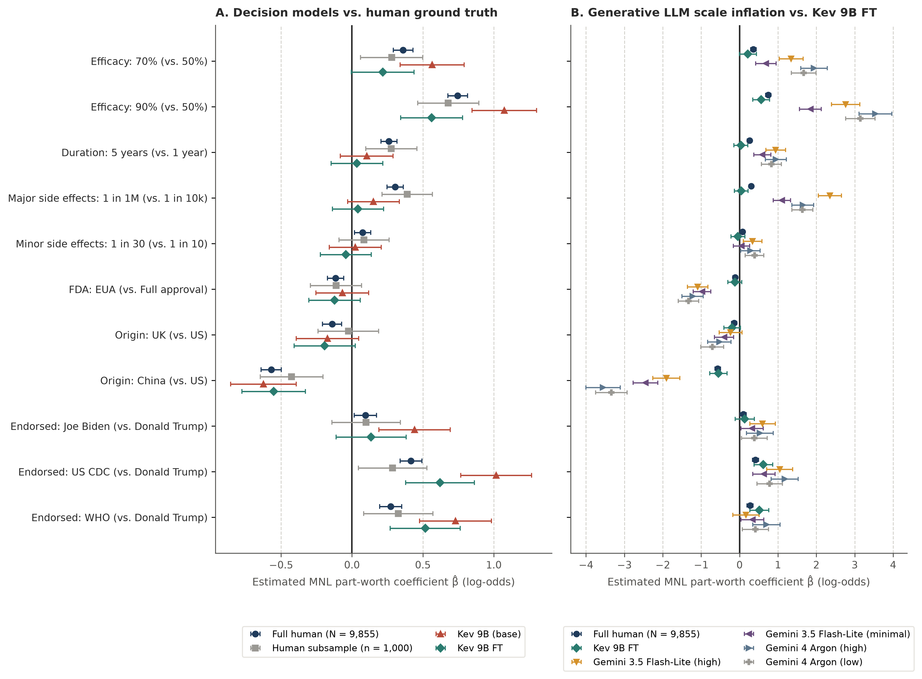
Figure 2. Estimated multinomial logit part-worth coefficients across COVID-19 vaccine attributes
Note. Estimates $\hat{β}$ and 95% asymptotic confidence intervals across the 11 non-reference vaccine indicators under 9-attribute respondent personas (n = 1,000 choice sets; generative LLM prompts additionally state country), benchmarked against full-sample (N = 9,855) and subsample (n = 1,000) human estimates (Kreps et al. 2020, Wang et al. 2026). Panel A compares Kev 9B (base) and Kev 9B (FT) against human benchmarks; Panel B shows coefficient inflation in generative LLMs across reasoning budgets.

6. Study 2: Front-of-Package Nutrition Labeling Trial

6.1 Experimental Design and OLS Specification
Our second held-out study evaluates causal treatment-effect recovery in the front-of-package (FOP) nutrition labeling randomized clinical trial of Grummon et al. (2025) (Table 1). In this trial, N = 5,633 US grocery shoppers are randomized to one of six between-subjects labeling arms $a_{i}$: Positive (reference arm), Nutrition Info, High In warning, Positive + Nutrition Info, Positive + High In, or Spectrum (1-to-5 star rating). Each shopper completes $q∈\{1,…,6\}$ three-option product healthfulness choice tasks across distinct food and beverage categories (36 arm-by-category tasks, 33,798 choices), where option $y_{1}$ denotes the objectively healthier product.
For each shopper $i$, we compute the mean probability of selecting the healthier product across the six tasks, ${\overset{‾}{p}}_{i}=\frac{1}{6}\sum_{q=1}^{6}{p_{i,q,1}}$, where $p_{i,q,1}$ is the binary choice indicator $y_{i,q,1}$ for human shoppers and the predicted probability $P_{model}(Y_{i,q}=y_{1}∣s_{i};θ)$ under arm $a_{i}$ for decision models. Following Grummon et al. (2025), we regress ${\overset{‾}{p}}_{i}$ on the five treatment-arm indicators via ordinary least squares (OLS) with HC1 heteroskedasticity-robust standard errors to obtain $\hat{β}∈R^{5}$ relative to Positive. We evaluate models on a 200-shopper subsample (n = 1,200 choices) against the full-sample human vector $β^{*}$ (N = 5,633) using $MAPE$, $MSE$, and Spearman rank correlation $ρ$. Each shopper profile contains $13$ attributes (Table W2): $6$ demographic attributes seen in survey training (sex, age, education, income, race, and household size) and $7$ covariates completely unseen during training (Hispanic ethnicity, number of children, SNAP receipt, WIC receipt, Nutrition Facts label usage, online grocery share, and nutrition literacy score).

6.2 Trial Estimation and Attribute Generalization Results
Calibration and treatment-effect recovery across model scales. Estimating OLS on the 200 sampled shoppers yields the finite-sample benchmark of $MAPE=22.7\%$ and $MSE=0.0016$ ($ρ=+0.40$, as finite-sample noise swaps the nearly tied Nutrition Info [$+0.184$] and Positive + Nutrition Info [$+0.179$] arms; Table 4; Figure W3 and Figure W4). Under $13$-attribute personas, larger off-the-shelf models actually worsen in choice cross-entropy (1.4770, 1.5124, and 1.5405 bits across 0.8B, 4B, and 9B) and yield higher OLS MSE than under random prompts ($0.0074$ vs. $0.0050$ on 0.8B, $0.0088$ vs. $0.0028$ on 4B, and $0.0047$ vs. $0.0034$ on 9B). Once fine-tuned on survey distributions ($T=1.00$), choice cross-entropy improves steadily as model scale increases (1.5536, 1.4659, and 1.3479 bits). On OLS recovery, Kev 0.8B (FT) improves rank correlation to $ρ=+0.70$ under both persona regimes, and Kev 4B (FT) lowers respondent-persona MAPE from $95.9\%$ to $83.0\%$ ($ρ=+0.80$; $MSE=0.0099$). At the $9\text{B}$ scale, Kev 9B (FT) reaches $ρ=+0.90$, lowers respondent-persona MAPE from $63.7\%$ to $44.3\%$, and cuts OLS MSE by $53.2\%$ ($0.0047$ to $0.0022$; and by $44.1\%$ under random prompts, $0.0034$ to $0.0019$), approaching the 200-shopper human subsample ($MSE=0.0016$).
Interpretive labels versus visual warning shields. Arm-level estimates (Figure 3, Panel A; Table W4) clarify both the accuracy and modality limits of text-only silicon sampling. Kev 9B (base) underpredicts the "They're the same" tie option ($26.7\%$ vs. human $31.6\%$ in Positive), favors the less healthy item in both High In arms, and overshoots both Nutrition Info arms ($+0.224$ and $+0.229$). Kev 9B (FT) restores realistic tie shares ($34.9\%$ in Positive), places all five arm estimates inside the 200-shopper subsample’s $95\%$ confidence intervals, and closely matches $β^{*}$ on all three symmetrical interpretive arms: Nutrition Info ($+0.177$ vs. $+0.184$), Positive + Nutrition Info ($+0.168$ vs. $+0.179$), and Spectrum ($+0.139$ vs. $+0.108$). Remaining error concentrates in the two asymmetric High In arms (High In: $−0.010$ vs. $+0.054$, up from base $−0.047$; Positive + High In: $+0.042$ vs. $+0.119$, up from base $+0.023$), where graphical black exclamation-mark shields in Grummon et al. (2025) were serialized into text (Front-of-package label: None vs. High In: ... | FDA.gov), creating institutional-tag salience ambiguity without visual warning cues.
Generalization to unseen shopper attributes. To test whether fine-tuning memorizes training demographics or generalizes to novel covariates, we evaluate single-attribute conditioning across the $6$ seen and $7$ unseen shopper attributes (Figure 3, Panel B; Table W5) as well as separate $6$-attribute seen and $7$-attribute unseen bundles. Kev 9B (base) degrades on unseen covariates (1.5328 bits unseen mean vs. 1.4866 bits seen; bundles 1.5316 vs. 1.4243 bits), performing worse than uniform guessing (1.5850 bits) on Nutrition Facts label usage (1.6661) and Share of groceries bought online (1.6016). Kev 9B (FT) lowers cross-entropy on all $13$ attributes and achieves a larger reduction on the $7$ unseen attributes (1.5328 to 1.3473 bits, $−12.1\%$; bundle 1.5316 to 1.3493 bits, $−11.9\%$) than on the $6$ seen attributes (1.4866 to 1.3477 bits, $−9.3\%$; bundle 1.4243 to 1.3465 bits, $−5.5\%$). This compresses the seen-versus-unseen calibration gap from 0.0462 to 0.0004 bits across single attributes (0.1073 to 0.0028 bits across bundles).
Table 4. Choice cross-entropy and OLS treatment-effect recovery on the nutrition labeling randomized trial
Estimator | CE (bits) | MAPE (%) | MSE | Spearman $ρ$
Human subsample (N = 200, n = 1,200) | — | 22.7% | 0.0016 | +0.40
Kev 0.8B (base) | 1.4770 | 58.5% | 0.0074 | +0.50
Kev 0.8B (FT) | 1.5536 | 66.5% | 0.0078 | +0.70
Kev 4B (base) | 1.5124 | 95.9% | 0.0088 | +0.80
Kev 4B (FT) | 1.4659 | 83.0% | 0.0099 | +0.80
Kev 9B (base) | 1.5405 | 63.7% | 0.0047 | +0.80
Kev 9B (FT) | 1.3479 | 44.3% | 0.0022 | +0.90

Note. Three-option choice cross-entropy (CE, in bits; uniform baseline $\log_{2}3=1.5850$ bits) and participant-level HC1 OLS treatment-effect error across $d=5$ labeling arms (relative to Positive) under 13-attribute respondent personas on the evaluation subsample (N = 200 shoppers, n = 1,200 choices), benchmarked against full-sample human $β^{*}$ (N = 5,633, 33,798 choices; Grummon et al. (2025)). Off-the-shelf (base) models use released calibration temperatures ($T=2.35$, $2.41$, and $2.19$); fine-tuned (FT) models use unit temperature ($T=1.00$).
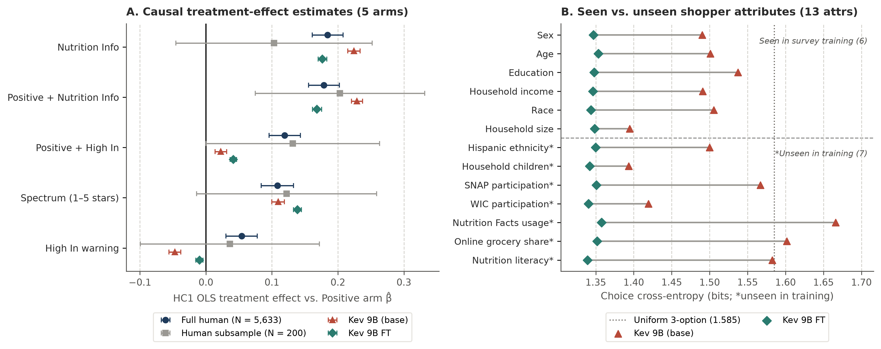
Figure 3. Causal treatment-effect recovery and shopper-attribute generalization on the nutrition labeling randomized trial
Note. Evaluation on the 200-shopper subsample (n = 1,200 choices) of Grummon et al. (2025). Panel A compares participant-level HC1 OLS treatment-effect estimates $\hat{β}$ and 95% confidence intervals across the 5 labeling arms (relative to Positive) under 13-attribute respondent personas against full-sample (N = 5,633) and subsample (N = 200) human benchmarks. Panel B compares single-attribute choice cross-entropy (in bits, relative to uniform guessing at $\log_{2}3=1.585$ bits) across 6 seen demographic attributes and 7 unseen shopper attributes.

7. Discussion and Conclusion
Aligning silicon sampling inside the model through distributional readouts and general survey training. Our findings show that the severe econometric biases documented in generative LLM silicon sampling (Goli and Singh 2024, Leng et al. 2026, Wang et al. 2026) are neither an inevitable limitation of foundation models nor solvable by scaling test-time reasoning or fine-tuning a text generator on a small task sample to emit single-letter choices (A, B, or C). Whereas prior marketing studies address this bias after inference by statistically correcting regression estimates (AAE; Wang et al. (2026)) or reweighting candidate outputs (HuMCal; Leng et al. (2026)) against human benchmarks, we show that human alignment can be achieved inside the model before inference when two conditions are met. First, architecturally, single-pass decision models replace single-letter text generation with a direct probability distribution over valid options, eliminating free-text parsing errors, Monte Carlo sampling variance, and safety-filter refusals—thereby retaining vaccine opt-out respondents that commercial generative LLMs drop or distort—while avoiding the more than twentyfold MSE penalty of choice discretization in Multinomial Logit estimation. Second, instead of fine-tuning on a small target-study sample, optimizing respondent-level cross-entropy across 1.88 million persona-linked general survey responses (US ISSP and Twin-2K-500) minimizes conditional Kullback-Leibler divergence $D_{KL}(P_{human}(Y_{q}∣s) ∥ P_{model}(Y_{q}∣s;θ))$ at unit temperature ($T=1.00$), learning generalizable conditional distributions across combinatorial multi-attribute personas and virtually eliminating the calibration gap between seen demographic attributes and unseen behavioral covariates on Kev 9B (FT).
Implications for zero-shot pre-testing ($m=0$) and future integration with post-hoc calibration ($m>0$). For empirical marketing researchers, distributional decision models expand the workflow of AI-assisted research prior to primary data collection ($m=0$), such as screening candidate product attributes before fielding a conjoint survey, pre-testing policy labels across demographic subpopulations, or auditing experimental instruments at minimal marginal compute (a single forward pass per choice task). At the same time, zero-shot silicon sampling complements rather than replaces human experimentation for high-stakes managerial or regulatory decisions, as even Kev 9B (FT) exhibits larger estimation error than a 200-participant human sample ($MSE=0.0267$ versus $0.0065$ in conjoint MNL; $0.0022$ versus $0.0016$ in trial OLS). When target-study human benchmarks are collected ($m>0$), our results motivate concrete directions for future research at the intersection of upstream decision-model training and downstream statistical calibration (Leng et al. 2026, Wang et al. 2026). In AI-augmented estimation (AAE; Wang et al. (2026)), asymptotic efficiency gains depend on the conditional informativeness of the auxiliary AI output for human choices given product features $x$ (their Proposition 2), rather than standalone marginal calibration alone, while finite-sample error depends on learning the first-stage mapping from $m$ primary observations (their Theorem 2). Investigating whether passing refusal-free, persona-conditioned probability vectors $p(x_{i,t},s_{i})$ from Kev 9B (FT) into AAE injects respondent-level variation beyond $x_{i,t}$ and simplifies first-stage link estimation at small $m$ is a promising next step. Similarly, in HuMCal (Leng et al. 2026), adding Kev 9B (FT) to a candidate checkpoint pool enlarges the simplex and weakly lowers in-sample calibration loss while escaping shared convex-hull inflation among off-the-shelf models, whereas replacing checkpoints guarantees non-increasing loss only under uniform dominance across all calibration items and mixtures (their Proposition A-7)—a condition violated when specific items attenuate or shift sign. Empirically characterizing the out-of-sample bias-variance trade-offs of combining respondent-aligned decision checkpoints with HuMCal and AAE remains an important open question.
Boundary conditions and methodological extensions. Our empirical evaluations also surface three clear boundary conditions that guide future model development. First, our nutrition labeling RCT analysis isolates a fundamental modality boundary of text-only silicon sampling: while Kev 9B (FT) accurately recovers causal treatment effects across all three symmetrical interpretive label arms (Nutrition Info, Positive + Nutrition Info, and Spectrum), it fails on the two asymmetric High In warning arms where graphical black exclamation-mark shields were serialized into asymmetric FDA.gov text strings. Extending respondent-level distributional training to multimodal vision-language decision heads that score visual package mockups, advertisements, and shelf displays directly is therefore an immediate priority. Second, because our training corpus (US ISSP and Twin-2K-500) centers on US social, political, and general behavioral attitudes rather than commercial or clinical product trade-offs, Kev 9B (FT) conservatively attenuates unfamiliar clinical risk-horizon attributes (Duration and rare Major side effects) toward zero, and intermediate scales (Kev 4B (FT)) can compress between-arm differences despite lowering individual choice cross-entropy. Incorporating historical commercial conjoint archives, scanner panels, and cross-national survey modules beyond the United States would broaden domain and cultural transfer. Third, both training and zero-shot inference condition only on observed persona covariates $s_{i}$, treating repeated choices per respondent as conditionally independent. Conditioning sequentially on prior observed choices—or coupling decision heads with hierarchical Bayes and mixed-logit random-coefficients models—could capture persistent unobserved taste heterogeneity in panel settings.
Conclusion. Accurate silicon sampling for econometric inference requires predicting calibrated conditional response distributions rather than generating deterministic text completions. By pairing single-pass decision heads with respondent-level cross-entropy training across 1.88 million public survey observations, distributional silicon sampling eliminates sampling variance and safety refusals, generalizes to novel respondent covariates, and substantially improves zero-shot parameter recovery in conjoint MNL and experimental OLS regressions. Open-weight, respondent-aligned decision models thus offer a practical and extensible foundation for behavioral simulation in marketing science.

Declarations

Funding and Competing Interests
All authors certify that they have no affiliations with or involvement in any organization or entity with any financial interest or non-financial interest in the subject matter or materials discussed in this manuscript. The authors have no funding to report.

References
Angelopoulos AN, Bates S, Fannjiang C, Jordan MI, Zrnic T (2023) Prediction-powered inference. Science 382(6671):669–674.
Argyle LP, Busby EC, Fulda N, Gubler JR, Rytting C, Wingate D (2023) Out of one, many: Using language models to simulate human samples. Political Analysis 31(3):337–351.
Asseri B, Asseri A (2026) Calibrated to whom? Persona and language effects on cultural values in JEV. arXiv preprint arXiv:2609.36399.
Bentegeac R, Le Guellec B, Kuchcinski G, Amouyel P, Hamroun A (2025) Token probabilities to mitigate large language models overconfidence in answering medical questions: Quantitative study. Journal of Medical Internet Research 27:e64348.
Brand J, Israeli A, Ngwe D (2023) Using LLMs for market research. Working Paper 23-062 (Harvard Business School).
Deas N, McKeown K (2025) Artificial impressions: Evaluating large language model behavior through the lens of trait impressions. Proceedings of the 2025 conference on Empirical Methods in Natural Language Processing, 19418–19444.
Deußer T, Sparrenberg L, Sifa R (2026) Evaluating and benchmarking the system one model Jev. arXiv preprint arXiv:2609.37647.
Durmus E, Nguyen K, Liao T, Schiefer N, Askell A, Bakhtin A, Chen C, et al. (2024) Towards measuring the representation of subjective global opinions in language models. First Conference on Language Modeling.
Gao T, Li J, Li Z, Chang Y, Wu Y (2026) More choices, fewer decisions: Ordinal-scale bias in JEV-like direct-decision models. arXiv preprint arXiv:2609.38827.
Geuter J, Cheng A, Alvarez-Melis D (2026) Releasing the inner Jev: A simple recipe for open decision models. arXiv preprint arXiv:2610.17205.
Goli A, Singh A (2024) Frontiers: Can large language models capture human preferences? Marketing Science 43(4):709–722.
Grummon AH, O’Sullivan K, Petimar J, Lee CJY, Zeitlin AB, Cleveland LP, Collis C, et al. (2025) Nutrition info and other front-of-package labels and simulated food and beverage purchases: A randomized clinical trial. JAMA Network Open 8(10):e2537389. https://doi.org/10.1001/jamanetworkopen.2025.37389.
Horton JJ, Filippas A, Manning BS (2023) Large language models as simulated economic agents: What can we learn from Homo Silicus? Working Paper 31122 (National Bureau of Economic Research).
Huang J, Li M, Shao S (2026) Distribution shift alignment helps LLMs simulate survey response distributions. Findings of the Association for Computational Linguistics: ACL 2026, 9395–9409.
Jung J, Lutz M, Sen I, Strohmaier M (2026) Do psychometric tests work for large language models? Evaluation of tests on sexism, racism, and morality. Proceedings of the 19th conference of the European Chapter of the Association for Computational Linguistics (volume 1: Long papers), 8143–8173.
Kabir M, Abrar A, Ananiadou S (2025) Break the checkbox: Challenging closed-style evaluations of cultural alignment in LLMs. Proceedings of the 2025 conference on Empirical Methods in Natural Language Processing, 24–51.
Kadavath S, Conerly T, Askell A, Henighan T, Drain D, Perez E, Schiefer N, et al. (2022) Language models (mostly) know what they know. arXiv preprint arXiv:2207.05221.
Koo R, Lee M, Raheja V, Park JI, Kim ZM, Kang D (2024) Benchmarking cognitive biases in large language models as evaluators. Findings of the Association for Computational Linguistics: ACL 2024, 517–545.
Kreps S, Prasad S, Brownstein JS, Hswen Y, Garibaldi BT, Zhang B, Kriner DL (2020) Factors associated with US adults’ likelihood of accepting COVID-19 vaccination. JAMA Network Open 3(10):e2025594.
Ku CT, Hsu C, Huang PC, Liu FC, Cheng IL, Kang Y (2026) Silicon sampling via cross-survey transfer. arXiv preprint arXiv:2607.03091.
Kuribayashi T, Oseki Y, Baldwin T (2024) Psychometric predictive power of large language models. Findings of the Association for Computational Linguistics: NAACL 2024, 1983–2005.
Leng Y, Sang Y, Agarwal A (2026) Reducing disparity between LLMs and humans: Optimal LLM sample calibration. Marketing Science. https://doi.org/10.1287/mksc.2024.0983.
Li H (2026) KITE: Scaling Jev population experiments with sparse flagship calibration. arXiv preprint arXiv:2609.27535.
Li Y, Wagle J (2026) LLM-as-Jev: LLMs are already Jev-style decision models – when and how to fine-tune them. arXiv preprint arXiv:2610.02076.
Palmer J (2026) Kev: Small Jev-like decision models. https://github.com/jaredpalmer/kev.
Santurkar S, Durmus E, Ladhak F, Lee C, Liang P, Hashimoto T (2023) Whose opinions do language models reflect? Proceedings of the 40th International Conference on Machine Learning, 29971–30004.
Sarstedt M, Adler SJ, Rau L, Schmitt B (2024) Using large language models to generate silicon samples in consumer and marketing research: Challenges, opportunities, and guidelines. Psychology & Marketing 41(6):1254–1270.
Shu B, Zhang L, Choi M, Dunagan L, Logeswaran L, Lee M, Card D, Jurgens D (2024) You don’t need a personality test to know these models are unreliable: Assessing the reliability of large language models on psychometric instruments. Proceedings of the 2024 conference of the North American Chapter of the Association for Computational Linguistics: Human Language Technologies (volume 1: Long papers), 5263–5281.
Suh J, Jahanparast E, Moon S, Kang M, Chang S (2025) Language model fine-tuning on scaled survey data for predicting distributions of public opinions. Proceedings of the 63rd annual meeting of the Association for Computational Linguistics (volume 1: Long papers), 21147–21170.
Toubia O, Gui GZ, Peng T, Merlau DJ, Li A, Chen H (2025) Database report: Twin-2K-500: A data set for building digital twins of over 2,000 people based on their answers to over 500 questions. Marketing Science 44(6):1446–1455.
Wadi D, Fredette M (2025) A Monte-Carlo sampling framework for reliable evaluation of large language models using behavioral analysis. Findings of the Association for Computational Linguistics: EMNLP 2025, 9414–9432.
Wadi D, Ghodrat M, Philp M (2026) Every token counts: Exact Likert-scale distributions for measuring LLM attitudes and biases. arXiv preprint arXiv:2608.10503.
Wang M, Zhang DJ, Zhang H (2026) Large language models for market research: A data-augmentation approach. Marketing Science 45(4):728–751. https://doi.org/10.1287/mksc.2025.0009.
Zahradnickova K, Polisensky J, Lukeš M, Hranický R, Pouč P (2026) Which AI? A comparative evaluation of generative AI and neuro-symbolic AI for silicon sampling. Psychology & Marketing. https://doi.org/10.1002/mar.70272.

Web Appendix
Table W1. Summary of the 10 US waves of the International Social Survey Programme (2015 to 2024)
Wave | Thematic module | Questions | Likert (score) | Categorical (choice) | Respondents | Mean Qs / respondent | Responses
2015 | Work orientations IV | 82 | 68 | 14 | 1,474 | 49.1 | 72,416
2016 | Role of government V | 60 | 52 | 8 | 1,384 | 58.6 | 81,043
2017 | Social networks and social resources | 60 | 32 | 28 | 1,173 | 59.2 | 69,500
2018 | Religion IV | 62 | 50 | 12 | 1,175 | 60.2 | 70,719
2019 | Social inequality V | 49 | 44 | 5 | 1,852 | 45.9 | 84,963
2020 | Environment IV | 55 | 45 | 10 | 1,847 | 52.3 | 96,598
2021 | Health and health care II | 58 | 50 | 8 | 1,146 | 54.8 | 62,793
2022 | Family and changing gender roles V | 55 | 32 | 23 | 1,126 | 45.6 | 51,303
2023 | National identity and citizenship | 60 | 56 | 4 | 1,589 | 56.3 | 89,391
2024 | Digital societies | 75 | 45 | 30 | 1,590 | 55.8 | 88,758
Total | All 10 US waves (2015 to 2024) | 616 | 474 | 142 | 14,356 | 53.5 | 767,484

Note. Counts combine training and held-out validation items extracted from the US subsample of each annual ISSP thematic module. Four ordinal Likert (score) items from the 2020 Environment IV wave (7,011 responses across 1,827 respondents) are held out for validation; all remaining 612 items (760,473 responses) enter training.
Table W2. Harmonized respondent persona attributes across training and evaluation datasets
Prompt attribute | Harmonized levels | Datasets
Sex | 3 (Male, Female, Non-binary) | ISSP, Twin-2K, Conjoint, Nutrition RCT
Age | 4 (18-29, 30-49, 50-64, 65+) | ISSP, Twin-2K, Conjoint, Nutrition RCT
Education | 4 (Less than high school, High school or some college, Associate’s degree, College graduate/some postgrad) | ISSP, Twin-2K, Conjoint, Nutrition RCT
Religion | 12 (Protestant, Catholic, Orthodox, …, Other) | ISSP, Twin-2K, Conjoint
Attendance of religious services | 6 (More than once a week, Once a week, Once or twice a month, A few times a year, Seldom, Never) | ISSP, Twin-2K
Political ideology | 8 (Very liberal, Liberal, Somewhat liberal, …, Other) | ISSP, Twin-2K, Conjoint
Voted in the last general election | 2 (Yes, No) | ISSP
Place of living | 5 (A big city, The suburbs or outskirts of a big city, A town or a small city, A country village, A farm or home in the country) | ISSP
Marital status | 6 (Married, Living with a partner, Divorced, Separated, Widowed, Never been married) | ISSP, Twin-2K
Main activity | 10 (Full-time employment, Part-time employment, Self-employed, …, Other) | ISSP, Twin-2K
Trade union membership | 2 (Yes, No) | ISSP
Political party | 5 (Democrat, Republican, Independent, Something else, Other candidate) | ISSP, Twin-2K, Conjoint
Income | 15 (Less than $30,000, $30,000 - $50,000, $50,000 - $75,000, …, $35,000 - $49,999) | ISSP, Twin-2K, Conjoint, Nutrition RCT
Region | 4 (Northeast, Midwest, South, West) | ISSP, Twin-2K, Conjoint
Ancestry | 96 (Algeria, American Indian, American only, …, Yugoslavia) | ISSP
Race | 5 (White, Black, Asian, Hispanic, Other) | Twin-2K, Conjoint, Nutrition RCT
How many people, including yourself, live in your household? | 5 (1, 2, 3, 4, More than 4) | Twin-2K, Nutrition RCT
Hispanic or Latino | 2 (No, Yes) | Nutrition RCT
How many children (ages 0-18) currently live in your household? | 4 (0, 1, 2, 3 or more) | Nutrition RCT
SNAP / Food Stamps recipient | 3 (Don’t know, No, Yes) | Nutrition RCT
Do you or anyone else in your household currently receive WIC benefits? | 3 (Don’t know, No, Yes) | Nutrition RCT
Nutrition Facts label usage | 5 (Always, Most of the time, Never, Rarely, Sometimes) | Nutrition RCT
Share of groceries bought online | 4 (25-49%, 50-74%, 75% or more, Less than 25%) | Nutrition RCT
Nutrition literacy score | 5 (0 out of 4, 1 out of 4, 2 out of 4, 3 out of 4, 4 out of 4) | Nutrition RCT

Note. Attribute levels show the harmonized natural-language categories rendered in each respondent’s persona state $s_{i}$ (abbreviated with ellipses where category lists exceed six values). The bottom seven attributes appear exclusively in the held-out nutrition labeling randomized clinical trial (Grummon et al. 2025) and are never observed during survey training.
Table W3. Estimated multinomial logit part-worth coefficients on the COVID-19 vaccine conjoint benchmark
Vaccine attribute level | Full human (N = 9,855) | Human subsample (n = 1,000) | Kev 9B (FT) | Kev 9B (base) | Gemini 3.5 Flash-Lite (high) | Gemini 3.5 Flash-Lite (minimal) | Gemini 4 Argon (high) | Gemini 4 Argon (low)
Efficacy: 70% (vs. 50%) | +0.361 (0.035) | +0.280 (0.112) | +0.217 (0.113) | +0.565 (0.115) | +1.344 (0.158) | +0.688 (0.135) | +1.940 (0.176) | +1.671 (0.163)
Efficacy: 90% (vs. 50%) | +0.746 (0.035) | +0.679 (0.110) | +0.562 (0.111) | +1.074 (0.116) | +2.764 (0.188) | +1.846 (0.145) | +3.538 (0.218) | +3.148 (0.196)
Duration: 5 years (vs. 1 year) | +0.261 (0.029) | +0.277 (0.092) | +0.035 (0.093) | +0.105 (0.095) | +0.940 (0.131) | +0.592 (0.114) | +0.948 (0.140) | +0.830 (0.133)
Major side effects: 1 in 1,000,000 (vs. 1 in 10,000) | +0.304 (0.029) | +0.389 (0.091) | +0.043 (0.092) | +0.152 (0.093) | +2.353 (0.154) | +1.103 (0.114) | +1.647 (0.146) | +1.634 (0.140)
Minor side effects: 1 in 30 (vs. 1 in 10) | +0.076 (0.029) | +0.085 (0.090) | -0.043 (0.092) | +0.024 (0.093) | +0.341 (0.124) | +0.051 (0.109) | +0.282 (0.128) | +0.389 (0.124)
FDA: Emergency Use Authorization (vs. Full approval) | -0.115 (0.029) | -0.113 (0.092) | -0.123 (0.093) | -0.068 (0.095) | -1.089 (0.136) | -0.978 (0.115) | -1.223 (0.141) | -1.329 (0.137)
Origin: United Kingdom (vs. United States) | -0.140 (0.035) | -0.026 (0.109) | -0.192 (0.110) | -0.173 (0.113) | -0.234 (0.151) | -0.402 (0.127) | -0.527 (0.157) | -0.710 (0.151)
Origin: China (vs. United States) | -0.570 (0.036) | -0.425 (0.113) | -0.553 (0.114) | -0.624 (0.118) | -1.908 (0.179) | -2.449 (0.164) | -3.556 (0.227) | -3.341 (0.210)
Endorsed: Joe Biden (vs. Donald Trump) | +0.095 (0.040) | +0.100 (0.123) | +0.135 (0.126) | +0.441 (0.128) | +0.600 (0.171) | +0.325 (0.148) | +0.531 (0.178) | +0.385 (0.170)
Endorsed: US CDC (vs. Donald Trump) | +0.416 (0.039) | +0.287 (0.123) | +0.621 (0.124) | +1.017 (0.127) | +1.045 (0.172) | +0.635 (0.148) | +1.175 (0.179) | +0.784 (0.169)
Endorsed: WHO (vs. Donald Trump) | +0.273 (0.040) | +0.327 (0.124) | +0.516 (0.126) | +0.730 (0.129) | +0.166 (0.173) | +0.334 (0.152) | +0.699 (0.181) | +0.411 (0.173)

Note. Point estimates and asymptotic standard errors (in parentheses) across the 11 binary vaccine attribute indicators on the 200-respondent subsample (n = 1,000 choice sets) under respondent-persona conditioning, alongside full-sample human estimates (N = 1,971 respondents, 9,855 choice sets; Kreps et al. (2020); Wang et al. (2026)). Respondent personas comprise 9 demographic and political attributes (generative LLM prompts additionally state country). Kev rows use the question wording, option labels, and attribute descriptions of the original survey instrument (Kreps et al. 2020); the generative LLMs are prompted with the Wang et al. (2026) wording.
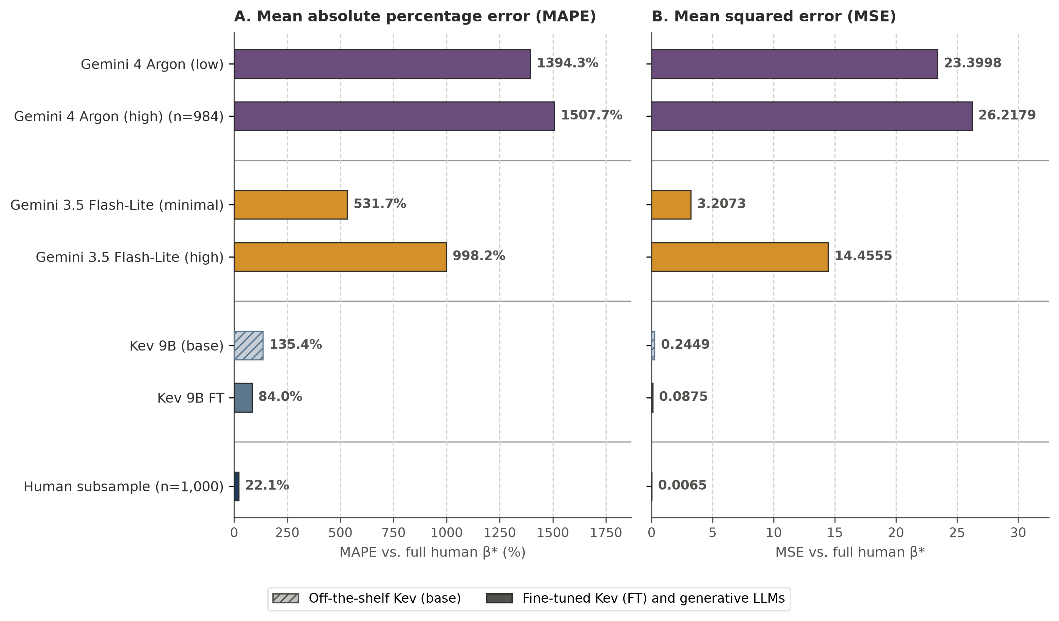
Figure W1. Multinomial logit part-worth estimation error under unconditioned random-persona prompts
Note. Panel A reports Mean Absolute Percentage Error (MAPE) and Panel B reports Mean Squared Error (MSE) across the $d=11$ vaccine attribute levels on the 200-respondent COVID-19 conjoint subsample (n = 1,000 choice sets; n = 984 for Gemini 4 Argon (high) after 16 neutrality refusals) relative to full-sample human $β^{*}$ (N = 9,855; Kreps et al. (2020); Wang et al. (2026)).
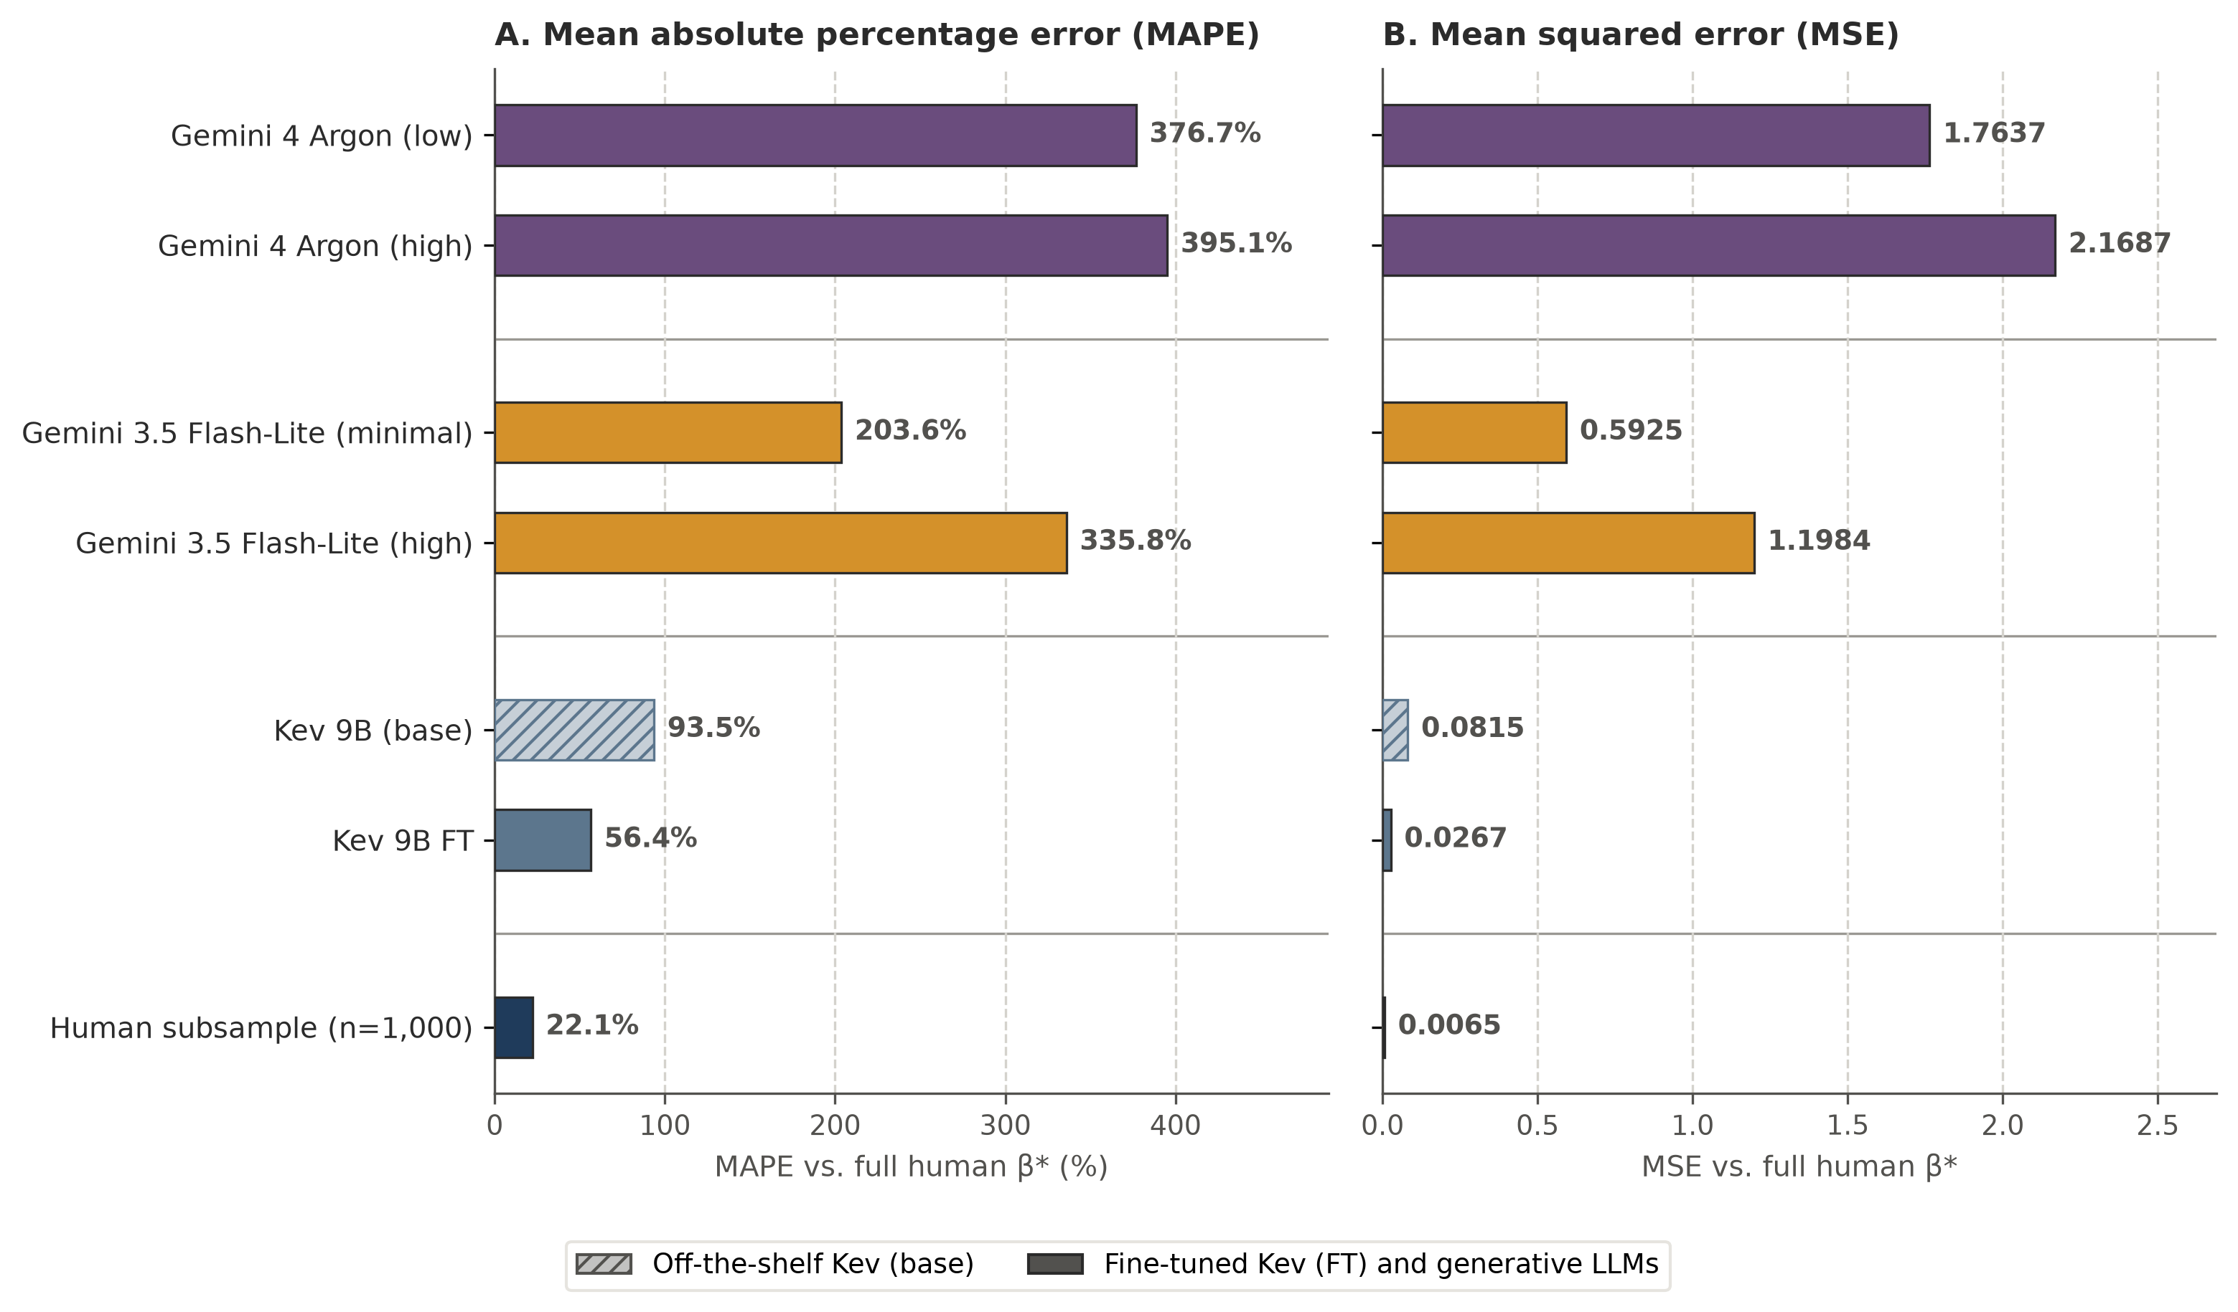
Figure W2. Multinomial logit part-worth estimation error under respondent-persona conditioning
Note. Panel A reports Mean Absolute Percentage Error (MAPE) and Panel B reports Mean Squared Error (MSE) across the $d=11$ vaccine attribute levels on the 200-respondent COVID-19 conjoint subsample (n = 1,000 choice sets) under 9-attribute respondent personas (generative LLM prompts additionally state country) relative to full-sample human $β^{*}$ (N = 9,855; Kreps et al. (2020); Wang et al. (2026)).
Table W4. Participant-level OLS treatment-effect estimates on the nutrition labeling randomized trial
Trial arm (vs. Positive) | Full human (N = 5,633) | Human subsample (N = 200) | Kev 0.8B (base) | Kev 0.8B (FT) | Kev 4B (base) | Kev 4B (FT) | Kev 9B (base) | Kev 9B (FT)
Nutrition Info label (vs. Positive) | +0.184 (0.012) | +0.103 (0.076) | +0.076 (0.002) | +0.116 (0.003) | +0.124 (0.003) | +0.065 (0.004) | +0.224 (0.005) | +0.177 (0.003)
Positive + Nutrition Info (vs. Positive) | +0.179 (0.012) | +0.203 (0.066) | +0.094 (0.002) | +0.105 (0.003) | +0.146 (0.003) | +0.069 (0.004) | +0.229 (0.004) | +0.168 (0.004)
Positive + High In (vs. Positive) | +0.119 (0.012) | +0.132 (0.067) | +0.011 (0.002) | -0.038 (0.003) | +0.000 (0.003) | -0.002 (0.004) | +0.023 (0.005) | +0.042 (0.003)
Spectrum 1-to-5 star label (vs. Positive) | +0.108 (0.012) | +0.122 (0.070) | +0.032 (0.003) | +0.057 (0.003) | +0.038 (0.003) | +0.057 (0.004) | +0.109 (0.005) | +0.139 (0.003)
High In warning label (vs. Positive) | +0.054 (0.012) | +0.036 (0.069) | +0.067 (0.002) | +0.014 (0.003) | -0.088 (0.003) | -0.022 (0.004) | -0.047 (0.005) | -0.010 (0.003)

Note. Ordinary least squares (OLS) point estimates and HC1 heteroskedasticity-robust standard errors (in parentheses) for the 5 front-of-package labeling arms relative to the Positive reference arm under respondent-persona conditioning (N = 200 shoppers, n = 1,200 choices), alongside full-sample human estimates (N = 5,633 shoppers, 33,798 choices; Grummon et al. (2025)). Kev rows use prompts built from the audited survey items with 13-attribute respondent personas.
Table W5. Single-attribute choice cross-entropy across seen and unseen shopper covariates
Attribute group | Shopper attribute | Kev 0.8B (base) | Kev 0.8B (FT) | Kev 4B (base) | Kev 4B (FT) | Kev 9B (base) | Kev 9B (FT)
Seen in training | Sex | 1.5253 | 1.5472 | 1.3948 | 1.4341 | 1.4902 | 1.3468
Seen in training | Age | 1.4806 | 1.5426 | 1.3974 | 1.4366 | 1.5011 | 1.3532
Seen in training | Education | 1.5152 | 1.5475 | 1.3897 | 1.4267 | 1.5375 | 1.3478
Seen in training | Income | 1.4764 | 1.5214 | 1.4416 | 1.4362 | 1.4908 | 1.3462
Seen in training | Race | 1.4746 | 1.5389 | 1.4243 | 1.4258 | 1.5054 | 1.3437
Seen in training | How many people, including yourself, live in your household? | 1.5395 | 1.5477 | 1.5033 | 1.4343 | 1.3946 | 1.3486
Seen mean | — | 1.5019 (6) | 1.5409 (6) | 1.4252 (6) | 1.4323 (6) | 1.4866 (6) | 1.3477 (6)
Unseen in training | Hispanic or Latino | 1.5420 | 1.5527 | 1.3834 | 1.4314 | 1.5001 | 1.3497
Unseen in training | How many children (ages 0-18) currently live in your household? | 1.5658 | 1.5499 | 1.5430 | 1.4370 | 1.3935 | 1.3420
Unseen in training | SNAP / Food Stamps recipient | 1.5709 | 1.5419 | 1.4581 | 1.4295 | 1.5669 | 1.3507
Unseen in training | Do you or anyone else in your household currently receive WIC benefits? | 1.4839 | 1.5286 | 1.5181 | 1.4360 | 1.4193 | 1.3404
Unseen in training | Nutrition Facts label usage | 1.4756 | 1.5366 | 1.4982 | 1.4372 | 1.6661 | 1.3576
Unseen in training | Share of groceries bought online | 1.4754 | 1.5311 | 1.4355 | 1.4494 | 1.6016 | 1.3518
Unseen in training | Nutrition literacy score | 1.4679 | 1.5418 | 1.4095 | 1.4387 | 1.5824 | 1.3391
Unseen mean | — | 1.5117 (7) | 1.5404 (7) | 1.4637 (7) | 1.4370 (7) | 1.5328 (7) | 1.3473 (7)

Note. Three-option choice cross-entropy (in bits; uniform baseline $\log_{2}3=1.5850$ bits) on the evaluation subsample (N = 200 shoppers, n = 1,200 choices) of Grummon et al. (2025) when conditioning each model on a single shopper attribute at a time, grouped into demographic covariates present in the survey training corpus and food-shopping and nutrition covariates unseen during training. Kev runs cover 6 seen and 7 unseen attributes. Group means average over the attributes in each group (count in parentheses).
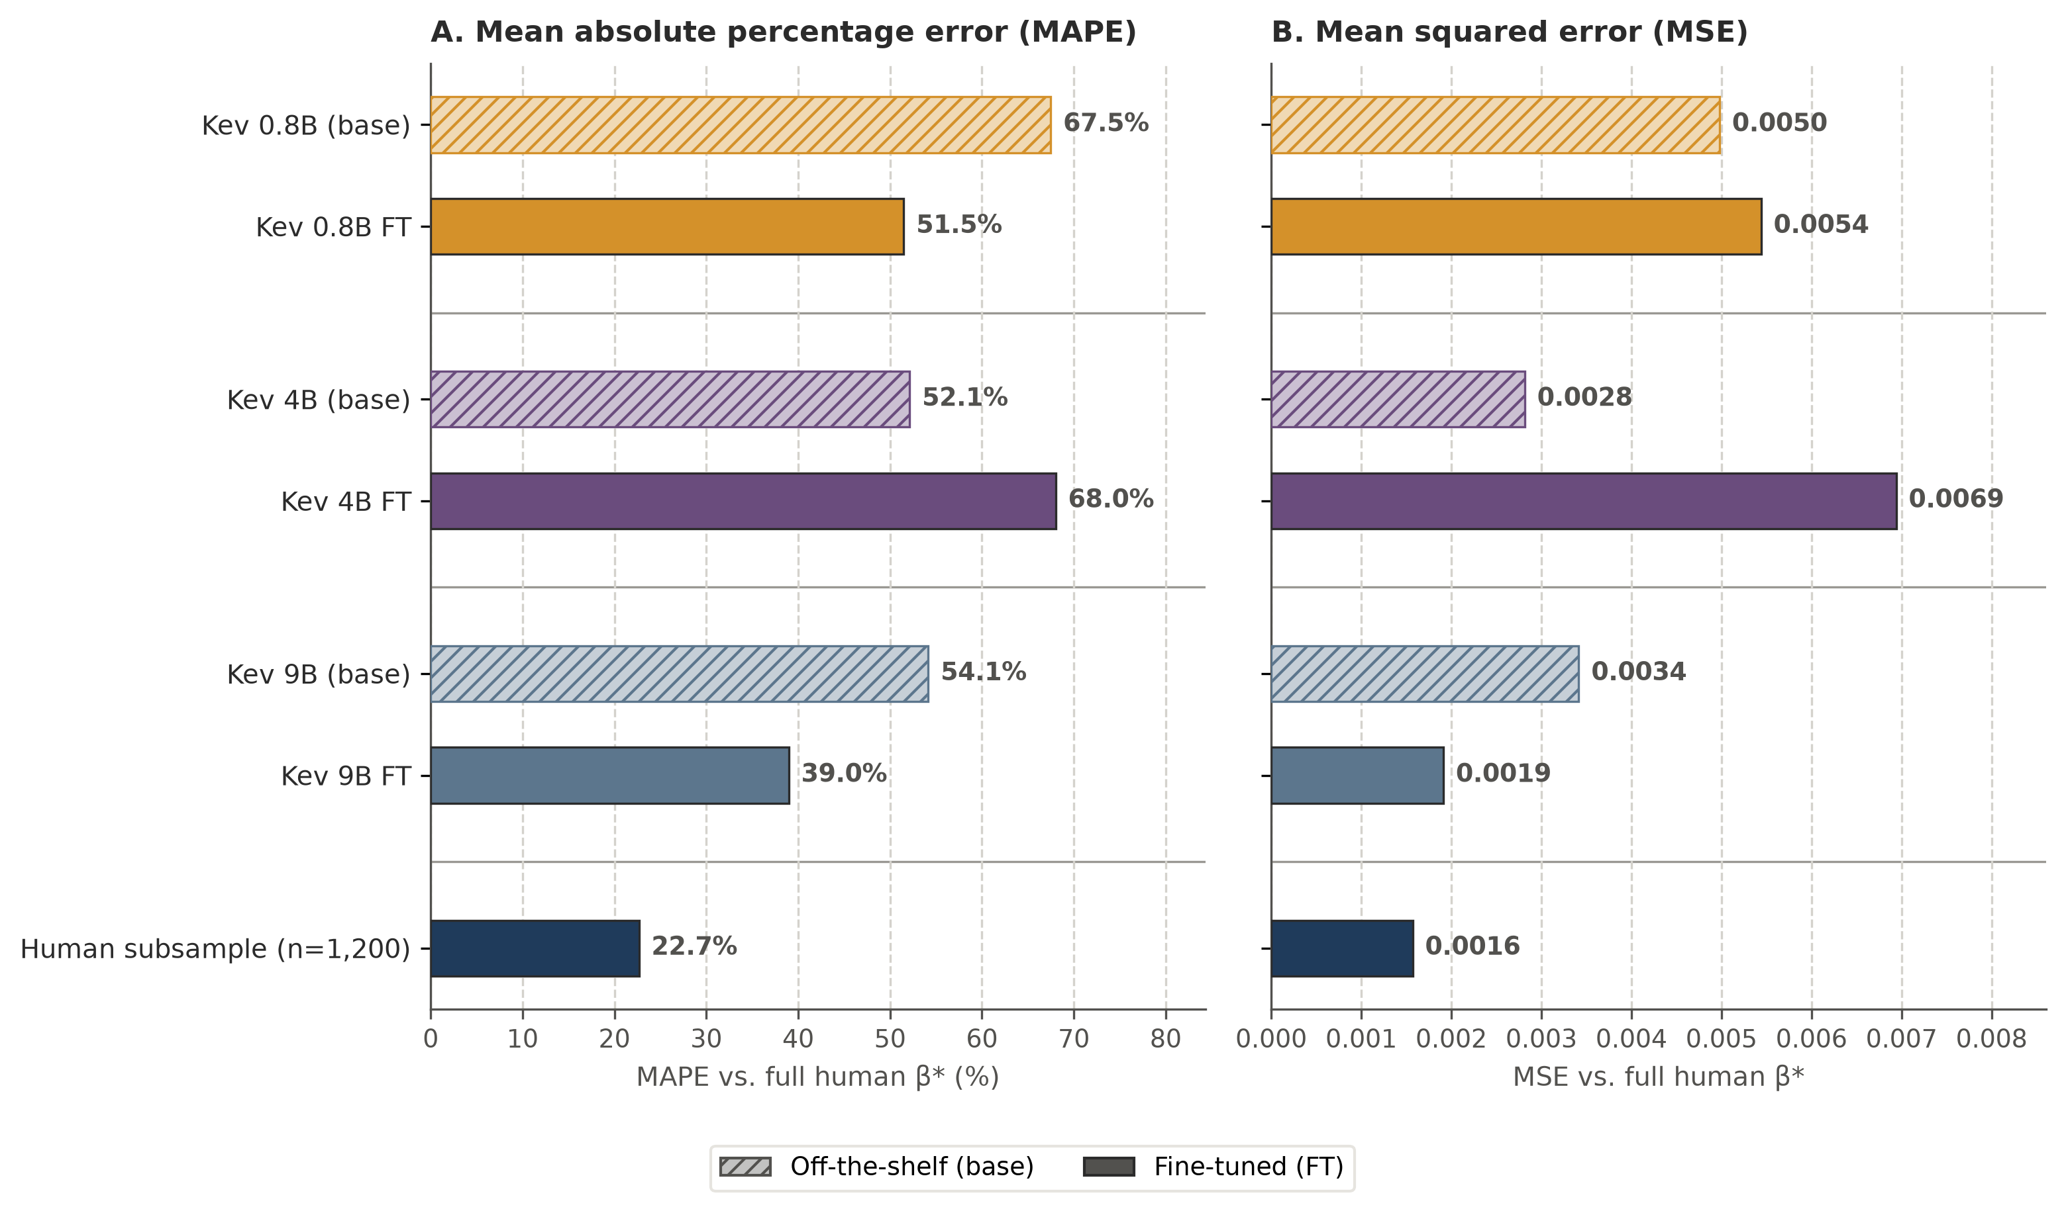
Figure W3. OLS treatment-effect estimation error on the nutrition labeling trial under random-persona prompts
Note. Panel A reports Mean Absolute Percentage Error (MAPE) and Panel B reports Mean Squared Error (MSE) for participant-level HC1 OLS treatment effects across the $d=5$ front-of-package labeling arms (relative to Positive) under unconditioned random-persona prompts (N = 200 shoppers, n = 1,200 choices) relative to full-sample human $β^{*}$ (N = 5,633; Grummon et al. (2025)).
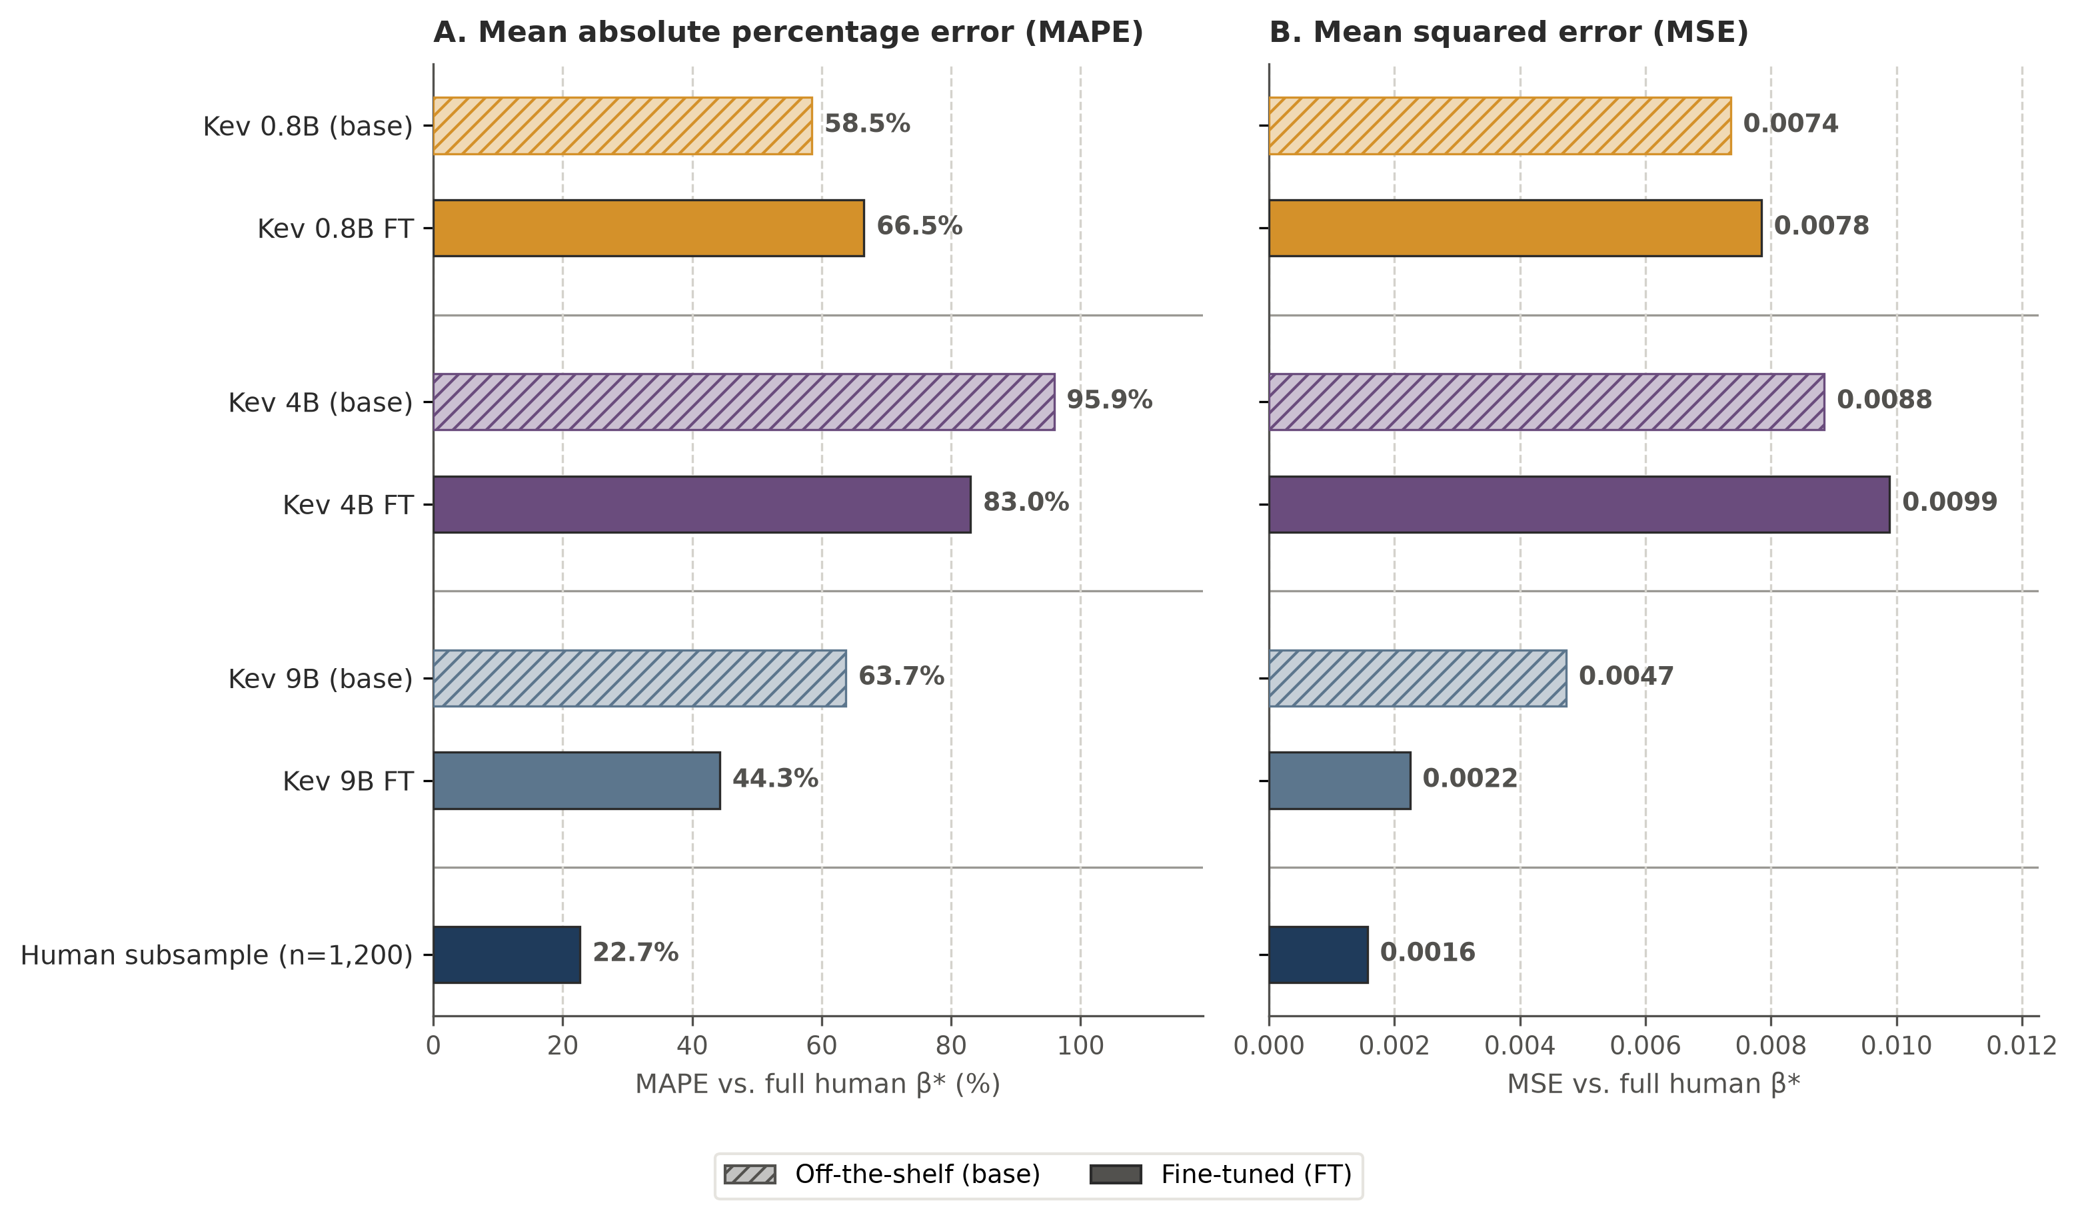
Figure W4. OLS treatment-effect estimation error on the nutrition labeling trial under respondent-persona conditioning
Note. Panel A reports Mean Absolute Percentage Error (MAPE) and Panel B reports Mean Squared Error (MSE) for participant-level HC1 OLS treatment effects across the $d=5$ front-of-package labeling arms (relative to Positive) under 13-attribute respondent personas (N = 200 shoppers, n = 1,200 choices) relative to full-sample human $β^{*}$ (N = 5,633; Grummon et al. (2025)).

