Spectrogram Computation

The Torchaudio spectrogram uses an STFT with a 1024-point FFT, Hann window, 87.5% overlap, and power scaling, while the MNE version employs Morlet wavelets with frequency-dependent cycles

Torchaudio Spectrogram Configuration
The spectrogram is computed using torchaudio.transforms.Spectrogram with:
Hann window (window_fn=torch.hann_window)
Centered frames (center=True)
Reflection padding (pad_mode='reflect')
One-sided spectrum (onesided=True)
No normalization (normalized=False)

Spectrogram Parameters
- FFT and Window Settings:
  - N_FFT = 1024: Number of FFT points (larger for better frequency resolution)
  - WIN_LENGTH = 512: Window length in samples
  - HOP_LENGTH = 64: Hop size between consecutive windows (87.5% overlap)
  - Resulting overlap: 87.5% (calculated as (1 - HOP_LENGTH/WIN_LENGTH)*100)
- Power and Scaling:
  - POWER = 2.0: Computes power spectrogram (magnitude squared)
  - Conversion to dB scale: 10 * log10(spec + 1e-10)
- Visualization Parameters:
  - CMAP = 'viridis': Colormap for spectrogram visualization

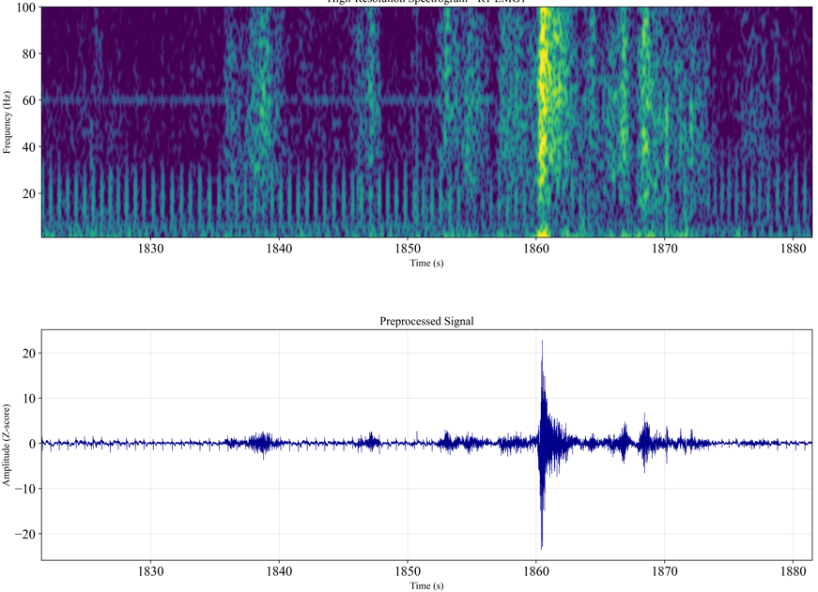

MNE Spectrogram Configuration
n_cycles = freqs / 2.0: Uses wavelet cycles that scale with frequency (more cycles for higher frequencies)
Computes time-frequency decomposition using Morlet wavelets
Uses Morlet wavelet transform (mne.time_frequency.tfr_morlet)
n_cycles = freqs / 2.0: The number of wavelet cycles scales linearly with frequency
Colormap: 'viridis'

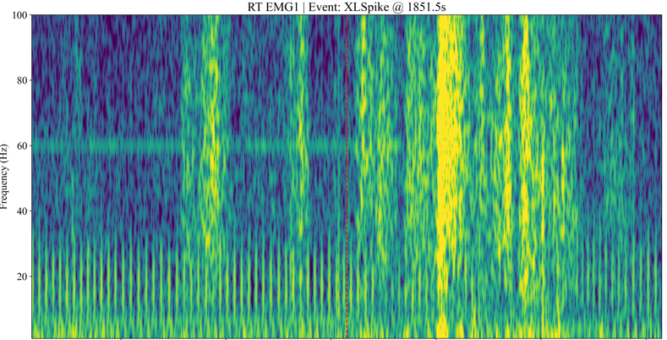

Comparison to FFT Approach

Characteristic | MNE Wavelet Version | Torchaudio FFT Version
Transform Type | Morlet Wavelet | Short-Time Fourier Transform (STFT)
Resolution Control | Cycles per frequency | Fixed N_FFT/Win_length
Frequency Resolution | Better at low frequencies | Uniform across spectrum
Time Resolution | Better at high frequencies | Uniform across spectrum
Window Function | Implicit Morlet wavelet | Explicit Hann window
Overlap | N/A (continuous) | 87.5% (HOP_LENGTH=64)

