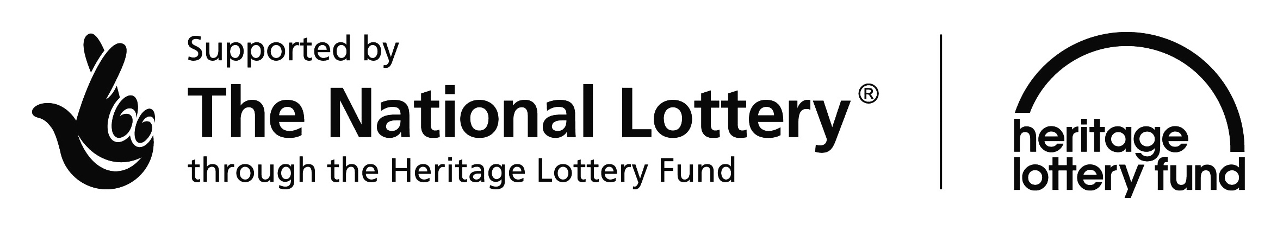[](https://www.google.co.uk/url?q=http://www.lico-project.eu/es/content/partners-0&sa=U&ei=NoopU4ijO8WM4ASbhoGoDA&ved=0CDUQ9QEwBA&usg=AFQjCNFp6OMSwKpdC-zQ-nWCwKZUPMyNqQ)The Common Story

Volunteer Interest Form

Name:

Email:

Phone:­­­­­­­­

Areas of Interest:

Time you could commit to the Project: (a rough estimate will be fine)

(please circle)

0-5 hours a month 6-10 hours a month 11 – 20 hours a month 20+ hours a month Unsure

Would you be interested in training?

(please circle)

Yes No

If so what areas?

If you have any relevant historical/archaeological/biological qualifications please state here:

Any other Comments:

Please add any other help you could offer, such as photographs, wartime memories or information about the Common

Please email back to [hpemberton@wandsworth.gov.uk](mailto:hpemberton@wandsworth.gov.uk) Thank You!