Notes:

**Metadata excel file:**

<https://data.mendeley.com/datasets/zr7vgbcyr2/1>

Skin lesions diagnostic -  Basal Cell Carcinoma (BCC), Squamous Cell Carcinoma (SCC), Actinic Keratosis (ACK), Seborrheic Keratosis (SEK), Bowen’s disease (BOD), Melanoma (MEL), and Nevus (NEV)

All BCC, SCC, and MEL are biopsy-proven

58% of the samples in this dataset are biopsy-proven

The images present in the dataset have different sizes because they are collected using different smartphone devices.

26 features

1,373 patients, 1,641 skin lesions, and 2,298 images present in the dataset

1. Preprocessing: Since skin lesions can have varying color and texture, preprocessing the images can help enhance the features that can aid in segmentation. Common preprocessing techniques include smoothing, color normalization, and contrast enhancement.

2. Thresholding: A simple thresholding technique is to select a threshold value based on the color intensity of the skin lesion. For example, if the skin lesion is darker than the surrounding skin, you can select a threshold value such that all pixels below this value are considered part of the lesion.

3. Region growing: Region growing is a technique that starts with a seed point and grows the region by adding neighboring pixels that satisfy certain criteria. For skin lesion segmentation, you can use color and texture similarity as the criteria for region growing.

<https://ietresearch.onlinelibrary.wiley.com/doi/10.1049/iet-ipr.2015.0385>

**Asymmetry**:

**Border**:

The lesion is divided into eight octants (slices). For each slice, an irregular periphery receives a score of one, it is scored zero if it is regular. Therefore, the highest border score is eight, and the minimum score is zero.

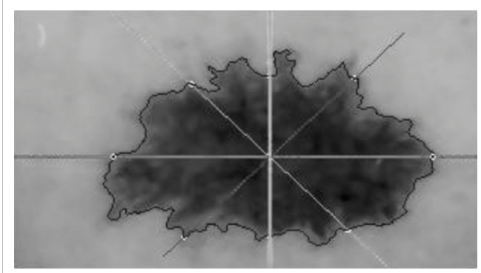

**Color**: presence of 6 colors

