2d shooter

2d shooter is a game where you play as a spacecraft lost in space battling enemies. The story behind it is unknown so you’ll have to use your imagination as to why our spaceship is lost in space

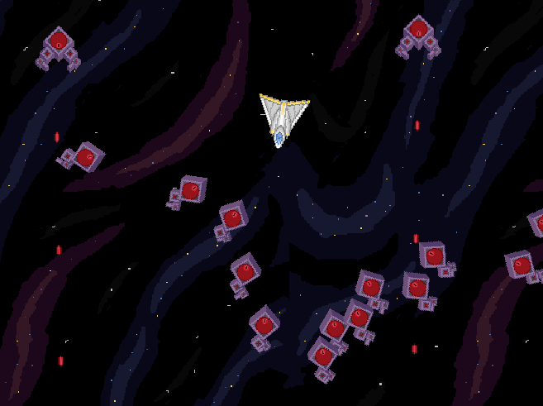Personal touch

My personal touch to the game was an infinity-level, which I tried to make as hectic as possible as that’s what these kinds of games made in more recent times capitalize on, hectic simplicity. Your only objective here is to survive as long as you can while beating your previous scores. I can’t say I’m super happy with the result, but it is what it is

Controls

The controls in the game are for movement and firing, and they’re w,a,s,d and “point and click”, respectively.

What I’d do different or improve

To make the game more interesting I would have made some kind of story as to why you are battling aliens in space. The story could be told through cutscenes between levels, through dialogue and through having objectives that would flesh out the story. Another couple thing I would improve is the level-design and the diversity of enemies