ScanMar_logger.py

V 10.02 Nov 2017

Dave Senciall, DFO NL region

Quick Guide:

A display and logging tool for the Scan(Mar)Bas net monitoring system:

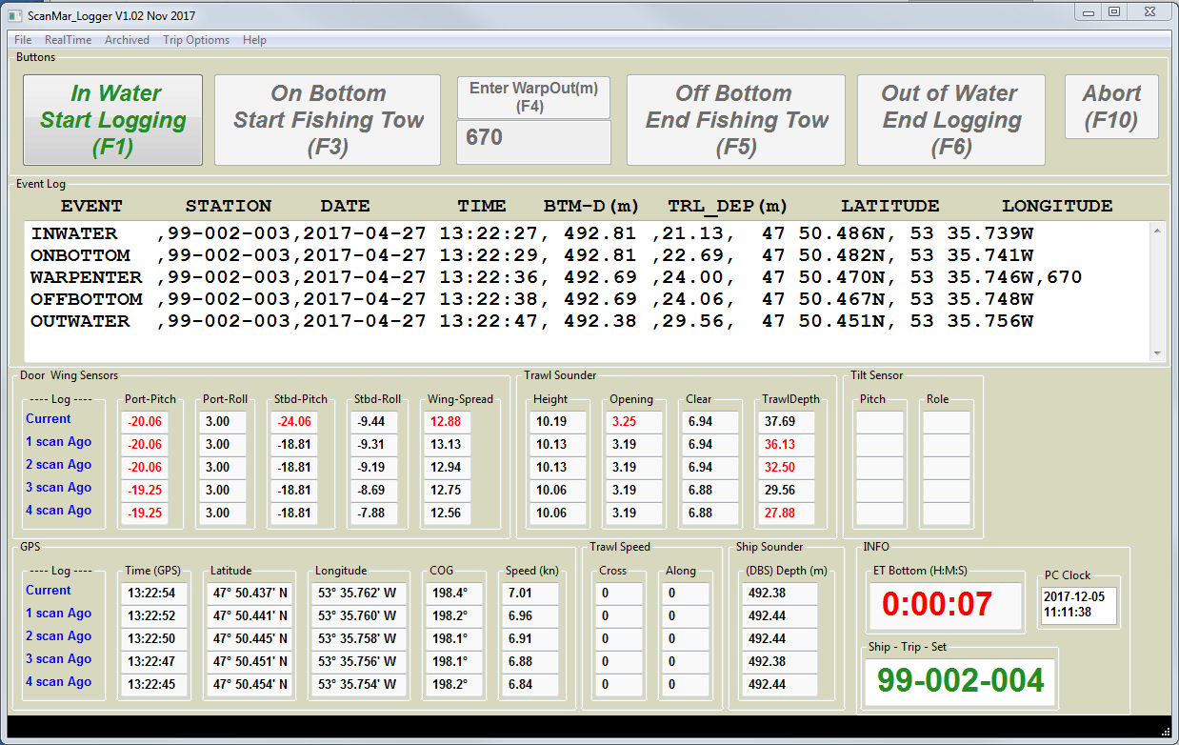

Basics of operation:

Data feed from ScanBas unit is read via serial port and displayed, as well as logging the raw nmea strings to file (xx.raw).

Decoded data is also logged to as CVS and JSON format files.

‘Events’ are logged to xxxx.log file

Data is stored by default in the directory C:\ScanMar_data

A csv, raw (and JSON) file is created for each fishing set. Named as : ahip-trip-set.csv ,. raw ,. json

A .log file is created for each mission. Named as : ship-trip.log

Startup :

Start the program via the short cut ScanMar_logger

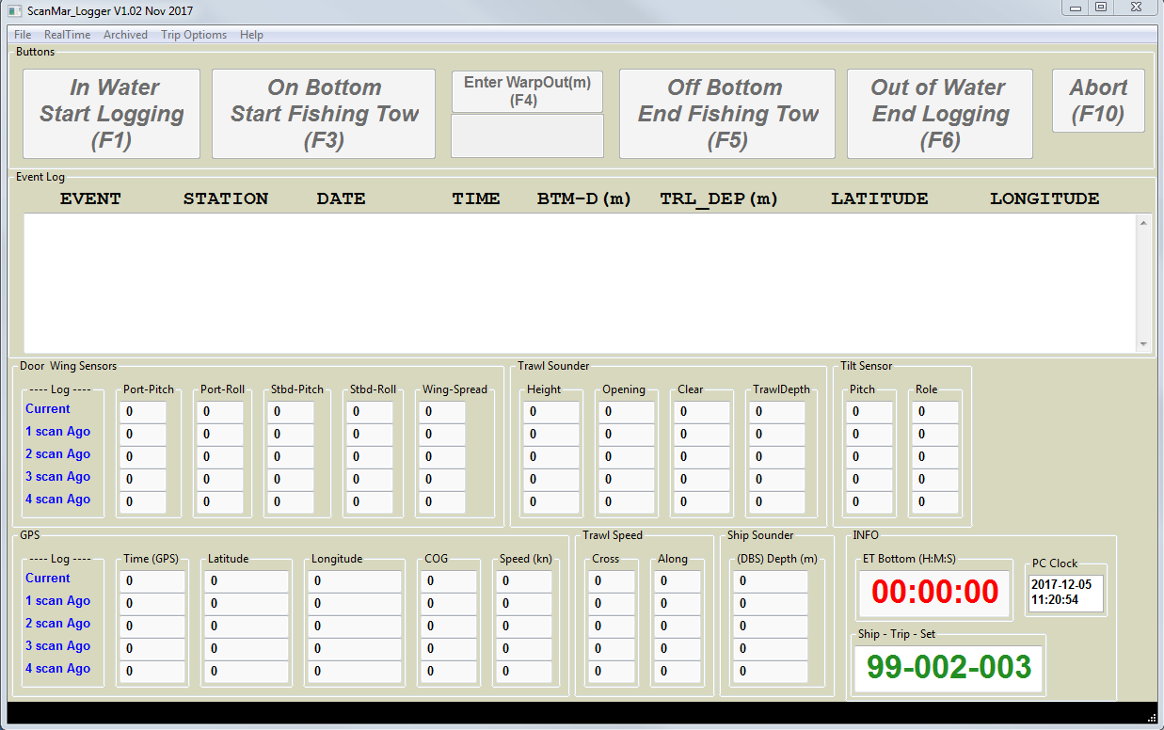

If the serial port needs configuring use the dialogue under File-> Serial Config : this should only be required for a new setup since the program remembers its configuration between sessions.

To set the Ship and mission go to Trip Options -> Set Ship trip set

This should be done at the beginning of a mission, it can also be used to over-ride the current settings and any point during a mission.

Once the mission has been setup ( and serial parameters if needed ) monitoring of the data feed can be initiated via the RealTime->Start . (please ensure Scanmar system is running first). Note that a pop up will present that informs you to wait until data is displayed before imitating logging. (If you attempt to log data to quick, the stream isn’t stable and things can go funny)

You will now notice that the First button is now GREEN (In Water Start Logging (F1) once this is selected, (either by mouse or function key) data logging for this set will begin, and the next button On Bottom Start Fishing Tow ((F3) will turn GREEN), this should be pressed at the start of the fishing component on the tow ( generally on bottom )

You now can enter WARP OUT… ( not that WARP out can be enter multiple times if corrected or adjustments are required ) ensure you press <ENTER> after typing the warp out number (in meters)

When the net lifts of bottom select the OFF BOTTOM END Fishing Tow (f%) button,, and then when at surface the Out of Water END Logging ( F6) button. At which point data logging will stop, and the system will set up for the next tow, auto incrementing the set number. An information box will display indicating it is ready for next tow and what the number will be.

If at any point a tow needs to be aborted, press the ABORT (F10) button. This will reset the system for a new TOW using the current tow number… ( note that any data logged, WILL NOT be erased, rather the repeat tow will be appended to the original files)

Scrolling Screen display:

The scrolling display presents the latest sensors values in the top row,, previous values scroll down the display. Values in RED are true sensors measurements, while values in BLACK are interpolated values generated by the scanmar system to fill in sensors data gaps.