**USER GUIDE - ScanMar_logger.py**

**Description:** A display and logging tool for the Scan(Mar)Bas net monitoring system

V 10.02 Nov 2017

Dave Senciall, DFO NL region

**COMPUTER SET-UP (Teleost 2017)**

1. The current version of this program required only one data feed which comes from the ScanBas unit and contains both sensor and GPS data. This feed is connected to the USB port on the rear right hand side USB port on the laptop. The feed comes from the Scanbas as a serial line which is connected to a KeySpan Serial/USB adapter which allows its connction to the laptop. The computer recognises this feed to the USB port as COM port 3. The data baud rate is 4800.
2. If you need to change where the Scanbas feed is plugged in you will need to select /change the the Com Port used by the program. See instructions below.
3. The program software is located on theC:\ SeaTrawl_logger.
4. There are two shortcuts to the program located on the desktop. One (Scanmar_logger.py) which only displays the data collection window, and a second one (**Scanmar_logger_console.py**) which also provides a black window (behind the main window) which displays any program errors) as they occur.
5. Logged data are located in **C:\ScanMar_data.** One file named Ship-Trip.log (e.g. 39-183.log) contains the fishing and tow times for all sets. Raw measurements are stored in individual files for each tow. These files are named with the ship-trip-set.raw (39-183-001.raw). Files are also saved in CSV format ship-trip-set.csv (39-183-001.csv).

**OPERATIONS**

1. Start program by cliking the icon **Scanmar_logger_console.py.**  This will bring up the following window, with a blank black window behind it. The following window should appear.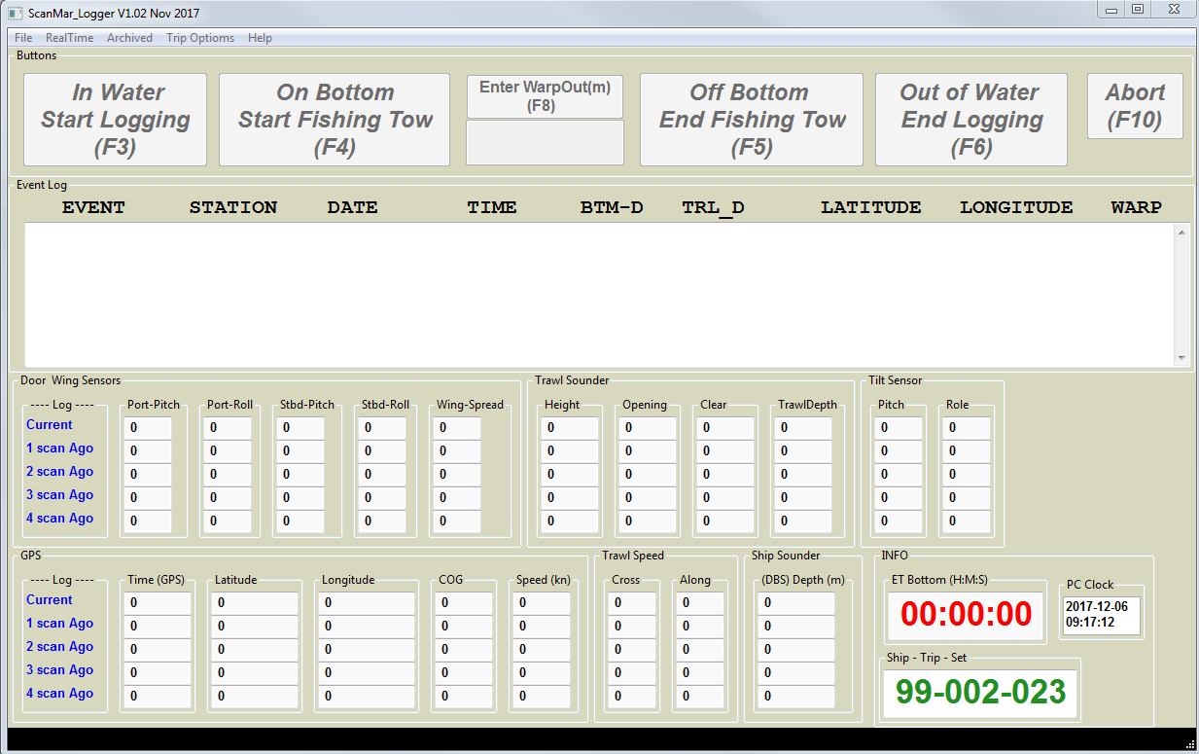
2. Serial Port configuration. This step should only be required for the initial program set-up or if USB port used has been changed. (The program on the Teleost is currently using COM 3). To change the serial Port configuration go to File> Serial Config. The baud rate used is 4800.
3. Initialise Trip and Set numbers. This is found under Trip Options -> Set Ship trip set. This would usually be done only at the beginning of a mission, although it can also be used to over-ride the current settings at any point during a mission (e.g. you want to skip a set ). **Also if you want to change to a different series of set numbers (e.g. 500s) for comparative tows.**
4. Once the mission has been setup ( and serial parameters if needed ) monitoring of the data feed can be initiated via the **RealTime->Start** . (Please ensure Scanmar system is running first).

At this point data coming from the Scanmar will be displayed in the window but logging does not occur until the buttons (e.g F3 ) are clicked. You will now notice that the First button (In Water Start Logging (F3)) is now GREEN – e.g. the program is ready to start logging.

**\*\*\*\* Note that a pop up will present that informs you to wait until data is displayed before imitating logging. (If you attempt to log data too quick, the stream isn’t stable and things can go funny)**

1. At the start of a set commence logging by either click the first button (**In Water Start Logging** ) or pressing (**F3**). Data logging for this set will begin. Data will now be written to files and a line for start of logging will appear in the Event log Box. At this point the button to be pressed next will turn GREEN.
2. When the trawl is positioned to start fishing (on bottom) click the ‘**On Bottom Start Fishing Tow’** button or press **F4**.
3. You now can enter **WARP OUT…(F8**) at your leisure. Note that WARP out can be enter multiple times if corrected or adjustments are required ) ensure you press <ENTER> after typing the warp out number (in meters)
4. At the end of the fishing portion of the set (i.e., when the net lifts of bottom) **click OFF BOTTOM END Fishing Tow (F5) button**.
5. When the doors are onboard click **Out of Water END Logging ( F6)** button. At which point data logging will stop, and the system will set up for the next tow, auto incrementing the set number. An information box will display indicating it is ready for next tow and what the **next** set number will be.
6. If at any point a tow needs to be aborted, press the ABORT (F10) button. This will reset the system for a new TOW using the current tow number… ( note that any data logged, WILL NOT be erased, rather the repeat tow will be appended to the original files)

Display window at end of fishing.

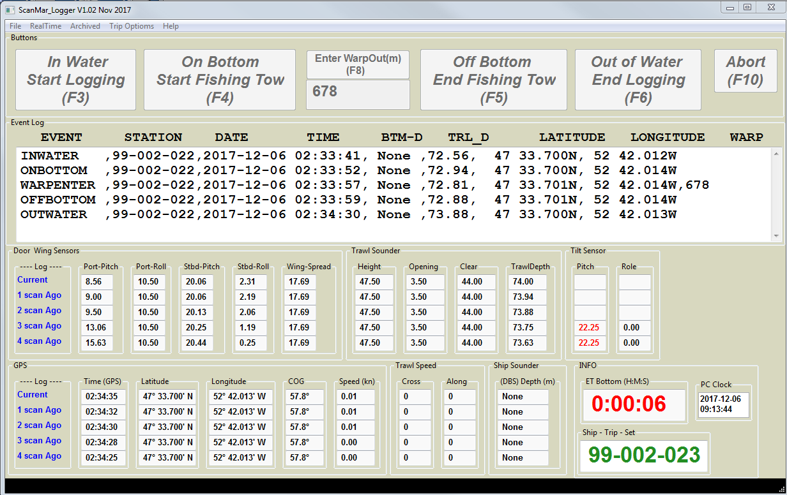

Scrolling Screen display:

The scrolling display presents the latest sensors values in the top row,, previous values scroll down the display. Values in RED are true sensors measurements, while values in BLACK are interpolated values generated by the Scanmar system to fill in sensors data gaps.