**David Tran**

**CSC 600**

**Ruby**

**5/15/17**

**1. Write a Ruby demo program that illustrates the use of all main Ruby conditional statements**

**[Reader, slide 51, and 52-74].**

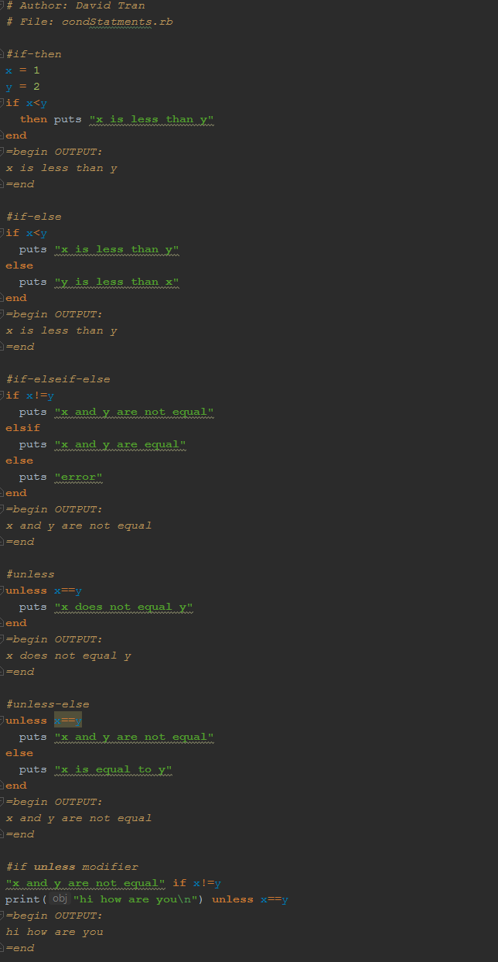

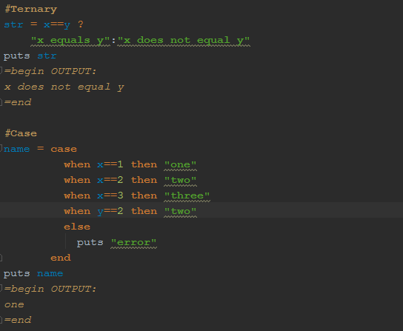

**2. Write a Ruby demo program that illustrates the use of all main Ruby loops and iterators**

**[Reader, slide 51, and 76-102].**

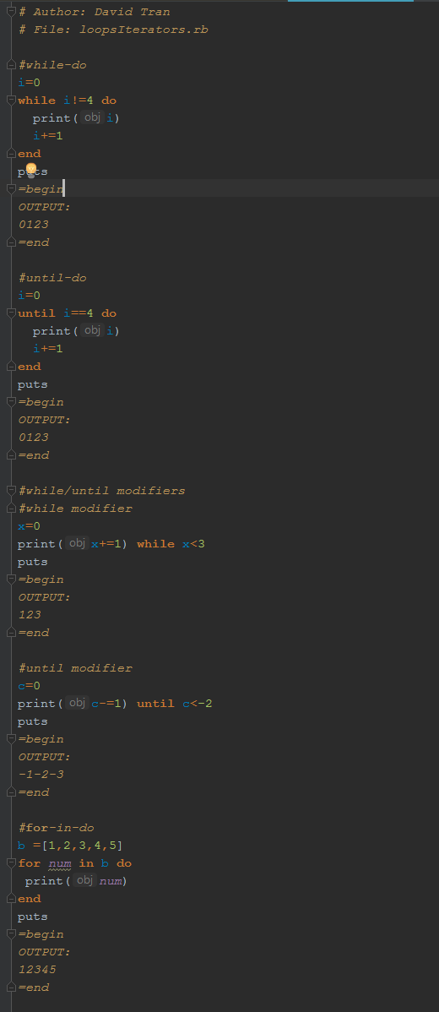

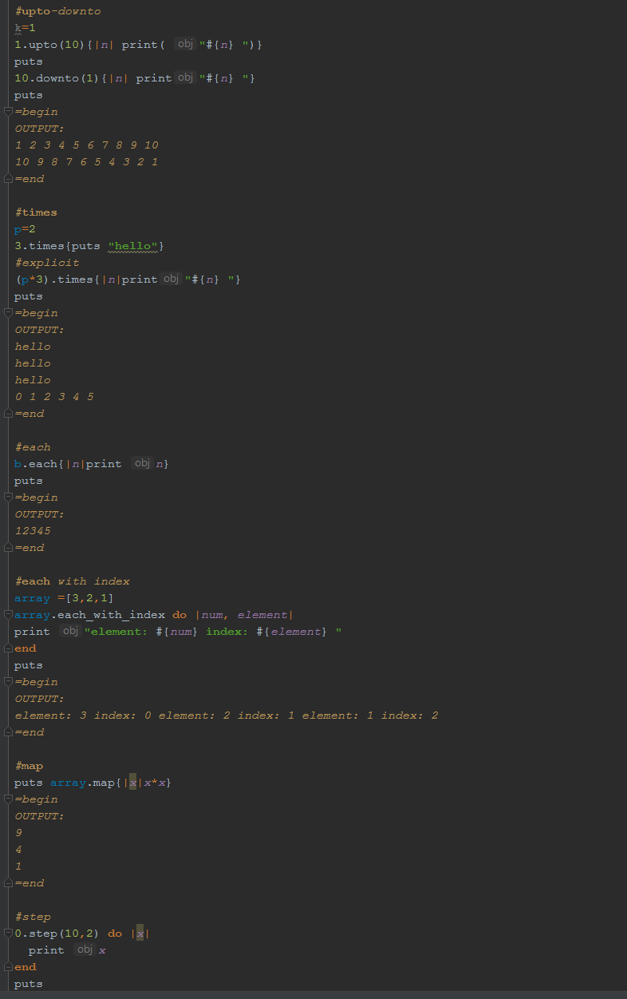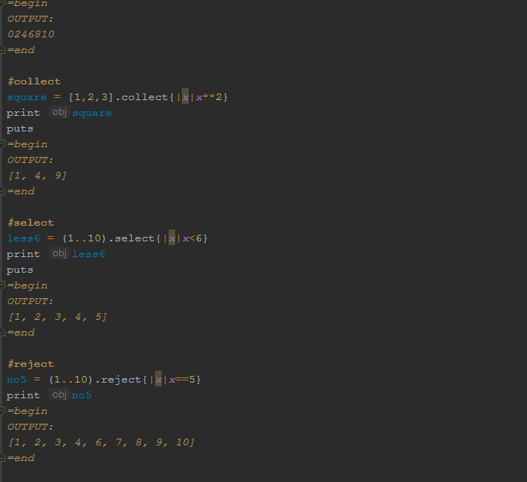

**3. Write a function mean_sigma(v) that returns two values: the mean value and the standard**

**deviation of numbers stored in the array v [Slides 135,141 show how to return two values].**

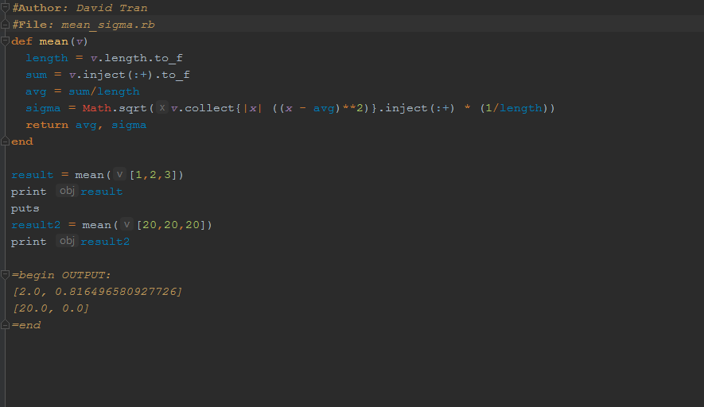

**4. Write a function sort(v) that returns the sorted array v. Do not use Ruby sort methods; write**

**your own sort. Array v must remain unchanged. [Slide 137 shows how to return an array]**

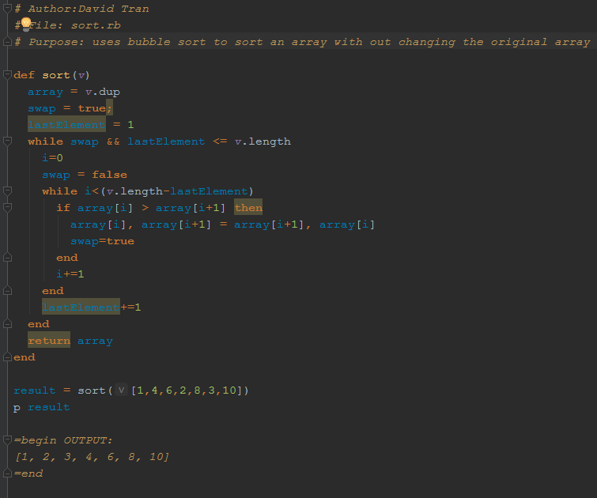

**5. Create a Ruby class triangle with initalizer, accessors, and member functions for computing**

**the perimeter and the area of arbitrary triangles. Make also a member function test that**

**checks sides a, b, and c and classifies the triangle as (1) equilateral, (2) isosceles, (3)**

**scalene, (4) right, and (5) not a triangle. Right triangle can be either isosceles or scalene.**

**Compute the perimeter and area only for valid triangles (verified by test). Show examples**

**of the use of this class.**

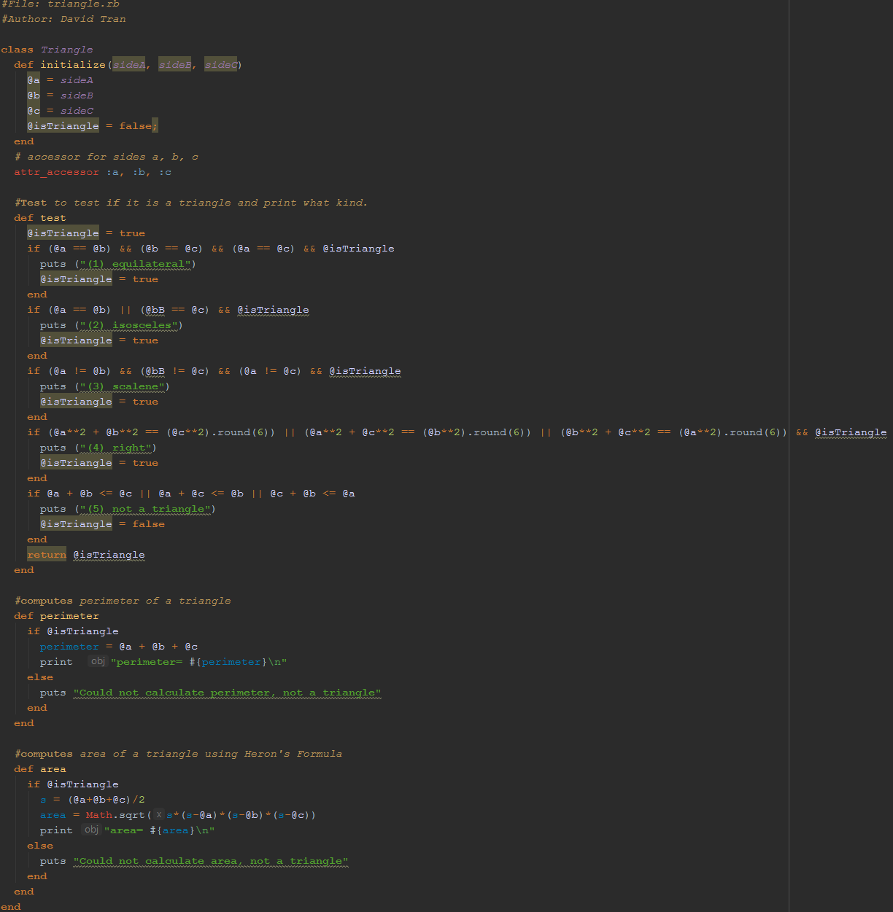

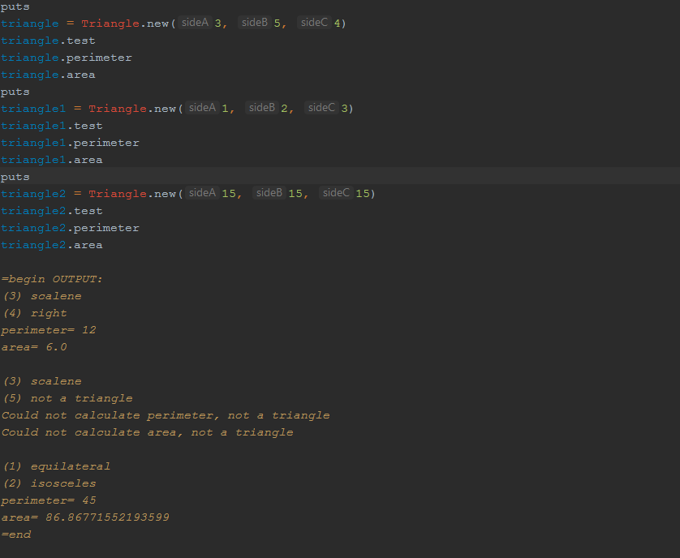

**6. Write Ruby recognizer methods limited? and sorted? that expand the Ruby class Array.**

**The expression array.limited?(amin,amax) should return true if amin ≤ a[i] ≤ amax for all**

**values of i. The expression array.sorted? should return**

**• 0 if the array is not sorted**

**• +1 if a[0] ≤ a[1] ≤ a[2] ≤ … (increasing sequence)**

**• -1 if a[0] ≥ a[1] ≥ a[2] ≥ … (decreasing sequence)**

**Show examples of the use of this method.**

