**Systems Analysis and Design**

**Phase 1 Research**

**D23128118**

**Davut Emre Ozkan**

**Introduction**

This study presents RoomRouter, a mobile application and a web site in development that aims to improve user experience within the hotel booking landscape. Apps like Booking.com, Expedia, and Ebookers offer many advantages over traditional methods, including simplified search functions, real-time availability checks, and personalized recommendations. RoomRouter's key focus is on providing a non-restrictive customer experience by prioritizing hotel choices during the booking process.

Moreover, the name RoomRouter acts as a unique identifier for the application. "Room" directly references finding a hotel room, while "Router" plays on its function of guiding users through the booking process, like how a router directs data packets to their destination.

**Research**

Booking.com, Expedia and Ebookers, which I mentioned in the introduction, and which can be considered the most popular apps and websites in the field of hotel reservations, are almost identical to each other, as can be seen in the screenshots taken from the home pages of the websites below. In addition to the interface functions, the way they work is also very similar. Alongside accommodation booking, these platforms also offer additional services, including the booking of flight tickets and car rentals.

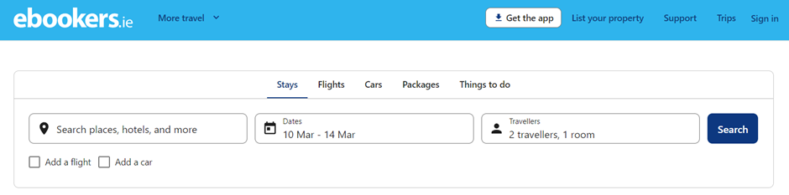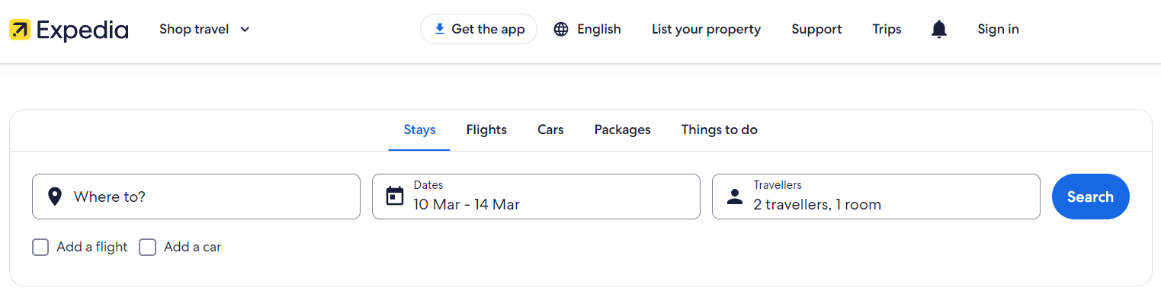**Screenshot 1 – Booking.com Main Page

**

Figure 3- www.expedia.ie Main Page Screenshot

Figure 3- www.ebookers.ie Main Page Screenshot

Figure 1- [www.booking.com](http://www.booking.com) Main Page Screenshot

* After selecting the date, location and room type, the hotel and its rooms are listed based on availability and algorithm recommendation.
* These hotel booking applications generally do not list hotels and rooms that are not available for the selected dates unless they are specifically displayed. They only list rooms that are available for the selected date ranges.
* After selecting the room, if user not logged in, the user is directed to the personal information screen; if the user logged in, the user is directly redirected to the payment screen.

**Scope**

According to the features mentioned in the research section, I believe that widely used hotel booking apps restrict users' experiences by only displaying hotels available within the chosen date range, thereby narrowing down options disregarding some hotel characteristics. At RoomRouter, the primary focus is ensuring a non-restrictive user experience by prioritizing hotel selection in the booking process. When users input dates, location and their desired criteria, the application not only lists hotels rooms available, It lists the best options even if they are not available at the time. RoomRouter displays availability after listing and selecting a hotel room. If, unfortunately, the chosen hotel is not available for the specified dates, RoomRouter promptly provides alternative suggestions, ensuring that users are presented with viable options even when their first choice is unavailable. The goal is not to limit users to only available options but rather to enhance their experience by offering accurate alternatives to their selected but unavailable hotels, thereby providing a more accurate and accommodating booking journey.

This assignment consists of a use case diagram, a use case narrative, an activity diagram, and a table containing non-functional requirements.

**References**

*Booking.com: The largest selection of hotels, homes, and vacation rentals* <https://www.booking.com/>

*Expedia.ie*

<https://www.expedia.ie/>

*Ebookers*

<https://www.ebookers.ie/>