Hardware Component Specification – Input Module

Overview and Perspective

Overview and Key Functions of System
This system is a credit card sized expansion card slot to provide the input signal to the system. It will have a single connector to supply the following to the expansion card: 170VDC, Ground, 6.3VAC (two pin differential), and an auxiliary input signal. A stereo audio signal will be summed together through two 1K resistors to create a mono audio signal for the line-stage amplifier.

Overview and Purpose of Hardware Component
The purpose of this component is to provide an audio signal to the amplifier, regardless of the source of that audio signal.

Component Perspective
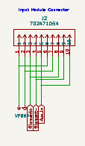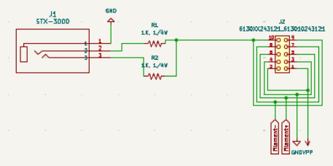

Component Details

Component Part Specification
- Qty. 1 10 Pin IDC connector.

Signal/Communication Interface(s)
Output:
- Auxiliary Audio

Power Interface(s)
Input:
- 170VDC power rail
- 6.3VAC power rail

Key Properties/Functions
The system will output an auxiliary audio signal.

