Hardware Component Specification – Line Stage

Overview and Perspective

Overview and Key Functions of System
This system is the first point of contact to amplify an auxillary signal. It is formed by two cascaded SRPP amplifier stages using a 6922/ECC88 dual triode vacuum tube. There is a negative feedback loop fed from the output to the cathode of the first SRPP stage. Gain is controlled by potentiometer RV1, which is a 10K potentiometer with one end bridged to the center, creating a 5K variable resistor. Gain is effectively RV1/R3. The Gain factor can be scaled from 0.003 to 15.15.

Overview and Purpose of Hardware Component
The purpose of this component is to amplify an auxiliary audio signal to be a suitable level for the power amplification stage and to compensate for the losses from the passive filter circuit.

Component Perspective
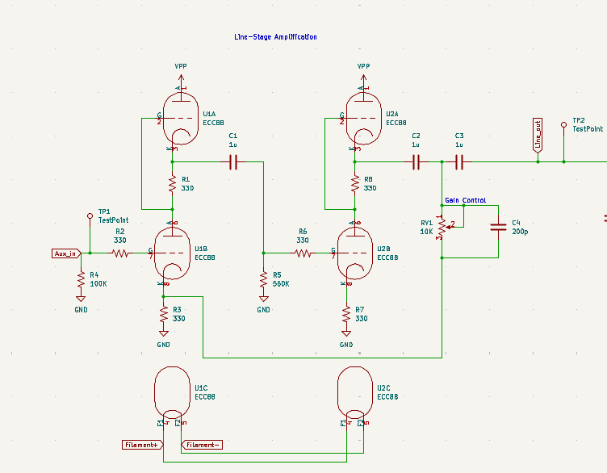

Component Details

Component Part Specification
- Qty. 2 ECC88 vacuum tubes
- Qty. 6 330 ohm 1/4W resistors
- Qty. 1 100K ohm 1/4W resistors
- Qty. 1 560K ohm 1/4W resistors
- Qty. 3 1uF 200V capacitors
- Qty. 1 10K ohm potentiometer
- Qty. 1 200pF 200V capacitor

Signal/Communication Interface(s)
Input:
- Auxiliary Audio
Output:
- Post line-stage audio signal

Power Interface(s)
Input:
- 170VDC power rail

Key Properties/Functions
The system will output an amplified audio signal.

