Hardware Component Specification – Power Amplification

Overview and Perspective

Overview and Key Functions of System
This system is the last amplification stage before the audio signal reaches the speaker. It is a single-ended class A amplifier formed by a single stage. The amplifying stage is a triode-connected tetrode vacuum tube in a common-cathode configuration. It feeds an audio transformer to convert the high output impedance from the vacuum tube to a low impedance compatible with 4 and 8 ohm speakers.

Overview and Purpose of Hardware Component
The purpose of this component is to provide the output power to drive a speaker.

Component Perspective
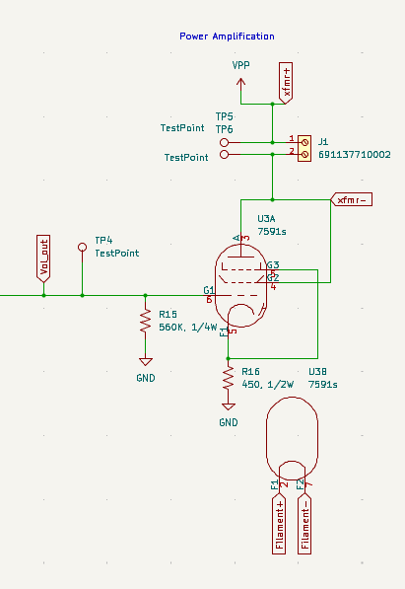

Component Details

Component Part Specification
- Qty. 1 560K 1/4W resistor
- Qty. 1 450 1/2W resistor
- Qty. 1 7591 tetrode vacuum tube
- Qty. 1 OT8SE+ audio transformer

Signal/Communication Interface(s)
Input:
- post-volume control audio signal
Output:
- Amplified Audio signal to speaker

Power Interface(s)
Input:
- 170VDC power rail

Key Properties/Functions
The system will transfer 0-2W of power to a 4 ohm speaker.

