Hardware Component Specification – Power Supply

Overview and Perspective

Overview and Key Functions of System
This system is comprised of a filtered full-wave rectifier and a transformer. The rectifier will output 170VDC given a 170Vpp 60 Hz input with a ripple voltage of 51 mV. The transformer will output 6.3VAC given the same 170Vpp input power. The whole system will be capable of delivering 15.5 watts. (Modified to add ICL in-line before C7 and C8 to limit inrush current to around 772 mA.)

Overview and Purpose of Hardware Component
The purpose of this component is to provide power to all of the sub-circuits of the system.

Component Perspective
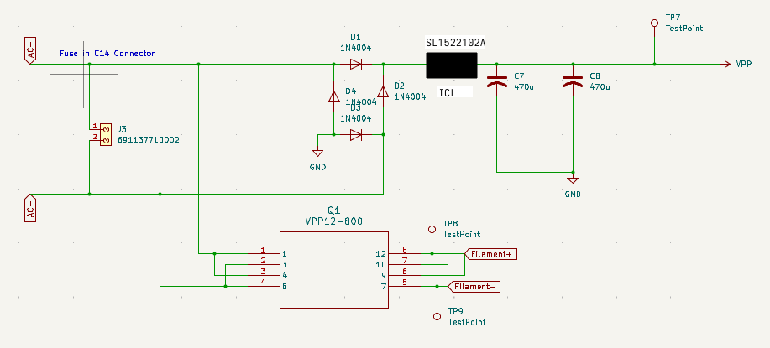

Component Details

Component Part Specification
- Qty. 4 1n4004 diodes
- Qty. 1 Fused C14 connector
- Qty. 1 200 mA fuse
- Qty. 1 120→6.3 V power transformer
- Qty. 2 470uF electrolytic capacitors 200V
- Qty. 1 SL1522102A ICL

Power Interface(s)
Input:
- North American 120Vrms main power
Output:
- 170VDC power rail
- 6.3VAC power rail

Key Properties/Functions
The system will transform 120Vrms main power into 170VDC and 6.4VAC derived rails.

