Hardware Component Specification – Line Stage

Overview and Perspective

Overview and Key Functions of System
This system allows the user to adjust the bass response, treble response, and volume level as desired. It is a passive system, which means the output voltage will be lower than the input voltage. For all three control dials, a 10K potentiometer is used. The bass and treble are adjustable to +/- 6dB. The volume control can attenuate the signal from 0% to 100% with steps of 1%.

Overview and Purpose of Hardware Component
The purpose of this component is to adjust the bass characteristics, the treble characteristics, and the volume level per the listener’s preference.

Component Perspective
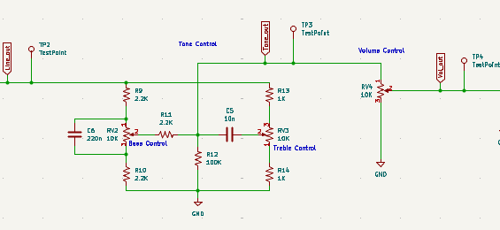

Component Details

Component Part Specification
- Qty. 3 2.2K 1/4W resistors
- Qty. 2 1K 1/4W resistors
- Qty. 1 220nF 50V capacitor
- Qty. 1 10nF 50V capacitor
- Qty. 1 100K ¼W resistor
- Qty. 2 10K ohm potentiometer

Signal/Communication Interface(s)
Input:
- Post-Line stage audio signal
Output:
- tuned post-line stage audio signal.

Power Interface(s)
none

Key Properties/Functions
The system will output a tuned audio signal suitable for power amplification.

