**Name:** Davy Nolan

**Performed:** Friday November 24th,

2017, 14:00 – 16:00 pm

**Date:** 27th November 2017

**Class:** Electrotechnology CS1025

***Laboratory Experiment 3***

**Introduction**

In the first part of the experiment demonstrates a circuit diagram to be constructed. It is critical to understand how to read schematic circuit diagrams and do understand the different symbols. The following circuit consisted of a 2V pk power source, a diode, an 10kΩ resistor and an oscilloscope.

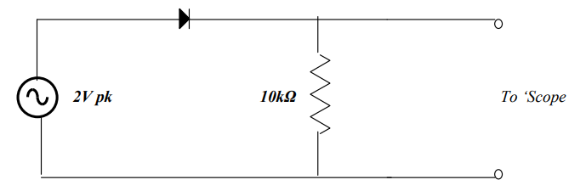

This circuit was to be connected and the output was to be observed and compared on the oscilloscope. The input and output had to be plotted.

In the second part of the experiment, another parallel circuit was connected but with a 1µF capacitor in parallel to the resistor. The supply frequency was set to 200Hz and then to 2KHz and the output was observed on the oscilloscope. The input and output were to be plotted in both cases. The experiment was repeated with a 10µF capacitor.

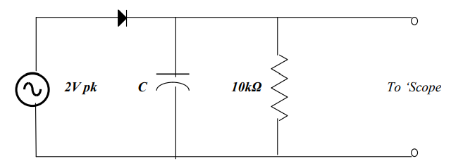

This is a photograph of the second circuit connected on a bread board.

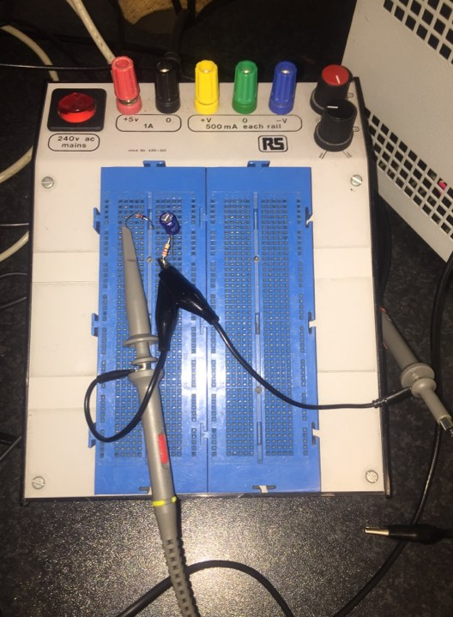

**Graphed Results**

*First Circuit:*

***Input***

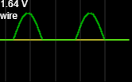

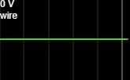***Output***

*Second Circuit:*

***Input***

**Explanation**

In both parts of this experiment, a ‘scope is used. This is short for oscilloscope. An oscilloscope is a laboratory instrument commonly used to display and analyse the waveform of electronic signals. In effect, the device draws a graph of the instantaneous signal voltage as a function of time. The graph of an oscilloscope is graphed with an x and y axis. The x-axis is measured in seconds per division, milliseconds per division and nanoseconds per division. The y-axis is measured in volts per division, millivolts per division, or microvolts per division. (reference:http://whatis.techtarget.com/definition/oscilloscope)

**Observations**

The graph of the first part of the experiment has an x-axis of milliseconds and a y-axis of millivolts. The graph appears to peak at a maximum of roughly 700 mV and a minimum of -700 mV. The estimated cut-in voltage of the diodes is 0.7 V.

The graph of the second part of the experiment has an x-axis of milliseconds and a y-axis of volts. The graph (with LED) has a maximum voltage of roughly 0.1 V and a minimum of -5 V. The graph (without LED) has a maximum voltage of roughly 3.8 V and a minimum of -5 V. Clearly, the LED affects the voltage waveform as there is a max voltage difference of 3.7 V between the two circuits with the LED and without the LED.

**Conclusion**

Overall, the experiment was difficult to perform due to lack of understanding and time but however, the results appear to be accurate.