1 Introduction

A few minutes after the Big Bang, recently formed neutrons and protons combined to create nuclei of Deuterium and Helium. It would not be for another 300,000 years before the universe became sufficiently cool to allow electrons to become bound to these nuclei and form neutral atoms. In this early universe, around 23% of all baryonic matter was Helium.

Since then, the amount of Helium has increased due to fusion within stars, but measuring this abundance is a task that has eluded astronomers for decades. However, modern techniques of asteroseismology allow astrophysicists to probe the internal compositions of stars, providing insight into the enrichment of Helium.

Asteroseismic data can be used to detect Helium within the connective envelope of red giant stars. Small signatures of Helium produce subtle ‘glitches’ in the frequencies of oscillation modes of the star. Over the duration of this project, these ‘glitches’ will be identified for an ensemble of a few thousand stars; the data will be used to produce a Bayesian hierarchical model, from which a new estimate for a Helium Enrichment law will be derived.

2 Aims

This project ultimately aims to produce a law for Helium enrichment as a function of metallicity. From there, other forms of enrichment laws will be considered and compared to models for validation.

For this project, the statistical programming language Stan will be employed to produce a Bayesian hierarchical model. The resulting relation for Helium enrichment will be tested through comparison with chemical evolution models, which can be created using another programming tool: PyChem.

3 Background and Motivation

3.1 Asteroseismology

The interior of a star may be one of the least accessible places in the galaxy and, as such, at- tempting to peer beyond the surface poses a challenge to astronomers. We have a detailed knowledge of our own planet’s interior due to the measurement of seismic activity at the sur- face (geo-seismology). The movement of tectonic plates and resulting oscillations allow measurements of the speed of sound beneath the surface. From these measurements, the temperature and density can be found and subsequently, other features can be deduced.

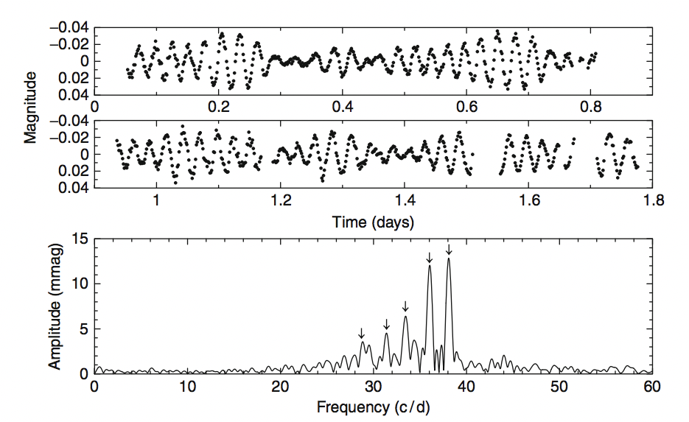

Figure 1: The variations in luminosity (upper two panels) of a pulsating star and the corresponding Fourier spectrum, identifying the component frequencies.

Cooler stars exhibit seismic effects much like our own planet, the study of which is known as asteroseismology. These stellar oscillations are caused by stochastic turbulence within the convective zones of the star’s interior. When this perturbation reaches the surface, the resulting rarefaction or compression causes variation in light, radial velocity, and line profile. These variations can be detected many light-years away, spectroscopically or photometrically.

When the entire star vibrates, it is known as a normal mode oscillation and provides the most information about the interior. The frequencies of stellar models are matched to observed frequencies, allowing the deduction of physical parameters and interior structure. The superposition of normal mode frequencies are viewed as sound waves passing through the various layers of the star.

Shown in the upper two panels in figure 1 is the light variation of a pulsating star. The frequencies can then be identified by performing a discrete Fourier transform (shown in equation 1), resulting in the spectrum in the lower panel of figure 1. Often the analysis is carried forward by further processing; fitting sinusoids to the data, determining and optimizing their frequencies, amplitudes and phases, often by least squares methods.

To determine the physical parameters of a star, the next stage is to identify the angular degrees of the modes of oscillation in the frequency spectra. The mode numbers contain information regarding the path length through the interior and the frequencies contain information of the ‘speed of sound’ along that path. Assuming the simplest normal mode (radial), the modes of oscillation are described by three indices l, m, n, where l is the angular degree, m is the harmonic order and n is the radial order. The different paths of these modes can be seen in figure 2. One can see the deeper penetration of some paths due to a lower angular degree. Other modes such as torsional r modes are not considered as these are of little practical importance.

However, the oscillation modes of a star are not spherically symmetric, and the l mode frequency is offset primarily due to the star’s rotation. This is called frequency splitting and can be used to determine rotation and other properties caused by lack of spherical symmetry.

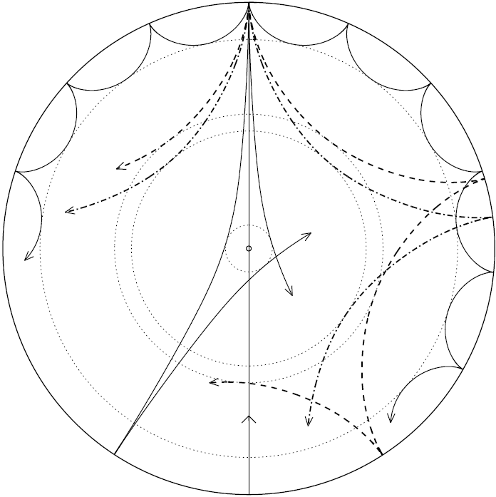

Figure 2: Cross-sectional diagram of a star showing the mode penetration. Low angular degree modes penetrate deeper.3

This project will be analysing data from Red Giants as their oscillations are similar to that of cool main sequence stars and characterisation of these modes leads to reliable estimations of mass and radius. Red Giants contain two resonant cavities: the core and the envelope. Gravity (g) modes only propagate in the core and acoustic (p) modes propagate through the both the core and the convective envelope. Predictions have been made that dis- continuities in sound-speed exist and disturb the observed oscillations. In Red Giants this discontinuity is the region in which Helium undergoes its second ionisation, known as the HeII envelope. This exists towards the surface of the star, meaning it is only acoustic modes that need to be considered.

The discontinuity in sound-speed produces a modulation in the observed oscillations frequencies, which we call the ‘acoustic glitch’ and is due to the rapid variation in chemical composition as Helium becomes fully ionised. The amplitude of the glitch related to the region of second ionization of helium is directly correlated to the amount of helium present in the envelope.

Localised effects varying the p mode oscillations can be caused by sharp changes in the interior stellar stratification with the adiabatic exponent:

γ1 = (d ln(P)/d ln(ρ))s

Where P is the pressure and ρ and is the density at constant entropy. The rapid variation in γ1 is referred to as the acoustic glitch, causing a shift in eigenfrequencies of the lower order, deeply penetrating oscillations. This presents itself as a decaying sinusoid within the recorded signal, as seen below:

A close up of a map


3.2 Bayesian statistics

Due to the relatively small signature of the Helium glitch within the observation of the star’s oscillation, the uncertainty for any single star will be large. Therefore, to produce reliable results, one must leverage the power of the ensemble and use data from thousands of Red Giants. In order to interpret data from such a large sample size, a statistical model must be created.

This will take the form of a Bayesian hierarchical model: a statistically rigorous way of making scientific inferences about a population based on many individual observations.7 When working with stellar observations, one can regard many of their parameters as having some kind of relation- ship. This lends itself to a hierarchical model, in which one can construct probability distributions that capture the dependencies between relevant variables while keeping models simple.

The first step in constructing a hierarchical model is to estimate a parameter and, using similar previous experiments, define a prior distribution. A likelihood (or sampling distribution) is what ties the model to the data, determining how likely it is, given the prior, for the model to produce the data one has. This results in what is called a posterior, which acts as a new prior, updated with information contained within the data. This is shown in the form of Bayes theorem in equation 2:

p(θ|y) ∝ p(y|θ)p(θ)

where p(θ) is the prior density for parameter θ, p(y|θ) is the likelihood (model) and p(θ|y) is the posterior density.  
One can expand this model by adding another level to the hierarchy: the parameters defining the distribution of parameter θ can also defined by a distribution of their shared dependencies. It is from this that the robustness is stemmed. The new hyperpriors upon which the latent variables are built, can also be expanded upon, introducing more parameters. This forms a hierarchical model within a multidimensional parameter space which, depending on the number of parameters, can become quite computationally taxing.

Useful formulae or definitions:

Average large frequency separation: average frequency spacing between consecutive overtones n for modes of a given l (equal to the inverse of twice the acoustic radius)

c = speed of sound in medium

A picture containing object


Acoustic depth τm,

rm is the radial distance where the feature is located.

Metallicity: used to describe the [abundance](https://en.wikipedia.org/wiki/Abundance_of_the_chemical_elements) of elements present in a star that are heavier than [hydrogen](https://en.wikipedia.org/wiki/Hydrogen) or [helium](https://en.wikipedia.org/wiki/Helium). Typically use Fe abundance since that is often the easiest to measure, and then assume that the other elements scale with Fe.

[Fe/H]=0, same metallicity as Sun