CIVE 202

Automation of NDOT Concrete Mix Design Model (Project #2)
Section 150

February 24th, 2026

Group Members
Rylee Renner, Dylan Dubas, Dawa Lamu Tamang and Zane Smith

Introduction
This project converts an Excel-based NDOT concrete mix design worksheet into a Python program that reproduces the same engineering logic in a more reliable, easy-to-understand, and repeatable format. The main objective is to automate the “Mix Design” worksheet process so a user can enter material properties and design parameters and receive a weight chart for one cubic yard of concrete, while also making the logic easier to verify and maintain than a spreadsheet-only workflow.
The engineering context for this work is grounded in Nebraska concrete mix design practice. NDOT’s Standard Specifications define concrete classes and key mix requirements (such as minimum total cementitious content, aggregate ranges, air content ranges, and maximum water-cement ratio) in Table 1002.02, including classes such as 47B, 47BD, and 47B-OL (NDOT, 2017). In addition, the NDOR (Nebraska Department of Roads) aggregate gradation research report (Final Report P336) emphasizes that aggregate blending and gradation affect workability, constructability, durability, and required water/air-entraining dosage in paving mixes, which directly supports the value of a structured computational tool for proportioning and scenario comparison (Heyen et al., n.d.).
This migration is not just a software rewrite. It is an engineering workflow improvement; the Python version preserves the original mix proportioning logic while making it more modular and easier to test for future use in a larger software tool.

Methods
Excel-to-Python translation strategy
The written code implements the worksheet logic as a sequence of Python functions and stepwise calculations rather than embedded spreadsheet formulas. In the notebook, the workflow begins by defining constants, then creates individual functions for each major calculation step, prompts the user for material/design inputs, and finally computes and prints a one-cubic-yard weight summary.
The main calculation functions include:
- calculate_water_weight_Q(...)
- calculate_volume_R(...) (cement volume)
- calculate_volume_S(...) (fly ash volume)
- calculate_volume_T(...) (silica fume volume)
- calculate_volume_U(...) (other SCM volume)
- calculate_air_volume_V(...)
- calculate_water_volume_W(...)
- calculate_total_aggregate_volume_X(...)
- calculate_fine_aggregate_Y(...)
- calculate_coarse_aggregate_Z(...)
- calculate_other_aggregate_AA(...)
This matches the original worksheet’s absolute-volume logic, which is consistent with NDOT/NDOR concrete proportioning practice where paste volume, air volume, and aggregate gradation/volume all interact to determine final proportions (James J. Knott, P.E. & Moe Jamshidi, PE, 2017).
Calculation workflow
The Python notebook follows this computational order:
- Water weight calculation (Q)
Water weight is computed from total cementitious content and the selected water-cement ratio (or water-cementitious ratio), using the sum of cement, fly ash, silica fume, and other SCM. This matches the expected worksheet logic for controlling water demand through the ratio target.
- Cementitious component volumes (R, S, T, U)
Each cementitious material weight is converted to volume using its specific gravity and the unit weight of water. This is required for an absolute-volume mix design.
- Air volume (V) and water volume (W)
Entrained air content and water weight are both converted into volumetric terms so they can be included in the one-cubic-yard volume balance.
- Total aggregate volume (X)
The remaining volume available for aggregate is calculated by subtracting all cementitious volumes, air volume, and water volume from one cubic yard (27 ft³).
- Aggregate weight calculations (Y, Z, AA)
The remaining aggregate volume is split into fine, coarse, and other aggregate fractions using percentage inputs, and each portion is converted to weight using the respective specific gravity.
- Final weight chart output
The notebook prints a structured one-cubic-yard weight summary for all materials (cementitious, aggregates, and water), which is the required deliverable for the NDOT mix design workflow.
This decomposition into functions improves reliability compared with Excel because each engineering step can be independently inspected, tested, and reused.
Input and output parameters for future users
Below is a list of the key parameters used in the Python implementation.
Inputs
- project_no — project identifier
- concrete_class — NDOT concrete class (e.g., 47B, 47BD, 47B-OL)
Cementitious materials (lb/cy)
- cement_A — cement content
- fly_ash_B — fly ash content
- silica_fume_C — silica fume content
- other_scm_D — other supplementary cementitious material
Design targets
- wc_ratio_E — maximum/target water-cement ratio
- air_content_F — target entrained air content (%)
Aggregate volume split
- percent_fine_G — percent fine aggregate
- percent_coarse_H — percent coarse aggregate
- percent_other_I — percent other aggregate (if used)
Specific gravities
- sg_cement_J
- sg_fly_ash_K
- sg_silica_fume_L
- sg_other_scm_M
- sg_fine_N
- sg_coarse_O
- sg_other_P
These inputs align well with NDOT specification parameters for concrete classes, especially where the specification sets class-specific limits for total cementitious materials, aggregate quantities, air content, and water-cement ratio. For example, Table 1002.02 in the NDOT Standard Specifications lists class requirements for 47B, 47BD, and 47B-OL, including minimum cementitious content and maximum water-cement ratio (James J. Knott, P.E. & Moe Jamshidi, PE, 2017).
Intermediate outputs
- water_weight_Q — water weight (lb/cy)
- R, S, T, U — cementitious material volumes (ft³)
- V — air volume (ft³)
- W — water volume (ft³)
- X — total aggregate volume (ft³)
- Y — fine aggregate weight (lb/cy)
- Z — coarse aggregate weight (lb/cy)
- AA — other aggregate weight (lb/cy)
Final output
- One-cubic-yard weight chart (lb/cy) for:
-Cement
-Fly ash
-Silica fume
-Other SCM
-Fine aggregate
-Coarse aggregate
-Other aggregate
-Water

Results

Comparison of the four selected mix designs
The project compares four mix scenarios to verify that the Python implementation reproduces expected mix-design behavior. Even without changing the equations, the scenario testing is valuable because it confirms the code responds correctly when key engineering parameters (water-cement ratio, air content, and cementitious content) are changed.
The scenario set includes a baseline 47B mix and modified cases involving 47B sensitivity changes, 47BD, and 47B-OL. These are meaningful choices because NDOT specifications treat these classes differently in terms of required cementitious content, air content range, and maximum water-cement ratio.
Scenario 1:
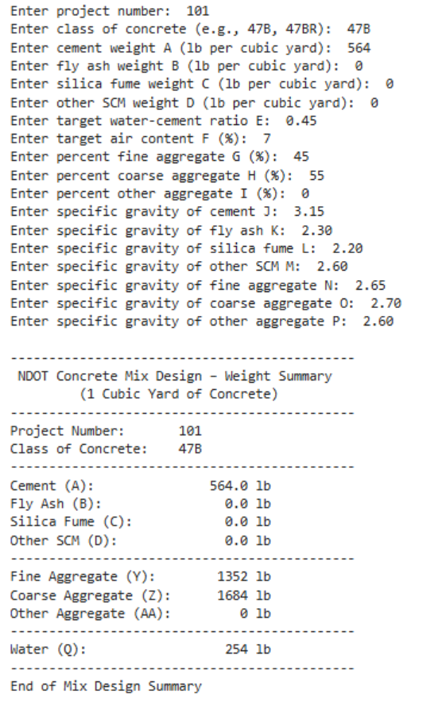

Scenario 1 represents a baseline NDOT Class 47B paving concrete mix. The selection of Class 47B is based on the NDOT Standard Specifications for Highway Construction, which define standard classes of concrete used for pavement applications. The Portland cement content was selected as 564 lb per cubic yard. to satisfy the NDOT minimum Portland cement requirement for paving concrete. NDOT specifications require air-entrained concrete for freeze-thaw durability, and a target air content of 7% was selected to represent typical paving concrete practice. A water–cement ratio of 0.45 was selected in accordance with NDOT durability-based limits for paving concrete. Aggregate proportions and specific gravity values were selected based on standard material property ranges commonly used in concrete mix design practice.

Scenario 2:
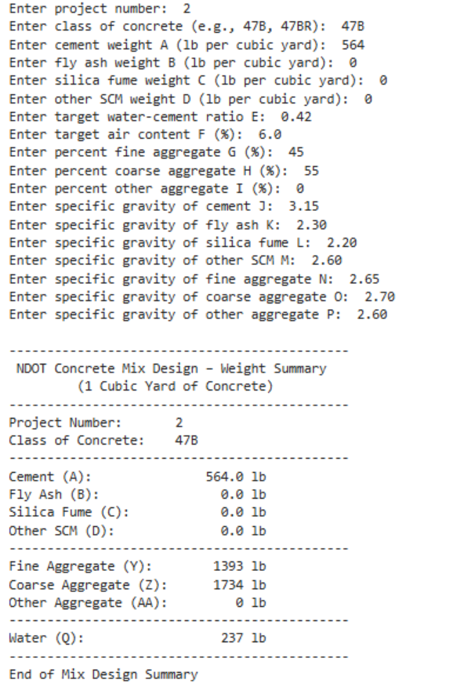

Scenario 2 was developed as a sensitivity test of the automated mix design workflow by reducing the target water-cement ratio from 0.45 to 0.42 and the target air content from 7% to 6%, while maintaining the NDOT minimum Portland cement content and aggregate proportions used in Scenario 1. As expected, the reduction in water–cement ratio resulted in a lower calculated water weight (from 254 lb to 237 lb per cubic yard), as well as an increase in calculated aggregate weight, with both course and fine aggregate increasing in weight compared to the control group from Scenario 1.

Scenario 3:
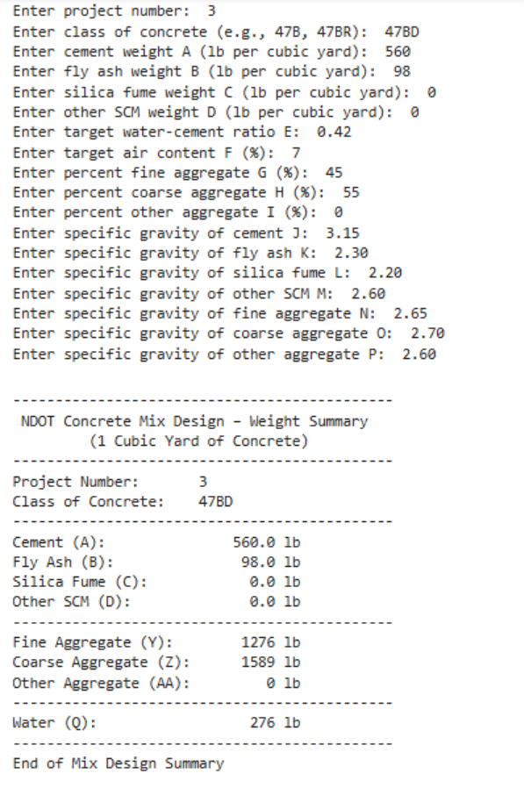
NDOT guidance for Class 47BD requires a higher total cementitious content and stricter durability controls than Class 47B. For this scenario, the total cementitious content was set to 658 lb per cubic yard using 560 lb per cubic yard of Portland cement and 98 lb per cubic yard of fly ash, while maintaining a target water–cement ratio of 0.42 and air content of 7.0%. Overrall this mix should have a higher paste-related volume, less remaining aggregate volume, and aggregate weights should be adjusted downward relative to a lower-paste case. This is an important validation case because it confirms the code can handle class-driven constraint changes, not just one fixed worksheet setup.

Scenario 4:
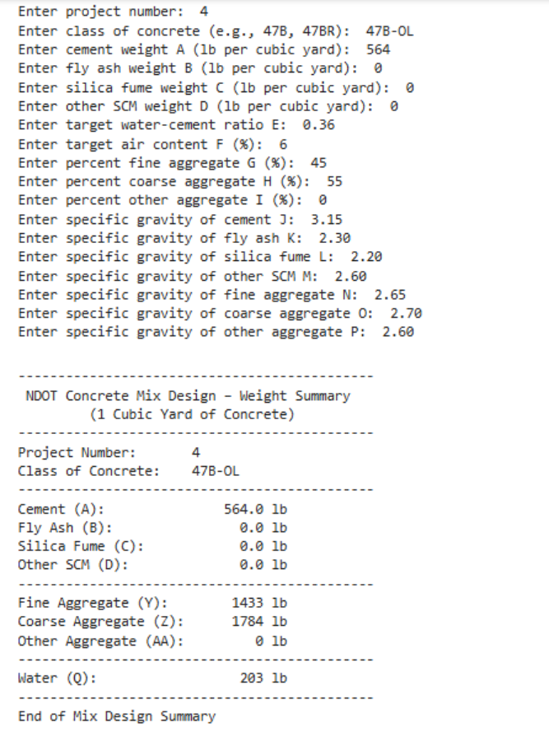
Scenario 4 represents NDOT Class 47B-OL, which includes stricter durability controls than standard Class 47B. NDOT Table 1002.02 specifies a minimum total cementitious content of 564 lb/cy for 47B-OL, specifies an air content range of 5.0–7.0%, and a maximum allowable water–cement ratio of 0.36. This can increase the volume available for aggregate.

Discussion
The four selected cases show that the Python implementation preserves the engineering relationships that the Excel worksheet was intended to capture
- 47B is a strong baseline case for general validation and routine paving/structural calculations.
- Modified 47B sensitivity testing is useful for exploring how small changes in air content and water-cement ratio affect final batch weights.
- 47BD is appropriate for more durability or bridge-related applications where stricter class requirements apply.
- 47B-OL supports overlay-specific scenarios and demonstrates that the code can handle alternate class requirements and corresponding mix proportion changes.
From an engineering software perspective, the most important result is that the Python implementation preserves the cause-and-effect behavior expected in concrete proportioning, finding that these scenarios apply. A lower allowed water-cement ratio reduces water content. Changing air content shifts the solid volume available to aggregates. Stricter classes alter cementitious and aggregate balances. Finally, aggregate-specific gravity/percent splits directly affect final batch weights. This is the key evidence that the migration successfully translated the Excel logic into code.

References

Heyen, W., Halsey, L., Robert Rea, Mick Syslo, Tim Krason, Tom Gernert, Jeremy Weigel, Debra Swanson, & Jim Beason. (n.d.). Optimized Aggregates Gradations for Portland Cement Concrete Mix Designs Evaluation. https://dot.nebraska.gov/media/3isfdv45/final report-p336.pdf

James J. Knott, P.E. & Moe Jamshidi, PE. (2017). Standard Specifications for Highway Construction 2017 Edition. Nebraska Department of Transportation. https://dot.nebraska.gov/media/g4qp4y0d/2017-specbook.pdf

Tarantula Mixture Design. (2021).

