**Network Programming – CENG 320 Fall 2015 Lab Assignment 8 Network Utilities**

Name: Rakul Mahenthiran

Date: Dec 9, 2015

**Script 1**

CENG320_p1.sh:

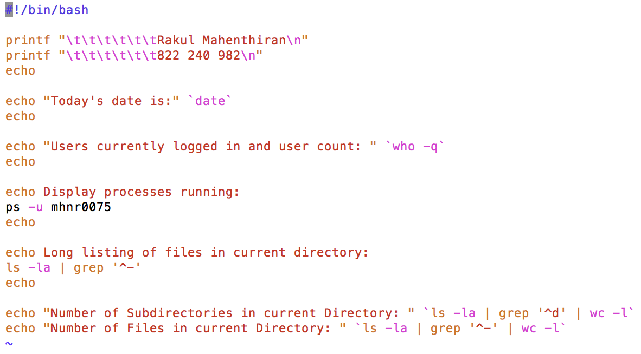

Client:

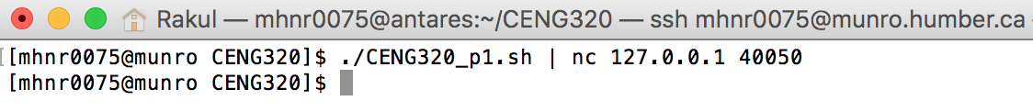

Server:

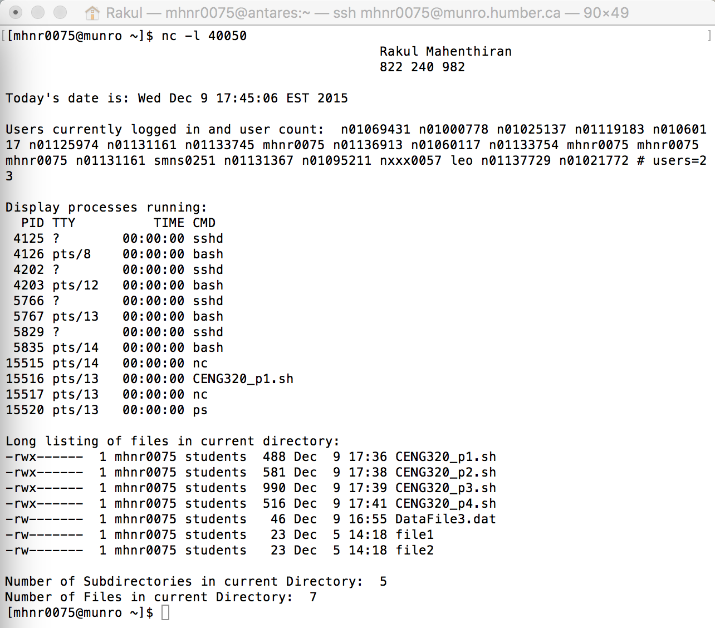

**Script 2**

CENG320_p2.sh:

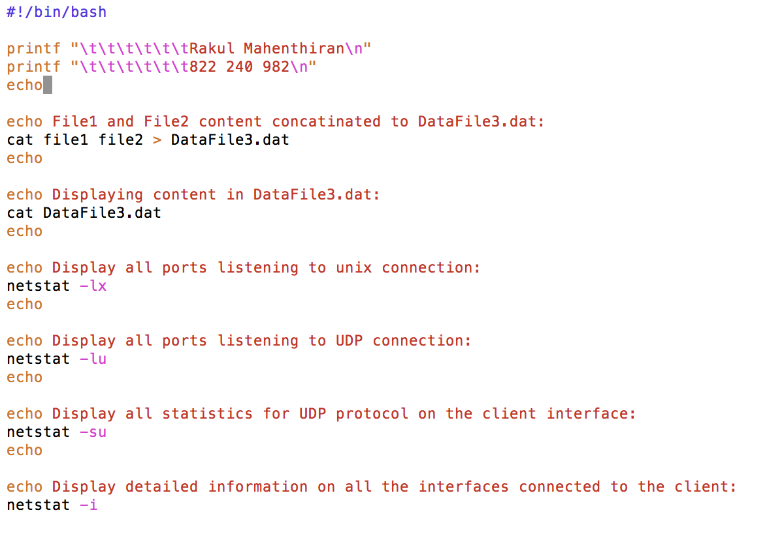

Client:

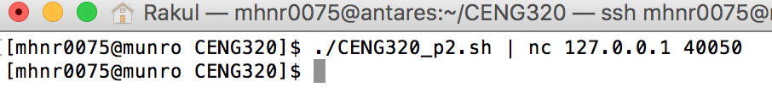

Server:

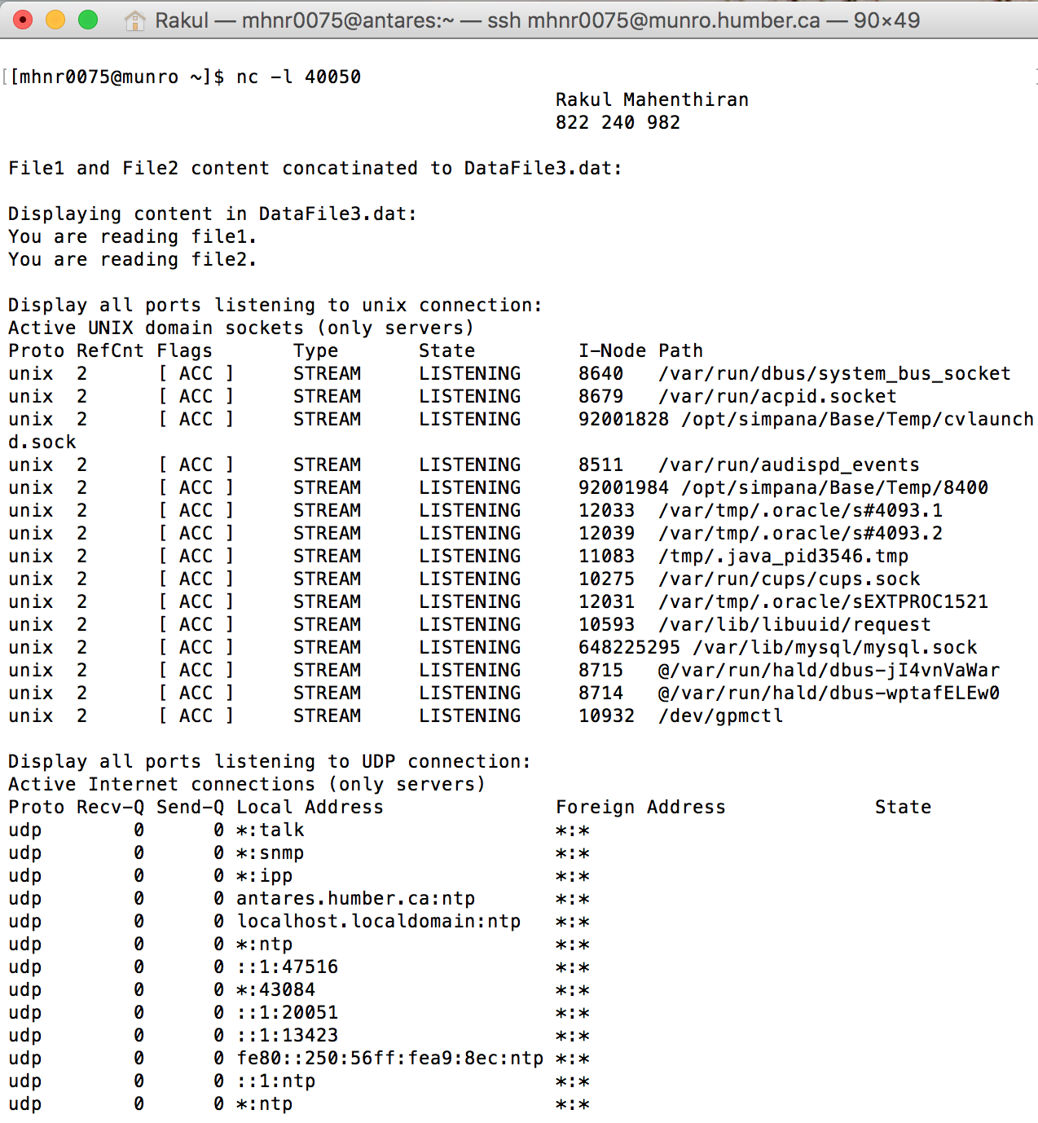

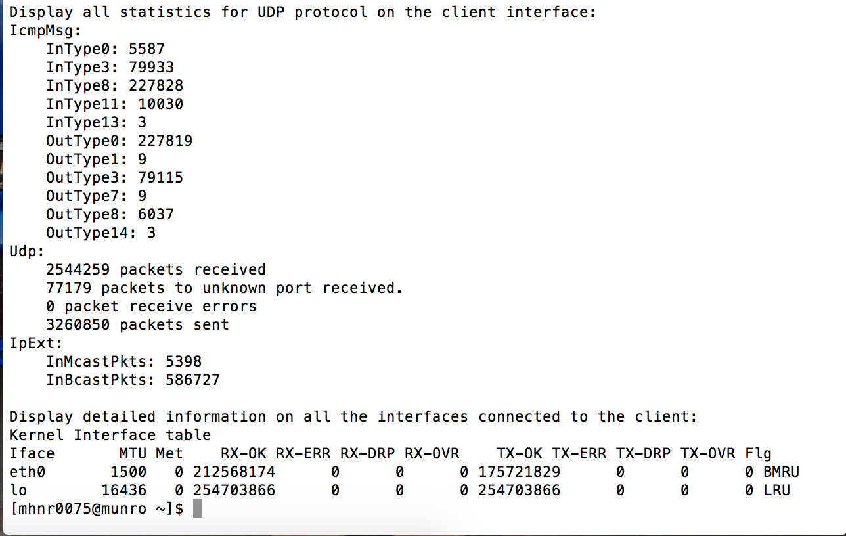

**Script 3**

CENG320_p3.sh:

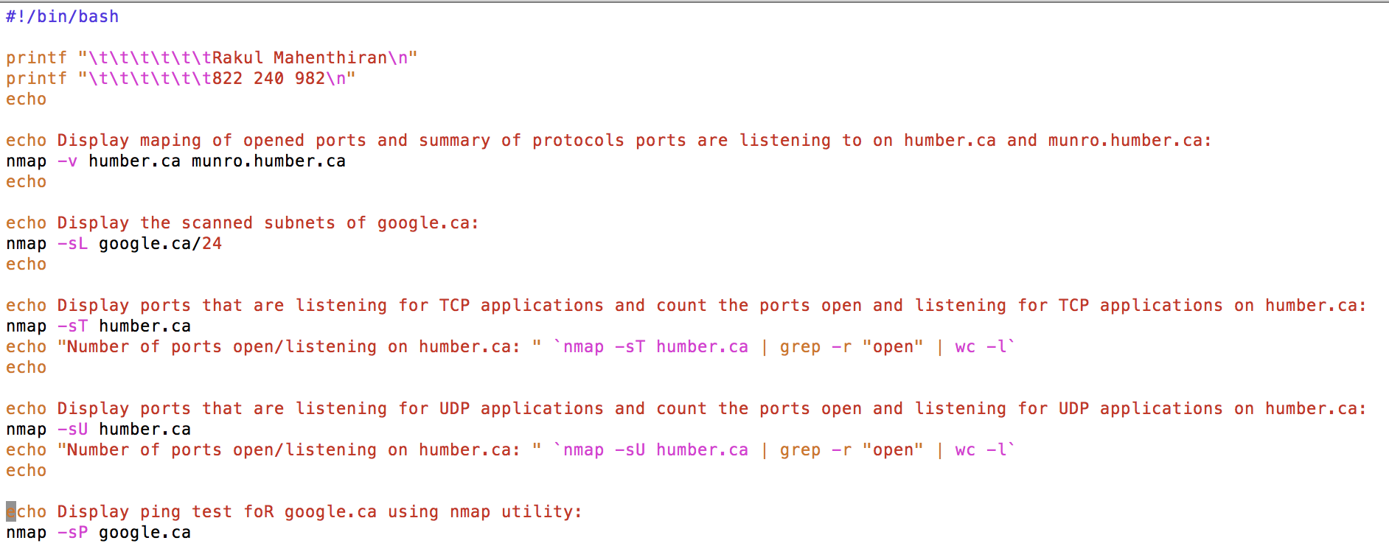

Client:

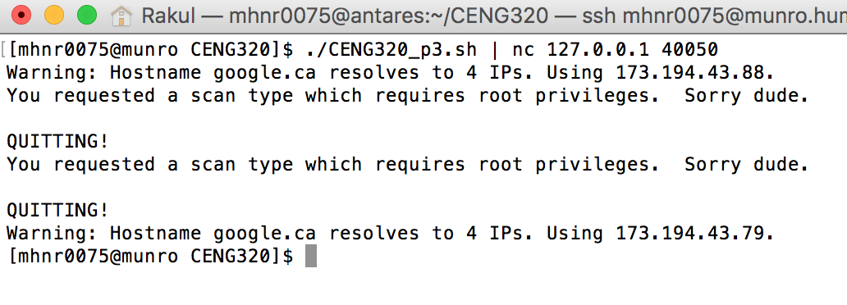

Server:

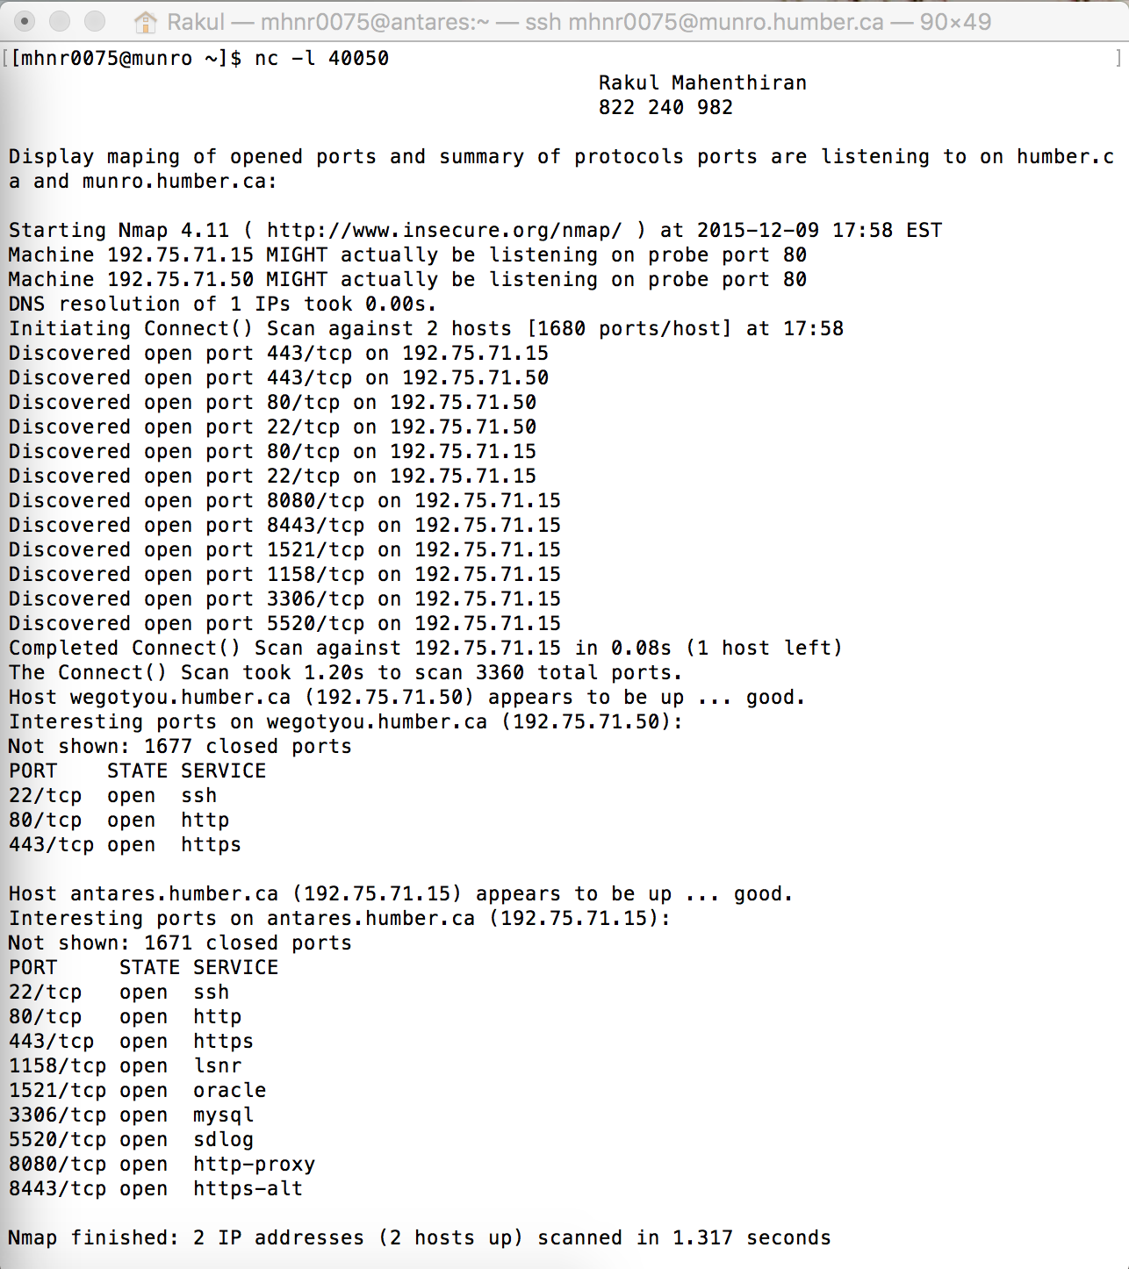

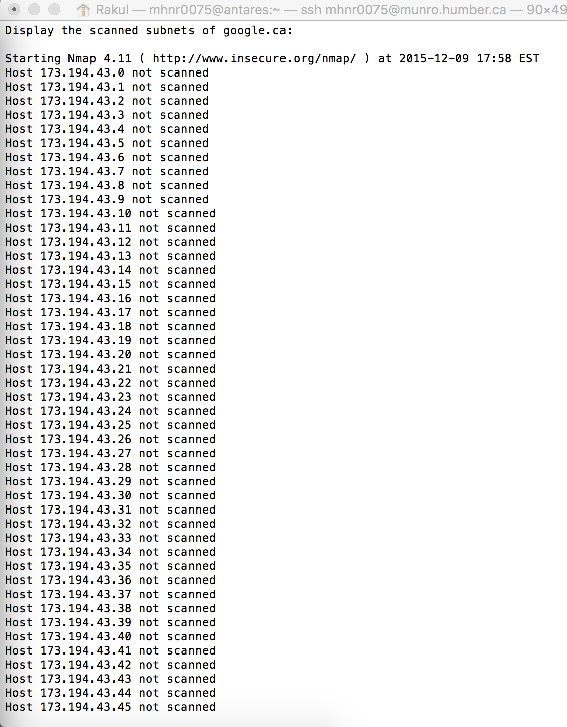 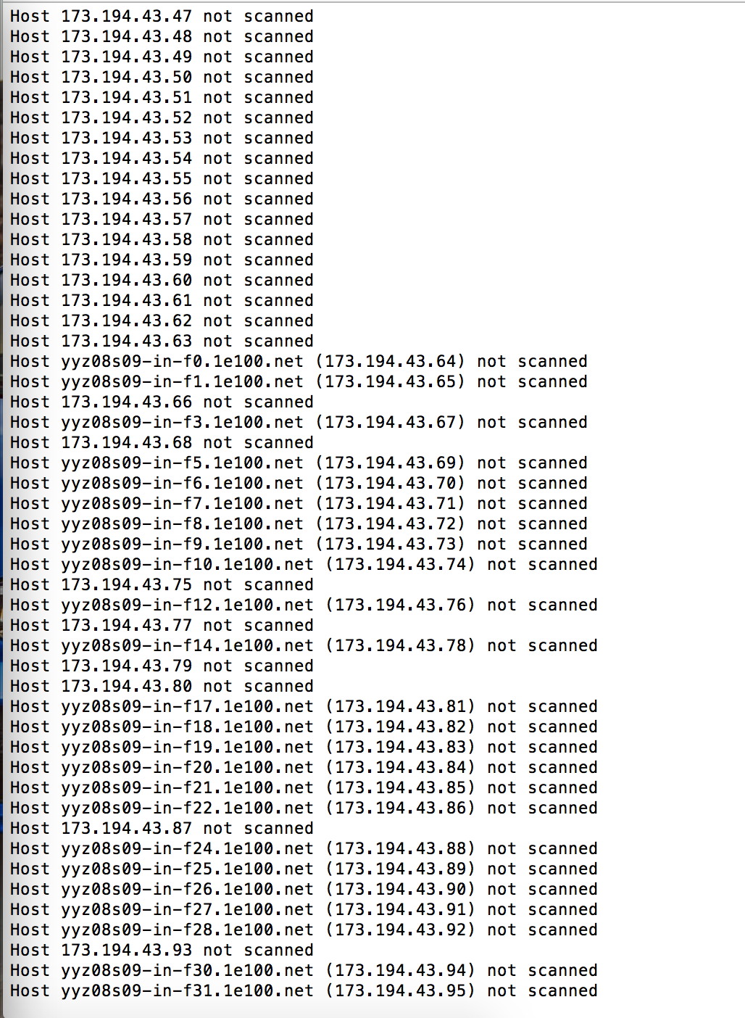

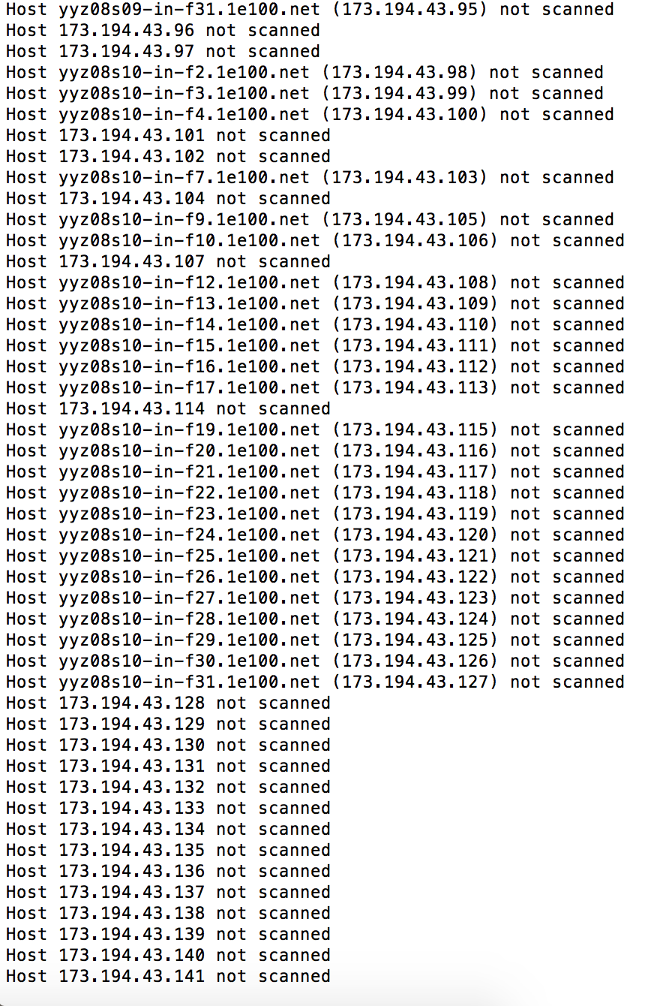 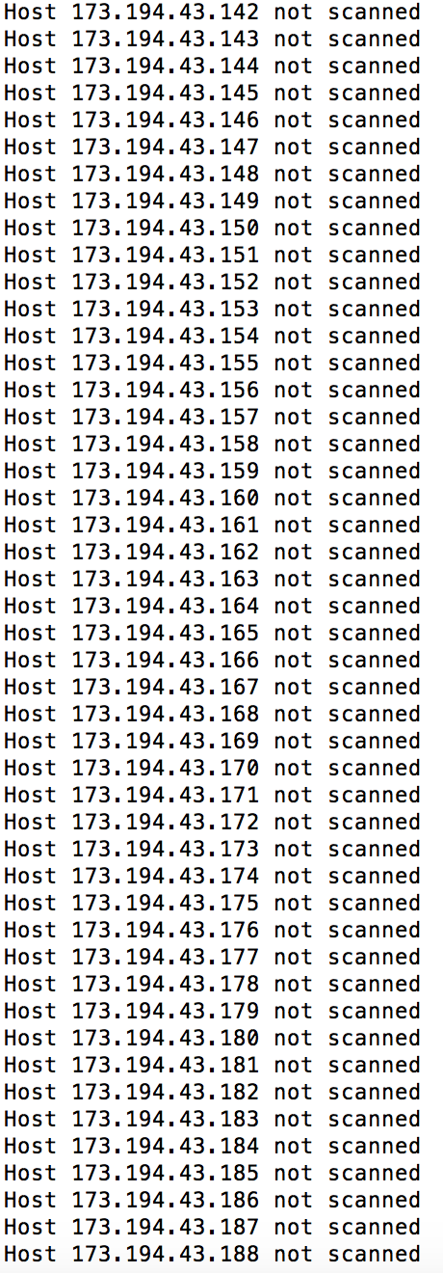

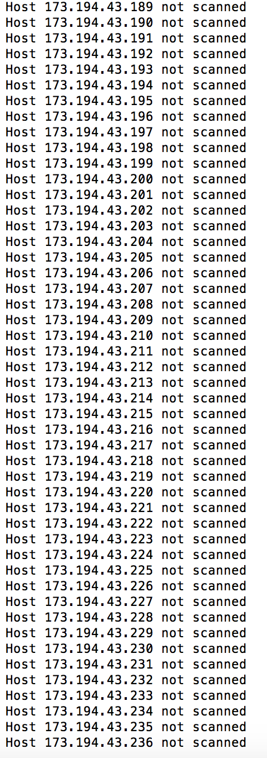

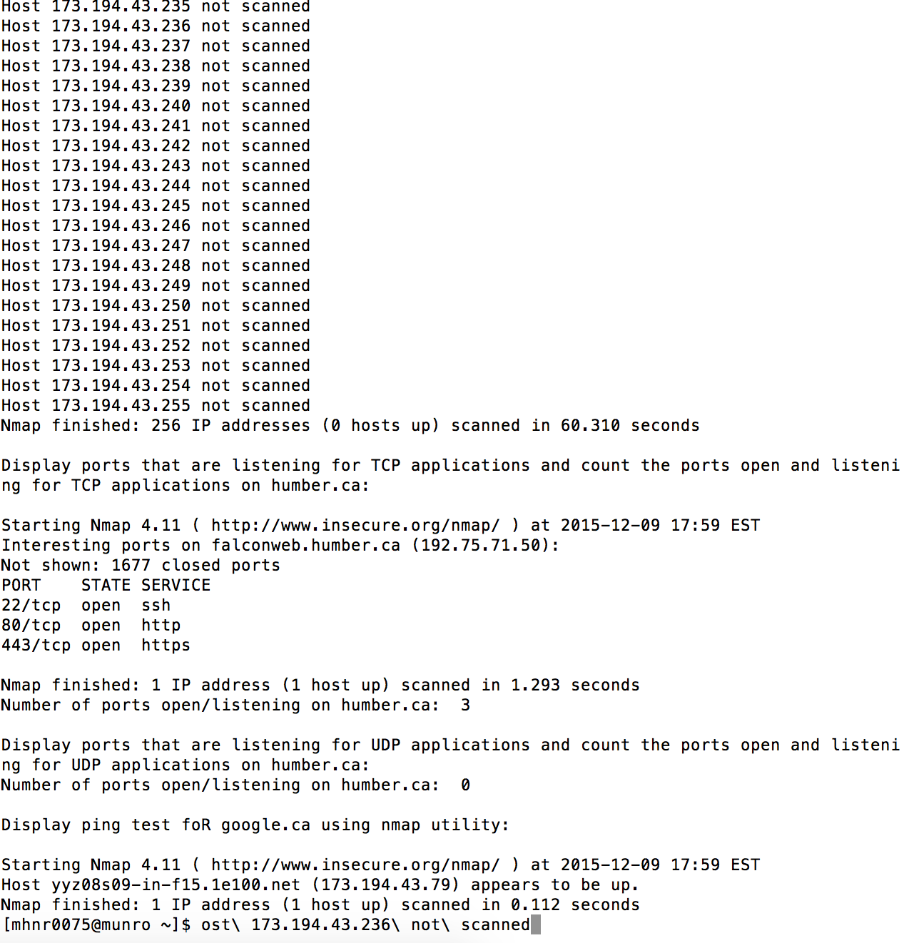

**Script 4**

CENG320_p4.sh:

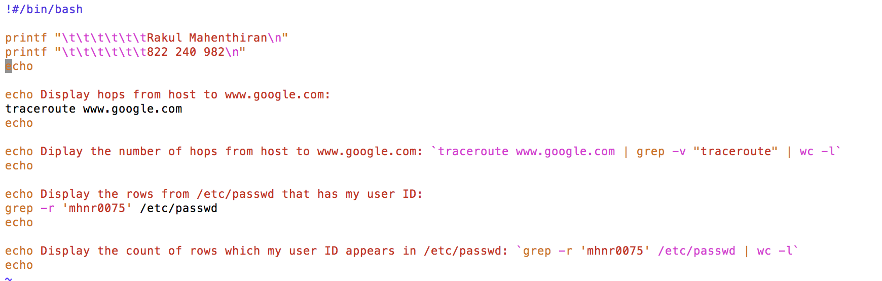

Client:

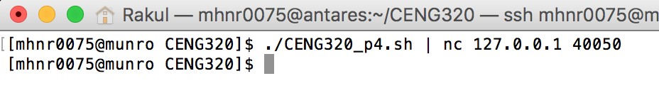

Server:

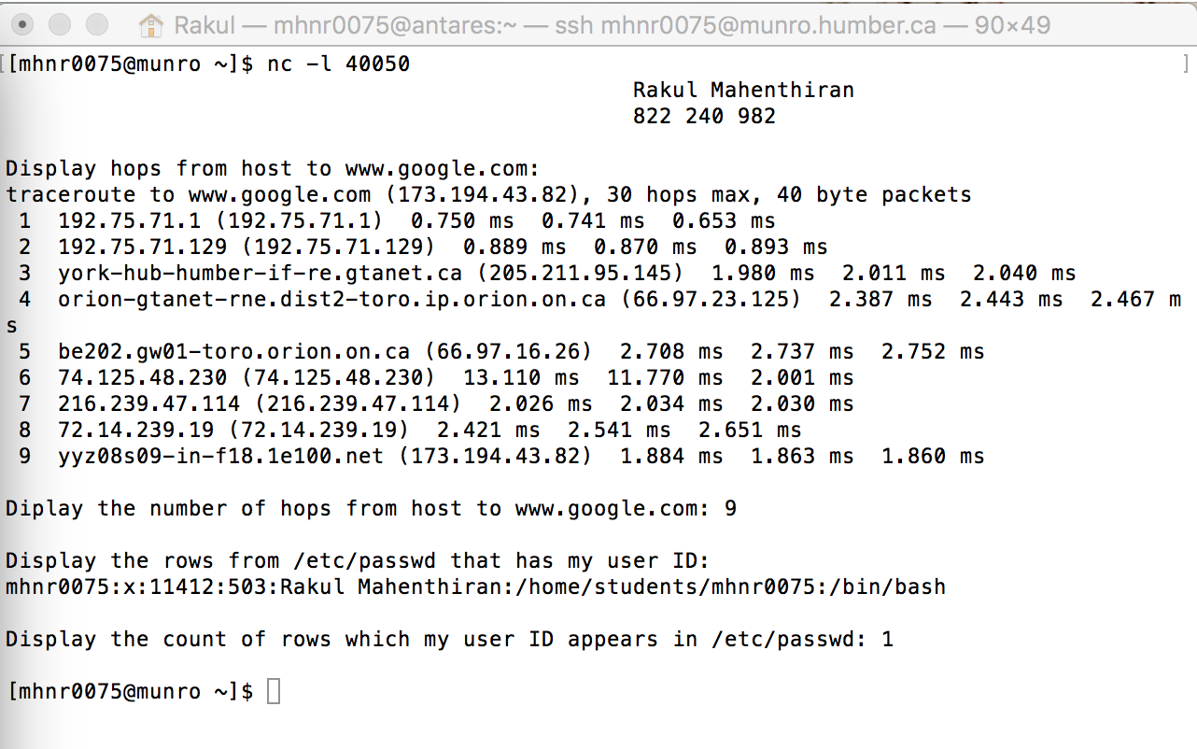

**Follow up Question:**

Netcat utility:

* The netcat utility is used for just about anything under the sun involving TCP or UDP communication. It can open TCP connections, send UDP packets, listen on arbitrary TCP and UDP ports, do port scanning, and deal with both IPv4 and IPv6.
* A system administrator can use this for simple TCP proxies, shell-script based HTTP clients and servers, network daemon testing, a SOCKS or HTTP ProxyCommand for ssh(1) and much, much more.
* Some netcat options are as follows:

-4 Forces nc to use IPv4 addresses only.

-6 Forces nc to use IPv6 addresses only.

-D Enable debugging on the socket.

-d Do not attempt to read from stdin

-h Prints out nc help.

Nmap utility:

* Nmap is an open source tool for network exploration and security auditing. It was designed to rapidly scan large networks, although it works fine against single hosts.
* A systems administrator will find it useful for routine tasks such as network inventory, managing service upgrade schedules, and

monitoring host or service uptime.

* Some nmap options are as follows:

-sL (List Scan)

-sP (Ping Scan)

-P0 (No ping)

-PS [portlist] (TCP SYN Ping)

-PE; -PP; -PM (ICMP Ping Types)

-PR (ARP Ping)

-n (No DNS resolution)

-R (DNS resolution for all targets)

Netstat utility:

* Netstat command displays various network related information such as network connections, routing tables, interface statistics, masquerade connections, multicast memberships etc.
* A systems administrator will find it useful to monitor and troubleshoot their network related problems and determine network traffic performance.
* Some netstat options are as follows:

--route , -r

Display the kernel routing tables.

--groups , -g

Display multicast group membership information for IPv4 and IPv6.

--interface=iface , -i

Display a table of all network interfaces, or the specified iface).

--masquerade , -M

Display a list of masqueraded connections.

--statistics , -s

Display summary statistics for each protocol.