# Chapter 3: Design

## Introduction

The stage of development where all the decision regarding the final product are made to make the product much better and smooth is known as design in programming. User interface, logical function are planned before the coding of an application in the design phase. It is executed based on the requirements of the application.

## 3.1 Structural Modelling

Structural Modelling is an analysis technique which presents the logical organization of the objects without indicating how they are stored, created, or manipulated so that analysts can focus on the business, without being distracted by technical details. (STRUCTURAL MODELING, 2020)

## 3.1.1 Class Diagram

Class diagram is a static diagram which represents the static view of an application. It describes the attributes and operations of a class and also the constraints imposed on the system. It is a part of unified modelling language. (UML - Class Diagram, 2020)

The importance of class diagram are:

* To show the classes and how it interacts within the system.
* To show the relationship between class and object as it is an object oriented application.
* To outline all the object which the system contains and finalize relationship between them.
* To reduce maintenance time as it provides the structural diagram of the application.

Notation of Class Diagram:

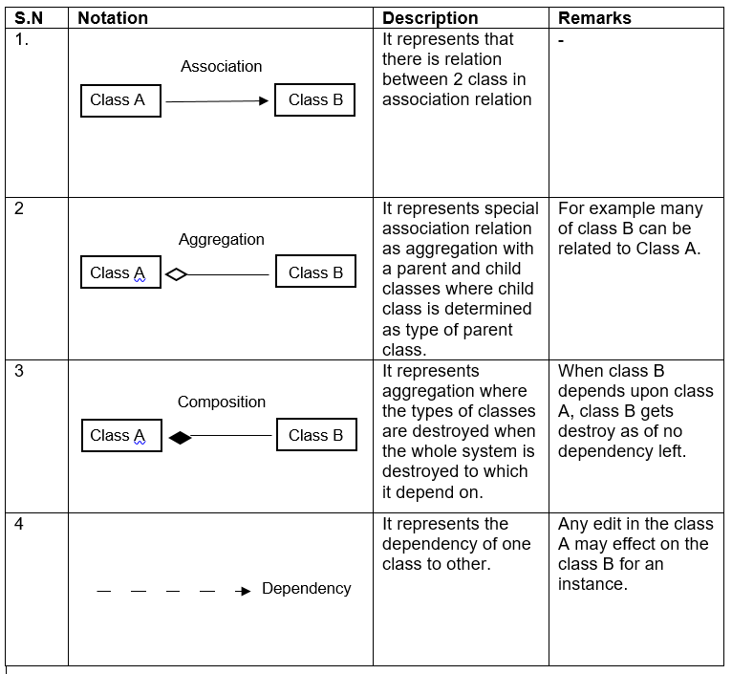

Table 5: Class Diagram Notation

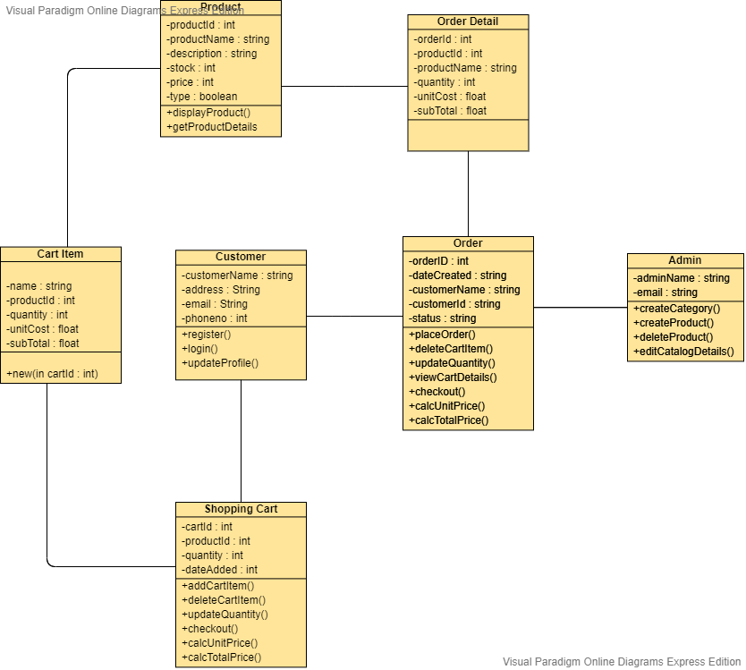

Figure 4: Class Diagram

## 3.1.2 Data Flow Diagram [DFD]

Data Flow Diagram (DFD) shows the flow of the system through a business procedure where it signifies all the inputs, output, data storage and other process which occurs in the website.

The importance of the data flow diagram are:

* Helps to narrate the end lines of the system.
* Can be included as a report in pre-implementing plans.
* Reduces data redundancy.
* Its structural diagram shows the execution of the website.

Notation of Data Flow Diagram (DFD):

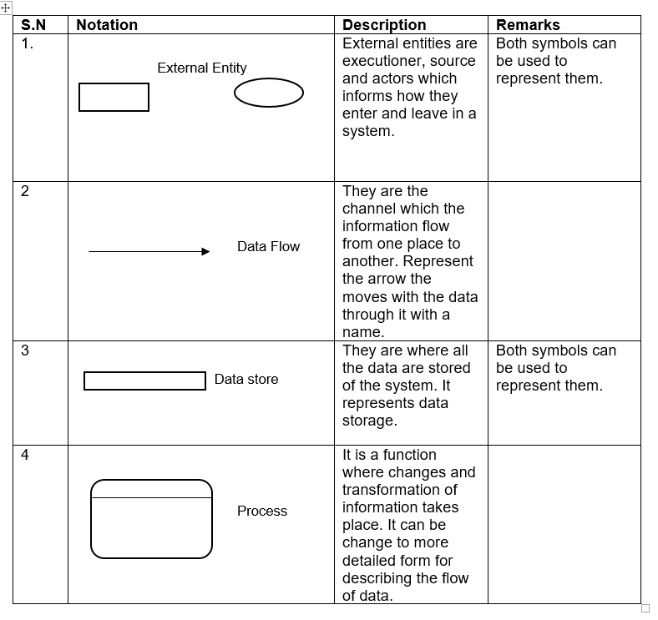

Table 6: Notation Diagram of Data Flow Diagram

Admin DFD:

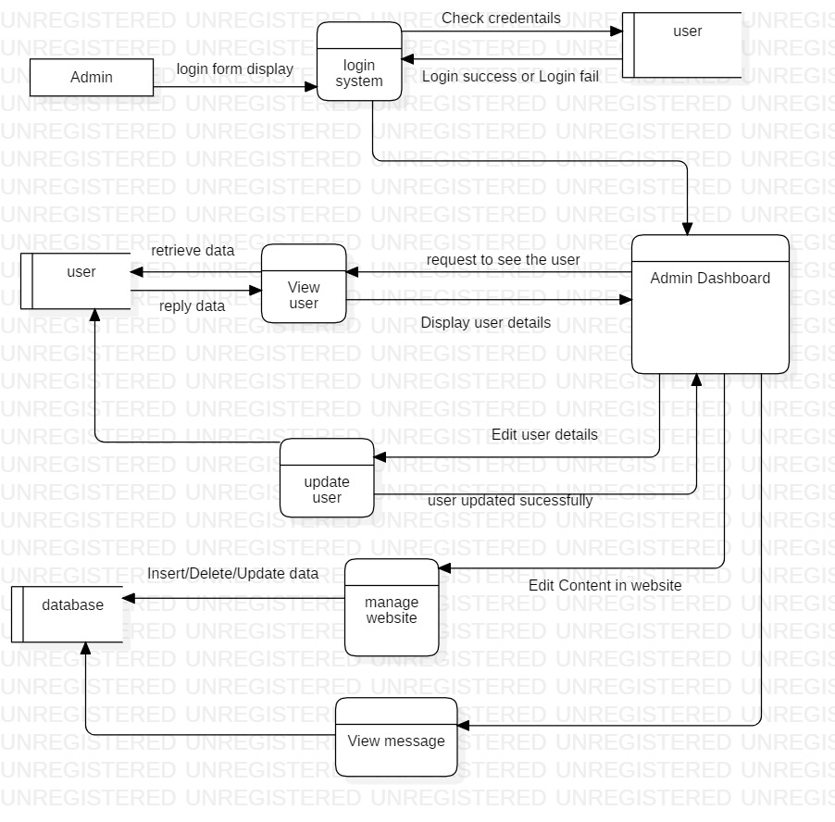

Figure 5: Admin DFD

## 3.2 Behavioral Modelling

Behavioral models describe the internal dynamic aspects of an information system that supports the business processes in an organization. During analysis, behavioral models describe what the internal logic of the processes is without specifying how the processes are to be implemented. Later, in the design and implementation phases, the detailed design of the operations contained in the object is fully specified. (BEHAVIORAL MODELING, 2020)

## 3.2.1 Activity Diagram

Activity Diagrams describe how activities are coordinated to provide a service which can be at different levels of abstraction. It describes the flow of methods to another method in a system.

Importance of activity diagram are:

* Helps to finalize the use case diagram.
* Views the flow of function in the system.
* It simplifies and improves complicated methods.
* It describes all logic of the system in particular diagrams.

Notations of activity diagram are: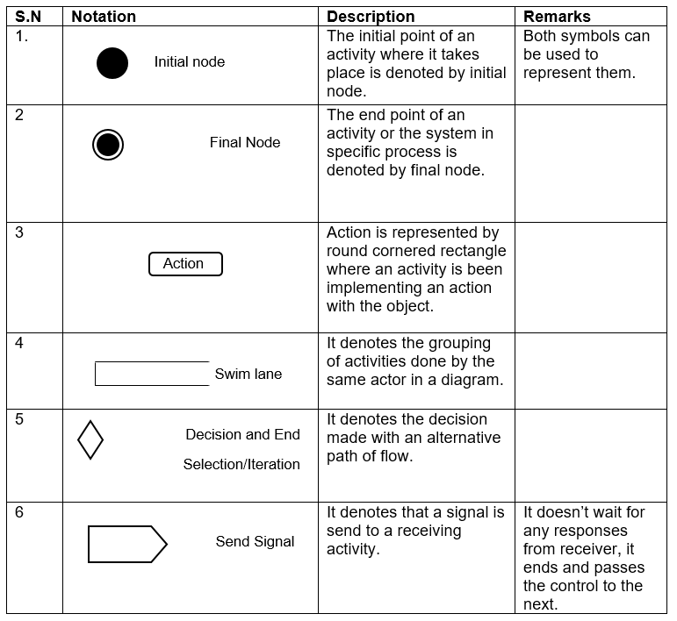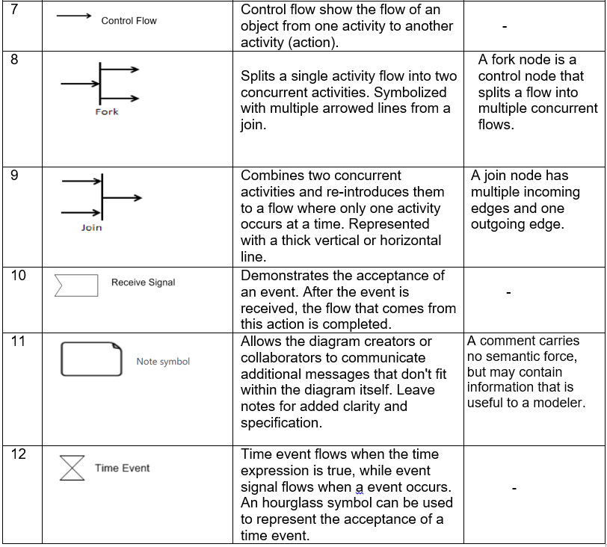

Table 7: Notation of activity diagram

Activity diagram of login and registration:

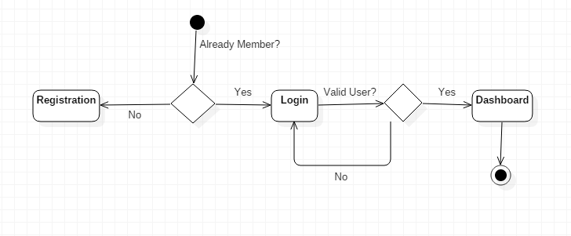

Figure 6: Activity Diagram of login and registration

## 3.2.2 Sequence Diagram

Sequence Diagrams are interaction diagrams that detail how operations are carried out. They capture the interaction between objects in the context of a collaboration. Sequence Diagrams are time focus and they show the order of the interaction visually by using the vertical axis of the diagram to represent time what messages are sent and when. (Sequence Diagram, 2020)

The importance of Sequence diagram are:

* It shows the reaction with object and its operations.
* It helps to plan and understand the function of object for future reference.
* It helps to adjust the operation of the system.
* It identifies problem, interface and architectural problems.

Notations of sequence diagram are:

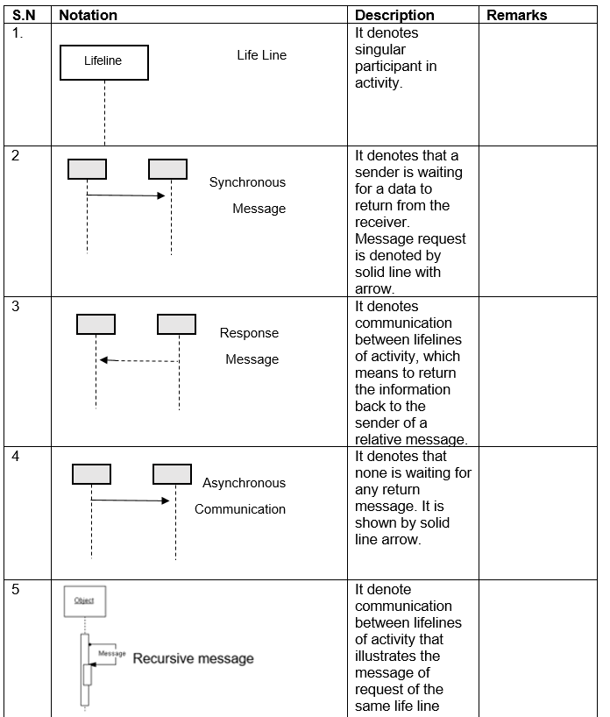

Table 8: Notation of Sequence Diagram

Sequence diagram of login system:

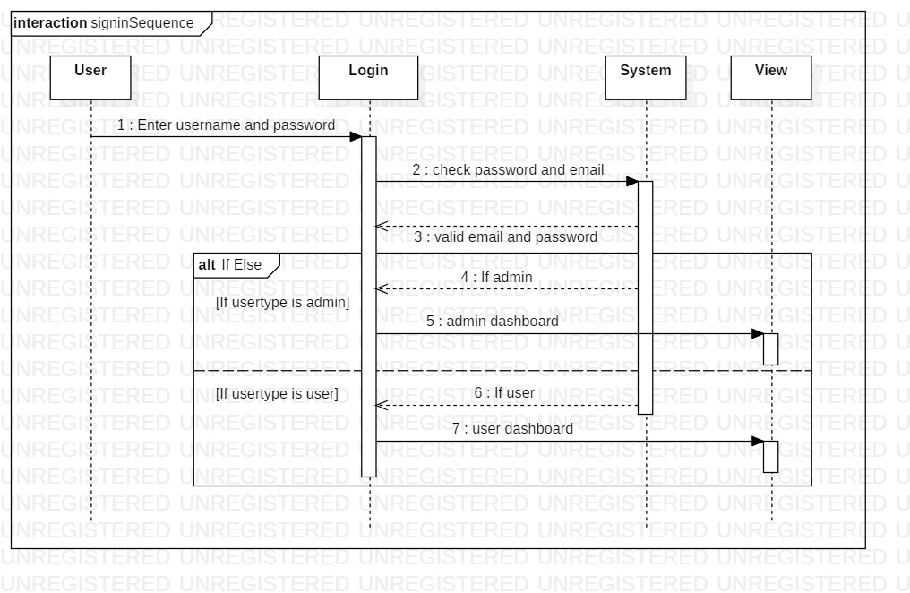

Figure 7: Sequence Diagram of login system

## 3.3 Database Modelling

**Database modelling (data modelling)** is the process of creating a data model for the data to be stored in a Database. This data model is a conceptual representation of Data objects, the associations between different data objects and the rules. Data modeling helps in the visual representation of data and enforces business rules, regulatory compliances, and government policies on the data. Data Models ensure consistency in naming conventions, default values, semantics, security while ensuring quality of the data. (Data Modelling, 2020)

## 3.3.1 ER Diagram

ER (Entity Relationship) diagram is a pictorial diagram illustrating the relationship between class, objects, function, etc. as per the requirement of the system and given by the client.

Importance of ER diagram:

* Object and attributes can be determined.
* Show the relation with one entity to another.
* It shows the number of relations implemented in the entity.

Table 9: ER Diagram

## 3.3.2 Data Dictionary

It is a set of data and information which contains metadata such as table name, column name, attributes, and related information.

|  |  |
| --- | --- |
| **S.N** | **Table Name** |
| 1 | Admin Table |
| 2 | Customer Table |
| 3 | Product Table |
| 4 | Order Table |
| 5 | Shopping Cart Table |
| 6 | Order Details Table |
| 7 | Cart Item Table |

Table 10: Table Names

Admin Table

|  |  |  |  |  |
| --- | --- | --- | --- | --- |
| Column Name | Type | Length | Nullable | Key |
| ID | Int | 10 | Not nullable | Primary Key |
| First_name | Varchar | 255 | Not nullable |  |
| Last_name | Varchar | 255 | Not nullable |  |
| Email | Varchar | 255 | Not nullable |  |
| Password | Varchar | 100 | Not nullable |  |

Table 11: Table Names

Table 12: Data Dictionary

## 3.4 UI Modelling

The process of developing front end layout of the website or an application before implementing in the back end of the system is called UI (User Interface) modeling. UI is very important nowadays as every people trust in a friendly user interface which help them to use it in an easy and smooth order. As my project is a website it is the key component of the project. Here, I have designed my layout in an external application called Balsamic.

## 3.4.1 Prototyping

Prototype is rough sketch of the layout of the front end design of any application or a website to sort out future problems. It helps to show the client how the system work in a user interface module.

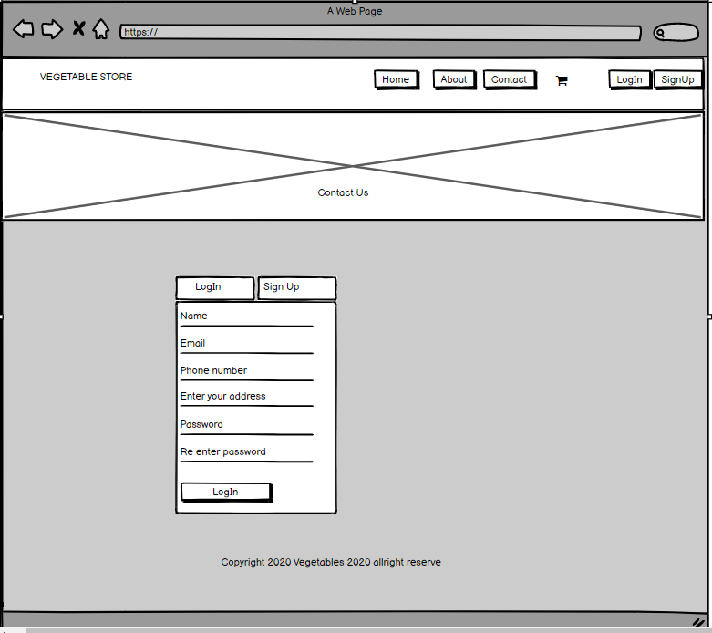

Figure 6: Registration Form

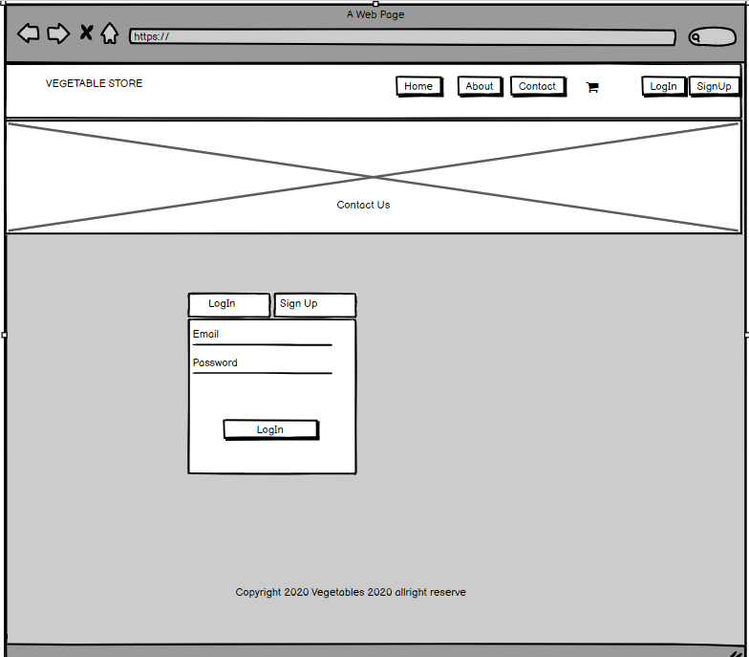

Figure 7: Login Form

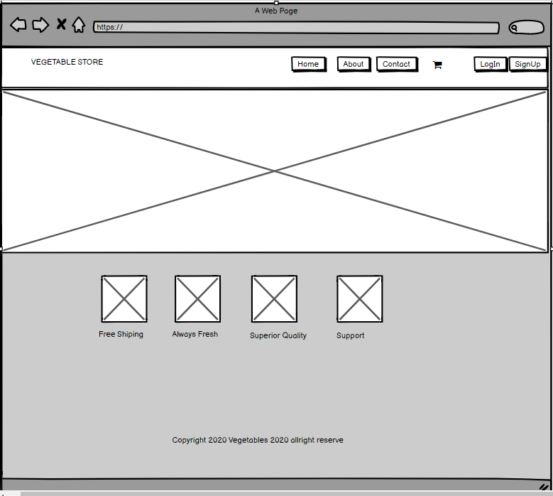

Figure 8: User’s Homepage

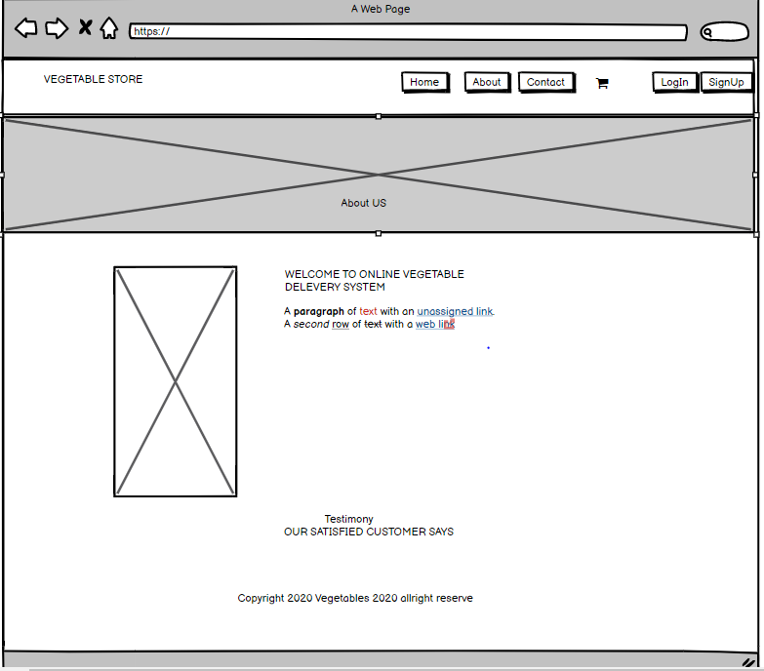

Figure 9: About Us

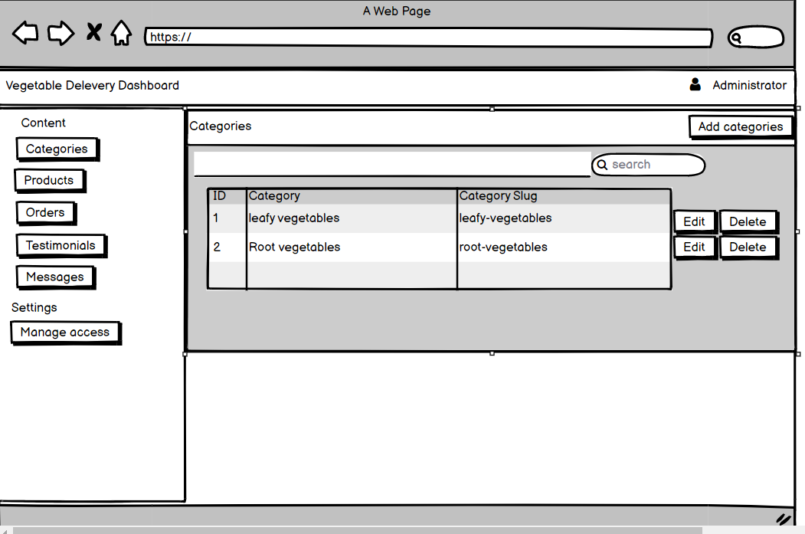

Figure 10: Add Category

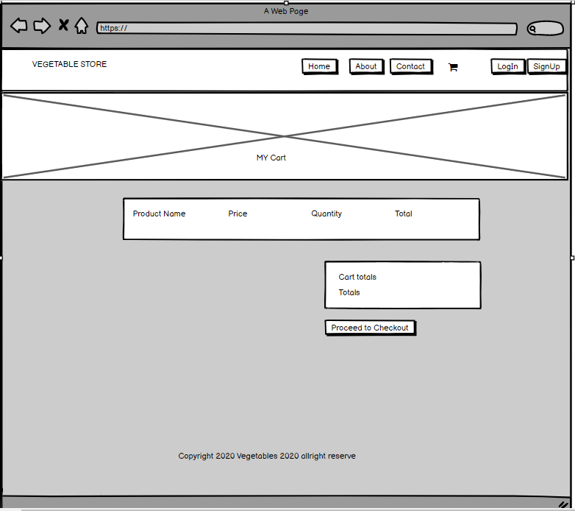

Figure 11: Add to Cart

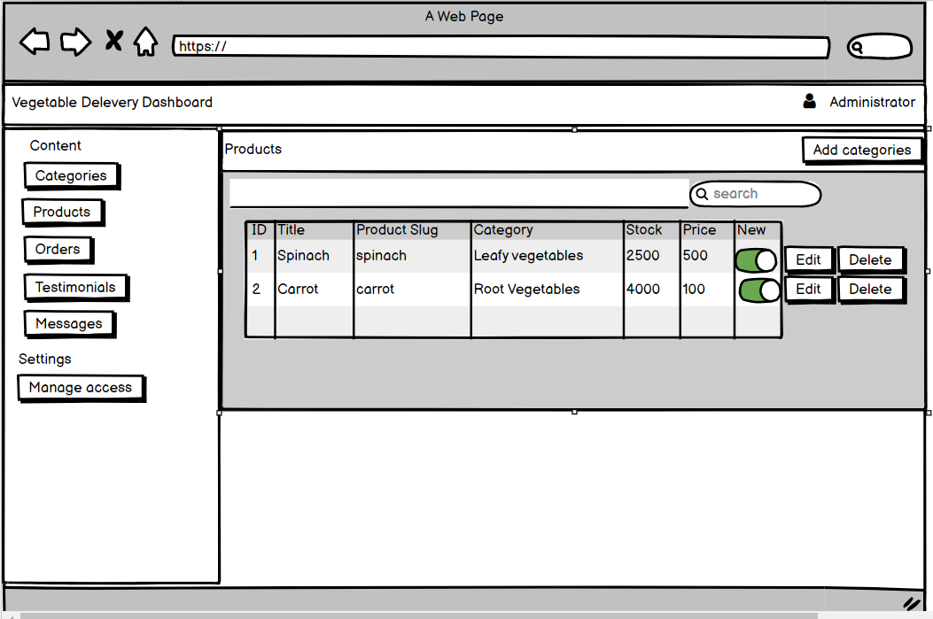

Figure 12: Add Product

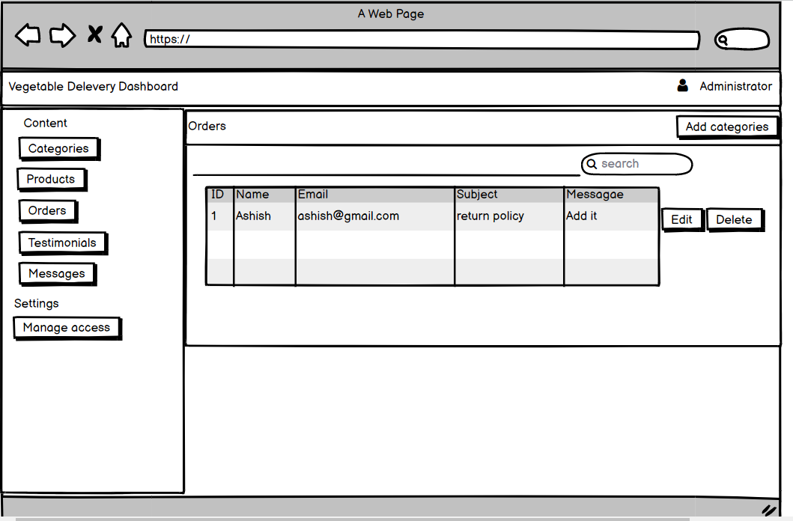

Figure 13: Message to Admin

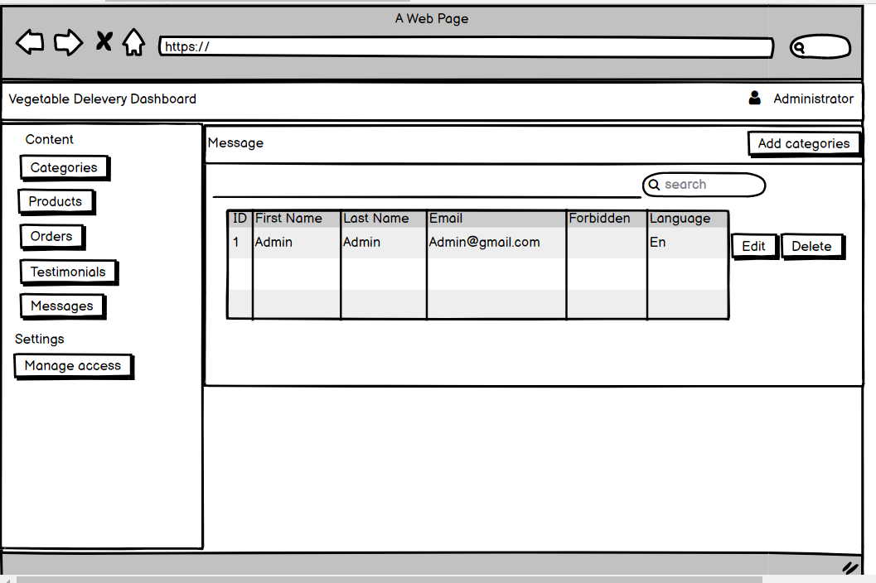

Figure 14: Manage Access