Contents

Table of Figures 2

Table of Tables 3

Chapter 1 4

Introduction 4

1.1 Introduction of the system 4

1.2 Background of the system 4

Problem Statement 4

1.3 Justification of the project 5

1.4 Overview of the purposed system 5

Chapter 2 6

Scope 6

2.1 Aims of the project 6

2.2 Objectives of the project 6

2.3 Feature of the project 6

2.4 Overview of the Scope 7

Chapter 3 8

Development Methodologies 8

3.1 Methodologies 8

3.2 Design Pattern 9

3.3 System Architecture 10

Chapter 4 11

Scheduling 11

4.1 WBS (Work Breakdown Structure) 11

4.2 Milestones 12

4.3 Gantt Chart 13

Chapter 5 15

Risk Management 15

Chapter 6 17

Configuration Management 17

Conclusion 18

# Table of Figures

Figure 1: Waterfall Approach 7

Figure 2: System Architecture 9

Figure 3: Work Breakdown Structure 10

Figure 4: Gantt Chart 13

# Table of Tables

Table 1: Milestones 11

Table 2: Gantt Chart Table 12

# Chapter 1

## Introduction

## Introduction of the system

Online vegetables and fruits is a functional website which is made to provide a platform for people in agricultural sectors. It facilitates both the sellers and buyers. It eases sellers by providing a platform to sell their products online to maximize their profits and eases buyers by supplying a platform where they can purchase the products they are in need of.

## Background of the system

Online vegetables and fruits as of now is delivering the products based on mobile calls. It is planning to expand its business by launching a website which provides an interface for both the customers and sellers to buy and sell their products. To launch a website the organization is planning to hire an institution to develop a suitable, user-friendly website which will meet the criteria of the website. The initial system of delivering the product has been done manually through mobile phones. So, the delivering company is making efforts to display all of their items on the user’s screen which will help both sides.

And launching website will make the company better. It will help to keep records of all the transactions, save users valuable information, maximize profits by utilizing and analyzing the users’ records of transactions.

### Problem Statement

The main aim of the online vegetables and fruits is to build a website which will be user-friendly, efficient, and less hazel. The company is making plans to manage the valuable data which will be an important aspect to uplift the profit margins of the company. It is launching website to simplify and automate the delivering system, payment methods, product details, etc.

The drawbacks of the current system are:

1. The delivery is little more time consuming.
2. Massive use of manual data recording system.
3. Leak in the information of the users’ and their transactions.
4. Unmanaged collection of records.
5. Users not being able to know the proper information about the products.

## 1.3 Justification of the project

The company has a massive number of users. To maintain the records of transactions and other important information the company is planning to upgrade their system from mobile based calls to a web-based system where users can not only call but also view their transactions, product details, etc. The new proposed system will overcome the drawbacks that were faced during the use of old system.

With the implementation of website, the company will be efficient, reliable, better than previous system. It will be able to keep proper track of their customers, sellers, their product details, transactions. The users who are using the system can also be reliable on the system since the information provided in the website is much reliable and verified. The new proposed system solves major problems faced in old system such as better delivery, better quality of products, every information about the product, etc

## 1.4 Overview of the purposed system

The new proposed system will allow sellers to contact the admin and sell their products online. Similarly, it will allow buyers to buy their desired product online. The new website will also facilitate users to deliver their desired needs in the website by providing them a contact access.

Similarly, the company will also benefit implementing the newly proposed system as it will be able to manage all the records of the users, their valuable assets.

# Chapter 2

## Scope

## 2.1 Aims of the project

The main goal of the system is to simplify and automate the record files and information related to the users like their personal information, their transaction details, etc.

1. To increase the performance, accuracy, reliability, and quality service.
2. To secure the personal data, payment details of the customers.

## 2.2 Objectives of the project

The main objective of the project is to improve the drawbacks faced during the old system. Some of those objectives are:

1. Provide accurate, updated, relevant details about the product.
2. To minimize traditional approaches.
3. To secure information about the customers.
4. To deliver better delivery services.

## 2.3 Feature of the project

The features of the project are:

1. **CRUD Function**

Admin can edit the information about the details they want like add, delete and update in database.

1. **Product Management**

Add new product, their details on the website.

1. **User Management**
2. Register new user to the system, delete existing user.
3. **Dashboard**

View all the details like the users’ information, product details, etc.

1. **Add to Cart**

Users will be able to purchase the product shown on the dashboard, and add to their cart if they want.

1. **Online Delivery**

The product will be delivered online. As for the payment it will be cash on delivery.

## 2.4 Overview of the Scope

The function of the system is to automate the overall system. It will make the selling of fruits and vegetables on large scale. It will also solve the delivery problems people face during the online delivery of products. The complete project will provide a better website which will facilitate users. With the use of website, users will be able to register and login to the system. By logging to the system, they will be able to sell and buy their products online.

The system will also provide online delivery where sellers will delivery the product selected by the buyers at their door. The payment method initially involves cash on delivery. It will be further upgraded to online payment system in the future. As of now, the payment will be done after the buyer confirms the product. As for administrative side, the admin can add new category, product, modify the users role, confirm the transactions, manage users registered in the system.

# Chapter 3

## Development Methodologies

## 3.1 Methodologies

For my project, the development methodology that I have chosen is Waterfall Method. It was the first Process Model to be introduced to us and is referred as a traditional methodology. Waterfall Method demonstrates the software process in a linear sequential flow. Since the model follows the linear sequential flow the development process begins only if the previous phase is complete.

The following illustration represents the different phases of the waterfall model.

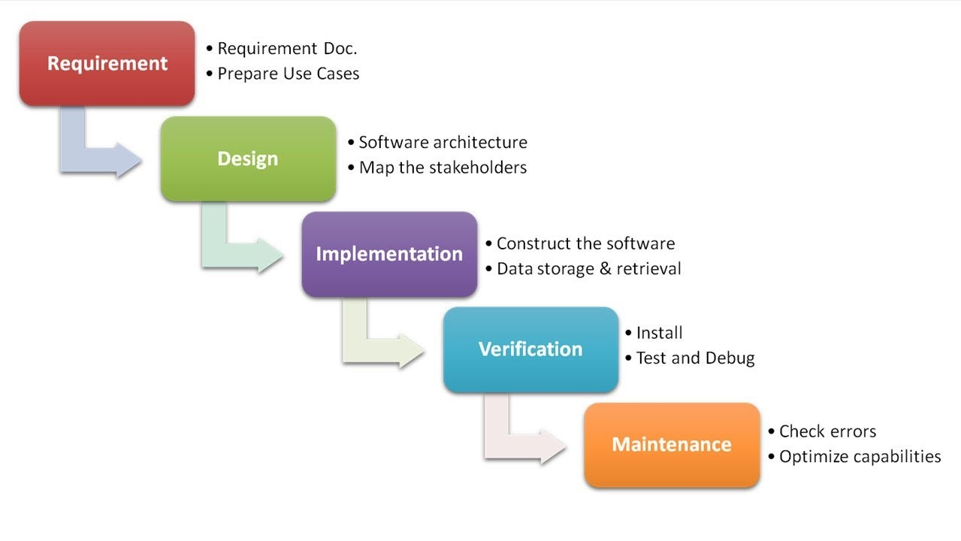

Figure 1: Waterfall Approach

## 3.2 Design Pattern

Out of the several design patterns available, the design pattern that I have chosen is Object-Oriented Programming (OOP). The reason why I have chosen this pattern is because this design pattern is much cleaner and modular compared to other design patterns. This design pattern is easy to test, debug and has better maintenance properties.

Object-Oriented Programming involves four major principles. They are:

1. Encapsulation.
2. Abstraction.
3. Inheritance.
4. Polymorphism.

## 3.3 System Architecture

System architecture means the abstract model of any system that defines its structure, behavior, and more views.

For my project, I have used 3-tier architecture. 3-tier architecture is the software architecture that is used in application as a specific type of client-server system. It is composed of 3 layers/tiers of logical computing. They are Presentation tier, Application tier and Data tier. The benefit of using this system architecture is enhanced speed of development, better scalability, performance and availability.

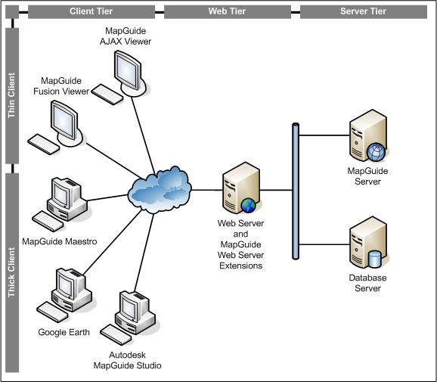

Figure 2: System Architecture

# Chapter 4

## Scheduling

## 4.1 WBS (Work Breakdown Structure)

The workflow that organizes the team work to manageable process is called work breakdown structure. It is important for planning and executing the project.

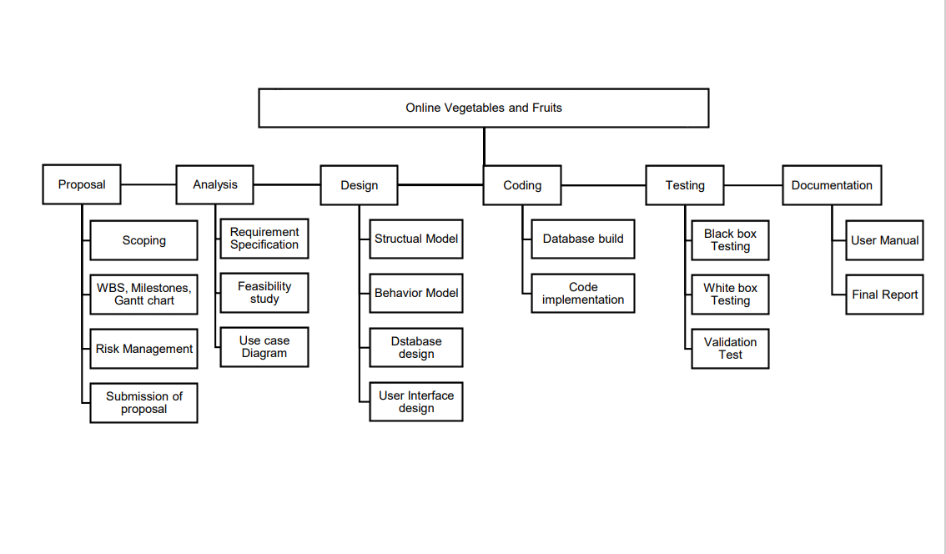

Figure 3: Work Breakdown Structure

## 4.2 Milestones

|  |  |  |
| --- | --- | --- |
| Task Name (Milestones) | No. of days | Date |
| **Proposal**  Scoping  WBS, Milestones, Gantt chart  Risk Management  Submission of proposal | **16**  4  5  4  3 | **16th June – 1st July, 2020**  16th June – 19th June, 2020  20th June – 24th June, 2020  25th June – 28th June, 2020  29th June – 1st July, 2020 |
| **Analysis**  Requirement Specification  Feasibility study  Use Case Diagram | **28**  26  10  2 | **2nd July – 29th July, 2020**  2nd July – 17th July, 2020  18th July – 27th July, 2020  28th July – 29th July, 2020 |
| **Design**  Structural Model  Behavior Model  Database Design  User Interface design | **31**  9  8  8  6 | **30th July – 29th August, 2020**  30th July – 7th August, 2020  8th August – 15th August, 2020  16th August – 23rd August, 2020  24th August – 29th August, 2020 |
| **Coding**  Database build  Code implementation | **22**  5  17 | **30th August – 20th September, 2020**  30th August – 3rd September, 2020  4th September – 20th September, 2020 |
| **Testing**  Black Box Testing  White box Testing  Validation Test | **10**  3  5  2 | **21st September – 30th September, 2020**  21st September – 23rd September, 2020  24th September -28th September, 2020  29th September – 30th September, 2020 |
| **Final Documentation**  User Manual  Final Report | **12**  5  7 | **1st October – 12th October, 2020**  1st October – 5th October, 2020  6th October – 12th October, 2020 |
| **Total Days** | **119** |  |

Table 1: Milestones

## 4.3 Gantt Chart

Gantt Chart is a figure which shows task activities with time. It is made in a horizontal manner showing time span and work breakdown showing the tasks of the project.

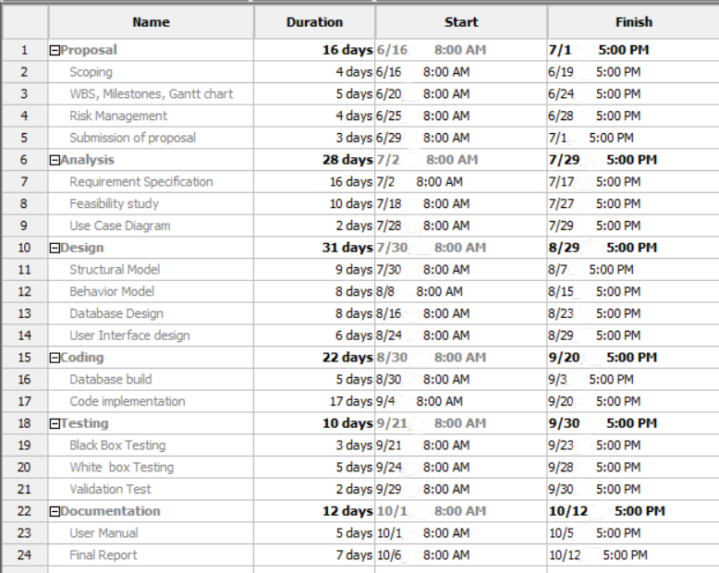

Table 2: Gantt Chart Table

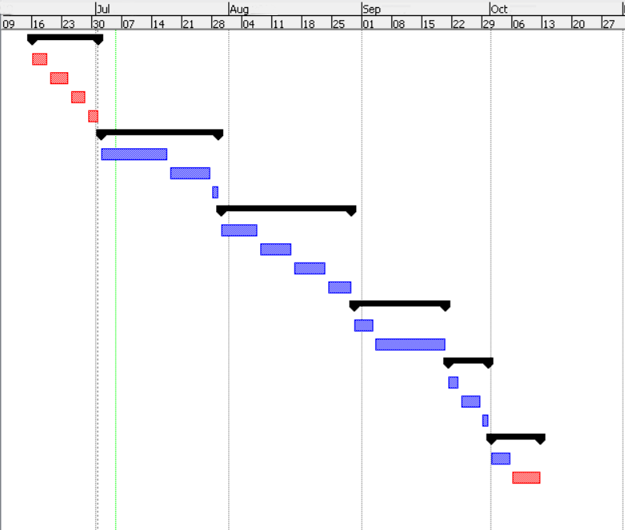

Figure 4: Gantt Chart

# Chapter 5

## Risk Management

The process of assessing, identifying and controlling threats to an organization’s fund or earning is called risk management. These threats, or risks, could stem from a wide variety of sources, including financial uncertainty, legal liabilities, strategic management errors, accidents and natural disasters.

All risk management processes follow the same basic steps, although sometimes different jargon is used to describe these steps. Together these 5 risk management process steps combine to deliver a simple and effective risk management process.

Step 1: Identify the Risk.

This process unleashes the risk of the project. Project risk register technique can be applied.

Step 2: Analyze the risk.

After identifying the risk, the institute tries to separate the risk of it occurring and its consequences.

Step 3: Evaluate or Rank the Risk.

Risk is further evaluated by determining its risk portion which is combination of consequences and likelihood.

Step 4: Treat the Risk.

The organization evaluate all the risk by ranking all the risk the organization is going to face. Its preventives are prevention tactics, risk mitigation process and contingency plan.

Step 5: Monitor and Review the risk.

Now we collect the data from the project risk register and use it to find and review the risks.

Likelihood table:

|  |  |
| --- | --- |
| **Likelihood** | **Value** |
| Low | 1 |
| Medium | 2 |
| High | 3 |

Risk consequences table:

|  |  |
| --- | --- |
| **Consequence** | **Value** |
| Very low | 1 |
| Low | 2 |
| Medium | 3 |
| High | 4 |
| Very high | 5 |

Risk Management table:

|  |  |  |  |  |  |
| --- | --- | --- | --- | --- | --- |
| **RID** | **Risk Name** | **Likelihood** | **Consequence** | **Impact** | **Action** |
| R1 | Requirements Change | 3 | 5 | 15 | Proper analysis of requirement in the beginning of the project. |
| R2 | Threats of virus | 2 | 3 | 6 | Antivirus installation. |
| R3 | Untrained employee | 2 | 3 | 6 | Training should be given to training. |
| R4 | Failure of server | 1 | 5 | 5 | Backup of data. |
| R5 | Improper estimation of budget | 1 | 5 | 5 | Requirement analysis should be implemented. |
| R6 | Stakeholder conflicts | 2 | 5 | 10 | Identification of stakeholder who has correct set of invest and resources. |

# Chapter 6

## Configuration Management

Configuration management is a process for maintaining computer systems, servers, and software in a desired, consistent state. It’s a way to make sure that a system performs as it’s expected to as changes are made over time. It also helps to protect the physical and logical assets. It seeks to find the configuration item, interdependencies and functional capabilities.

We have used GitHub to manage the project and have kept the related files and folders of the project for availability.

To access the files:

# Conclusion

This website application makes efficient use of the information related to users. It secures users’ data and information. It also analyzes all the transactions of the users in case of emergency. It will assist both the sellers and buyers and manages the products and their delivery services. The main purpose of the website is to facilitate users.

To complete the project, I have performed different kinds of analysis, study, design, etc. to make a better web application which will help to fulfill all the requirements of the users.