Acrobot Documentation

Contact: David Michelman, ([daweim0@gmail.com](mailto:daweim0@gmail.com), [miched@rpi.edu](mailto:miched@rpi.edu))

Hardware:

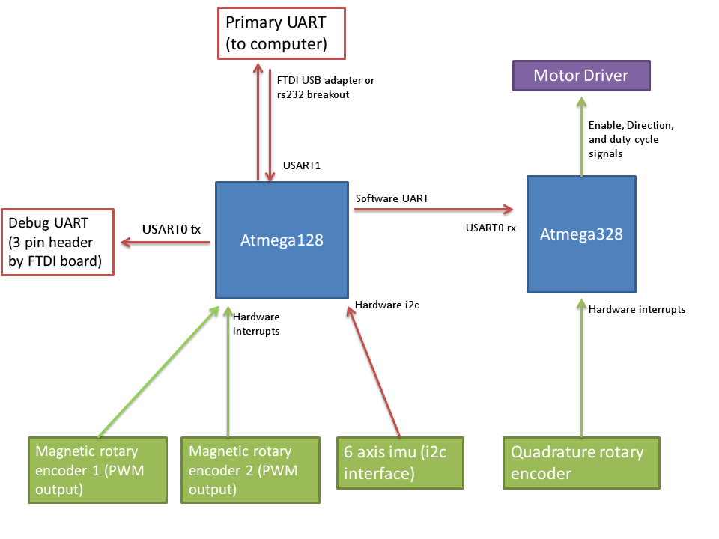

AVR Software:

All avr code used in this project was written in Atmel Studio 7. The atmega128 manages most sensor inputs and serial communications with a computer. Its firmware is in the “acrobot_compiler_testing” project. The atmega328 acts as a motor driver, taking serial input from the atmega128 and reading the rotary encoder on the elbow joint and setting the motor power levels. Its firmware is in the “rotary_encoder_motor_4” project. The firmware for the atmega128 is mostly stable while the firmware for the atmega328 has not yet been developed to a functional state. See comments in both for further description.

Python Software:

All the python code is contained in the pyode folder. The most important parts were documented, the rest may or may not be useful.

Dependencies:

Hardware.py only requires pyserial and numpy to function. The simulation code relies on the Open Dynamics Engine and its python bindings for the simulation in ode_interface.py and simulation.py (use the python binding packaged with ODE, don’t use pyode). Cython is used to speed up some functions in lookup_table_hopper.py but pure python versions still exist in lookup_table_hopper.py. Setting use_cython to false (set on line 69 of lookup_table_hopper.py) should remove the cython dependency, but is probably buggy.

Important files:

This is a list of all the files that might be important. The more important files have short descriptions.

* 3dGrapher.py
* acrobot_math.py
* acrobot_state.py -A helper data structure for storing the position of an acrobat. (lists of size 4 or 5 are also used in older sections of the code)
* balance_curve.csv
* build_cython.sh -compiles lookup_table_hopper_helper.pyx and tests it against the pure python version
* dampening.py
* hardware_listener.py
* hardware_lookup_table_generator.py
* hardware.py -Sends and receives data from the acrobat hardware. It should be interchangeable with ode_interface.py (in theory)
* hardware_simulation.py -Acts as a main class for all acrobat activities, **simulated or real**. A lot of parameters (such as the target state and whether ODE or the acrobat hardware should be used) can be controlled by changing the default values of the arguments of run().
* hopper2.py
* input_box.py -used in the graphical simulation
* interpolation_consistancy_checker.py -Checks lookup_table_hopper_helper.pyx against the python version (for debugging).
* logger.py -Utility for writing csv files
* lookup_table_checker.py -Checks the accuracy of a lookup table against ODE
* lookup_table_generator_interpolated.py -Creates lookup tables from logs generated by hardware_lookup_table_generator.py
* lookup_table_generator.py - Creates lookup tables from ODE
* lookup_table_hopper_helper.pyx -Cython files
* lookup_table_hopper.py -Actually searches the lookup table for possible paths. This file has much better comments than the rest, so reading through it is probably better than a summary here.
* ode_interface.py -A wrapper for ODE (the physics library used). It lets ODE and the actual hardware be used interchangeably
* parameter_optimizer.py
* parent_log_trimmed.csv
* pid.py
* setup.py -Compiles lookup_table_hopper_helper.pyx
* simulation.py
* start_parallel.bat
* stop, stop.py -An emergency stop for the hardware

The following files are previously generated lookup tables (both from the hardware and simulation). The parameters following table and number are the dimensions of the table and maximum/minimum angles stored. Table names are parsed in the function get_table_name() in lookup_table_hopper.py

* table114_[1.2, 1.8, -0.5, 0.5, -0.8, 0.8, -1.25, 1.25, -1, 1, 0.025, 0.025, 0.25, 10, 0, 0].npy
* table115_[1.45, 1.65, -0.2, 0.2, -0.8, 0.8, -1.25, 1.25, -1, 1, 0.01, 0.025, 0.25, 10, 0, 0].npy
* table116_[1.45, 1.65, -0.2, 0.2, -0.8, 0.8, -1.25, 1.25, -1, 1, 0.01, 0.025, 0.25, 10, 0, 0].npy
* table117_[0.8726646259971648, 2.0943951023931953, -0.8726646259971648, 0.8726646259971648, -2.0, 2.0, -4.0, 4.0, -100, 100, 0.1, 0.2, 10, 10, 0, 0].npy
* table200_[0.8726646259971648, 2.0943951023931953, -0.8726646259971648, 0.8726646259971648, -2.0, 2.0, -4.0, 4.0, -80, 80, 0.15, 0.25, 20, 10, 0, 0].npy
* table27_[0, 6.283185307179586, -3.141592653589793, 3.141592653589793, -2.0, 2.0, -4.0, 4.0, -40, 40, 0.2, 0.2, 2].npy
* table28_[0, 6.2831853071795862, -3.1415926535897931, 3.1415926535897931, -1.5, 1.5, -4.0, 4.0, -60, 60, 0.29999999999999999, 0.29999999999999999, 4].npy
* table300_[0, 6.283185307179586, -3.141592653589793, 3.141592653589793, -2.0, 2.0, -3.0, 3.0, -1.0, 1.0, 0.1, 0.1, 0.5, 10, 0, 0].npy

These files are used in the interactive simulation

* parent_log_balance_curve.csv - A list of balanced points
* parent_log_balance_curve_left.csv - A list of points with an elbow angle slightly smaller than balanced
* parent_log_balance_curve_right.csv - A list of points with an elbow angle slightly greater than balanced