**How to connect to RDS instance using AWS Console and Session Manager or AWS CLI with SSM plugin**

When or after you create your Bastion host make sure that you attach a role to the EC2 instance which contains the “AmazonSSMManagedInstanceCore” policy.  
  
In order to connect to RDS instance through bastion host, there has to be Inbound rule in the database Security group which allows inbound traffic to specific port from private IP or security group of the bastion host.

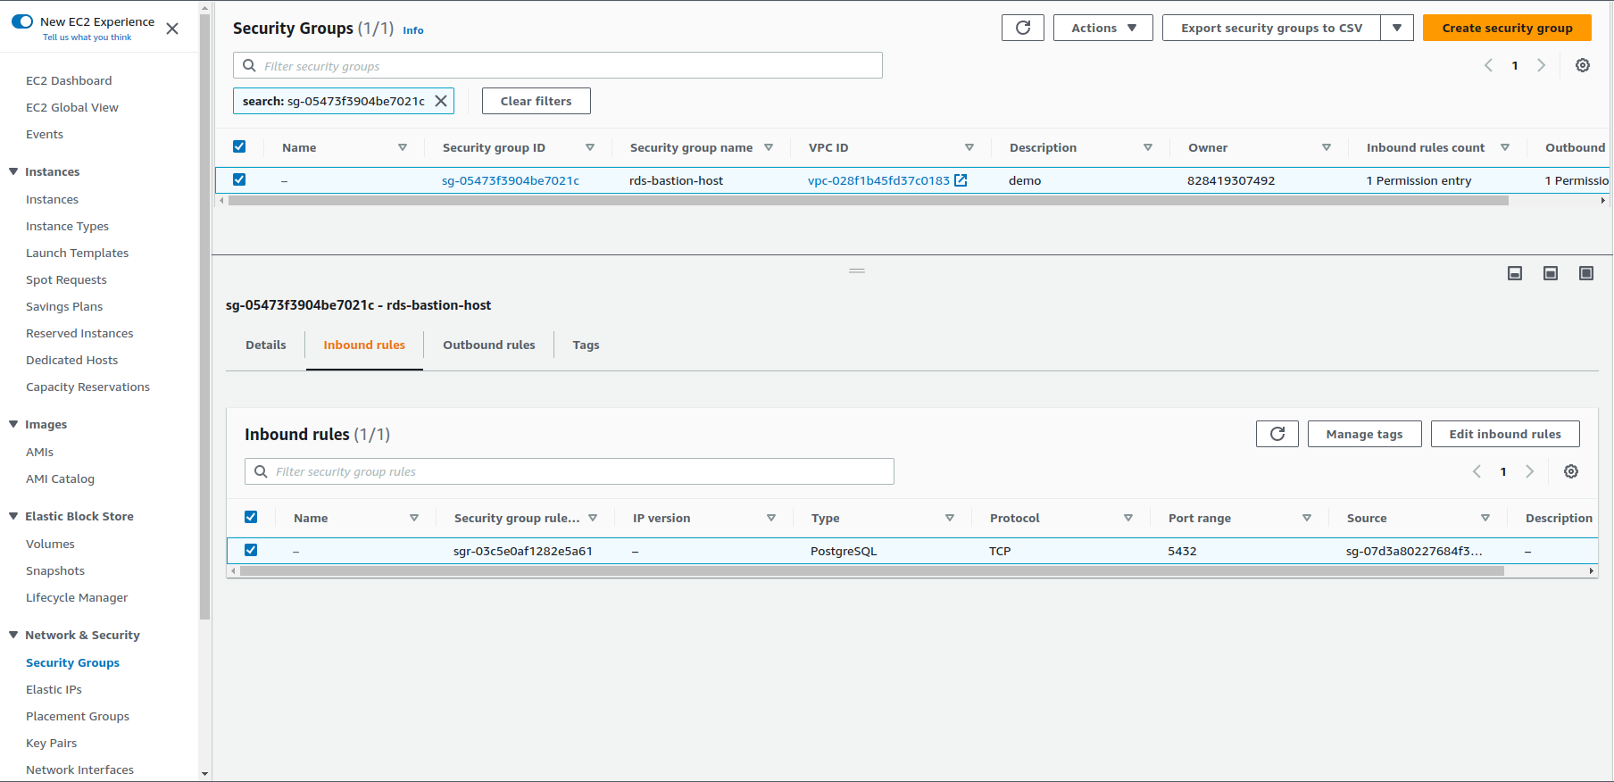

**One way to connect is through AWS Console Session Manager:**

1. Navigate to EC2 service, choose **bastion-host** instance and click on “**Connect**” in the upper right corner.

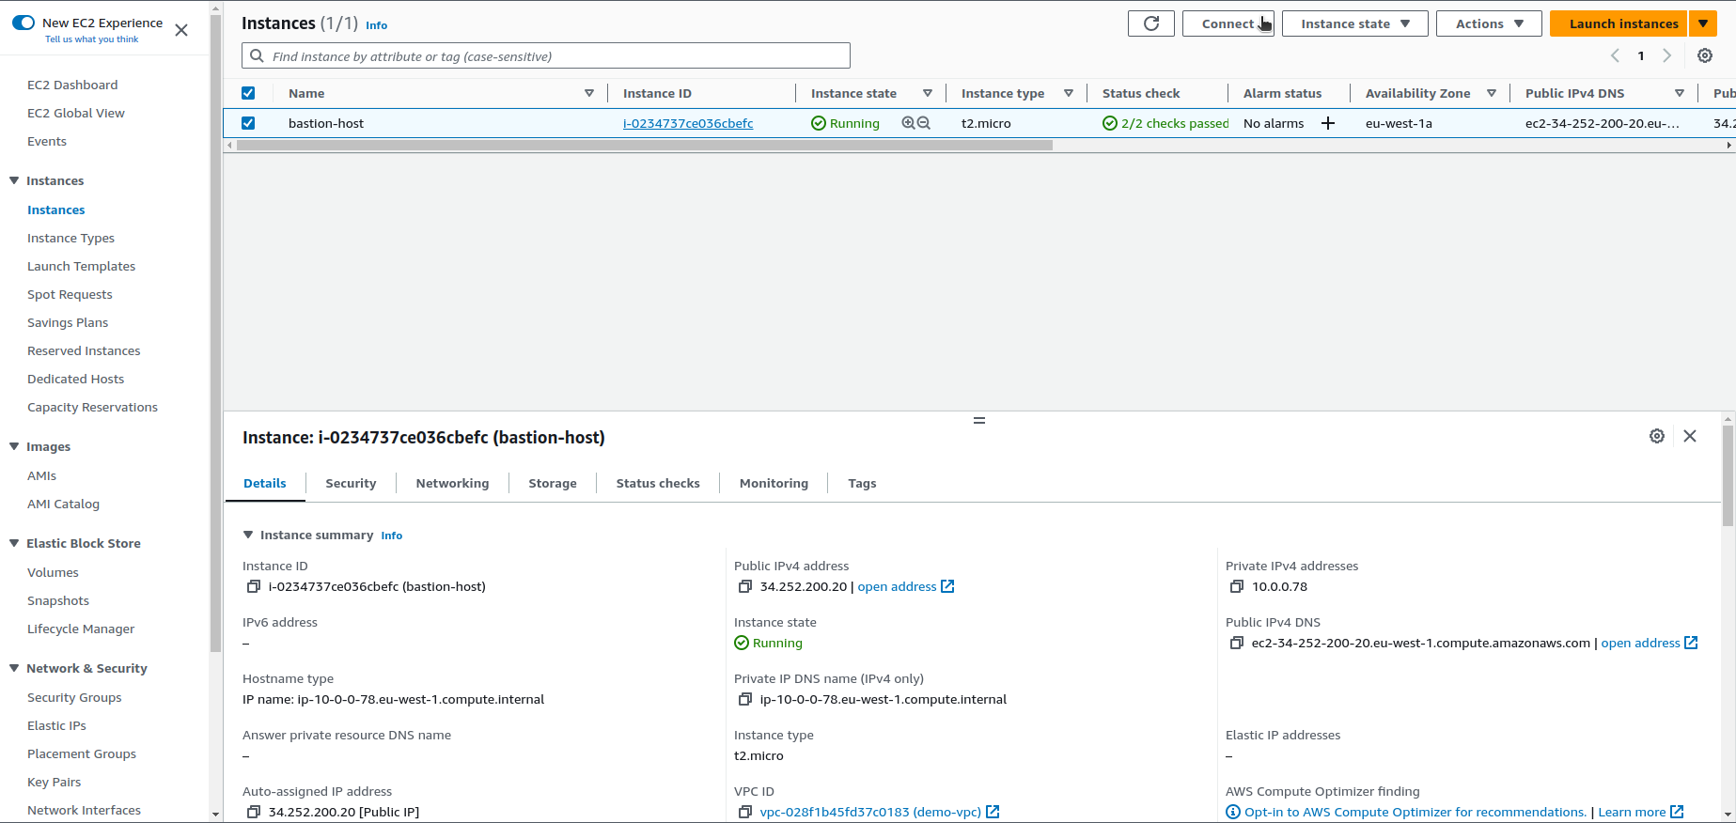

2. Choose Session Manager tab and click on “**Connect**”.

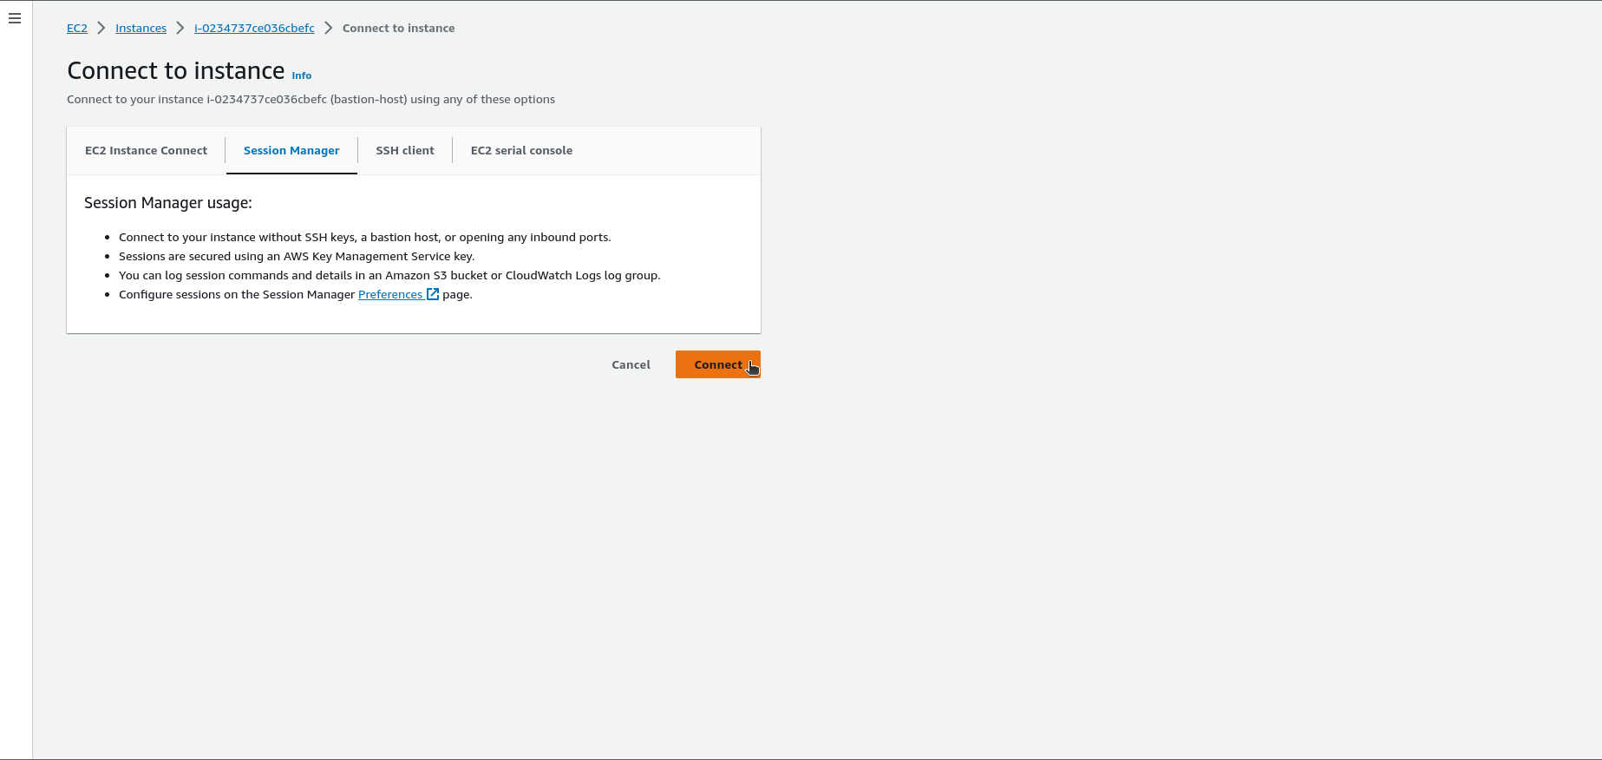

3. Now You can connect using, for example, **mysql** or **psql** command:

*psql -h demo.cjbsflodxtzy.eu-west-1.rds.amazonaws.com -U postgres*

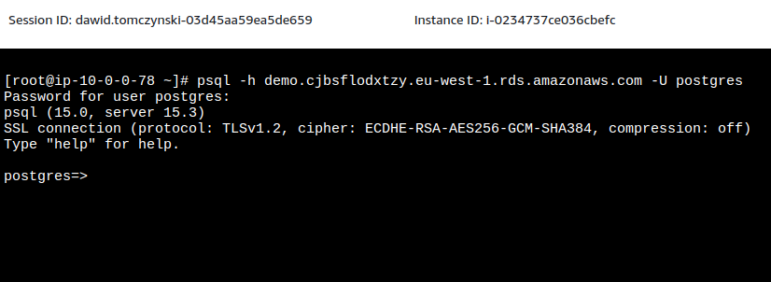

**The other way to connect is through AWS CLI with SSM plugin installed.**

[AWS CLI installation](https://docs.aws.amazon.com/cli/latest/userguide/getting-started-install.html)

[AWS CLI credentials configuration](https://docs.aws.amazon.com/cli/latest/userguide/cli-configure-files.html#cli-configure-files-methods)

[SSM plugin installation](https://docs.aws.amazon.com/systems-manager/latest/userguide/session-manager-working-with-install-plugin.html)

AWS SSM plugin, like AWS CLI, uses AWS credentials for connection so it’s important to set them up first.

Open the terminal on Your local machine and start the connection between Your local host and RDS instance with this command:

*aws ssm start-session --document-name AWS-StartPortForwardingSessionToRemoteHost --parameters '{"host":["****RDS_INSTANCE_ENDPOINT****"], "portNumber":["****5432****"], "localPortNumber":["****5432****"]}' --region* ***eu-west-1*** *--target* ***BASTION_HOST_INSTANCE_ID***

Change **RDS_INSTANCE_ENDPOINT** to Your RDS endpoint, e.g. *demo.cjbsflodxtzy.eu-west-1.rds.amazonaws.com*

Change **BASTION_HOST_INSTANCE_ID** to Your bastion host EC2 instance ID, e.g. *i-0234737ce036cbefc*

Set RDS instance and local **ports** depending on database engine, and the **AWS region** of RDS instance and bastion host.

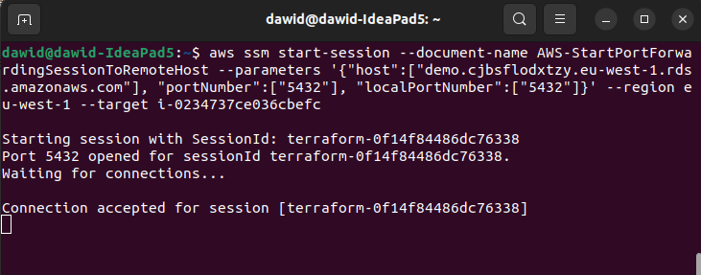

Next You will be able to connect to the database with, for example, **mysql** or **psql** command in a new terminal or any database client with **localhost** as host:

*psql -h 127.0.0.1 -U postgres*

