IronCode RDS cost analysis

Investigation reason:

* Discover ways to get RDS cheaper

Based on the Cloudvisor Customer portal the costs were the following:

|  |  |  |
| --- | --- | --- |
| February | March | April (not yet full month) |
| $13.78 | $263.61 | $90.49 will be around ~$100 |

As seen from the cost explorer:

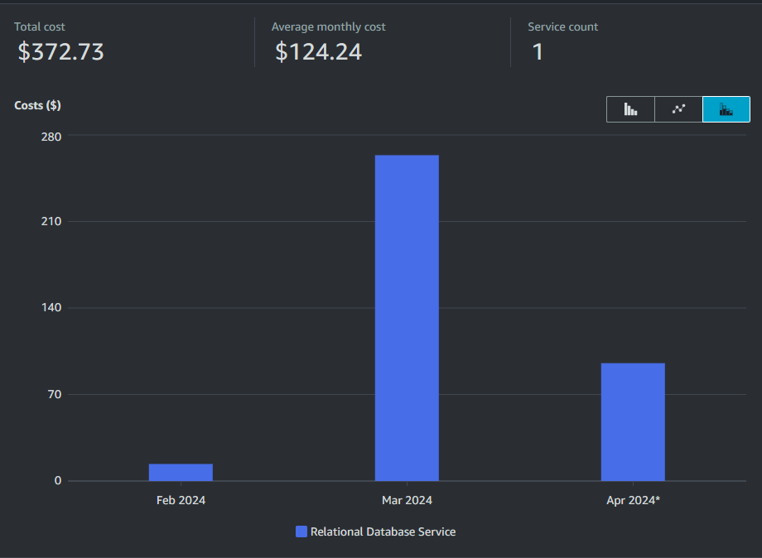

**NOTE: this diagram is from cost explorer and it does not show the proper number of costs due to the resell partnership**

## Costs breakdown per month

February:

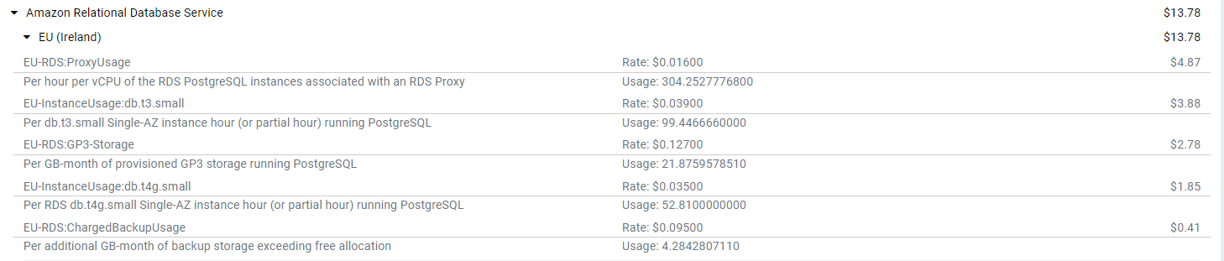

March:

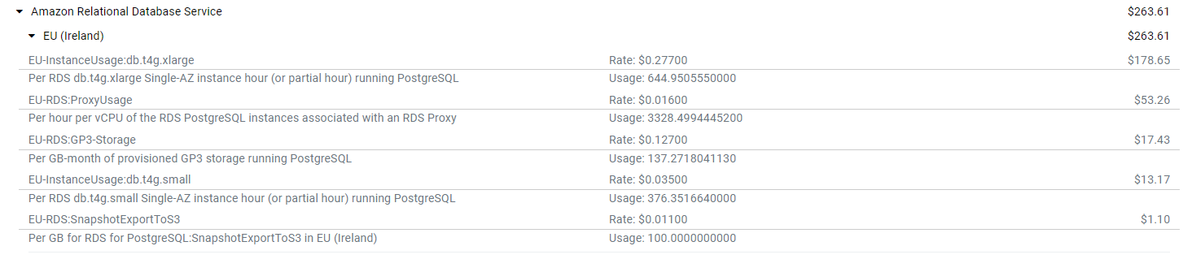

April:

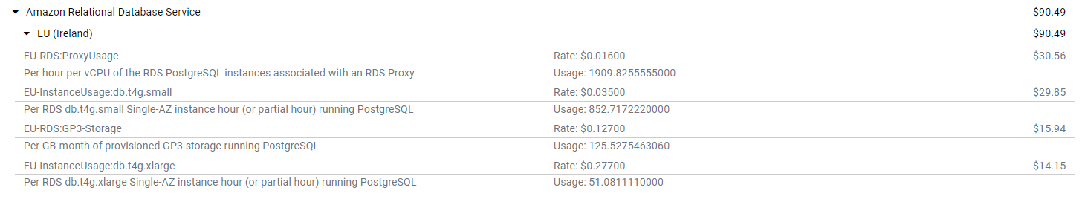

## RDS Cost Analysis result

In the above information it is clearly seen that the increased costs were caused by using “t4g.xlarge” which costs around ~$190.5300 monthly.  
There was a change during this April, to db.t4g.small instance type which drastically decreased the costs to ~$24.0900 monthly.  
  
**Based on this the database is already optimized to the lowest possible instance type!**

In fact, the current instance type is really on the edge, of its performance and it might not endure a sudden user\traffic increase, which could cause delays or outages!

### CPU usage metrics:

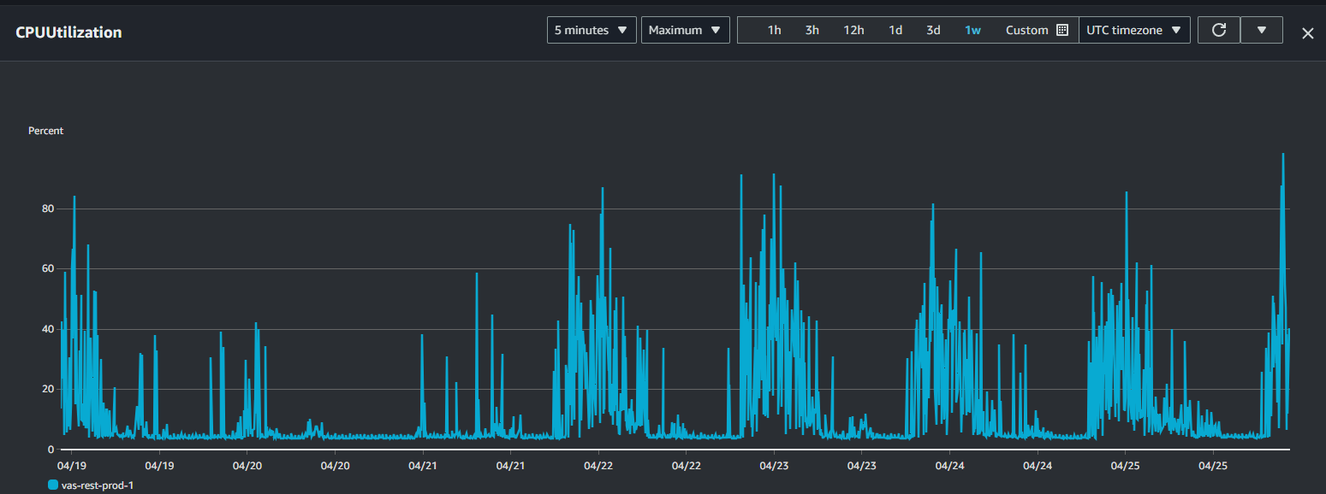  
From the above metrics it can be seen CPU is on 50% average but it is frequently goes up to 80% or even more with the current traffic.  
At this rate the database can become clumsy, and slow to response which can greatly affect user experience or the consuming application’s performance.

### Memory usage metrics:

The current instance type provides 2GiB of memory.  
From that only 6-700 MiB-s are available with the current usage.  
  
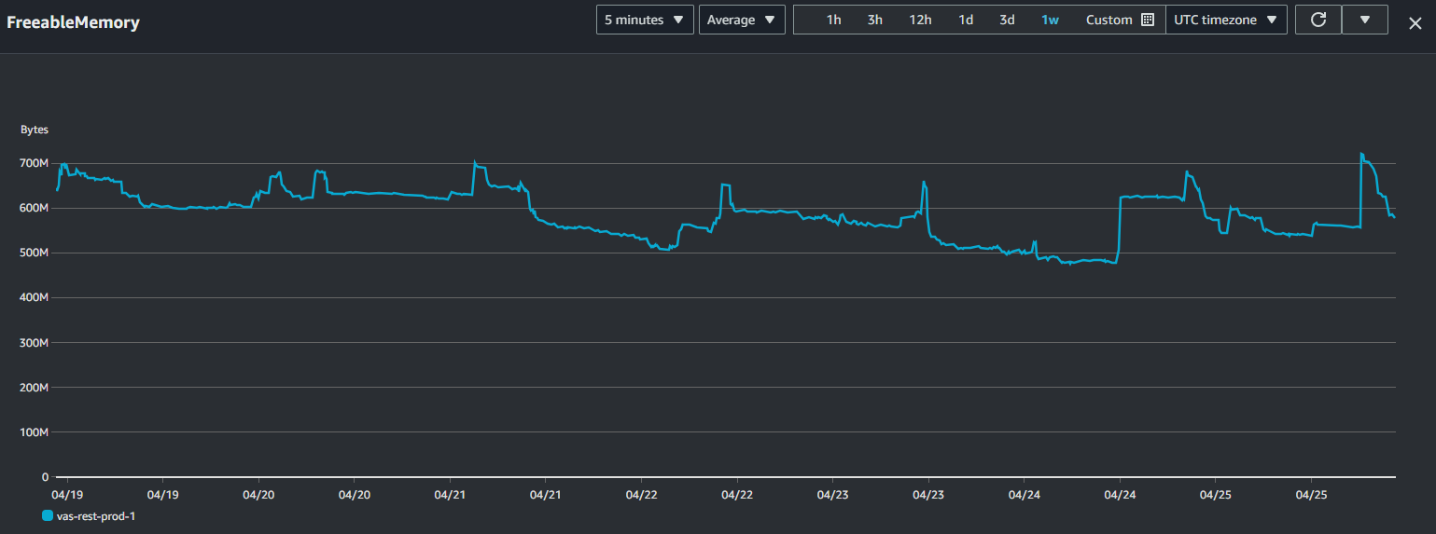  
  
Consider this not as critical as the CPU, but still it does not leave too much room to extended traffic\usage.

### Summary \ Recommendations

Consider the following:

* Consider your current usage, userbase and network traffic. If it is satisfactory in the current situation I would not change, but keep in mind that the database is currently close to its limits.   
    
  Therefore on the long term, I would suggest the usage of:  
  [db.t4g.medium](https://instances.vantage.sh/aws/rds/db.t4g.medium) *$47.4500 monthly*   
  Or if CPU is very limited than change to:  
  [db.t4g.xlarge](https://instances.vantage.sh/aws/rds/db.t4g.xlarge) but this one is way pricier *$190.5300 monthly*   
    
  Your current costs are around *$24.0900 monthly*  
  Please always consider the pricing and the usage in order to decide what would be the optimal for your use case.
* Consider the use of RDS Reserved instances.  
  Reserved instances comes with an upfront price, but generally speaking they lower the price. As an example, the currently used db.t4g.small instance type costs $24.0900 monthly but it would only cost $16.8630 monthly if there is a reserved price. This could leave an option to increase the database type to a bigger one to support future increased usage\traffic.