**Amazon Macie**

Amazon Macie is a service designed to automatically discover, classify, and protect sensitive data in AWS.

**Amazon Macie Overview**

1. **Discovery and Classification**

Amazon Macie uses machine learning to automatically discover and classify sensitive data such as Personally Identifiable Information (PII), financial data, and intellectual property.

1. **Data Protection**

It provides monitoring and alerts for suspicious activity, helping to protect sensitive data from unauthorized access or accidental leaks.

1. **Compliance**

Macie helps in meeting regulatory compliance requirements by identifying and protecting sensitive data.

**Use Cases**

1. **Data Discovery and Classification**
   * Automatically identify and classify sensitive data within your AWS environment.
   * Discover and categorize sensitive data to maintain compliance with data protection regulations.
2. **Data Security and Monitoring**

* Monitor and receive alerts for suspicious activity related to sensitive data.
* Implement data loss prevention (DLP) policies to prevent unauthorized access or data leaks.

1. **Compliance Management**
   * Assist in complying with data protection regulations (e.g., GDPR, HIPAA) by identifying and protecting sensitive information.
   * Simplify the process of managing and securing sensitive data in accordance with industry standards.

**How to Use Amazon Macie**

1. **Enable Macie**

* Sign in to the AWS Management Console.
* Open the Macie console and enable the service for your AWS account.

1. **Create and Configure Macie S3 Buckets**

* Specify the S3 buckets that you want Macie to monitor.
* Configure the settings for each bucket, including encryption and logging options.

1. **Configure Macie for Sensitive Data Discovery**

* Set up and configure Macie to automatically discover and classify sensitive data.
* Customize classification settings based on your specific needs.

1. **Review Macie Findings**

* Regularly review Macie findings to identify and address any security or compliance issues.
* Investigate and take action on any alerts generated by Macie.

**Pricing**

Amazon Macie pricing involves charges for the amount of data analyzed and the number of S3 buckets to monitor.

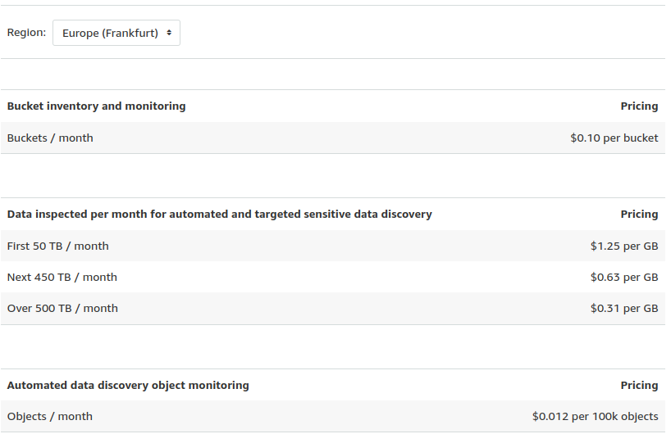

[AWS Documentation](https://docs.aws.amazon.com/macie/latest/user/what-is-macie.html)