**AWS CloudTrail**

AWS CloudTrail is a service that enables governance, compliance, operational auditing, and risk auditing of your AWS account. It records all API calls made on your account, capturing details such as who made the call, the services used, the actions performed, parameters for the actions, and the response elements returned by AWS. CloudTrail provides a comprehensive event history of your AWS account activities, which is invaluable for security, monitoring, and troubleshooting.

CloudTrail is enabled by default and stores data for the last 90 days. For longer periods users need to set up and configure CloudTrail logging to start recording events. Once enabled, CloudTrail logs are stored in an Amazon S3 bucket, and the service can be configured to deliver notifications via Amazon SNS (Simple Notification Service) when new log files are available.

**Benefits of Using AWS CloudTrail**

**1. Visibility:** CloudTrail provides a detailed history of API calls made on your AWS account, offering visibility into who did what, when, and from where.

**2. Security and Compliance:** It aids in security analysis, resource change tracking, and compliance auditing by monitoring and logging activities across AWS resources.

**3. Troubleshooting:** CloudTrail logs are useful for troubleshooting operational issues, identifying the source of errors, and investigating security incidents.

**4. Alerts and Notifications:** CloudTrail can be configured to send alerts when specific events occur, allowing users to respond promptly to security threats or unauthorized activities.

**5. Integration with Other AWS Services:** CloudTrail can be integrated with other AWS services like AWS CloudWatch, AWS CloudWatch Logs, and AWS Config, enabling users to perform advanced monitoring and analysis.

**What You Can Get Out of AWS CloudTrail**

**1. Audit Trails:** Detailed audit trails for compliance purposes, allowing organizations to meet regulatory requirements.

**2. Security Monitoring:** Detection of unauthorized or suspicious activities by analyzing CloudTrail logs.

**3. Operational Insights:** Understanding operational patterns and identifying areas for optimization.

**4. Incident Response:** Swift and effective response to security incidents based on real-time or historical data.

**5. Change Management:** Tracking changes to resources over time for effective change management.

**Costs**

While CloudTrail itself is a free service, there may be associated costs for storing the generated log files in Amazon S3. Users are billed based on the amount of data ingested, archived, and analyzed. It's important to consider S3 storage costs and potential costs if integrating CloudTrail with other AWS services.

**How to enable CloudTrail**

1. Sign in to the AWS Management Console and open the [AWS CloudTrail console](https://console.aws.amazon.com/cloudtrail/).
2. On the **CloudTrail** service home page choose **Create trail**.

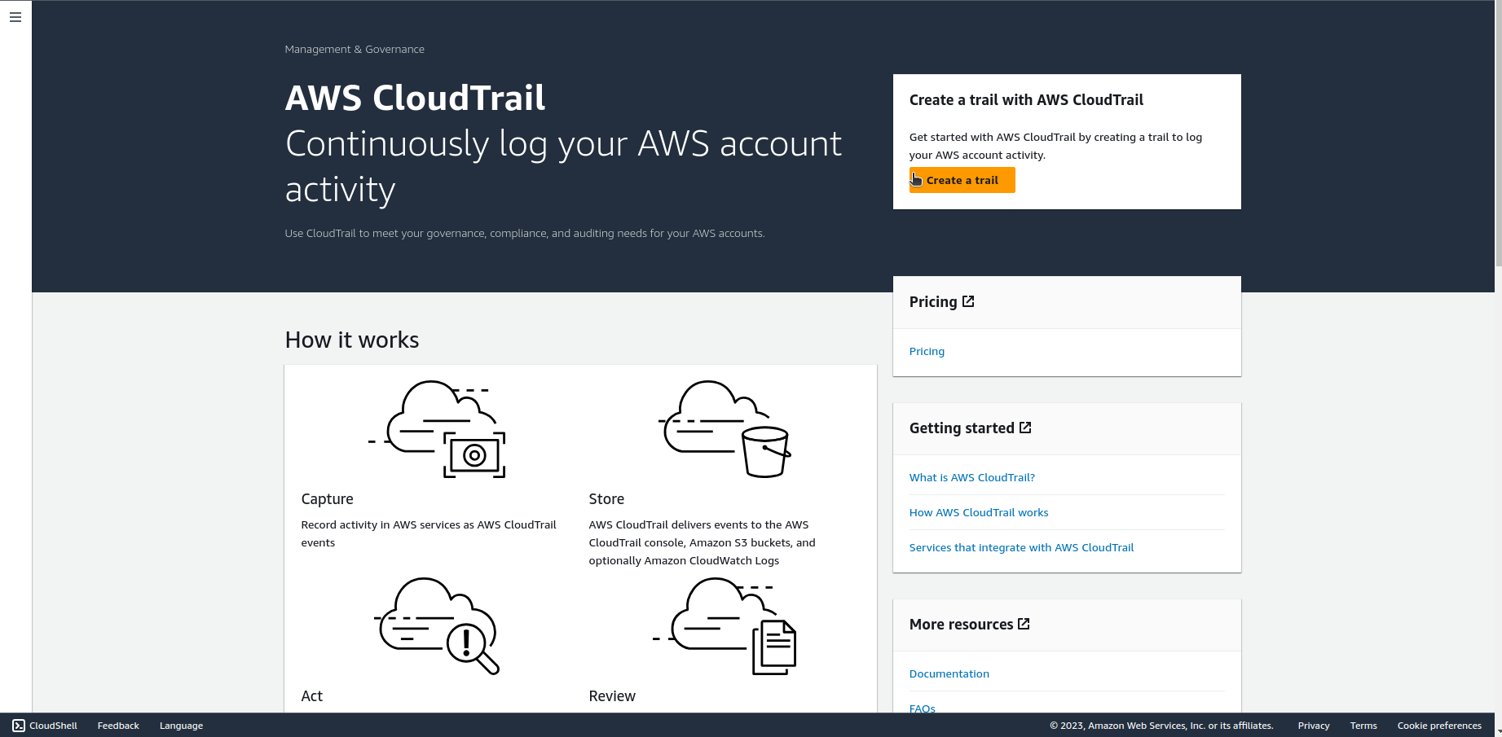

1. On the **Quick trail create** page, for **Trail name**, type a name for your trail and click on **Create trail.**

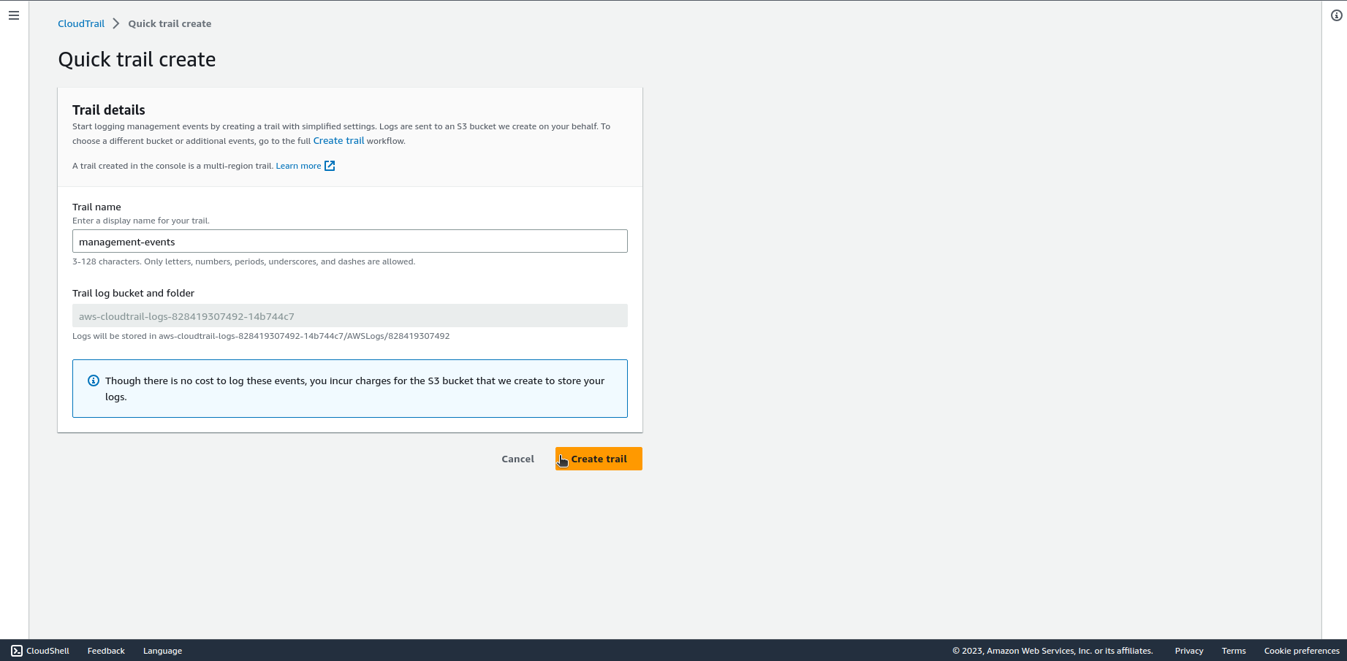

1. The new trail appears on the **Trails** page.