**How to enable AWS Compute Optimizer**

1. Log in to the AWS console, navigate to AWS Compute Optimizer service and click on “Get started” on the right side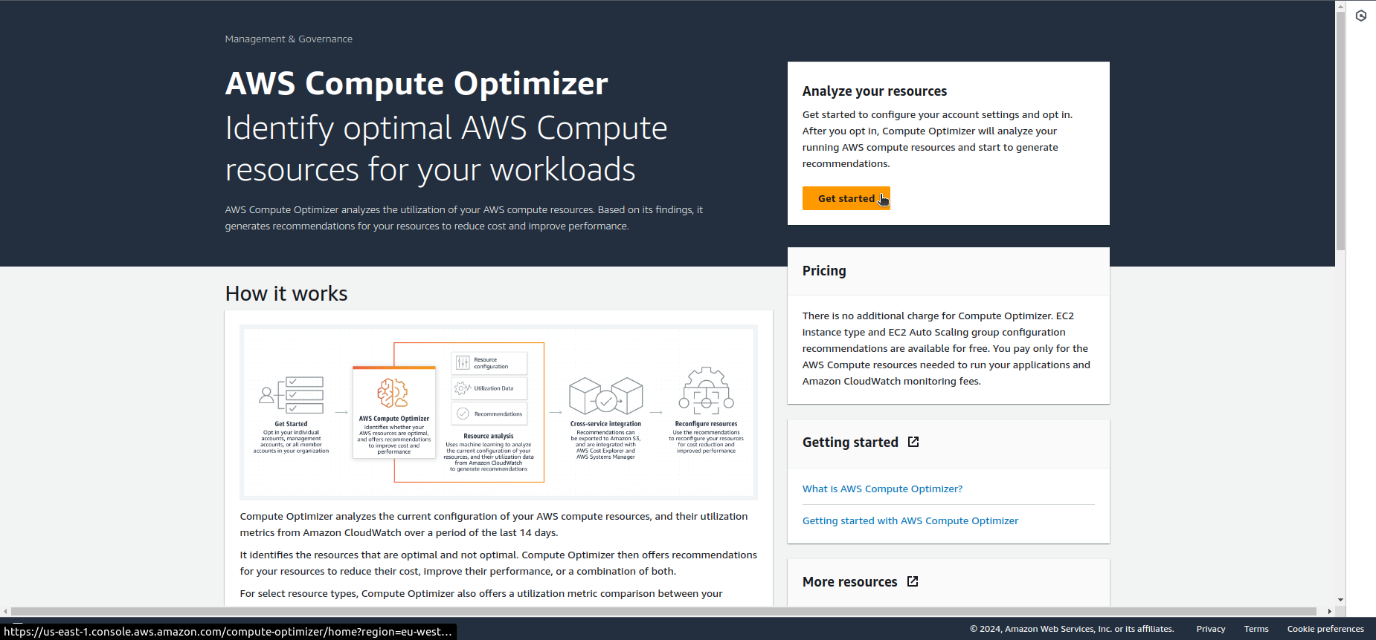.
2. In the next window click on “Opt in”.  
     
     
   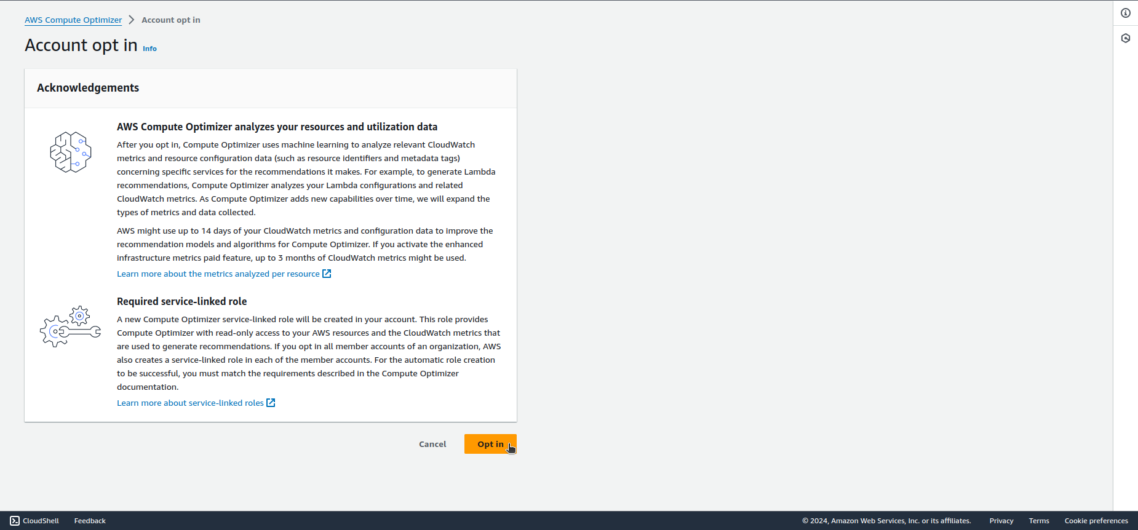
3. After up to 24 hours You can check optimization recommendations for Your account.