**ENABLE COST ALLOCATION TAGS**

Below You can find instructions on how to enable Cost Allocation tags:

1. Sign in to the AWS Management Console and open the AWS Billing console at <https://console.aws.amazon.com/billing/>.
2. In the navigation pane, choose “**Cost allocation tags**”.
3. Select the tags that you want to activate, for example “**aws:createdBy”**.
4. Choose “**Activate”**.

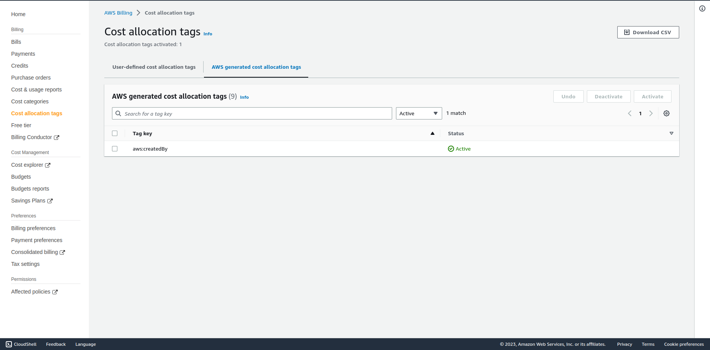

After you create and apply user-defined tags to your resources, it can take up to 24 hours for the tags to appear on your cost allocation tags page for activation. After you select your tags for activation, it can take up to 24 hours for tags to activate.

For an example of how tags appear in your billing report with cost allocation tags, see [Viewing a cost allocation report](https://docs.aws.amazon.com/awsaccountbilling/latest/aboutv2/configurecostallocreport.html" \l "allocation-viewing).