**Recommendations on AWS Resource Tagging Policy for Cost Monitoring**

* **Define a standardized tagging policy:** Establish a clear and comprehensive tagging policy that outlines the mandatory tags for all AWS resources. This policy should cover key attributes such as project, owner, environment, purpose, and any other relevant categorization criteria.
* **Use consistent and meaningful tags:** Ensure that the tags assigned to resources are consistent and meaningful across your organization. Avoid using generic tags that provide little value for cost monitoring purposes. Use specific tags that reflect the resource's purpose, usage, or departmental allocation.
* **Make tags mandatory:** Set up mechanisms, such as AWS Identity and Access Management (IAM) policies or AWS Config rules, to enforce the mandatory tagging policy. This ensures that every resource created or modified must include the required tags.
* **Define cost allocation tags:** Identify and define cost allocation tags that align with your organization's financial reporting requirements. Common cost allocation tags include project, department, business unit, and cost center. These tags enable you to categorize costs accurately and allocate them to the respective stakeholders.
* **Regularly review and update tags:** Establish a process to periodically review the tagging policy and ensure compliance. As your organization evolves, new resources may be introduced or existing resources may require updates to their tags. Regularly review and update tags to maintain accurate cost monitoring.

**Example Tagging Policy:**

* Tag Key: Project

Tag Value: MarketingCampaignA

* Tag Key: Owner

Tag Value: JohnSmith

* Tag Key: Environment

Tag Value: Production

* Tag Key: Purpose

Tag Value: WebApp

* Tag Key: CostCenter

Tag Value: CC12345

**Enabling and Creating Cost Allocation Tags:**

1. Sign in to the AWS Management Console and open the AWS Billing console at <https://console.aws.amazon.com/billing/>.
2. In the navigation pane, choose “**Cost allocation tags**”.
3. Select the tags that you want to activate, for example “**aws:createdBy”**.
4. Choose “**Activate”**.
5. Repeat steps 2 and 3 for each additional cost allocation tag you want to activate.

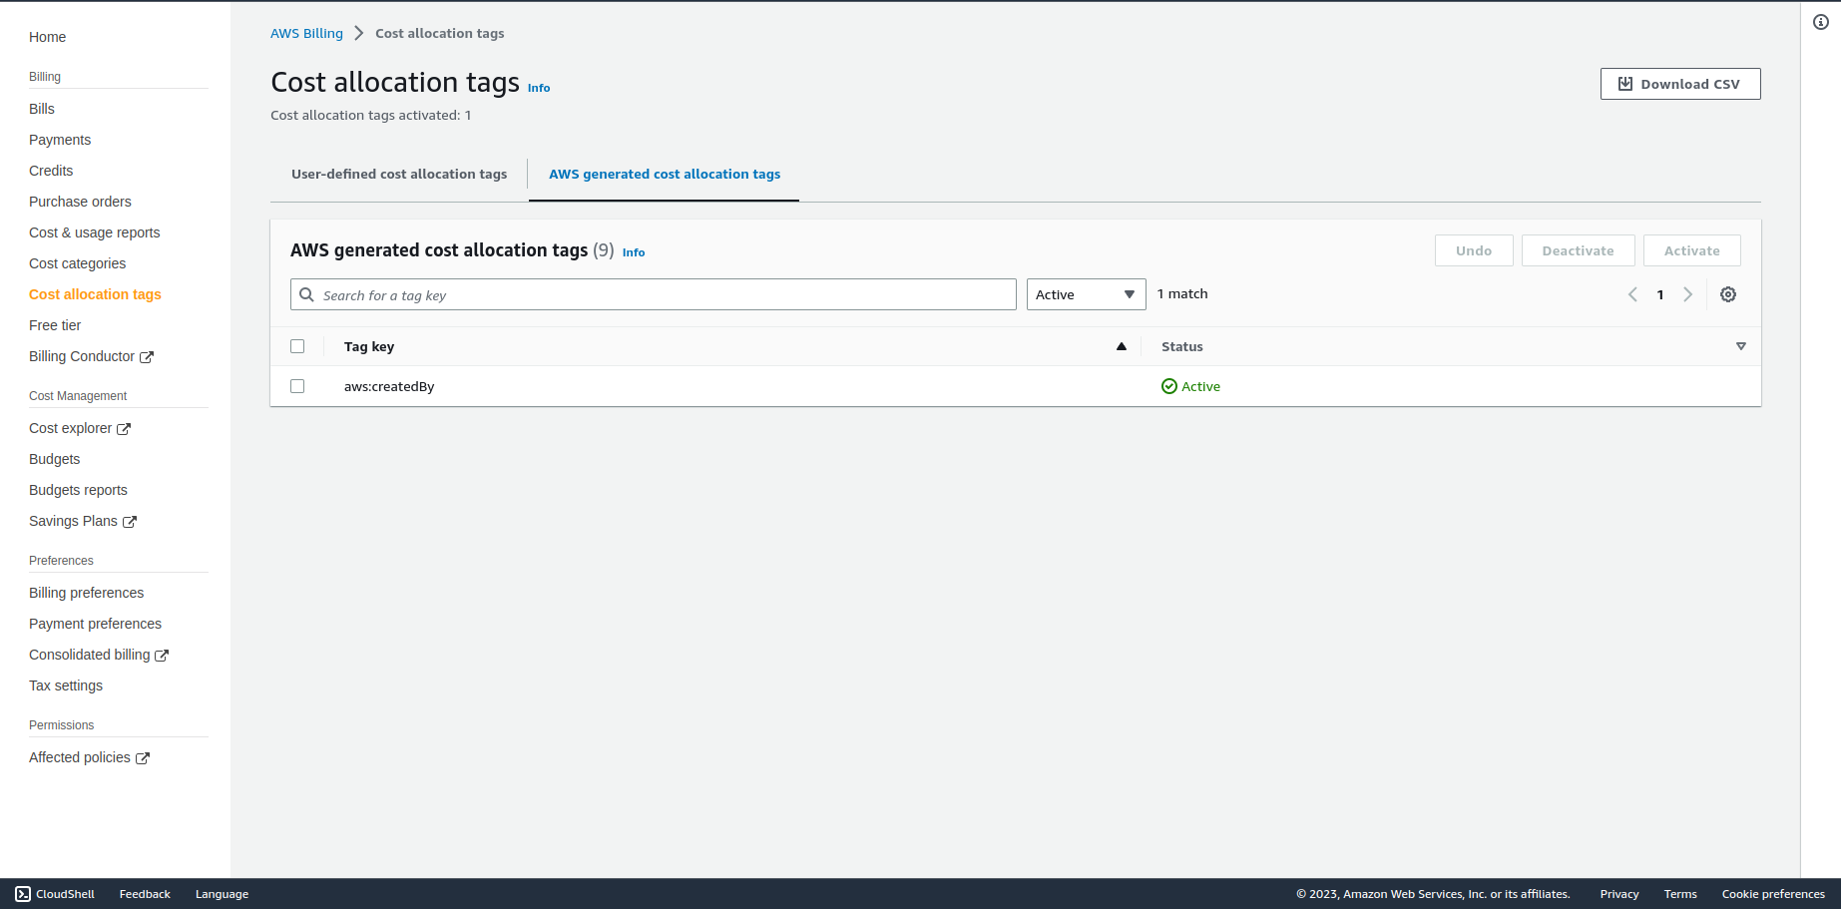

Once you have created the necessary cost allocation tags, you can assign them to your AWS resources either during resource creation or by modifying the existing resources.

After you create and apply user-defined tags to your resources, it can take up to 24 hours for the tags to appear on your cost allocation tags page for activation. After you select your tags for activation, it can take up to 24 hours for tags to activate.

By following these recommendations and implementing a well-defined tagging policy, you can **effectively monitor and allocate costs across your AWS resources**. This enables better **cost optimization, resource tracking, and financial accountability** within your organization.