**AWS API Gateway API definitions backup**

**REST API**

1. Open [AWS API Gateway console](https://eu-west-1.console.aws.amazon.com/apigateway/main/apis?region=eu-west-1) and choose Your ***REST API Gateway***.
2. Choose ***Stages*** section on the left pane, then the appropiate stage and click on the ***Export*** tab.

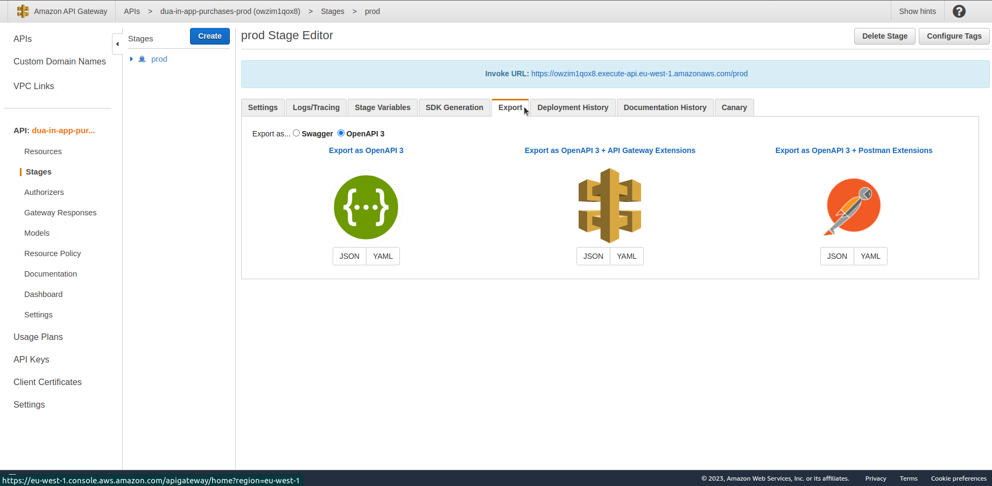

1. Choose Swagger or OpenAPI 3 and click on the file format – the file will be downloaded to Your local drive.
2. You can automate the process by using AWS CLI and creating automated cron script. Here’s the example command:

*aws apigateway get-export --parameters extensions='apigateway' --rest-api-id abcdefg123 --stage-name dev --export-type swagger latestswagger2.json*

**For the recreation/replacement of the API, you can use the API definition import engine in the OpenAPI standard.**

Documentation: <https://docs.aws.amazon.com/apigateway/latest/developerguide/api-gateway-export-api.html>

**HTTP API**

1. Open [AWS API Gateway console](https://eu-west-1.console.aws.amazon.com/apigateway/main/apis?region=eu-west-1) and choose Your ***HTTP API Gateway***.
2. On the left pane choose ***Export***.
3. Choose the Latest configuration or specific stage configuration, whether to include API Gateway extensions and output format and click on Download.

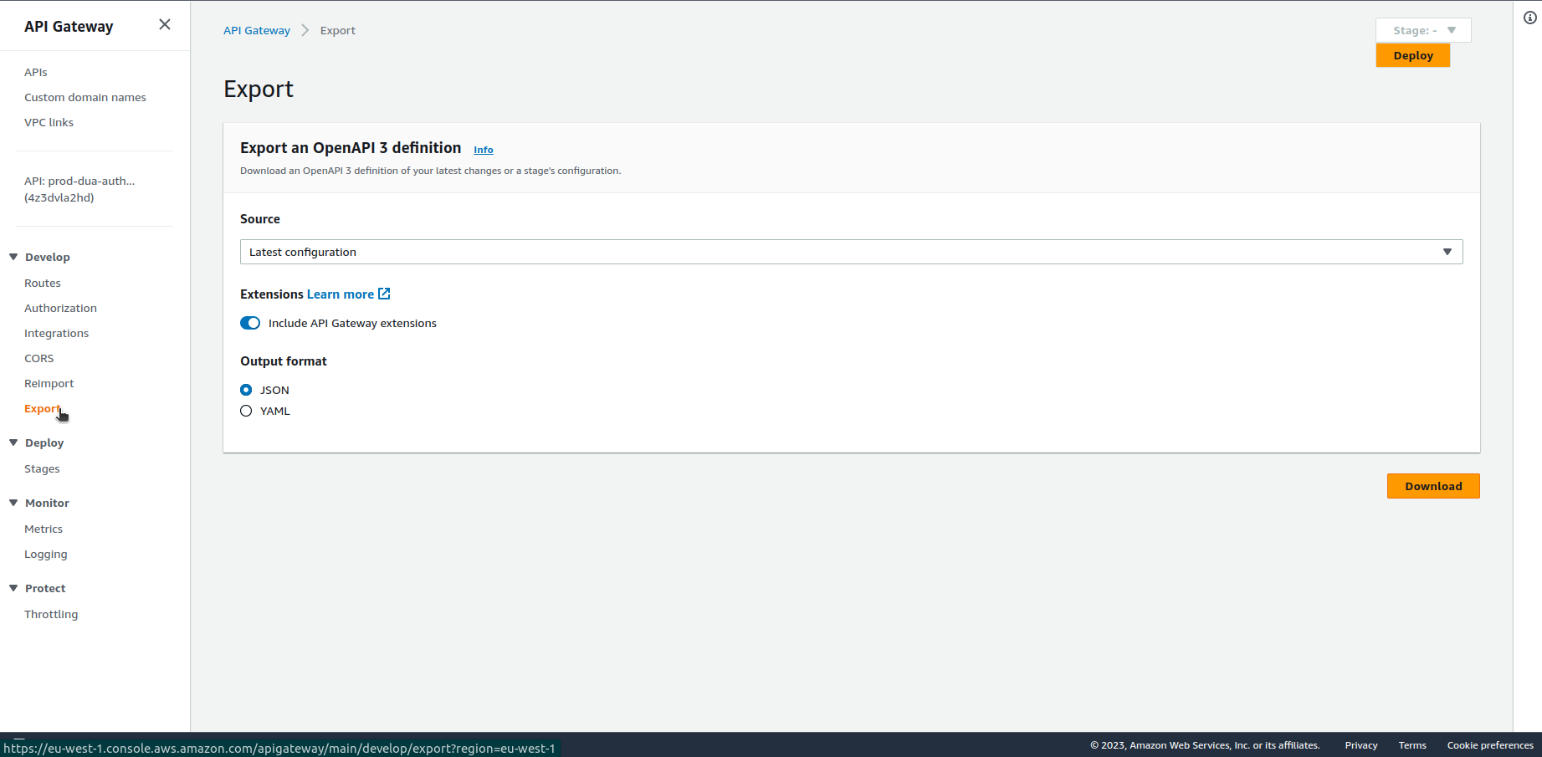

1. You can automate the process by using AWS CLI and creating automated cron script. Here’s the example command:

*aws apigatewayv2 export-api --api-id api-id --output-type YAML --specification OAS30 --stage-name prod stage-definition.yaml*

***For the recreation/replacement of the API, you can use the API definition import engine in the OpenAPI standard.***

Documentation:

<https://docs.aws.amazon.com/apigateway/latest/developerguide/http-api-export.html>

**WebSocket API**

For WebSocket APIs, the use of infrastructure as code is the best alternative to maintain configurations and replicate them later.