**AWS CloudFormation backup using Former2**

**Former2** is a powerful tool that streamlines the process of generating CloudFormation templates from existing AWS resources. By reverse-engineering your deployed infrastructure, Former2 generates accurate and comprehensive CloudFormation templates, saving you considerable time and effort. This tool is especially beneficial when creating a disaster recovery plan or migrating to infrastructure-as-code, as it accelerates the transition by automatically generating templates that reflect your existing AWS setup. With Former2, users can quickly capture their AWS resources' configurations in CloudFormation syntax, facilitating consistent and reproducible infrastructure deployments.

The official website is <https://former2.com/>, but it is recommended to deploy it locally by cloning the GitHub repository, using Docker Compose to deploy the stack, and accessing it from the browser using Incognito mode. The tool uses IAM user credentials that are stored in the browser's cache. The user should have ReadOnly permission.

**Deployment**

1. Open the terminal and clone the Github repository from <https://github.com/iann0036/former2> to Your local drive.

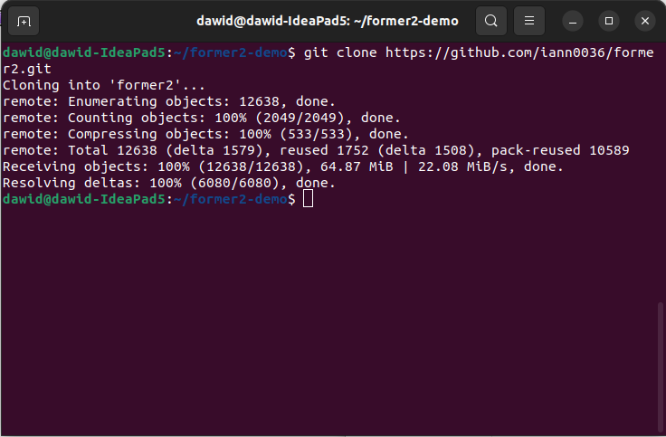

1. Go to the newly created folder former2 and run *docker compose up -d*.

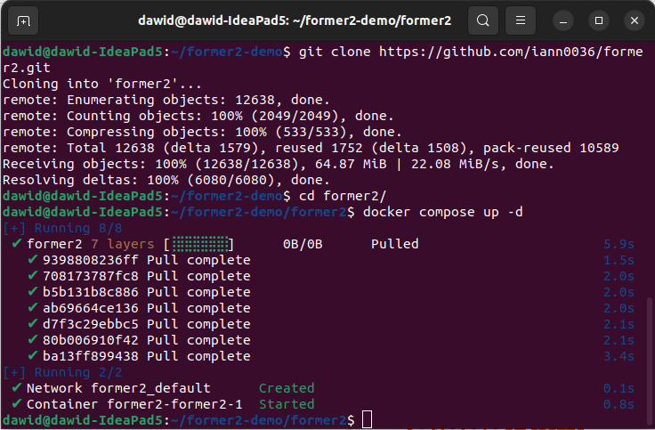

1. The stack has been locally deployed. It can be accessed from the browser on ***localhost***.

**IAM User creation**

1. Log in to Your AWS console and go to the [IAM service](https://us-east-1.console.aws.amazon.com/iamv2/home" \l "/home).

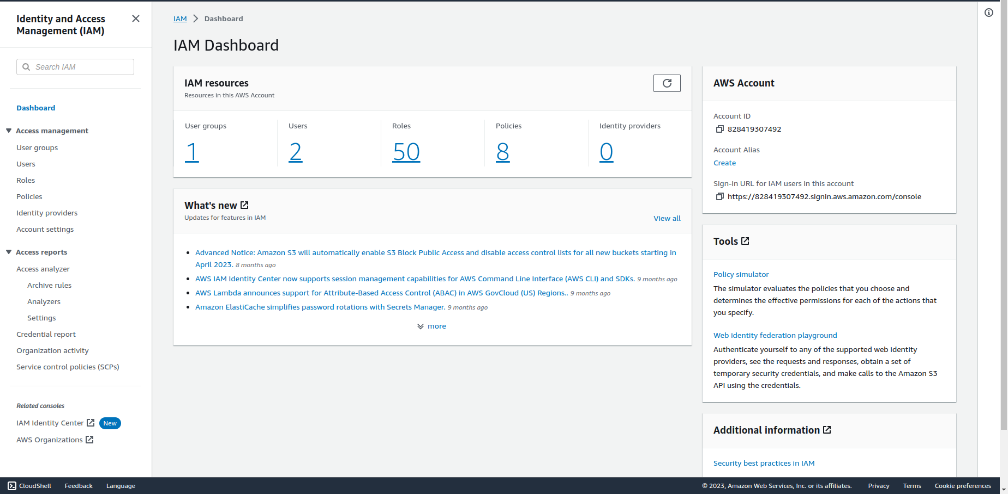

1. Select ***Users*** and click on ***Create user*** in the upper right corner.

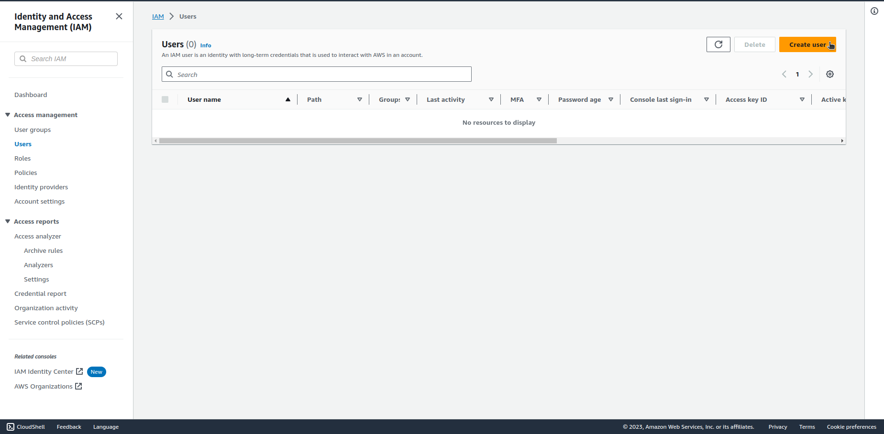

1. Give the new user a name and click on ***Next***.

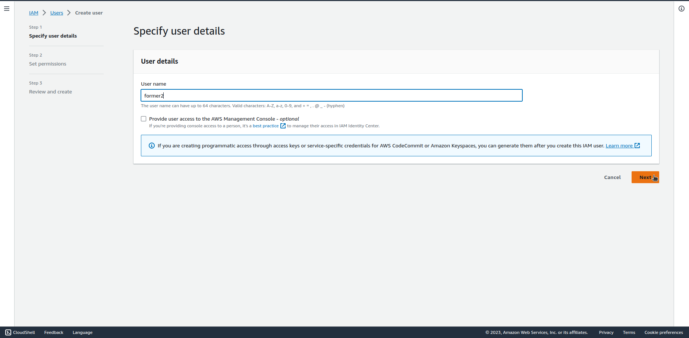

1. Choose ***Attach policies directly*** tab, search for ***ReadOnlyAccess*** policy and filter by type AWS managed – job function. Select the checkbox next to the policy and click on ***Next***.

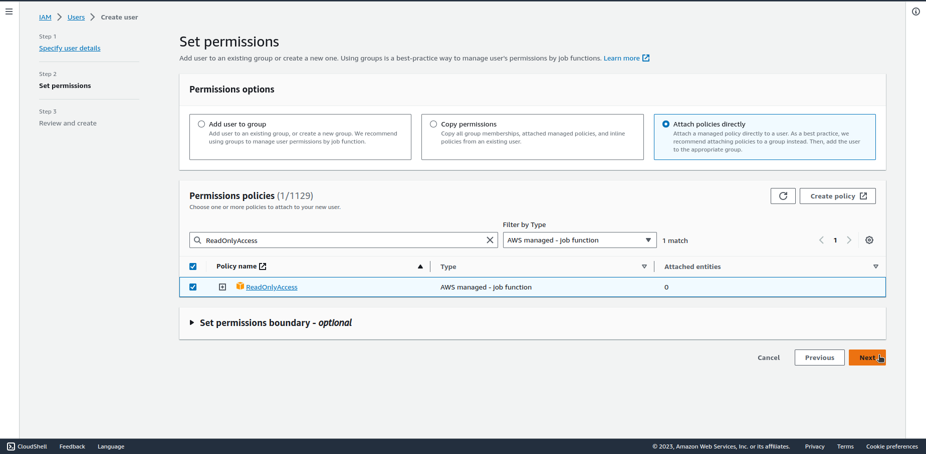

1. Review the new user settings and click on ***Create user***.

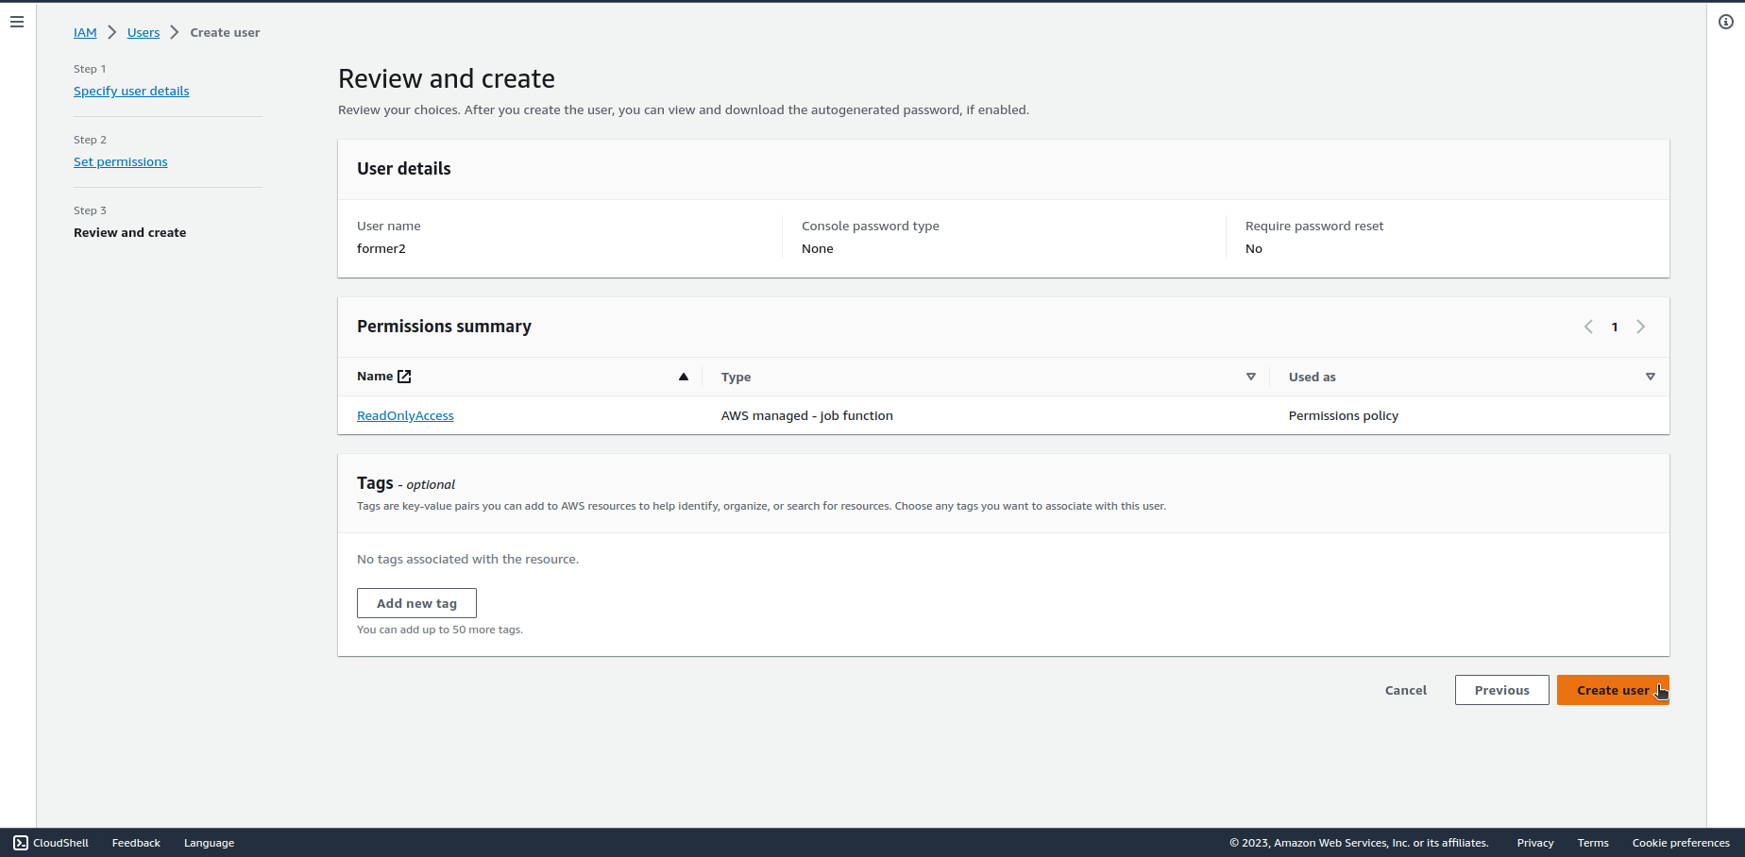

1. Click on the name of the newly created user.

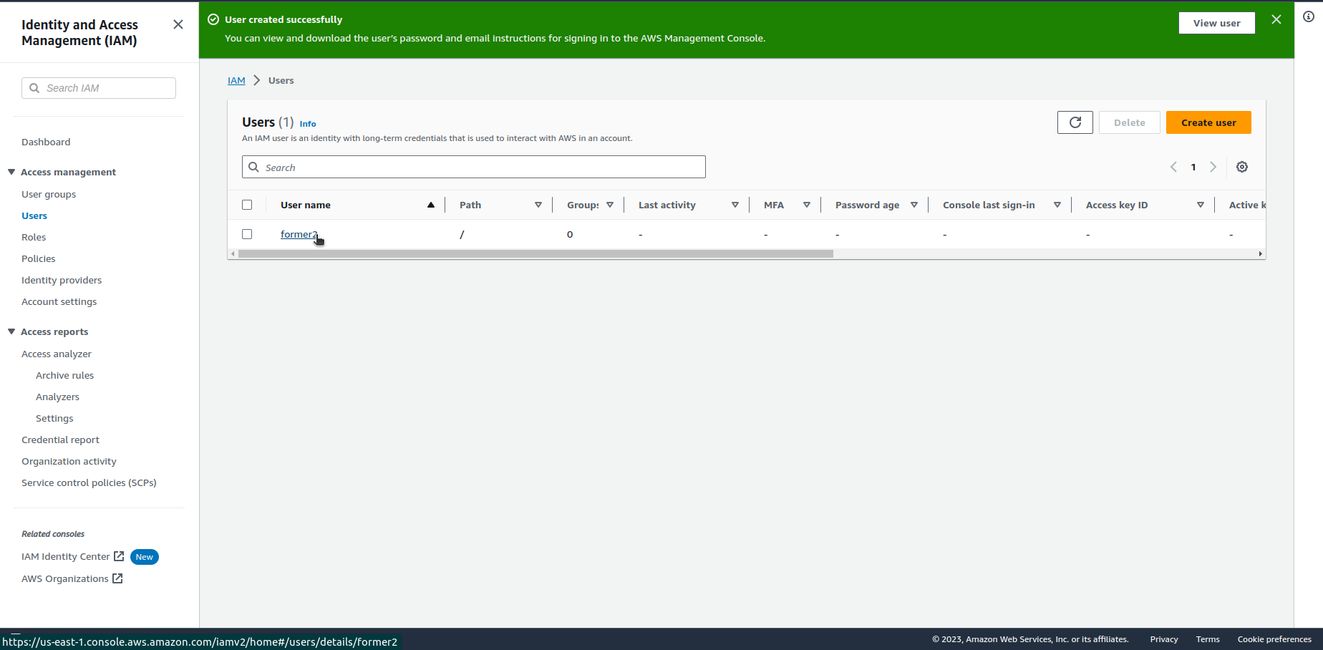

1. Select ***Security credentials*** tab and click on ***Create access key*** under the ***Access keys*** section.

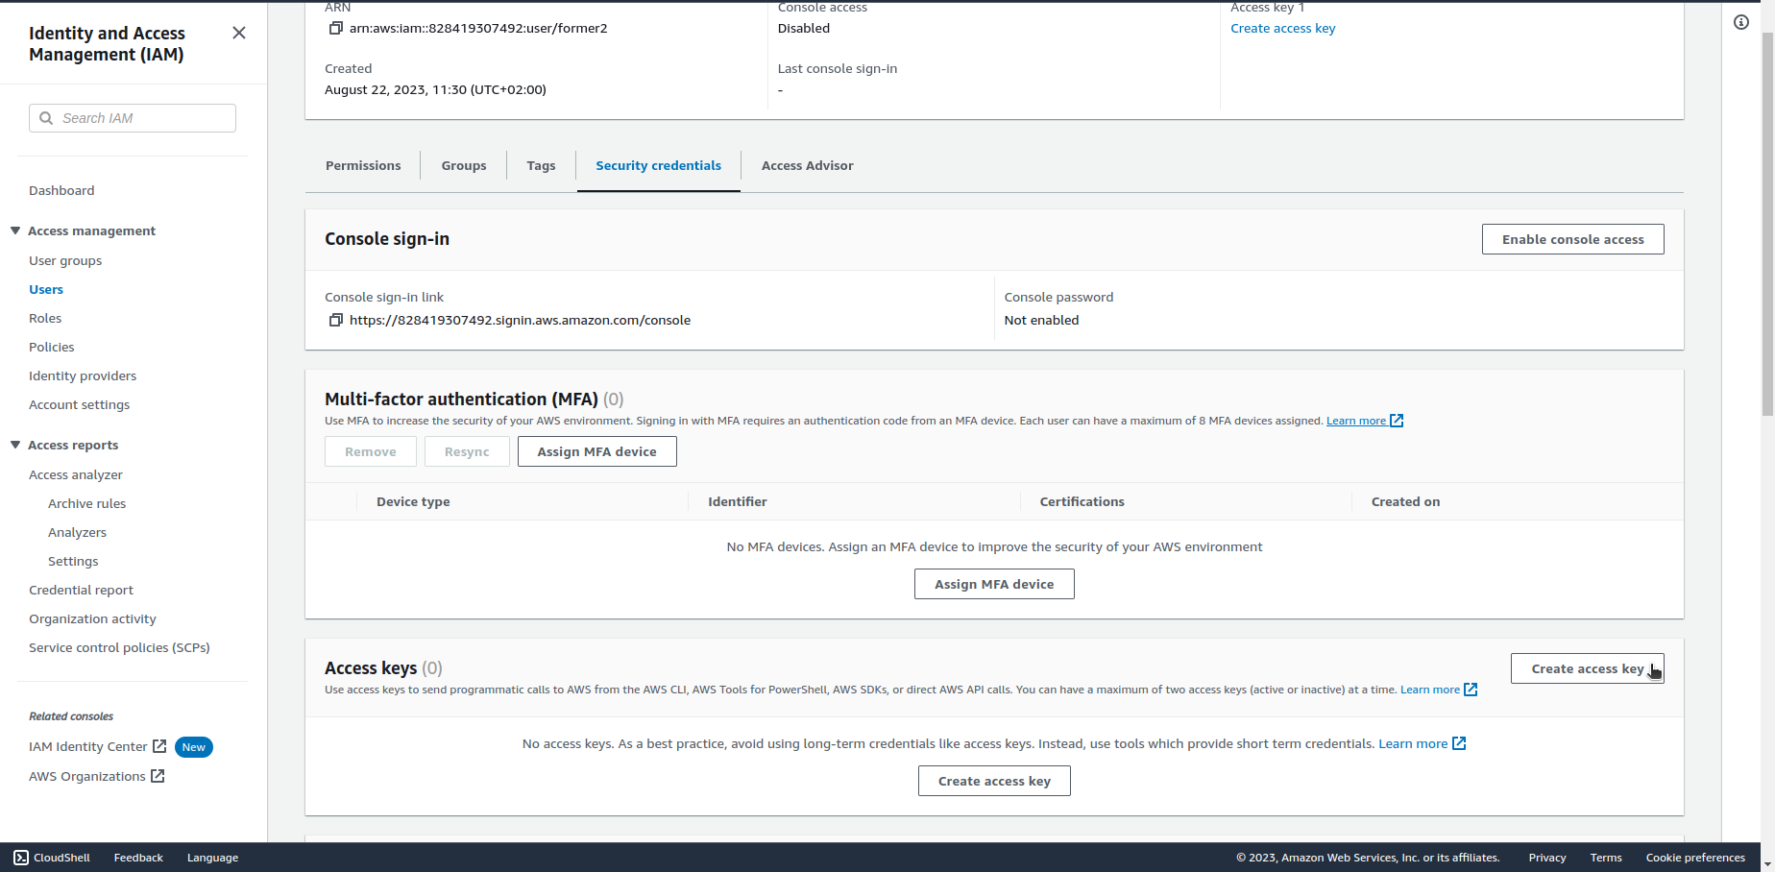

1. Select ***Command Line Interface (CLI)*** option and select the checkbox on the bottom of the page. Click on ***Next***.

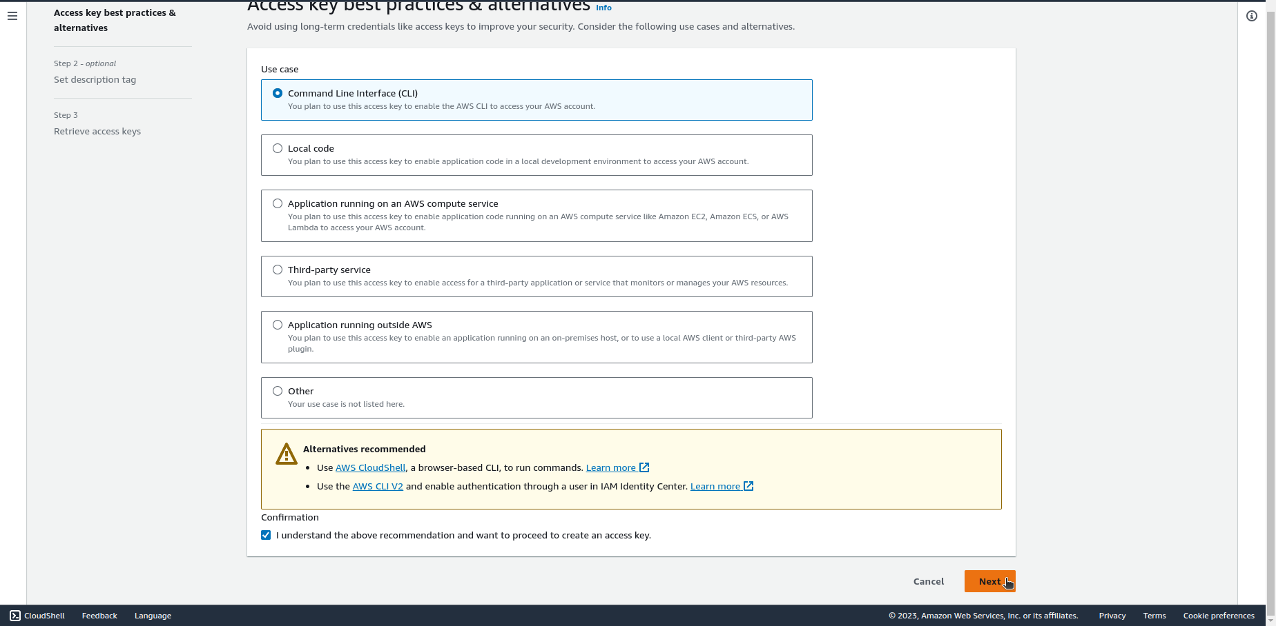

1. (Optional) Describe the purpose of this access key and click on ***Create access key***.

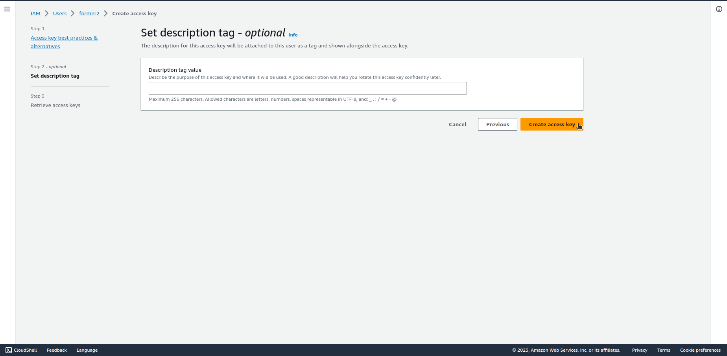

1. Save the Access key and Secret access key for later use with Former2 tool and click on ***Done***.

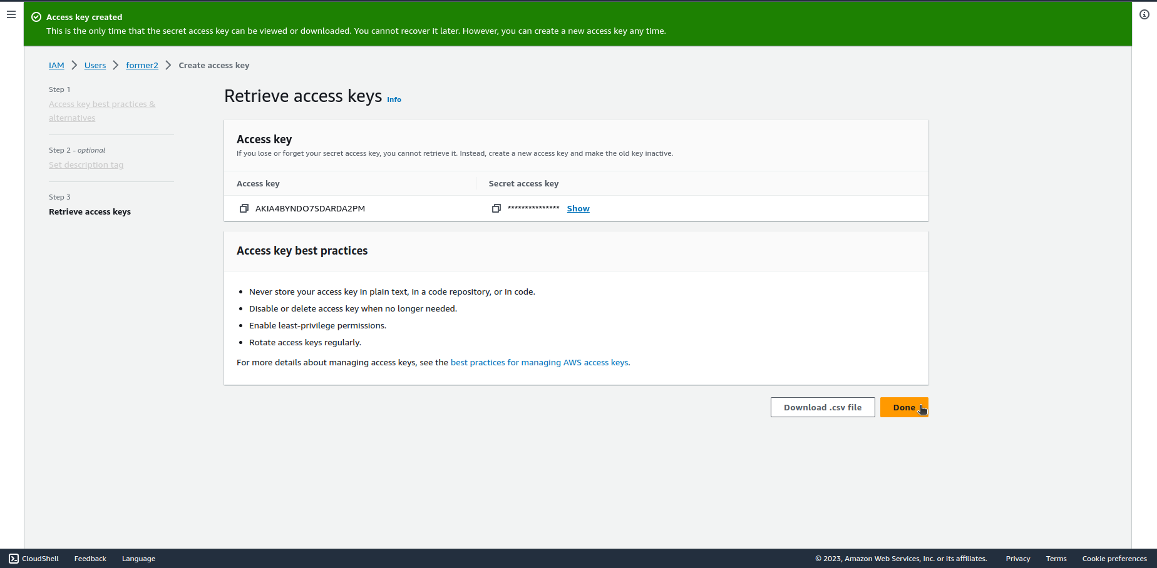

**Former2 tool usage**

1. Open Your browser in Incognito mode and type ***localhost*** in the URL. You should see the welcome page of Former2. Click on ***Continue to credentials***.

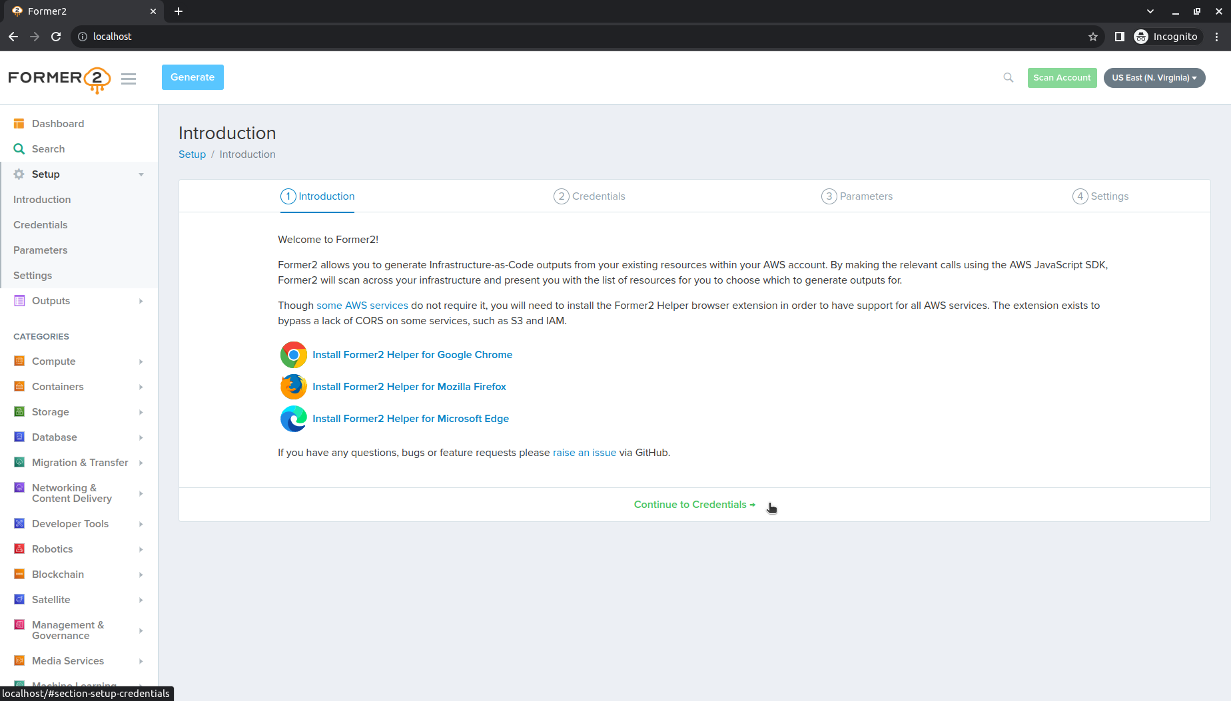

1. Enter the previously created Access key and Secret Access Key and click on ***Continue to Parameters***.

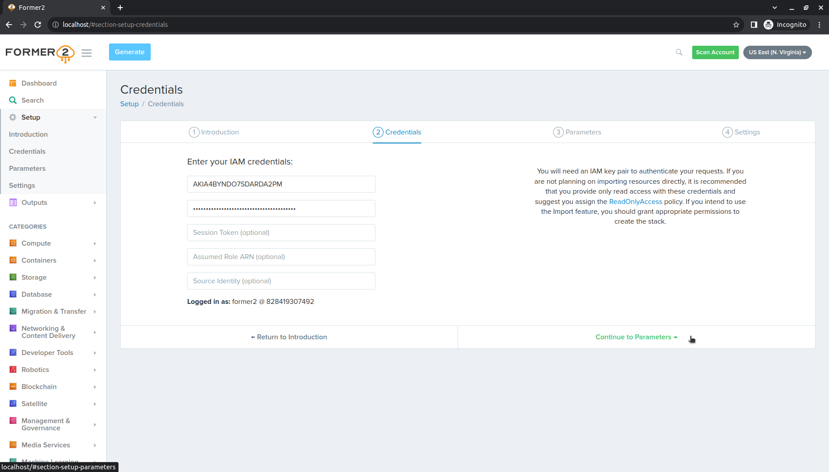

1. (Optional) You can set Your own CloudFormation stack parameters. Click on ***Continue to Settings***.

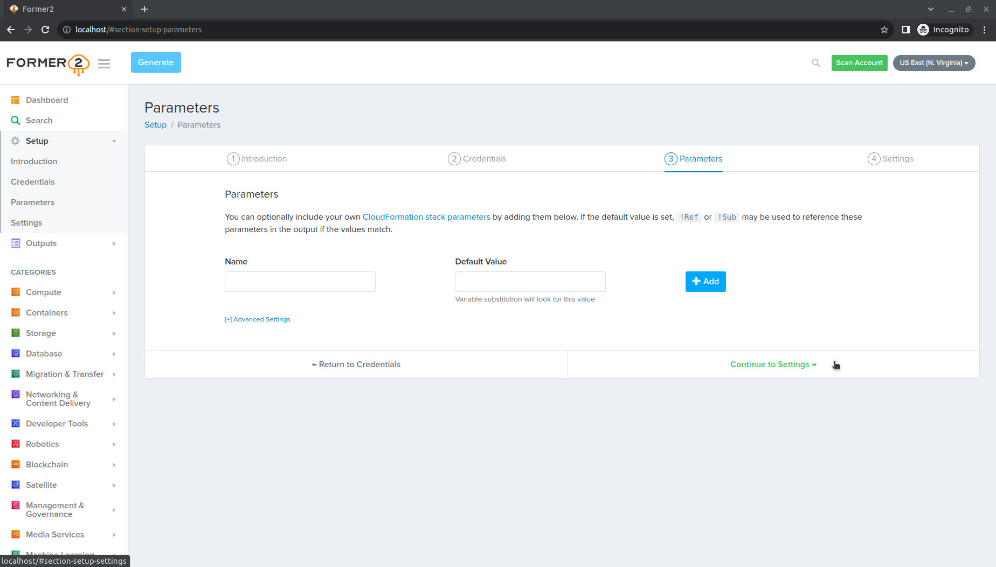

1. Now You can set the default settings like number of spaces in output YAML files, default output language, programming language, etc. Select Your region in the upper right corner and click on ***Scan Account***.

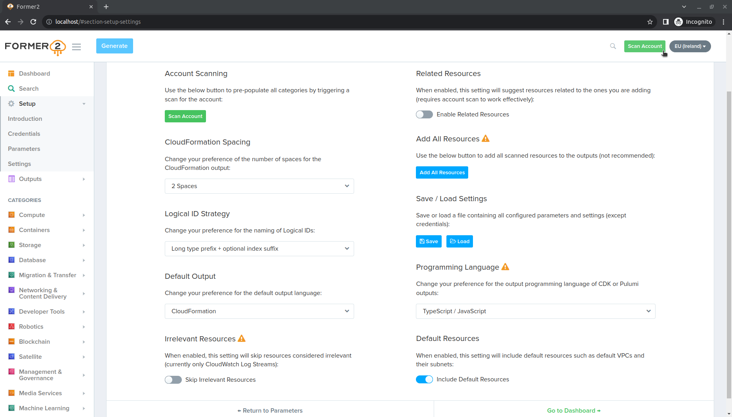

1. After the scan will be completed go to ***Dashboard***, select the service that You want to get template of, select the checkbox next to the resource, click on ***Add Selected*** and then on ***Generate*** on the top of the page.

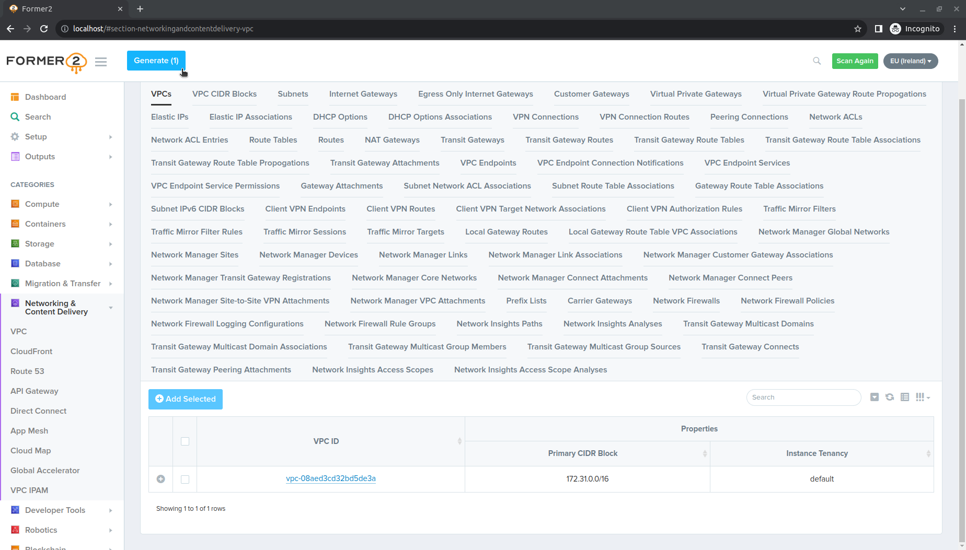

1. The template is ready, You can now copy it to the file.

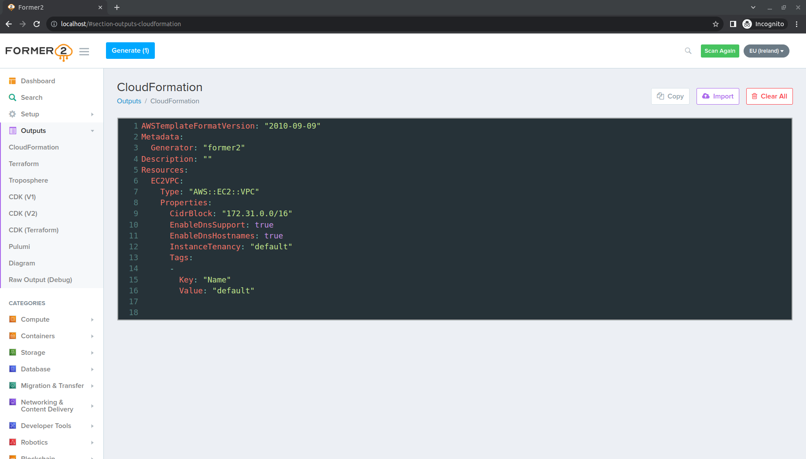

You can add as many resources as You want. Take under consideration that those templates always have to be double checked if everything was imported correctly. The potential variables in most of the time will be hardcoded and not all the dependencies could be imported.

**Cleanup**

After the work is done use ***docker compose down*** to delete the stack.