**AWS DynamoDB cross region backup**

You can backup Your DynamoDB tables by using **AWS Backup** service.

1. Open the [AWS DynamoDB console](https://eu-west-1.console.aws.amazon.com/dynamodbv2/home?region=eu-west-1" \l "dashboard) and go to ***Backups*** (on the left pane).

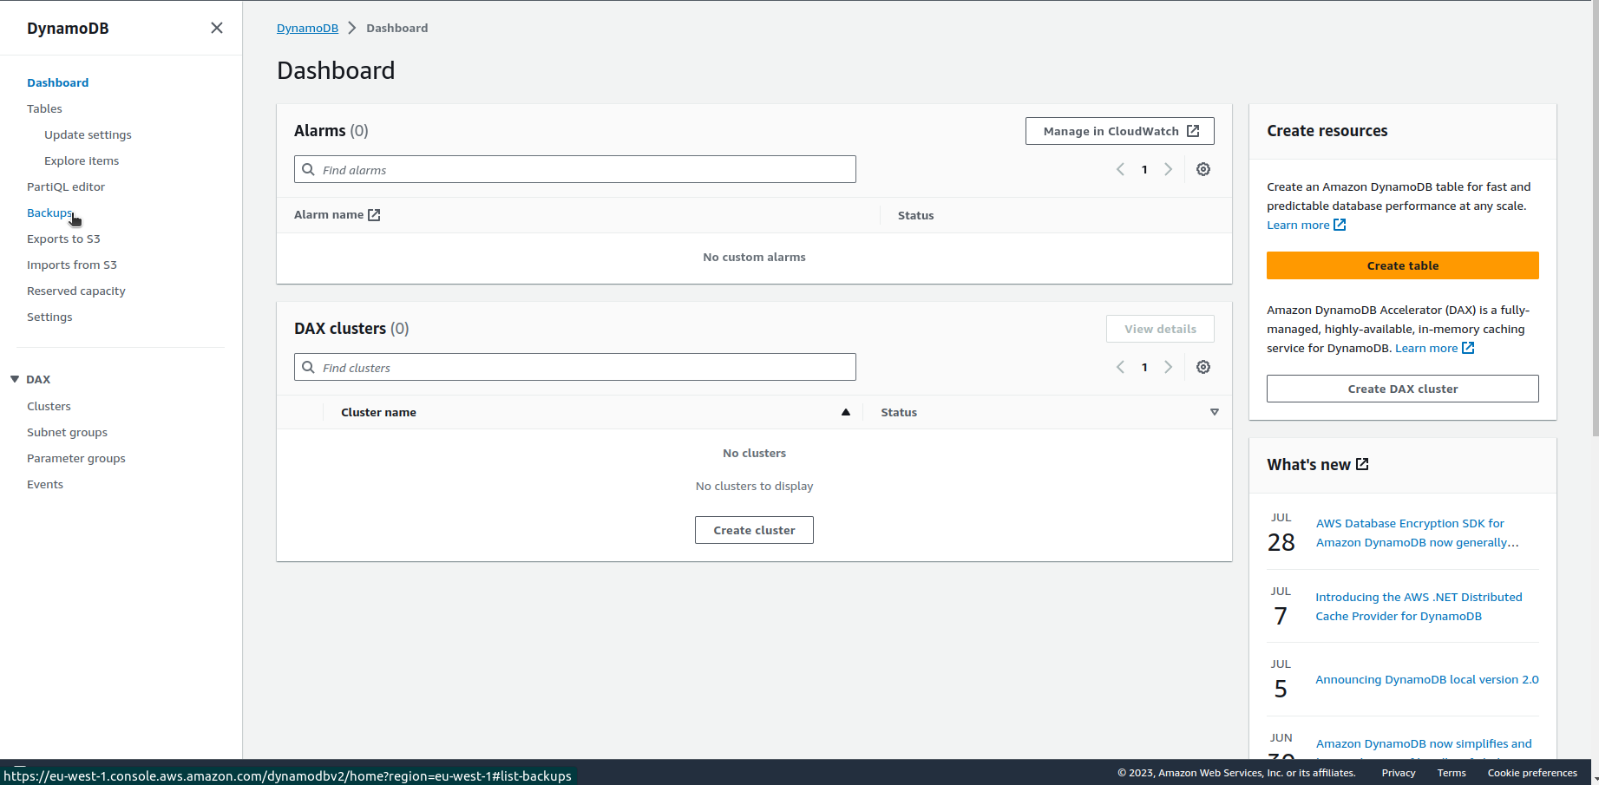

1. Click on ***Schedule automatic backups*** on the ***Backups*** tab.
2. 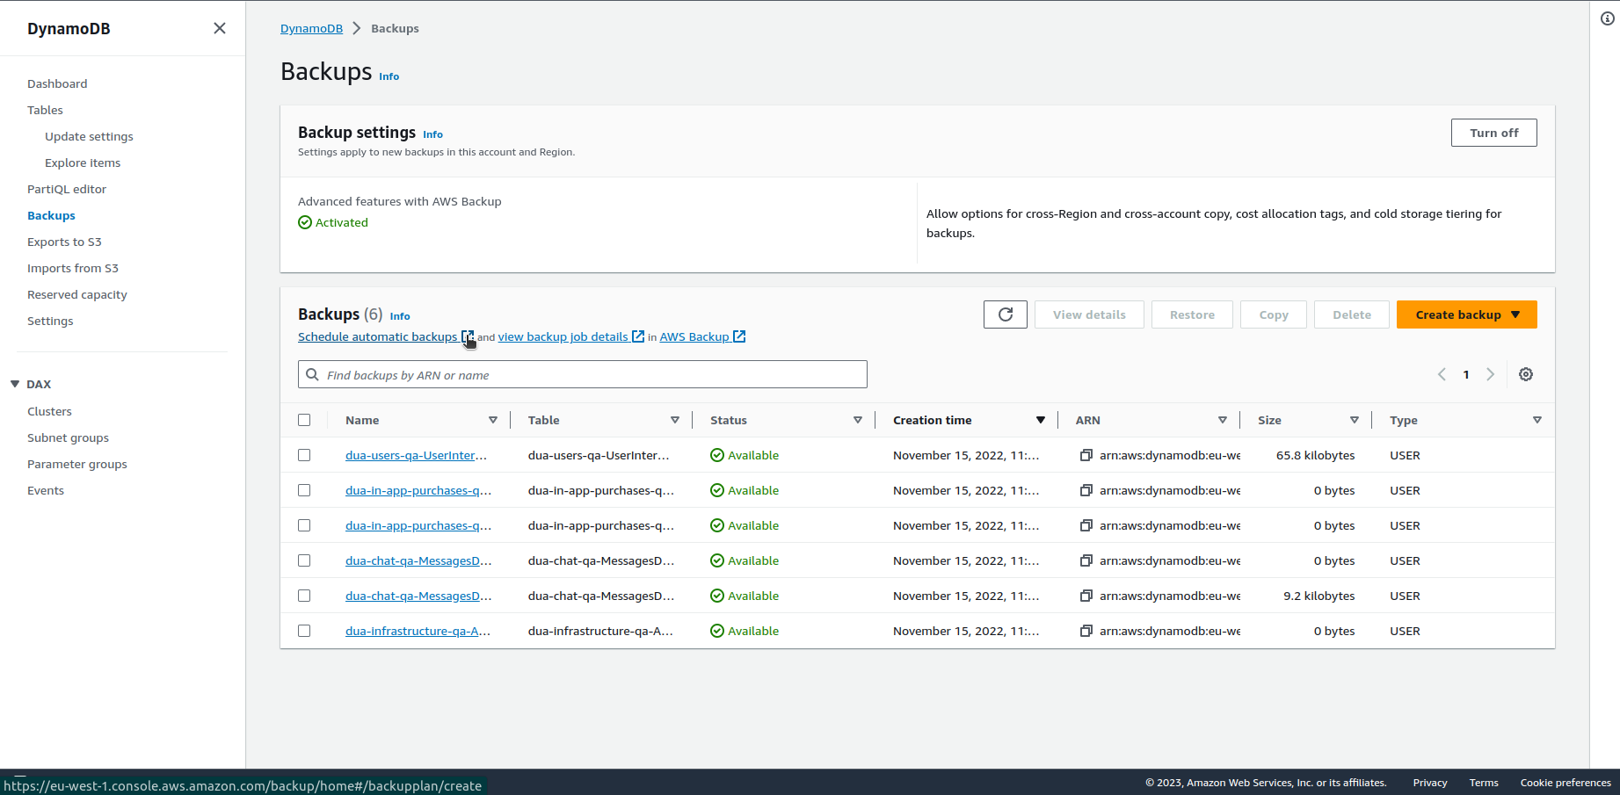Give the backup plan a name and set backup rule configuration as You need with ***Copy to destination*** option set for a different AWS Region.

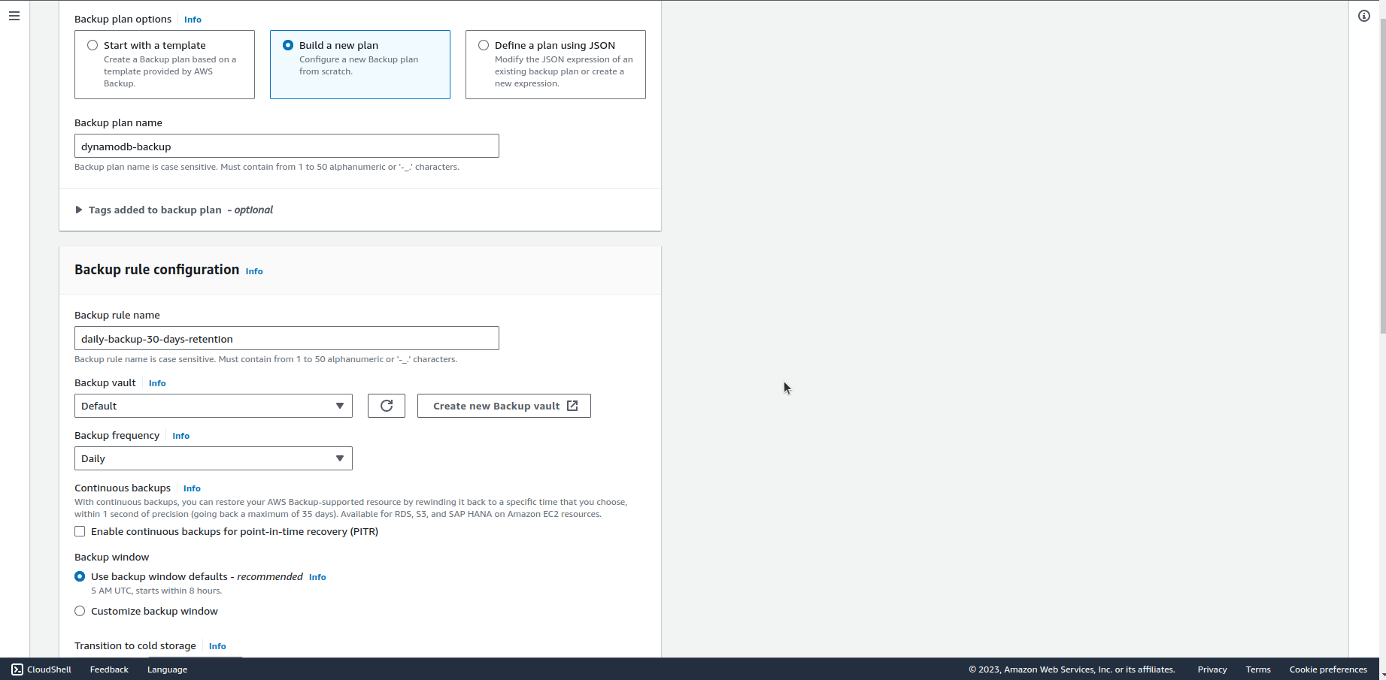

1. 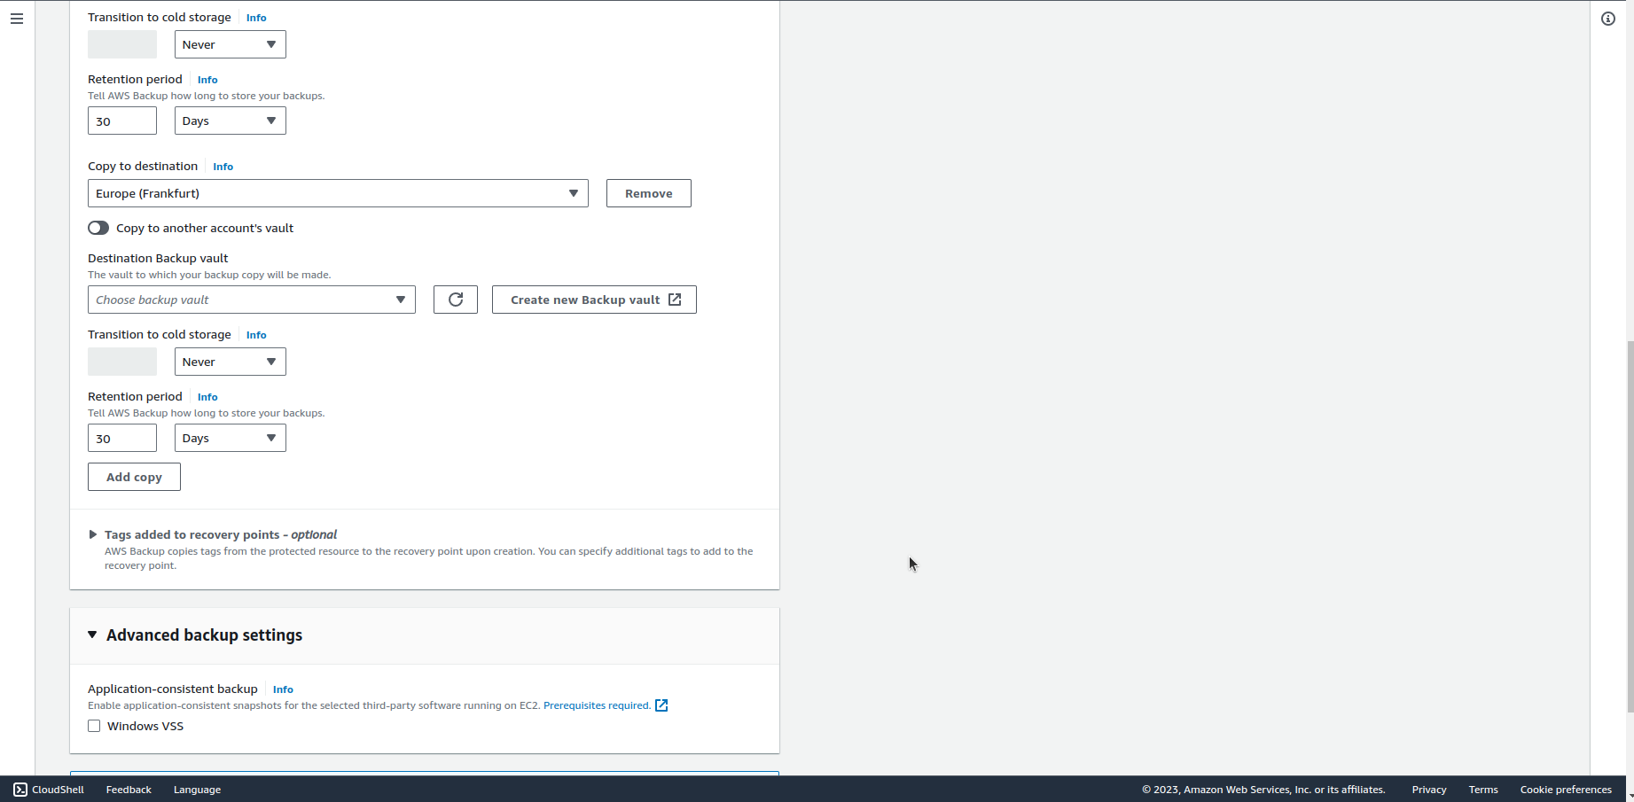Click on ***Create plan*** on the bottom of the page.

**Pricing**

Storage: $0.11 / GB, 100 GB = $11 / month

Cross region data transfer: $0.04 / GB, 100 GB = $4 / month

Sum: **$15 / month**

https://aws.amazon.com/backup/pricing/