**AWS ECR cross region backup**

1. Open the [AWS ECR console](https://eu-west-1.console.aws.amazon.com/ecr/repositories?region=eu-west-1) and go to ***Private registry*** on the left pane.
2. 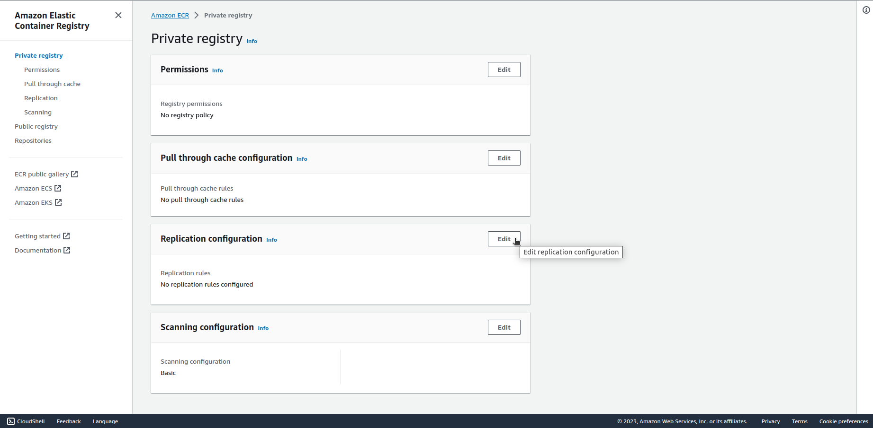Click on ***Edit*** on ***Replication configuration*** tab.
3. Click on ***Add rule*** and go through settings choosing Cross-region replication and the region for backup.
4. Click on ***Submit rule*** on the last window to create replication rule.

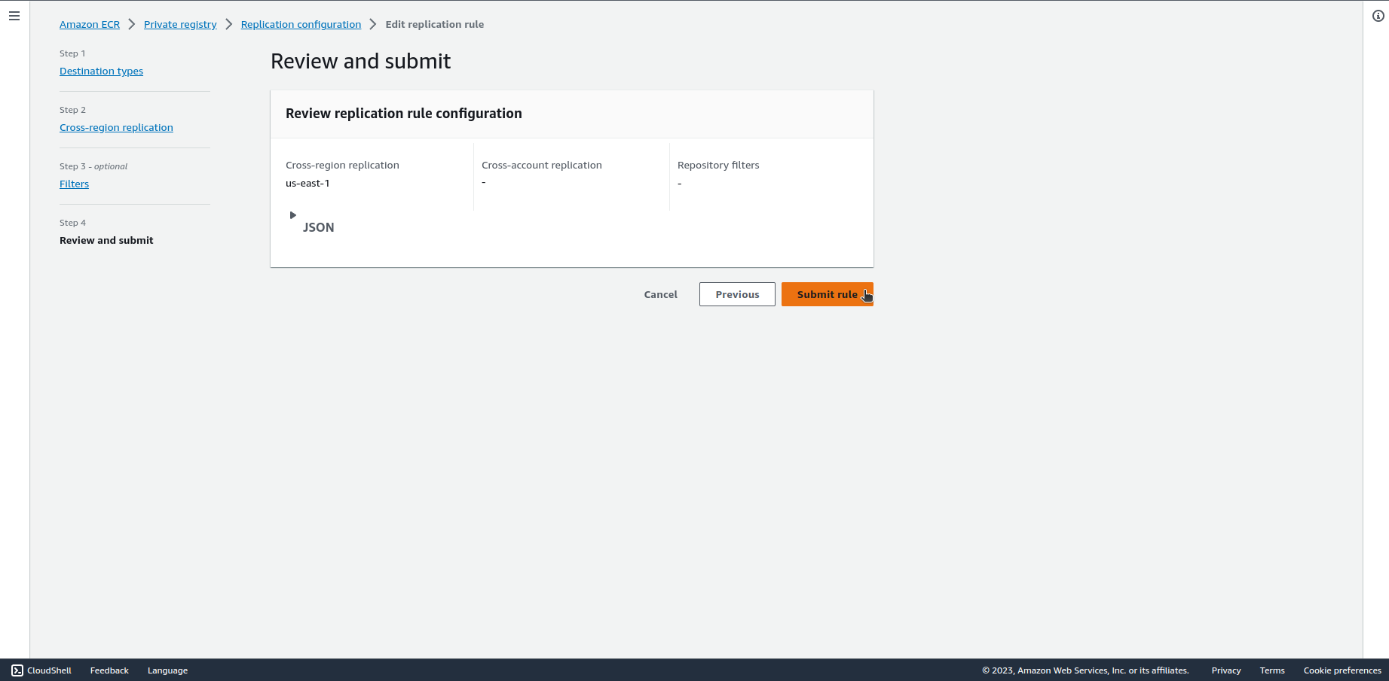

This will only replicate the images added after the replication rule was created. In order to replicate existing images, use the attached bash or python script.

Documentation:

<https://docs.aws.amazon.com/AmazonECR/latest/userguide/registry-settings-configure.html>