**AWS ElastiCache cross region backup**

If You have automatic backup for ElastiCache Redis cluster enabled, You can export the snapshots to S3 bucket and then replicate it to other region.

1. Open the [AWS ElastiCache console](https://eu-west-1.console.aws.amazon.com/elasticache/home?region=eu-west-1" \l "/) and go to ***Backups*** on the left pane.
2. Choose the backup that You want to replicate and click on ***Copy*** in the right upper corner.

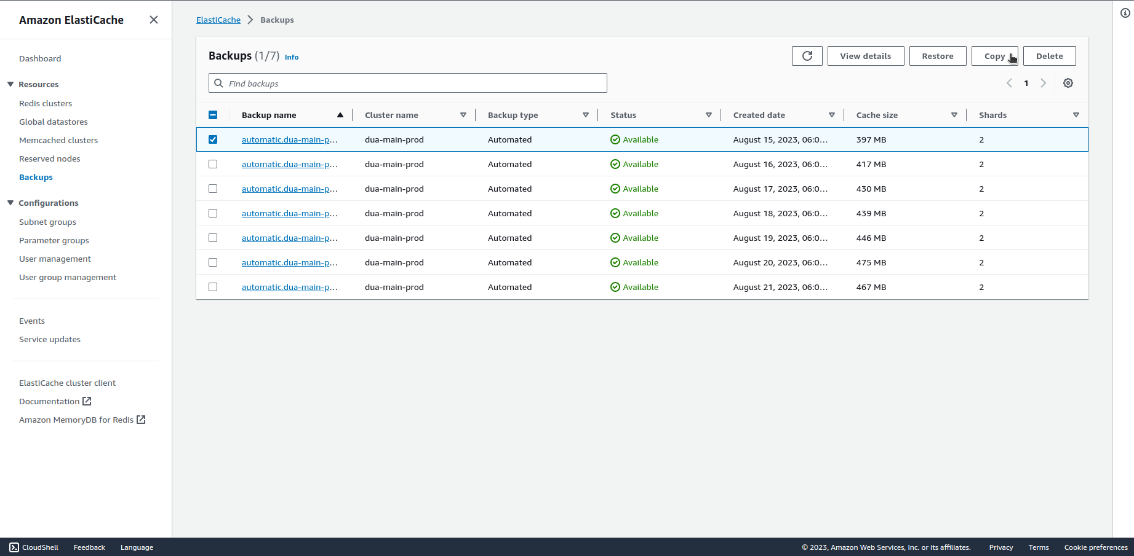

1. Set a new backup name and choose existing S3 bucket or create a new one. The bucket must have the following permissions under ACL section:

Add grantee Canonical Id: 540804c33a284a299d2547575ce1010f2312ef3da9b3a053c8bc45bf233e4353

Objects: List, Write

Bucket ACL: Read, Write

1. Click on ***Copy*** on the bottom of the page to export the snapshot.

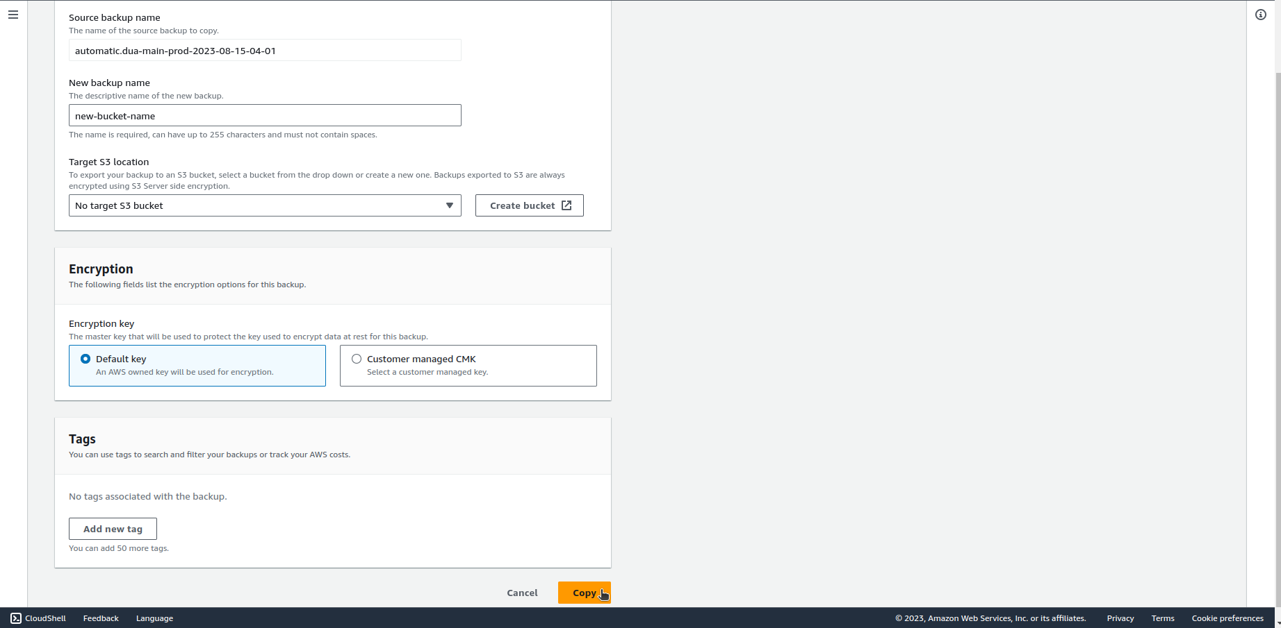

1. You can replicate S3 bucket to other region using the instructions attached.

Documentation:

<https://docs.aws.amazon.com/AmazonElastiCache/latest/red-ug/backups-exporting.html>