**AWS Aurora RDS cross region backup**

You can create an Amazon Aurora MySQL DB cluster as a read replica in a different AWS Region than the source DB cluster or copy DB snapshots to other region.

**Read replica**

1. Choose the replication target region and create there VPC, subnets, security groups, etc. and DB subnet group similar to the source region resources. You can use Former2 to create CloudFormation templates.
2. Open the [AWS RDS console](https://eu-west-1.console.aws.amazon.com/rds/home?region=eu-west-1), go to ***Databases*** on the left pane and choose Your DB cluster.

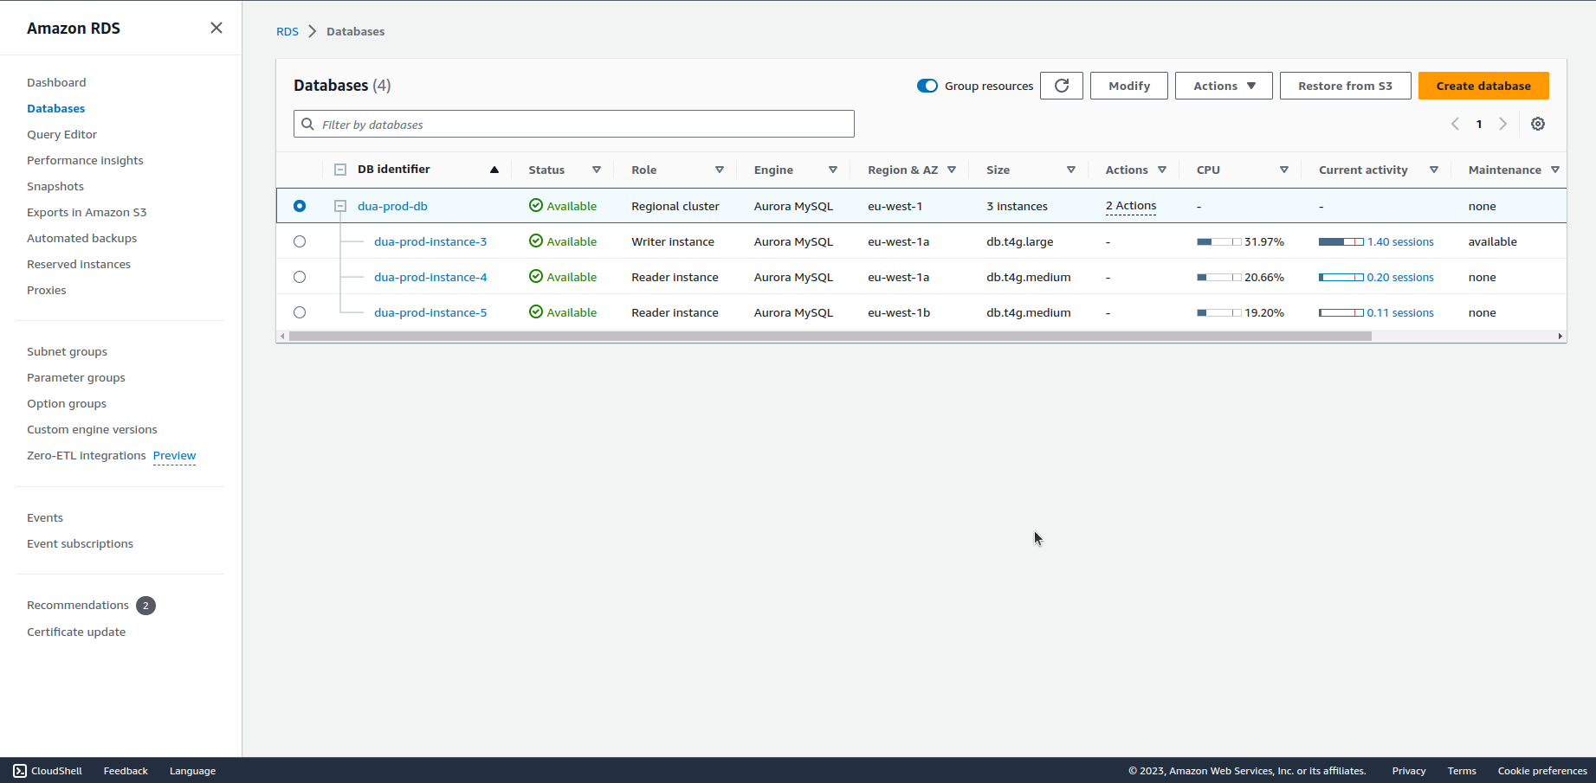

1. Click on ***Actions*** and choose ***Create cross region read replica***.

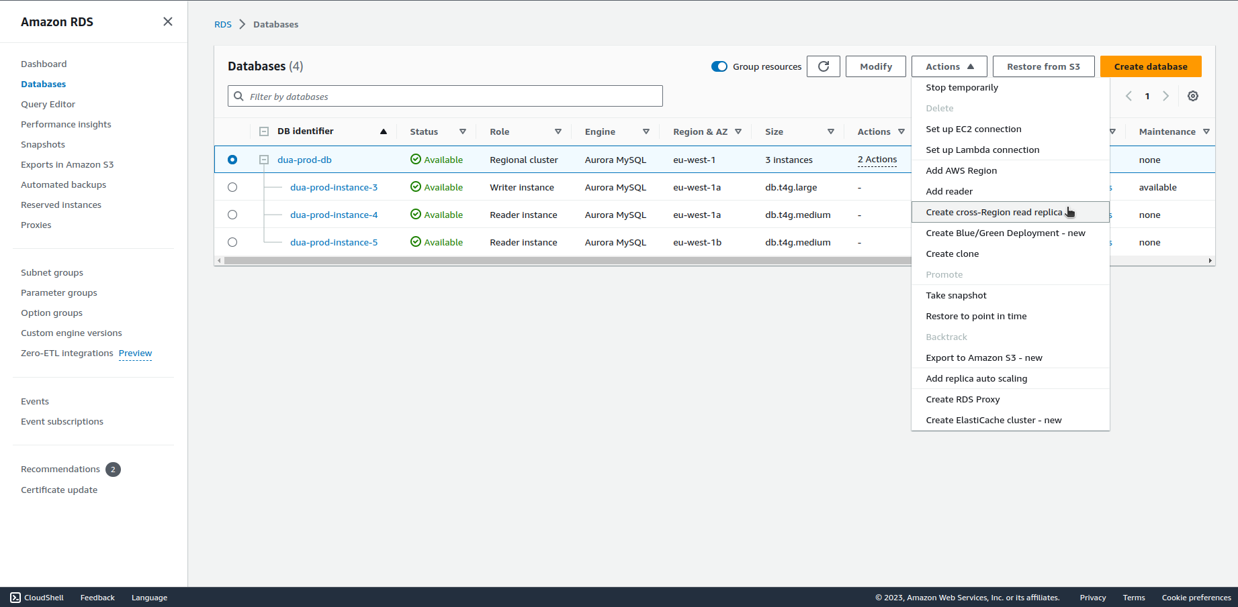

1. Set all the settings as You need, choose the target region, VPC and subnet group created in step 1, then click on ***Create*** at the bottom of the page.

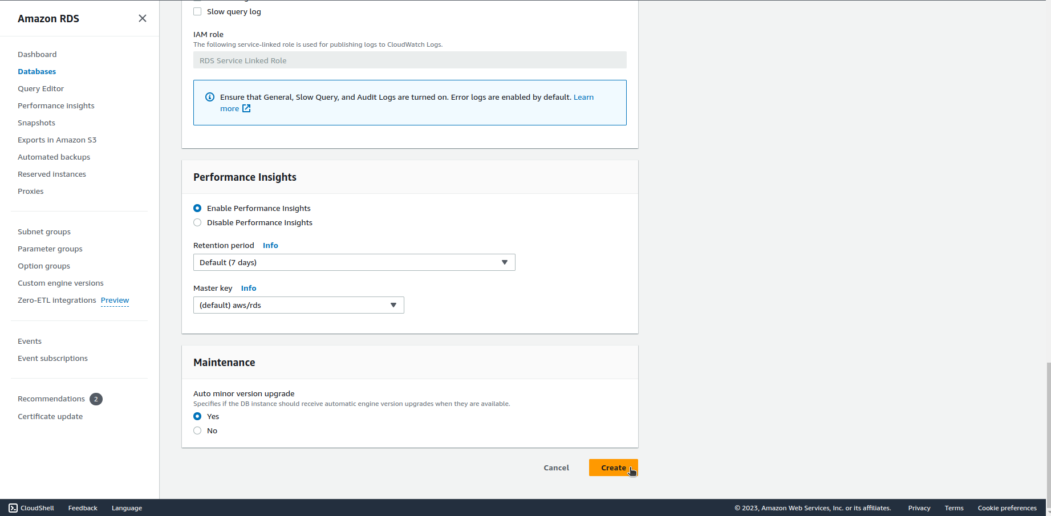

Documentation:

<https://docs.aws.amazon.com/AmazonRDS/latest/AuroraUserGuide/AuroraMySQL.Replication.CrossRegion.html>

**Copy snapshots**

1. Open the [AWS RDS console](https://eu-west-1.console.aws.amazon.com/rds/home?region=eu-west-1), go to ***Snapshots*** on the left pane, choose the snapshot to copy and under ***Actions*** click on ***Copy snapshot***.

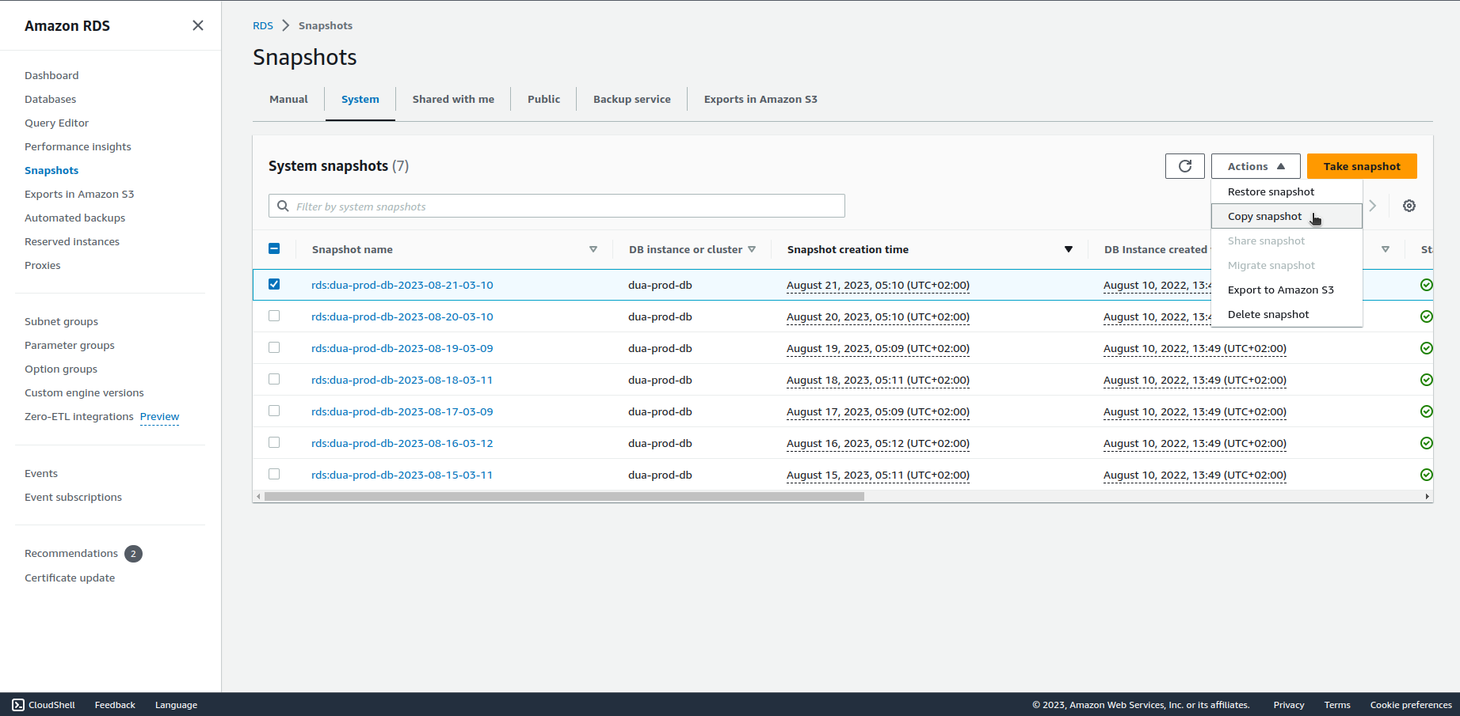

1. Choose destination region, set the snapshot identifier and click on ***Copy snapshot*** at the bottom of the page.

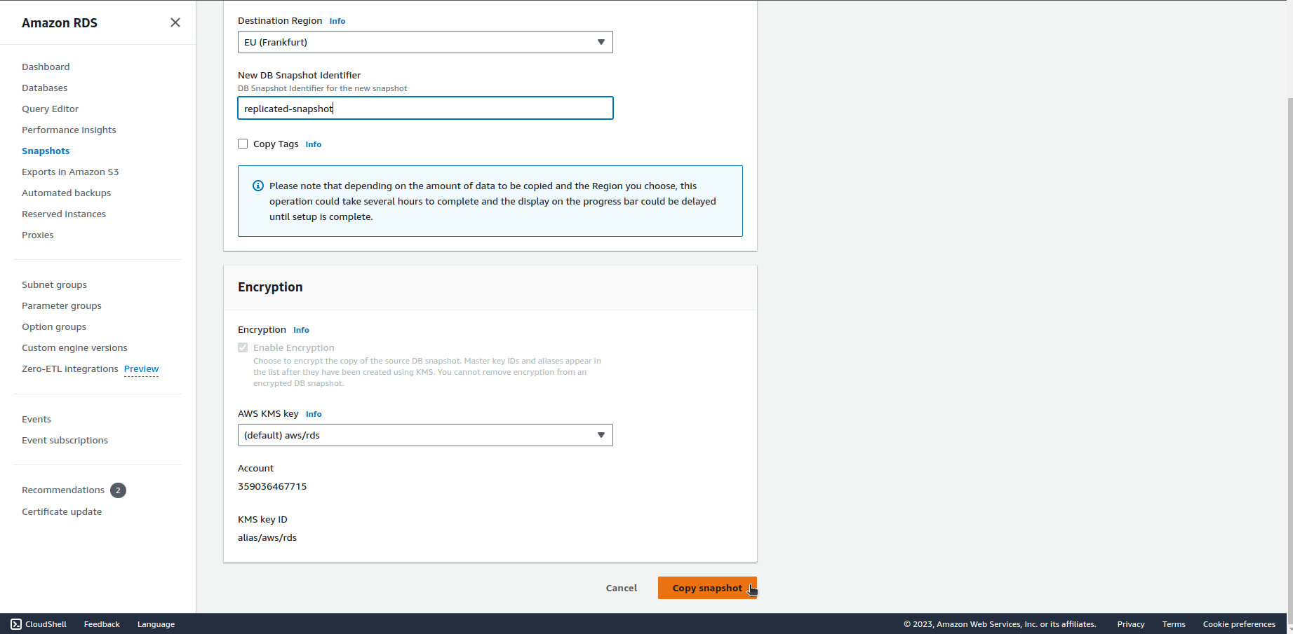

Documentation:

<https://docs.aws.amazon.com/AmazonRDS/latest/UserGuide/USER_CopySnapshot.html>