**AWS Secrets Manager cross region backup**

1. Open the [AWS Secrets Manager console](https://eu-west-1.console.aws.amazon.com/secretsmanager/landing?region=eu-west-1) and choose the secret.
2. Click on ***Replicate secret to other Regions*** in the upper right corner.

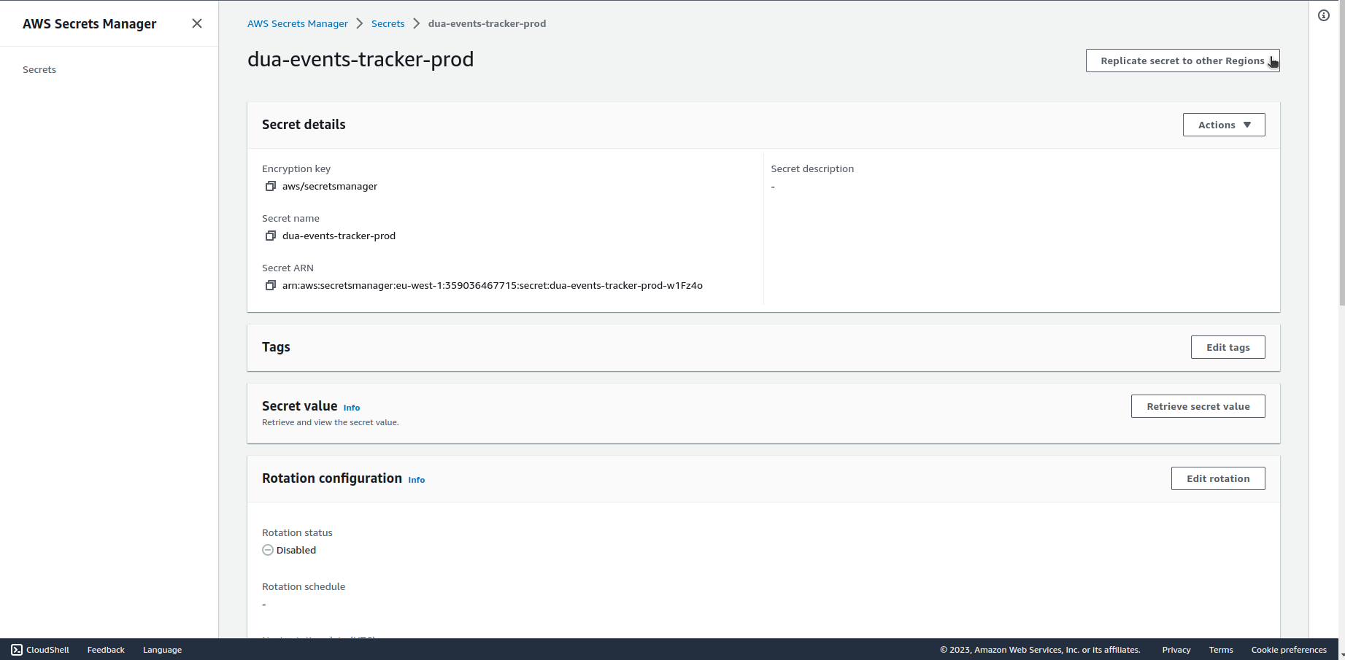

1. Choose the region, encryption key and click on ***Replicate secret***.

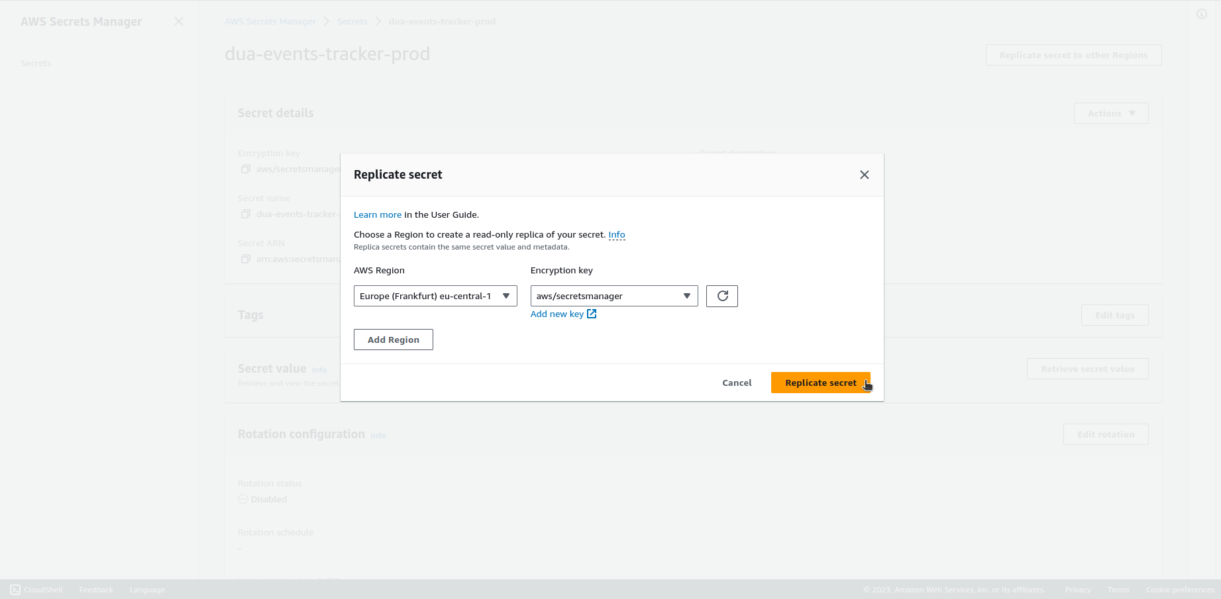.

1. You can automate the process by using AWS CLI and creating automated cron script. Here’s the example command:

*aws secretsmanager replicate-secret-to-regions --secret-id MyTestSecret --add-replica-regions Region=eu-west-3*

Documentation:

<https://docs.aws.amazon.com/secretsmanager/latest/userguide/create-manage-multi-region-secrets.html>