**How to enable EBS encryption by default**

1. Open the [Amazon EC2 console](https://console.aws.amazon.com/ec2/).
2. From the navigation bar, select the Region.
3. From the navigation pane, select **EC2 Dashboard**.
4. In the upper-right corner of the page, choose **Account Attributes**, **EBS encryption**.

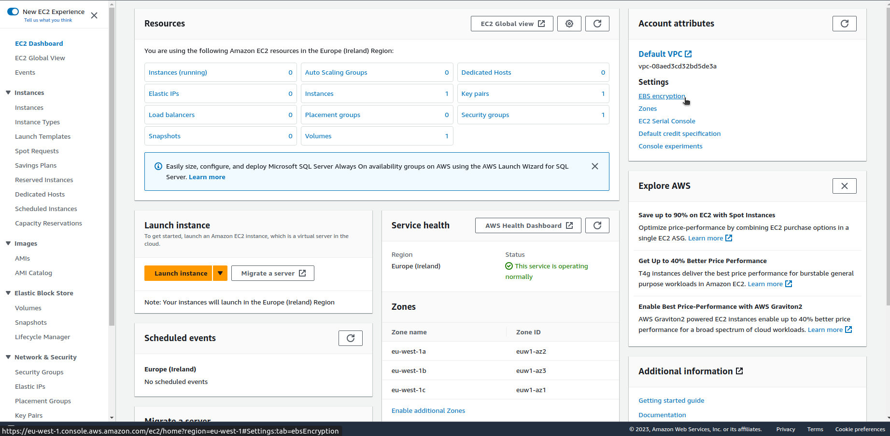

1. Choose **Manage**.

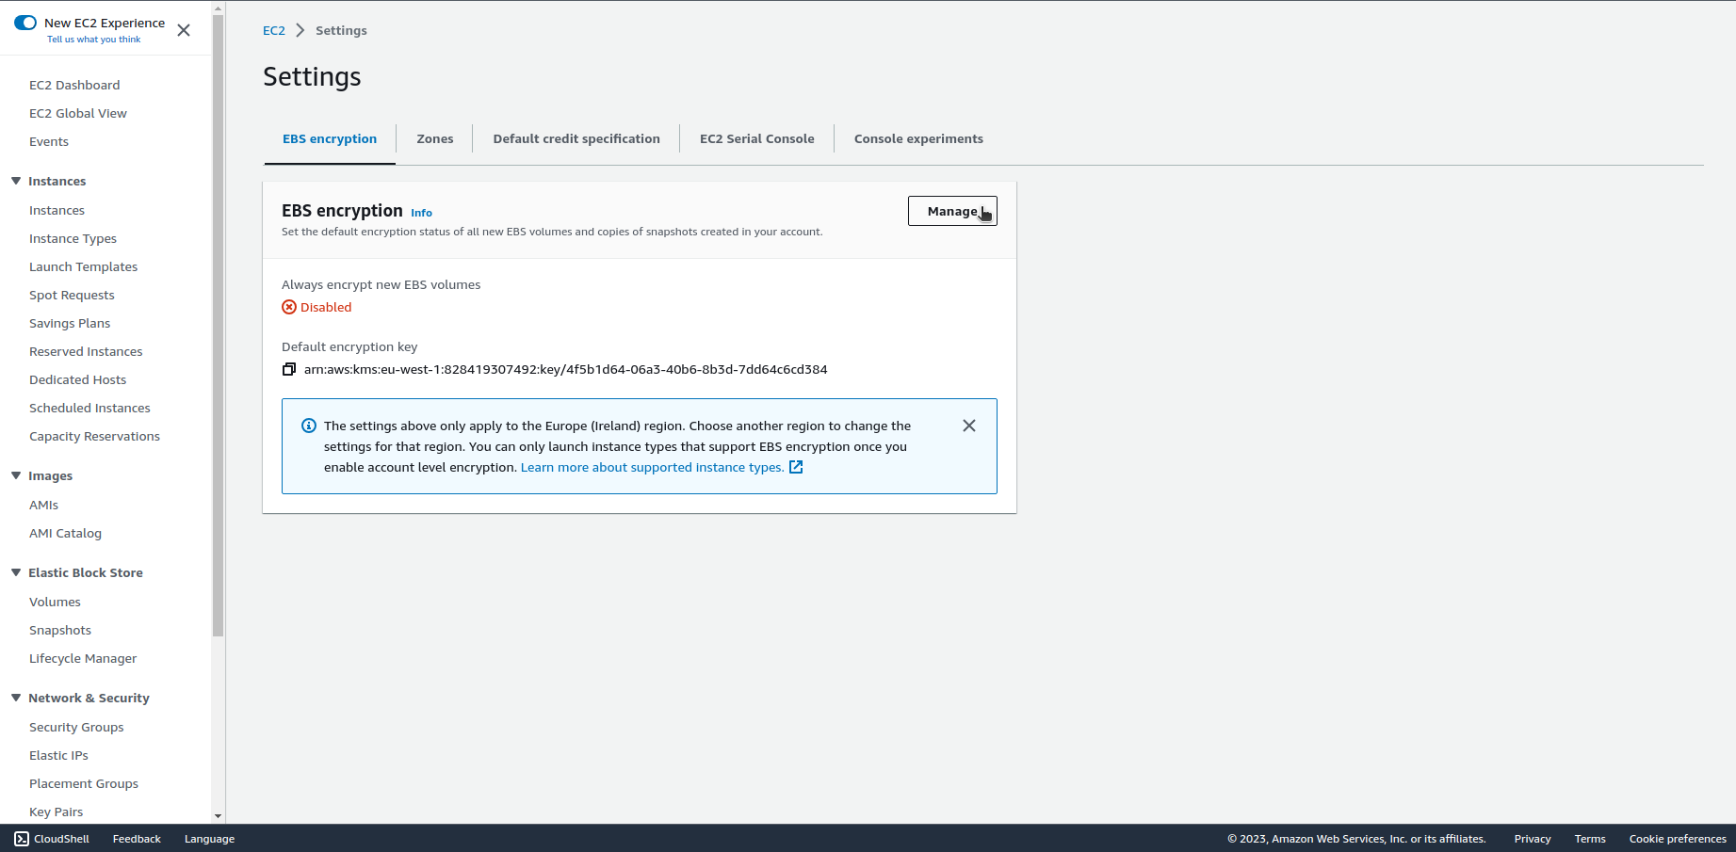

1. Select **Enable**. Keep the AWS managed key with the alias alias/aws/ebs created on your behalf as the default encryption key, or choose a symmetric customer managed encryption key.
2. Choose **Update EBS encryption**.

