**EBS MOUNT**

**1. Attach the EBS Volume to the EC2 Instance:**

* Go to the AWS Management Console and navigate to the EC2 Dashboard.
* From the left-hand menu, select "Volumes" under the "Elastic Block Store" section.
* Locate the newly created EBS volume in the list.
* Select the volume, click on “Actions” in the upper right corner and then on "Attach volume".
* 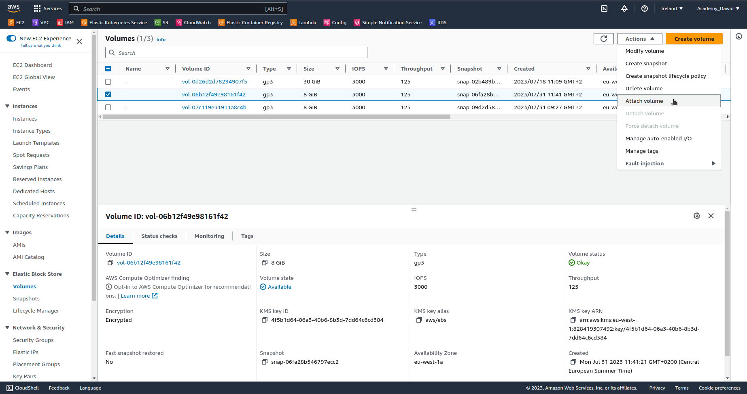In the "Attach Volume" dialog box, select the EC2 instance to which you want to attach the volume.
* Note down the device name (e.g., /dev/sdf) to which the volume is attached. You'll need this information later.
* Click on "Attach volume".

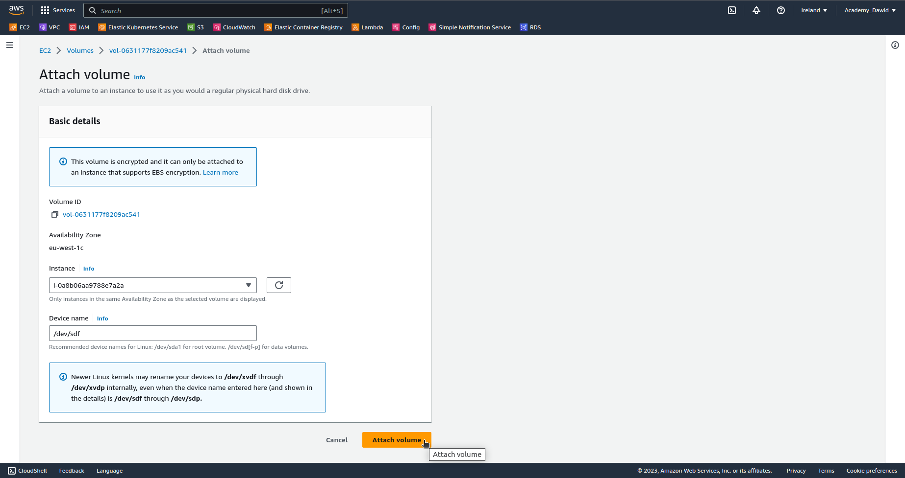

**2. SSH into the EC2 Instance:**

* Open your terminal or SSH client on your local machine.
* Use the key pair associated with your EC2 instance to log in:

ssh -i /path/to/your/key.pem ec2-user@your_ec2_instance_public_dns

Note: Replace `/path/to/your/key.pem` with the actual path to your private key file and `your_ec2_instance_public_dns` with the public DNS or IP address of your EC2 instance.

* You can also use Session Manager to connect.

**3. Check Existing Block Devices:**

* Run the following command to list the current block devices attached to your instance:

***lsblk -f***

* The newly attached EBS volume should be listed. Note that UUID of the volumes are the same.

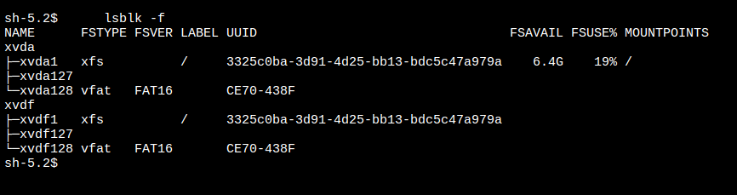

**4. Mount the EBS Volume:**

* First, let's create a directory where you'll mount the EBS volume. For example, create a directory named "data":

***sudo mkdir /mnt/data***

* Now You’ll have to change the UUID of the volume:

***sudo xfs_repair -L /dev/xvdf1***

***uuidgen***

***sudo xfs_admin -U <newly-generated-uuid> /dev/xvdf1***

Note: Replace `/dev/xvdf1` with the correct device name for your volume.

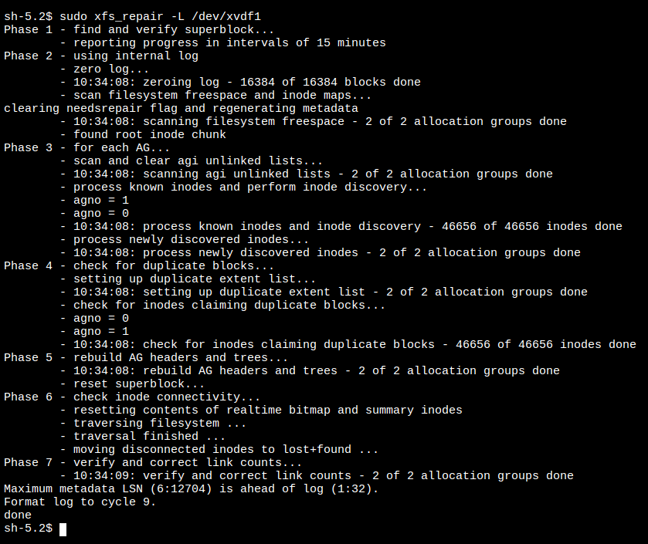

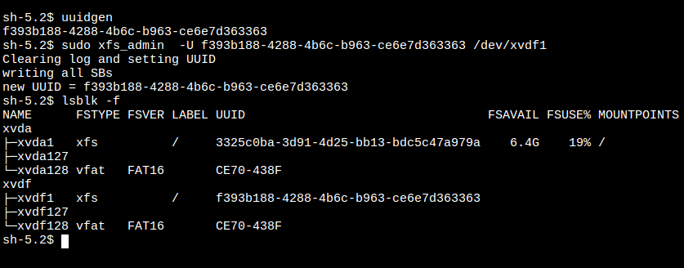

* Mount the EBS volume to the directory you created:

**sudo mount /dev/xvdf1 /mnt/data**

Note: Replace `/dev/xvdf1` with the correct device name for your volume.

**5. Verify the Mount:**

* Run the `df -h` command to verify that the volume has been successfully mounted:

***df -h***

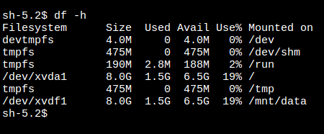

**6. Make the Mount Persistent:**

* By default, the mount will not persist across reboots. If you want the volume to be automatically mounted whenever the instance starts, you'll need to update the `/etc/fstab` file. Open the file in an editor, for example:

***sudo nano /etc/fstab***

* Add the following line at the end of the file (replace the device name and mount point with your specific details):

***UUID=<new-UUID> /mnt/data xfs defaults,noatime 1 1***

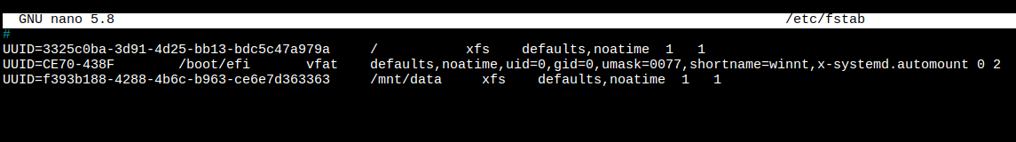

That's it! Now you have successfully mounted the new EBS volume with your data on your EC2 instance, and you can access the data stored on it. Remember to handle the data with caution and ensure you have proper backups before performing any critical operations.