**IAM Instance Profile**

IAM instance profiles in AWS provide a secure and scalable way to grant permissions to EC2 instances. Instead of using hardcoded credentials, you use instance profiles to associate IAM roles (with permissions of your choice) with EC2 instances during launch. Here are some recommendations for using IAM instance profiles effectively:

**1. Security Best Practices:**

* Avoid using long-lived AWS access keys directly on instances. Instance profiles help reduce the risk associated with managing and securing access keys, as they are automatically rotated.
* IAM roles associated with instance profiles have temporary credentials, which are automatically rotated by AWS, adding an additional layer of security.

**2. Least Privilege Principle:**

* Follow the principle of least privilege by assigning IAM roles with the minimum required permissions to perform specific tasks. This limits the potential impact of security vulnerabilities or unintended actions.
* Regularly review and update IAM policies to ensure they align with the current requirements of your EC2 instances.

**3. Automated Credential Management:**

* Use IAM roles to automate credential management. IAM roles associated with instance profiles automatically rotate credentials, reducing the operational overhead of managing access keys manually.
* Leverage AWS SDKs and tools that support instance profiles for automatic handling of temporary credentials.

**4. Easier Role Management:**

* Centralize IAM role management for EC2 instances, making it easier to modify permissions for a group of instances by updating the associated instance profile.
* IAM instance profiles can be easily added or removed during instance launch or stopped/started instances, providing flexibility in managing access.

**5. Integration with AWS Services:**

* Leverage IAM roles for EC2 instances to grant permissions for seamless integration with other AWS services, such as S3, DynamoDB, or Lambda.
* This approach is especially useful when running applications that need to interact with multiple AWS services securely.

**6. Consistent Role Assignment:**

* Ensure a consistent approach to role assignment across your EC2 instances. This makes it easier to audit and understand the permissions granted to different instances.
* Use tagging to label instances based on their roles and functions for better organization and tracking.

**7. Logging and Monitoring:**

* Enable AWS CloudTrail logging to capture API calls and changes to IAM roles associated with instance profiles. This provides an audit trail for security and compliance purposes.
* Utilize AWS Config rules to monitor and enforce compliance with IAM best practices.

**8. Documentation and Training:**

* Clearly document the IAM roles and permissions associated with instance profiles. This documentation is crucial for onboarding new team members and ensuring a consistent understanding of access controls.

By following these recommendations, you can enhance the security, manageability, and scalability of your AWS infrastructure when using IAM instance profiles with EC2 instances.

**Create IAM instance profile**

1. Access the AWS Management Console and navigate to IAM service.
2. In the IAM dashboard, click on "Roles" in the left navigation pane.
3. Click the "Create role" button to initiate the process of creating a new IAM role.
4. Choose the trusted entity type. For EC2 instances, select "AWS service," and then select "EC2" as the use case.

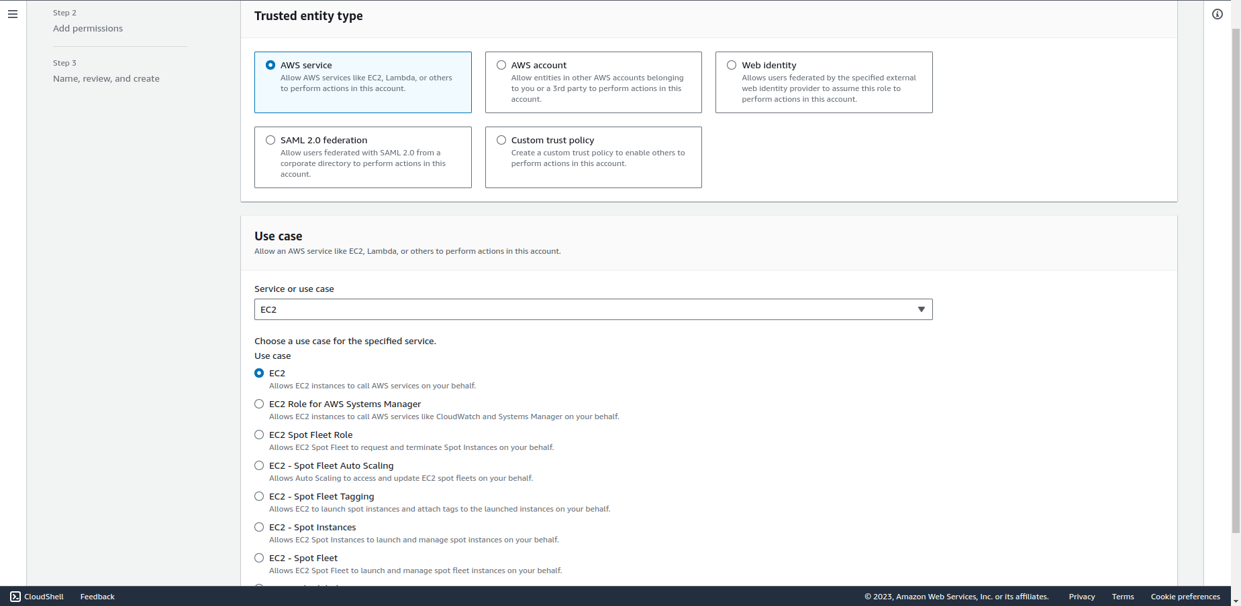

1. In the "Attach permissions policies" step, search and select the policies that define the permissions you want to grant to EC2 instances associated with this instance profile. You can attach one or more policies based on your requirements.
2. Provide a meaningful name and description for the IAM role. Ensure the role name is descriptive of its purpose.
3. Click the "Create role" button to proceed.

**Attach IAM instance profile to EC2 instance**

1. Open the AWS Management Console and navigate to the EC2 service.
2. Select your EC2 instance, click on "Actions" at the top right corner, then "Security", and then "Modify IAM role".

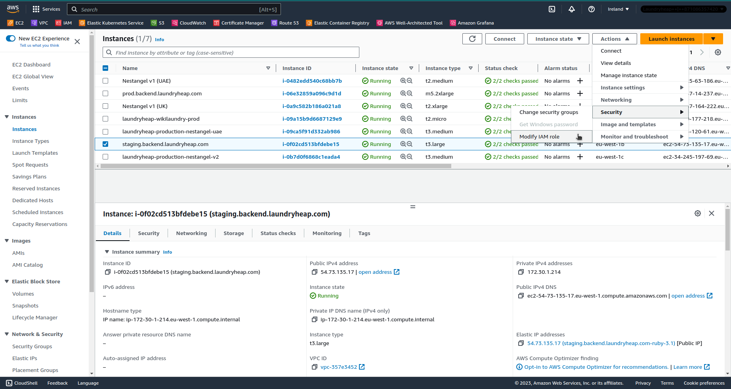

1. Click on "Choose IAM role", select the newly created IAM role and click on "Update IAM role".
2. Now you can remove IAM User credentials from the EC2 instance.