**AWS Systems Manager**

**Managing Amazon EC2 Instances Using AWS Systems Manager**

Managing Amazon EC2 instances through AWS Systems Manager provides a more secure and centralized approach compared to allowing direct access. Systems Manager offers features like Automation, Run Command, and Session Manager, allowing you to perform tasks without exposing your instances to direct external access. This enhances security, simplifies maintenance, and provides a unified platform for managing your EC2 fleet.

**How and Why It Should Be Used**

**1. Enhanced Security**

Direct access to EC2 instances might expose them to security risks. Systems Manager enables you to perform actions without the need for SSH/RDP, reducing the attack surface and enhancing security.

**2. Centralized Management**

Systems Manager provides a unified interface for managing EC2 instances across multiple AWS accounts and regions. This simplifies administration tasks and ensures consistent configurations.

**3. Automation and Compliance**

Systems Manager allows you to automate tasks, ensuring that your EC2 instances adhere to compliance standards. Automation can be used for patch management, software installations, and configuration changes.

**4. Session Manager for Secure Access**

Session Manager provides secure, audited access to EC2 instances without the need for bastion hosts or open ports. It uses IAM roles and policies to control access.

**Instructions**

**Step 1: Create IAM Role with SSMManagedInstanceCore Policy**

1. Navigate to the IAM console.
2. Choose "Roles" and click "Create role."
3. Select "AWS service" as the trusted entity, choose EC2, and click "Next."

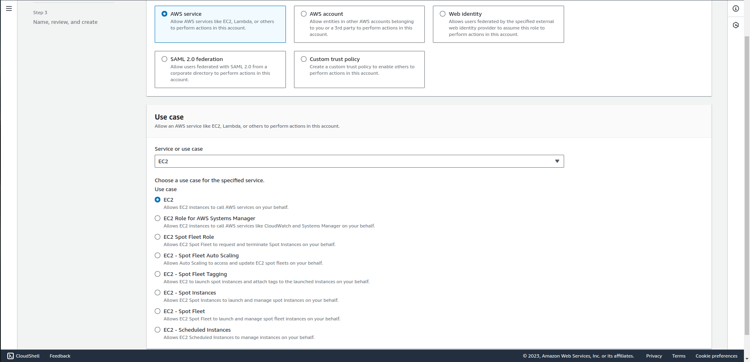

1. Attach the policy "AmazonSSMManagedInstanceCore" to the role.

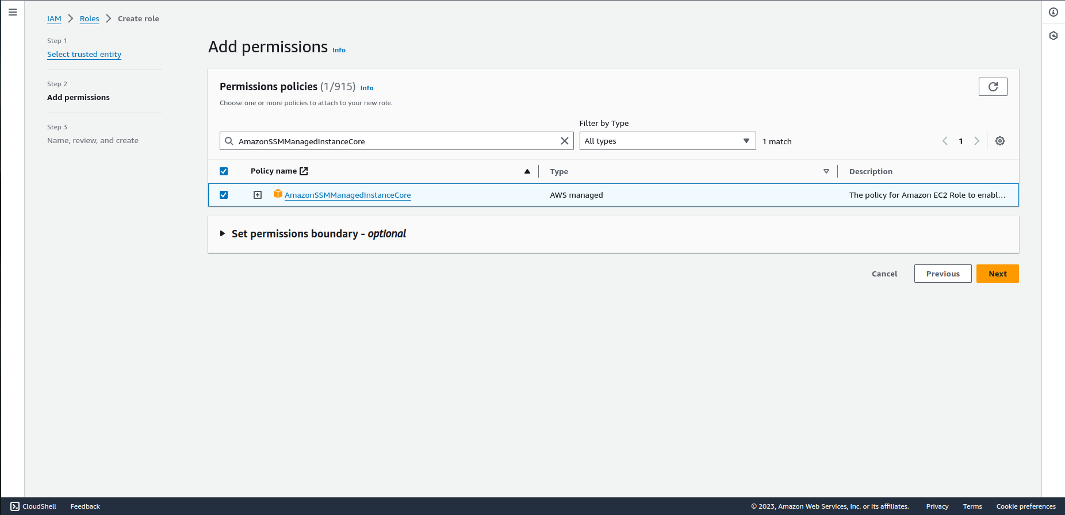

1. Complete the role creation process, giving it a meaningful name.

**Step 2: Attach IAM Role to EC2 Instance**

1. Launch an EC2 instance or select an existing one.
2. In the instance details page, choose "Actions" > "Security" > "Modify IAM Role."

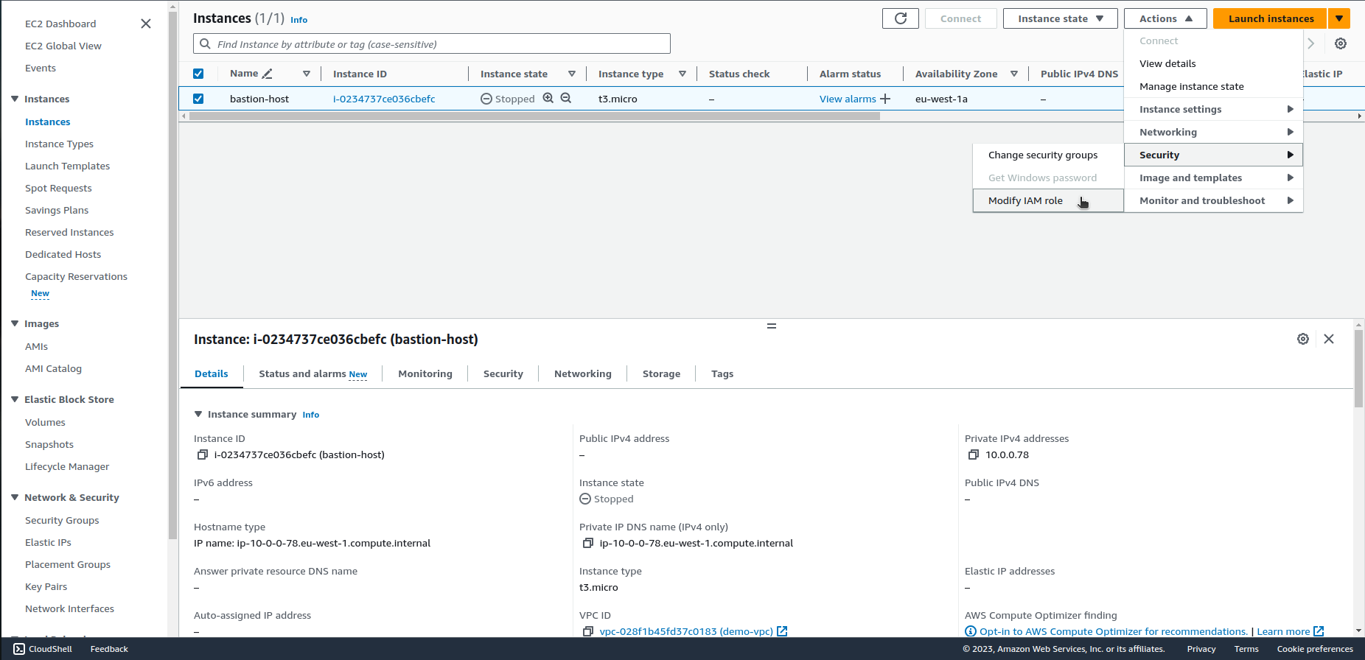

1. Select the IAM role created in Step 1 and save the changes.

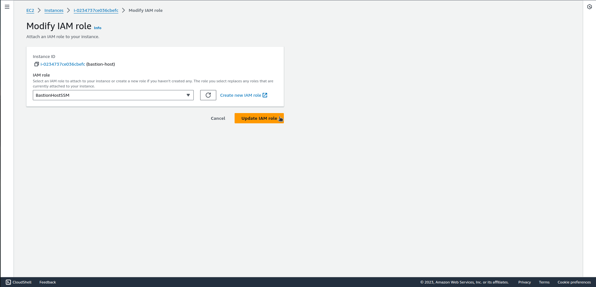

**Step 3: Connect to the Instance with Session Manager**

1. Open the AWS Systems Manager console.
2. In the navigation pane, choose "Session Manager" and click on “Start session”.

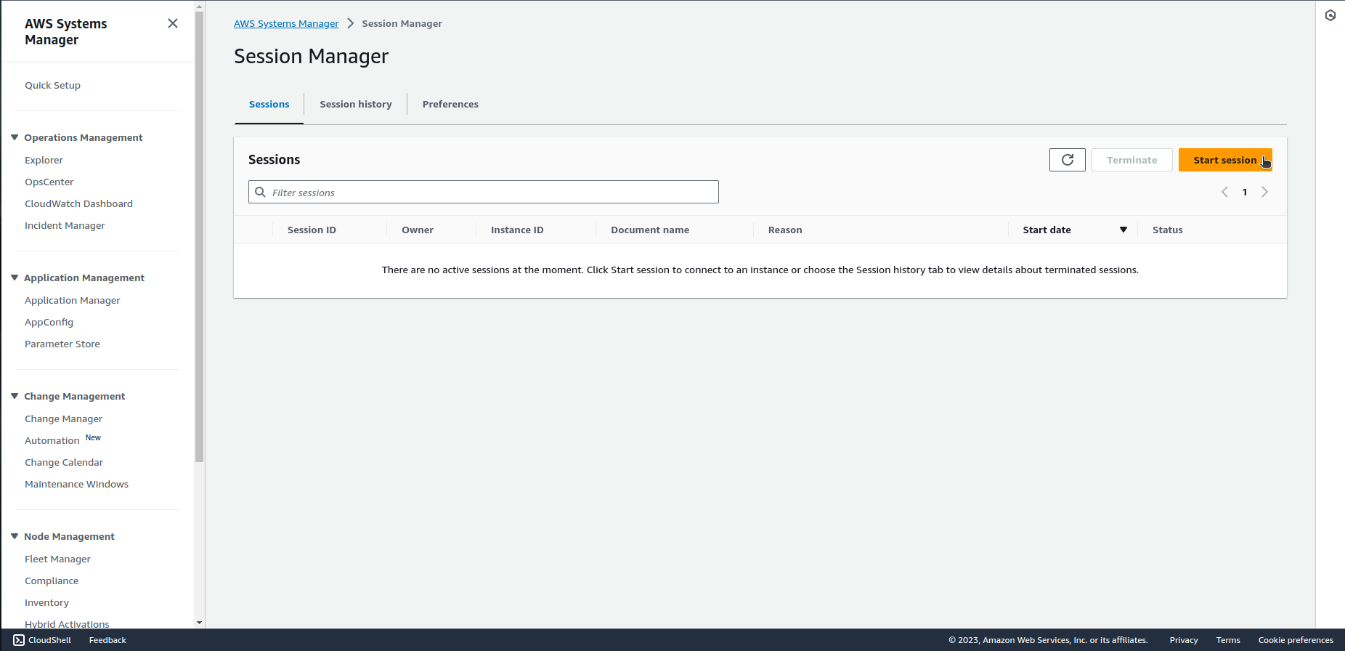

1. Select the target instance from the list and click "Start session."

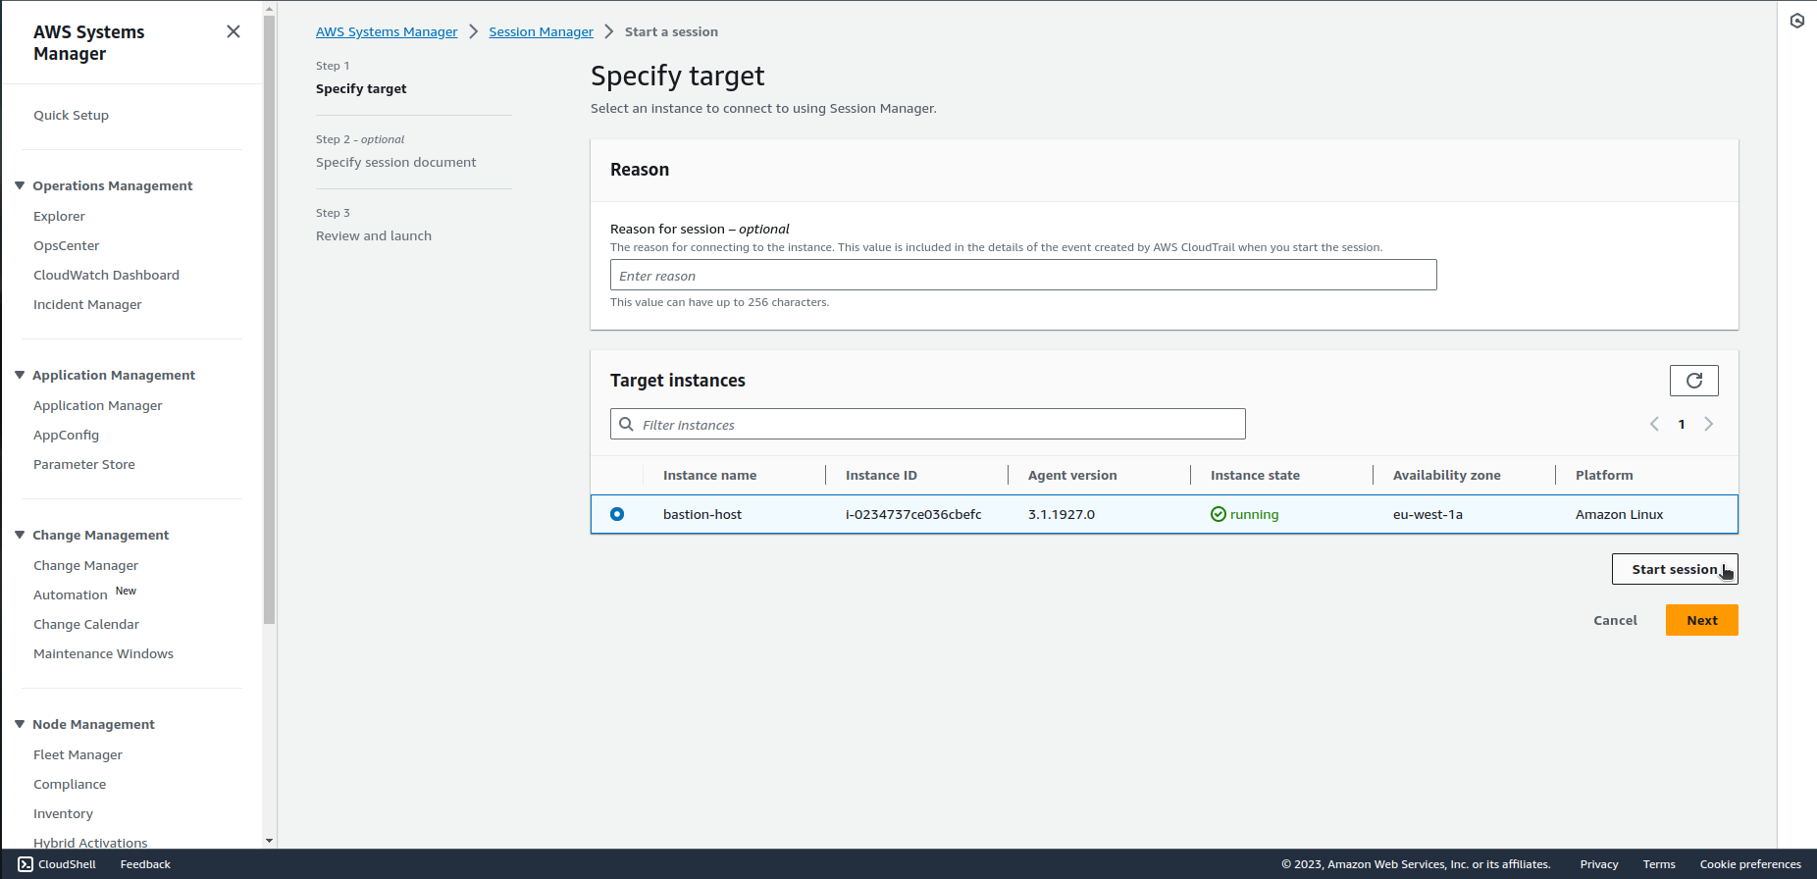

1. You'll be connected to the instance without the need for SSH or RDP.

Note: [Ensure that the EC2 instance has the Systems Manager agent installed and running](https://docs.aws.amazon.com/systems-manager/latest/userguide/session-manager-prerequisites.html).

[AWS documentation](https://docs.aws.amazon.com/systems-manager/latest/userguide/session-manager.html)