**AWS Google Workspace IAM federation Review**

AWS provides a very nice guide on how to establish a connection between Google Workspace and AWS Console. As a result you will be able to use your google Accounts to login to AWS console.  
  
This guide can be found in the link below: <https://aws.amazon.com/blogs/security/how-to-set-up-federated-single-sign-on-to-aws-using-google-workspace/>

Following next, some conclusions and points that are worth mentioned and were brought up in the discussion we had during our WAFR Review call:

1. After the solution is completed your AWS login now happens from your Google workspace Apps, as Step 6i of the guide describes 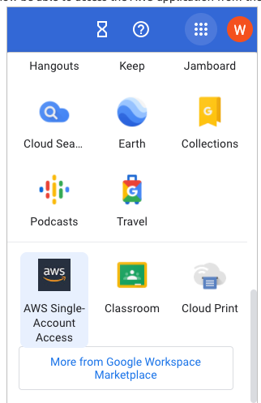
2. AWS console login (<https://aws.amazon.com/console/>), is still valid and can be used for AWS IAM Users login and of course for **root user**
3. The roles that AWS Users should have (google workspace users from now on aswell) are managed on AWS IAM console but they are different from AWS Service IAM Roles.

They are now **SAML 2.0 federation** Roles and assigned to Google Users then from the **Google Directory - Users** console. (Guide is implementing that in Step 3e and Step 4d)

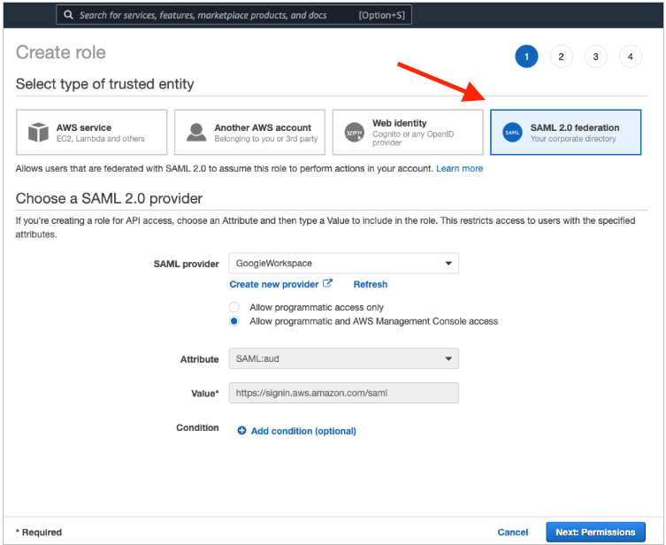

IAM Programmatic access is **unaffected,** IAM Users that have specific access and access keys assigned to them remain the same and can continue to work like that. (with or without console access). Also, new users can be created like that, moving authentication to Google workspace, does not decommission the AWS Console login capability.