**AWS GuardDuty**

AWS GuardDuty is a managed threat detection service that continuously monitors for malicious or unauthorized activity in your AWS environment. It leverages machine learning, anomaly detection, and integrated threat intelligence to identify potential security threats. GuardDuty analyzes various data sources, including VPC flow logs, CloudTrail event logs, DNS logs, and more, to detect and alert on suspicious behavior.

**Usage and Benefits**

**1. Threat Detection:** GuardDuty helps identify and prioritize potential security threats, such as unauthorized access, compromised instances, or malicious activity within your AWS environment.

**2. Easy Integration:** It seamlessly integrates with existing AWS services like CloudWatch and CloudTrail, providing comprehensive visibility into activities and events.

**3. Low Operational Overhead:** As a fully managed service, GuardDuty requires minimal configuration and maintenance, allowing organizations to focus on responding to incidents rather than managing the underlying infrastructure.

**4. Scalability:** GuardDuty scales automatically based on your AWS usage, ensuring continuous monitoring regardless of the size of your environment.

**5. Global Threat Intelligence:** GuardDuty leverages threat intelligence from various sources to enhance its detection capabilities, providing a more comprehensive defense against emerging threats.

**Costs**

GuardDuty provides a cost estimation feature to help users understand the potential daily average usage costs. The estimates cover various metrics such as Account ID, Data Source (e.g., VPC flow logs, CloudTrail logs), Feature (e.g., CloudTrail data events, EKS Audit Log Monitoring), and S3 buckets. During the **30-day free trial period**, the cost estimation projects what your estimated costs will be after the trial period.

GuardDuty usage costs are calculated based on the past 7 to 30 days of usage, and the estimates are for the current Region only. The trial usage cost estimate includes foundational data sources and features in the trial period.

**Pricing:**

* **AWS CloudTrail management event analysis:** GuardDuty continuously analyzes CloudTrail management events. Management events (also known as control plane) provide information about management operations that are performed on resources in your AWS account. CloudTrail management event analysis is charged per 1 million events per month and is prorated.

**Per one million events / month $4.60 per one million events**

* **Amazon Virtual Private Cloud (VPC) Flow Log and DNS query log analysis:** GuardDuty continuously analyzes Amazon VPC Flow Logs and Domain Name System (DNS) query logs. VPC Flow Log and DNS query log analysis is charged per gigabyte (GB) per month. Both VPC Flow Log and DNS query log analyses are discounted with volume.

**First 500 GB / month $1.15 per GB**

**Next 2,000 GB / month $0.58 per GB**

**Next 7,500 GB / month $0.29 per GB**

**Over 10,000 GB / month $0.17 per GB**

**How to Enable GuardDuty**

1. Sign in to the AWS Management Console:

- Navigate to the GuardDuty console.

2. Get Started:

- On the main screen click on “Get Started”.

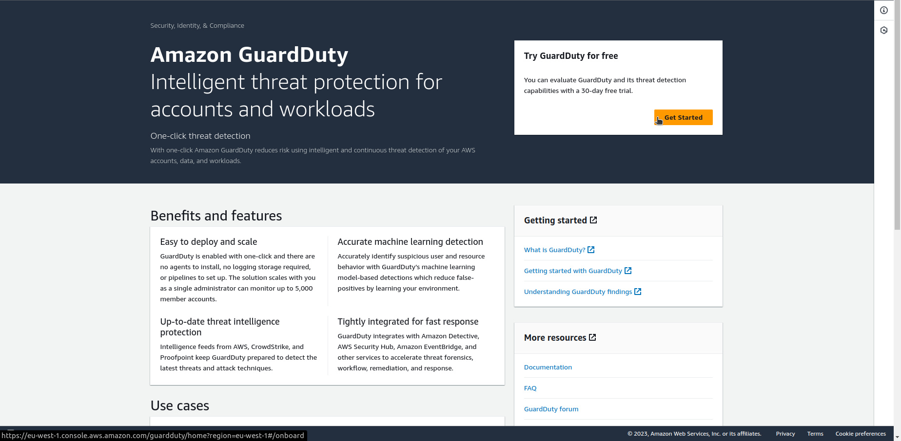

3. Enable GuardDuty:

- Click on "Enable GuardDuty”.

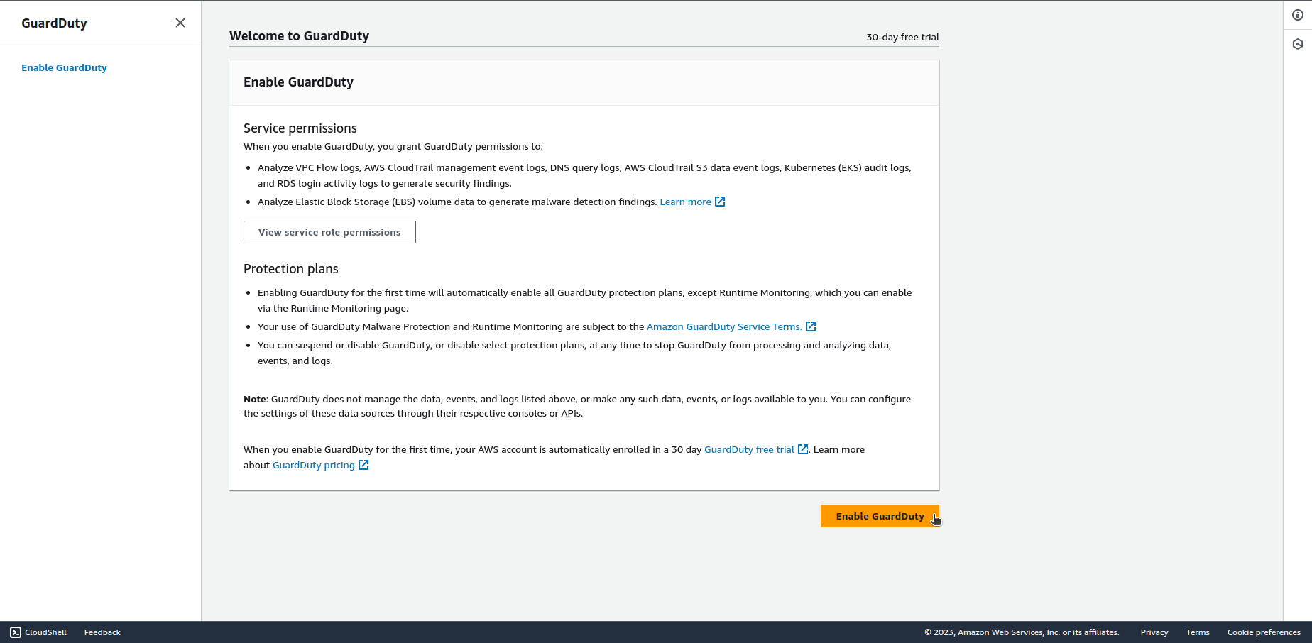

4. Review and Confirm:

- Review Protection plans and turn off the ones You don’t need.

5. Start Monitoring:

- GuardDuty will start monitoring your AWS environment for security threats based on the configured settings.

By following these steps, you can enable AWS GuardDuty and enhance the security of your AWS environment. Regularly review GuardDuty findings to respond promptly to potential security incidents.