**How to change account password   
policy in AWS**

1. 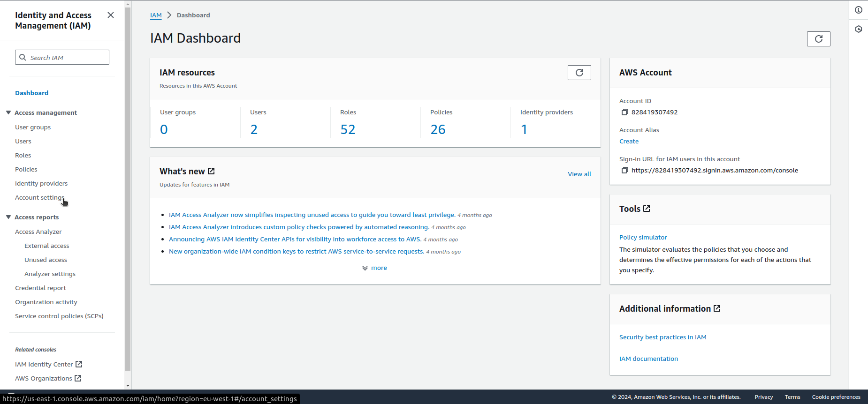Log in to the AWS console, navigate to IAM service and click on “Account settings” on the left pane.
2. 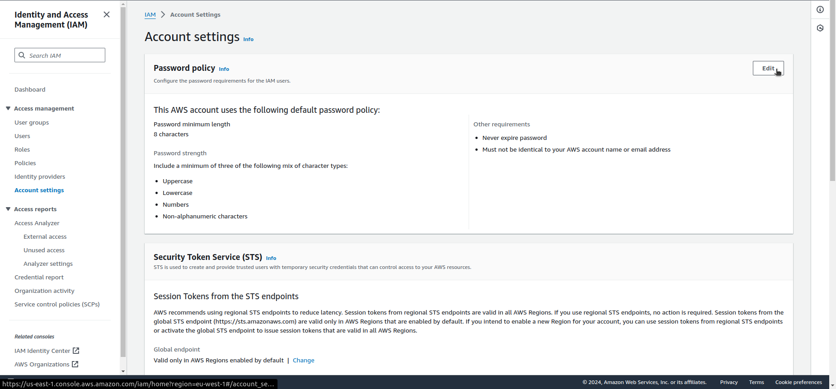In the “Password policy” section click on “Edit” in the left upper corner.
3. 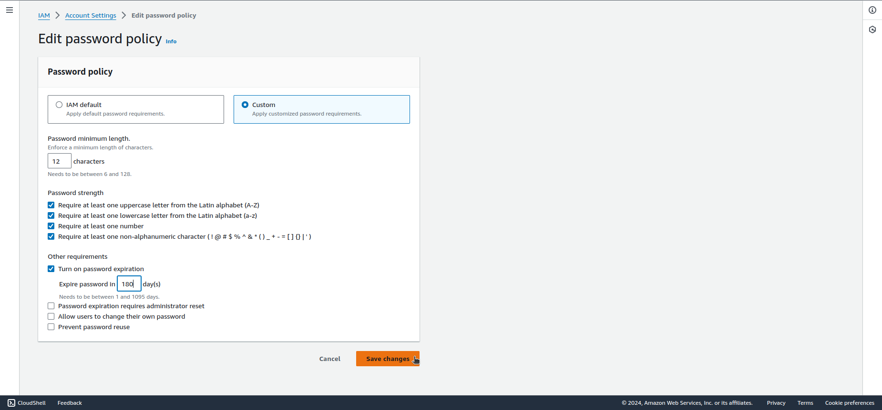Select “Custom” and create Your own, strong password policy with the password expiration option enabled.
4. Click on “Save changes”.