**AWS Systems Manager Patch Manager**

AWS Systems Manager Patch Manager is a service that helps you automate the process of patching your managed instances with security-related updates. It allows you to select, approve, and apply patches to your instances, making it easier to keep your infrastructure up to date and secure. Here are some key features and concepts related to AWS Systems Manager Patch Manager:

1. **Patch Baselines**

Patch baselines are a set of rules that define which patches are approved for installation on your instances. AWS provides predefined baselines for common operating systems, and you can also create custom baselines to suit your specific requirements.

1. **Approval Rules**

Approval rules allow you to automate the approval process for patches based on criteria such as severity, classification, or specific patches. This helps you ensure that critical security patches are automatically approved for installation.

1. **Patch Groups**

Patch groups are used to organize your instances based on their patching needs. You can assign instances to specific patch groups, making it easier to manage and schedule patching operations for different sets of instances.

1. **Patch Compliance**

Patch compliance reports provide visibility into the patching status of your instances. You can use these reports to track which instances are missing patches and take corrective actions as needed.

1. **Scheduling Patching Operations**

You can schedule patching operations to occur at specific times, making it convenient to plan maintenance windows and minimize the impact on your applications.

1. **Integration with AWS Identity and Access Management (IAM)**

AWS Systems Manager Patch Manager integrates with IAM, allowing you to control access to patching operations and ensure that only authorized users or systems can approve or apply patches.

1. **AWS CLI and SDK Support**

Patch Manager can be managed using the AWS Management Console, AWS Command Line Interface (CLI), or SDKs, providing flexibility in how you interact with the service.

[AWS Documentation](https://docs.aws.amazon.com/systems-manager/latest/userguide/patch-manager.html)

**Enable Patch Manager**

1. Open to AWS Console and navigate to Systems Manager service and click on “Quick Setup” on the left-side pane.

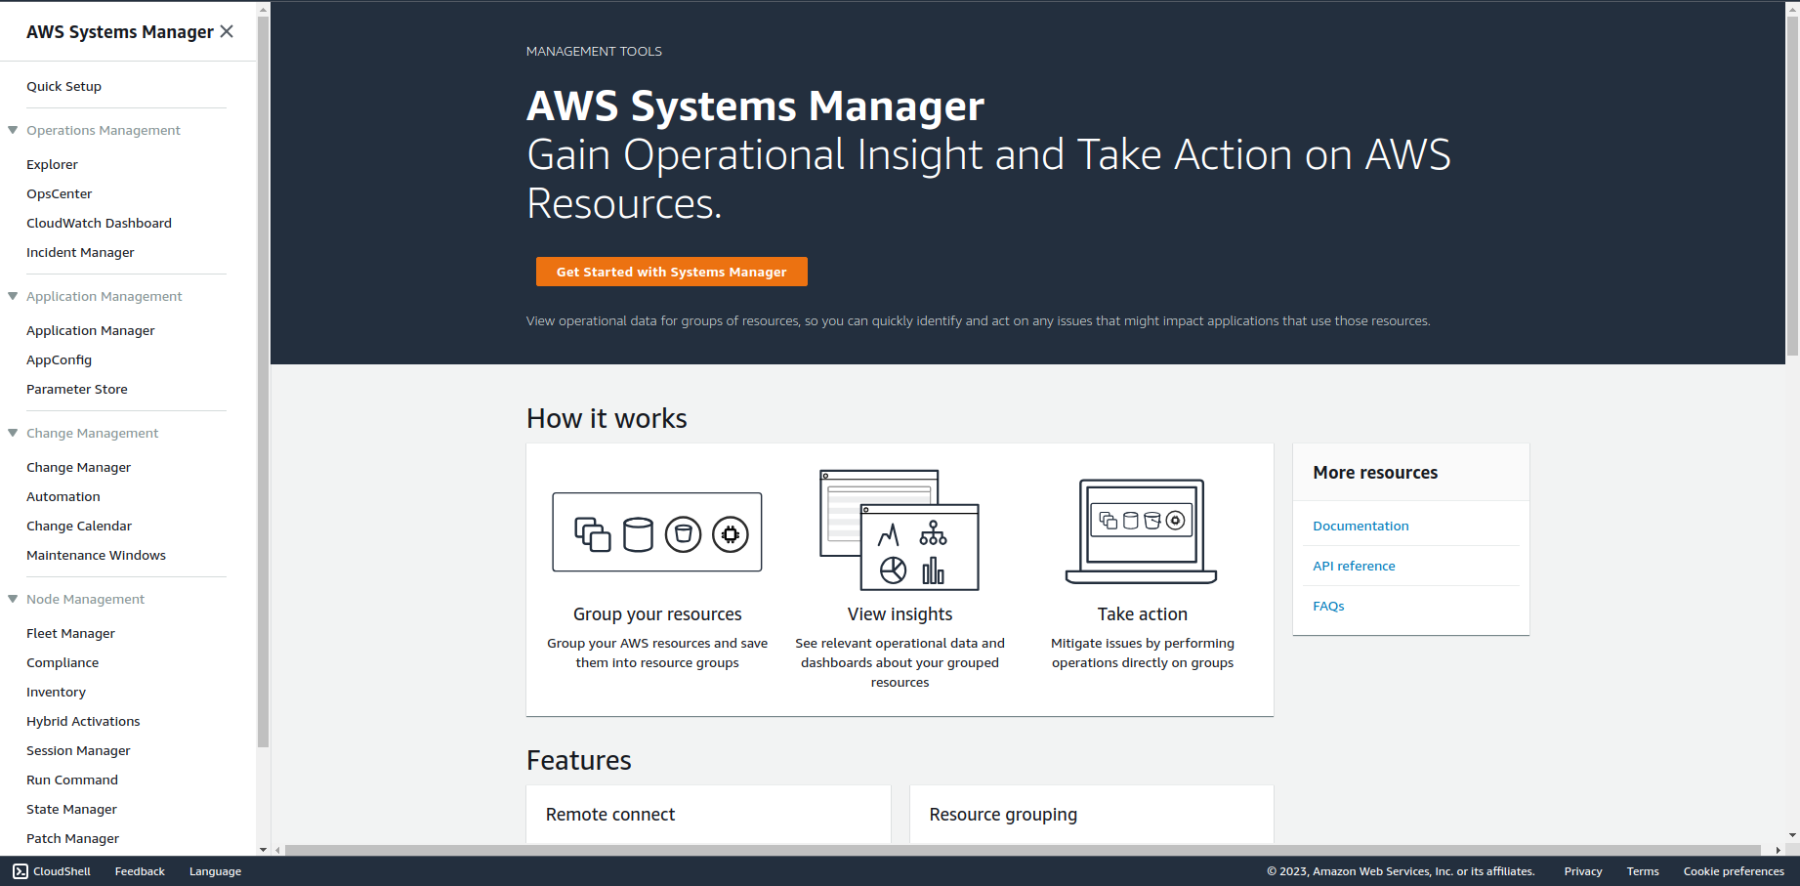

2. On the “Patch manager” window click on “Create”.

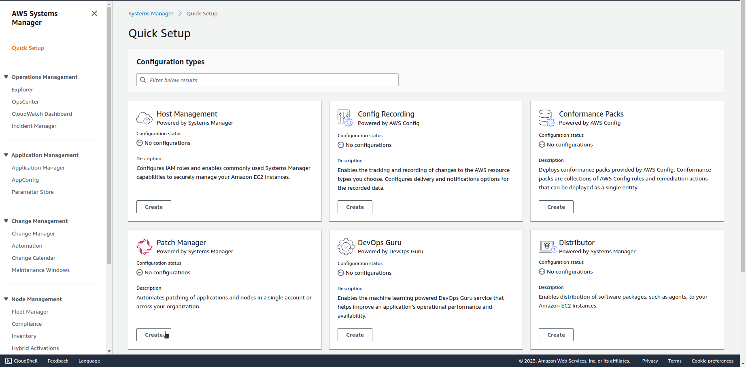

3. Name the configuration, choose if You only want to scan for the updates or install them as well. Choose the recommended or create a custom schedule.

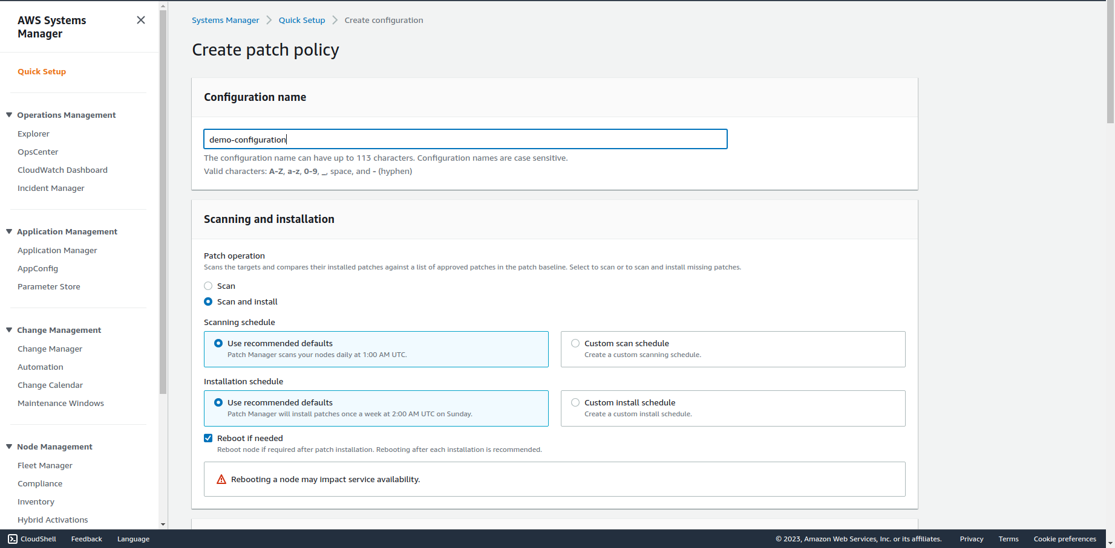

4. Select the recommended Patch baseline or create a custom one, decide You want to store logs and choose the target instances.

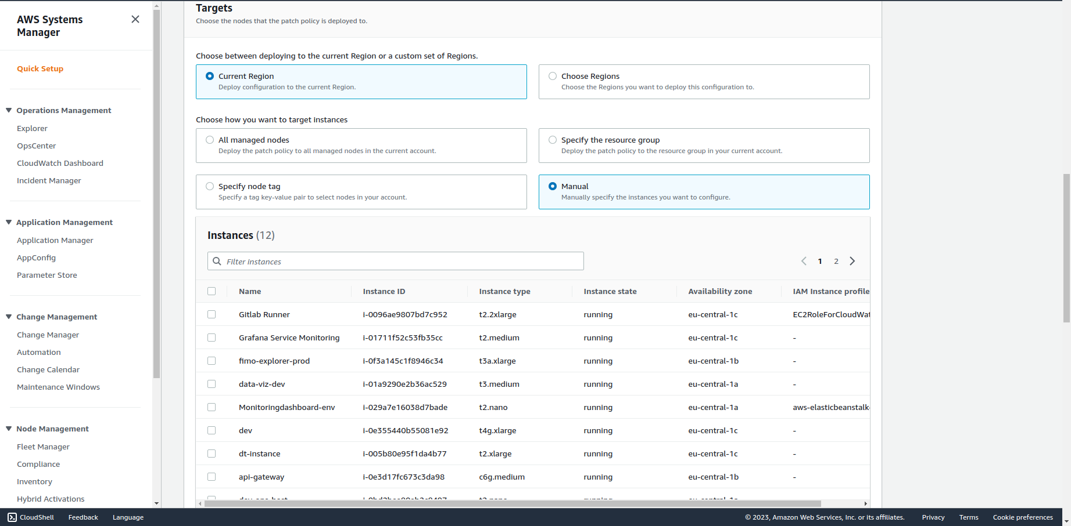

5. Customize Rate control settings and attach IAM instance profiles to the selected EC2 instances if they do not have it yet.

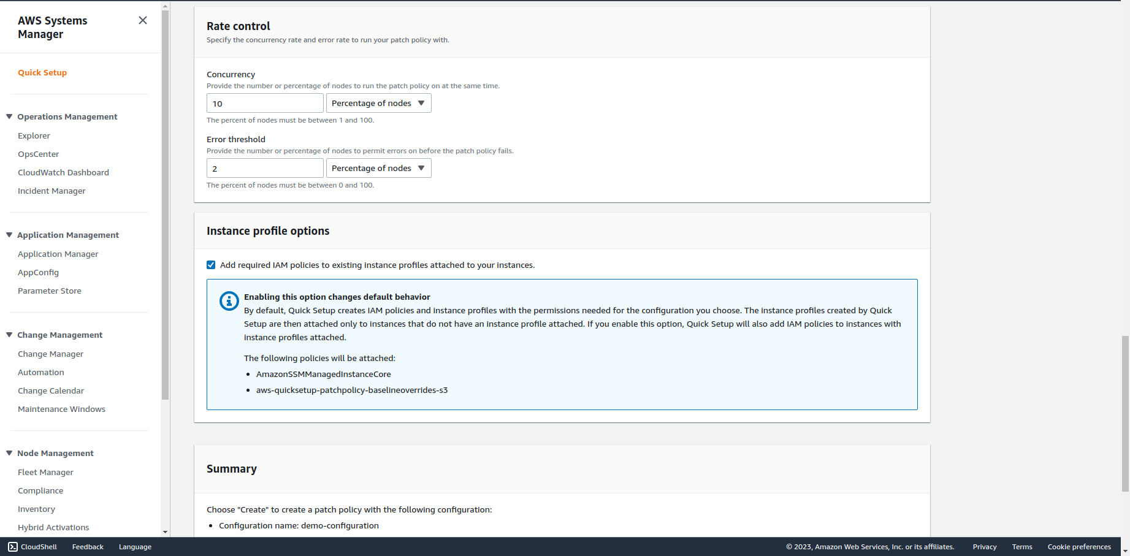

6. Check the summary and click on “Create”.