**RDS Backups Automated Cross Region Replication**

Documentation Reference: <https://docs.aws.amazon.com/AmazonRDS/latest/UserGuide/USER_ReplicateBackups.html>

To enable the automated cross region backups for an RDS instance:

* Navigate to the Automated Backups menu of the Amazon RDS service, [https://eu-west-1.console.aws.amazon.com/rds/home?region=eu-west-1#automatedbackups](https://eu-west-1.console.aws.amazon.com/rds/home?region=eu-west-1" \l "automatedbackups):
* Select the backup of the db instance that you want to enable the cross region replication
* Select the Actions - Manage cross-Region Replication option from the menu  
    
  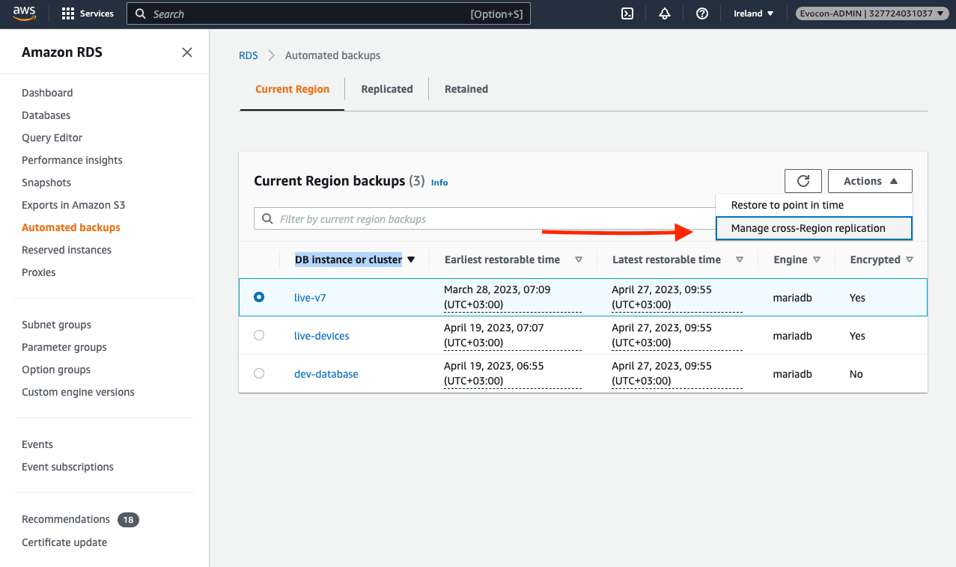

* In the Manage cross-Region replication menu, select **Enable replication in another AWS Region** and then align the respective values of:
  + Destination Region
  + Replicated backup retention period
* The AWS KMS key ARN to enable encryption in the destination Region, this applies only in case the DB has encryption enabled. For example, the **live-v7** has encryption enabled and its KMS key can be fetched as shown in the screenshot attached below from the automated backups menu  
  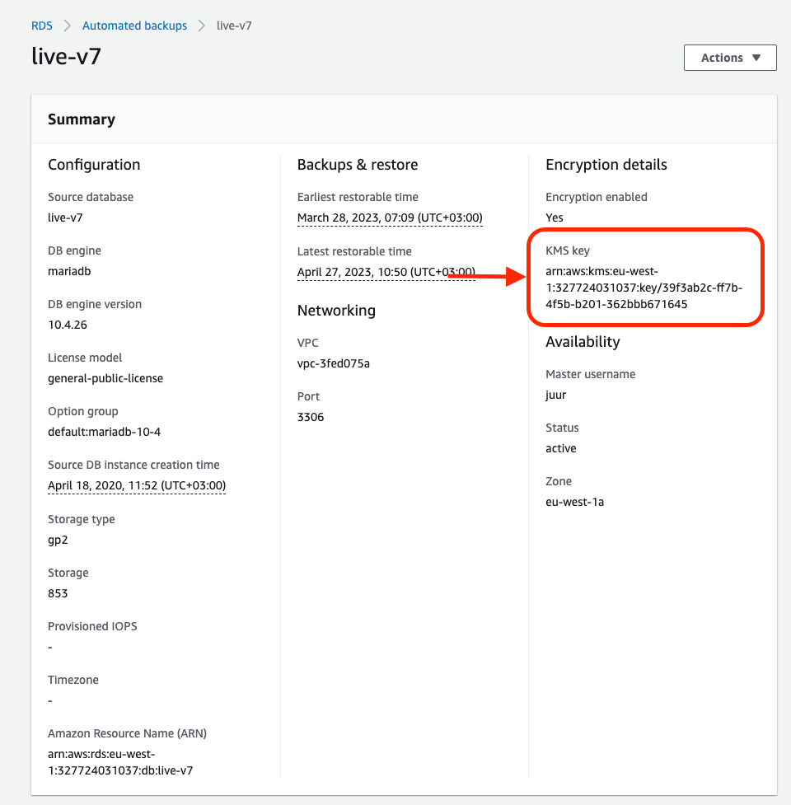

After configuring, In the source Region, replicated backups are listed on the Current Region tab of the Automated backups page. In the destination Region, replicated backups are listed on the Replica